Environmental Susceptibility for All: A Data-Driven Approach Suggests Individual Differences in Domain-General and Domain-Specific Patterns of Environmental Susceptibility – Supplementary Materials

Note 1: Prosocial behavior task description
Children who completed the study online participated in a modified dictator game, which was implemented in the broader ‘game-story’ of the entire study. The task began with the following explanation: “In the following game, you will be able to gain points, which will be translated into a prize. You also have the option to donate points. We will turn the points you have donated into Shekels [Israeli currency] and donate them to an organization that takes care of children in need.” The task included five trials, in which children were presented with two options, each describes a different distribution of points between themselves and donating, where one of the options was the prosocial choice. For example: “Which do you prefer? 1) To earn 20 points for yourself and not donate any points to children in need. 2) To earn 10 points for yourself and donate 10 points to children in need” (the second option being the prosocial choice). The order of the two options were presented randomly. Each prosocial choice was coded as 1, and each non-prosocial choice as 0. A prosocial score was computed as the sum of trial scores, ranging from 0 (no prosocial choices) to 5 (all prosocial choices) (Rum et al., 2022).

Note 2: R packages used for the data analyses
We used the package lavaan (Rosseel, 2012) for Confirmatory Factor Analysis (CFA), the function kmeans for k-means cluster analysis, the Rtsne package (Krijthe, 2015) for t-Distributed Stochastic Neighbor Embedding (t-SNE) analysis (van der Maaten, 2014), the prcomp function for Principal Component Analysis (PCA), the paran package for Horn’s parallel analysis (Dinno, 2018) and the geometry package (Habel et al., 2019) to find the convex hull of the data.

Supplementary Tables
Table S1
Model Details and Fit Indices for the CFA Tested Models
Model | Model description | Comments | χ² | df | CFI | RMSEA [90% CI] | SRMR | ∆ χ² | p
Environmental measures
Parents and peers | Four latent factors: 1. Parents-negative (conflict with mothers and fathers, maternal punitive strategies, maternal corporal punishment, maternal verbal hostility, maternal love withdrawal); 2. Parents-positive (involvement of mothers and fathers, regard for mothers and fathers, mothers and fathers regard for child, maternal warmth, maternal democratic participation, maternal reasoning); 3. Peers-negative (peer problems); 4. Peer-positive (support from friends and twins). | Model did not converge | - | - | - | - | - | - | -
Separate parents, twins  as peers | Six latent factors: 1. Mother-negative (conflict, punitive strategies, corporal punishment, verbal hostility, love withdrawal); 2. Father-negative (conflict); 3. Mother-positive (involvement, regard for parent, regard for child, warmth, democratic participation, reasoning); 4. Father-positive (involvement, regard for parent, regard for child); 5. Peer-negative (peer problems); 6. Peer-positive (support from friends and twins). | Difference from previous model: separating mothers and fathers as two different sources. | 2630.945 | 510 | .889 | .053 [.051, .055] | .057 | - | -
Separate social inputs | Seven latent factors: 1. Mother-negative (conflict, punitive strategies, corporal punishment, verbal hostility, love withdrawal); 2. Father-negative (conflict); 3. Mother-positive (involvement, regard for parent, regard for child, warmth, democratic participation, reasoning); 4. Father-positive (involvement, regard for parent, regard for child); 5. Peer-negative (peer problems); 6. Peer-positive (support); 7. Twin-positive (support). | Difference from previous model: separating twins and peers as two different sources. | 1977.578 | 504 | .923 | .045 [.043, .047] | .044 | - | -
Separate social inputs  with common method  correction | Same as the separate social inputs model, with modeling the associations between relationship with parents’ scales that are identical for mothers and fathers. |  | 1621.057 | 501 | .941 | .039 [.037, .041] | .045 | 356.52 | < .001
Separate social inputs  extended | Same as the separate social inputs with common-method model, removing insignificant correlations between latent factors. | Chosen model | 1626.679 | 507 | .941 | .039 [.037, .041] | .047 | 5.621 | .467
Outcome measures
Positive-negative | Two latent factors: 1. Positive outcomes (empathy, prosocial behavior, and self-esteem); 2. Negative outcomes (conduct problems and aggression). | Model did not converge | - | - | - | - | - | - | -
Five-factor solution | Five latent factors: 1. Cognitive empathy (cognitive empathy items); 2. Emotional empathy (emotional empathy, empathic concern); 3. Prosocial behavior (Prosocial behavior scales and task) 4. Aggression (conduct problems and aggression); 5. Self-esteem (self-esteem items). | Model did not converge | - | - | - | - | - | - | -
Four-factor solutionª | Four latent factors: 1. Cognitive empathy (cognitive empathy items); 2. Interpersonal concern (emotional empathy, empathic concern, and prosocial behavior); 3. Aggression (conduct problems and aggression); 4. Self-esteem (self-esteem items). | Chosen model | 715.167 | 291 | .942 | .031 [.028, .034] | .039 | - | -
Note. Models were tested separately for the environmental measures and outcome measures. All models modeled in addition to the detailed factors the source of reporting, that is, whether the scales were reported by the children or by the mothers. In all models we didn’t model correlations between the source latent factors and content latent factors. Acceptable model fit was indicated by values of Comparative Fit Index (CFI) > .9, Root Mean Square Error of Approximation (RMSEA) < .1 and Standardized Root Mean Square Residual (SRMR) < .1 (Kline, 2016). Nested models were compared using the anova function. The model in bold type is the model chosen.
ª This model was chosen based on work done by Mairon et al., (under review), which conducted extensive CFA on measures related to empathy and prosocial behavior, and found two latent factors: mentalizing (cognitive aspects of empathy) and interpersonal concern (emotional empathy, empathic concern, and prosociality).

Table S2
Correlations with Confidence Intervals between Environment and Outcome Factor Scores
Variable | 1 | 2 | 3 | 4 | 5 | 6 | 7 | 8 | 9 | 10
Environmental exposures:
1. Mother-negative
2. Father-negative | -.01
 | [-.06, .05]
3. Mother-positive | -.13** | .52**
 | [-.18, -.08] | [.48, .56]
4. Father-positive | .02 | -.31** | .47**
 | [-.03, .07] | [-.36, -.26] | [.43, .51]
5. Peers-negative | .30** | .13** | -.25** | -.18**
 | [.25, .34] | [.07, .18] | [-.29, -.20] | [-.23, -.13]
6. Peers-positive | -.18** | .06* | .35** | .28** | -.03
 | [-.23, -.13] | [.00, .11] | [.31, .40] | [.23, .33] | [-.08, .02]
7. Twin-positive | -.00 | .01 | .40** | .31** | -.36** | .20**
 | [-.05, .05] | [-.04, .06] | [.36, .45] | [.26, .36] | [-.40, -.31] | [.15, .25]
Developmental outcomes:
8. Cognitive empathy | -.03 | -.00 | .23** | .20** | -.17** | .10** | .32**
 | [-.08, .02] | [-.05, .05] | [.18, .28] | [.16, .25] | [-.22, -.12] | [.04, .15] | [.27, .37]
9. Interpersonal concern | -.08** | .00 | .24** | .20** | -.17** | .16** | .26** | .71**
 | [-.13, -.03] | [-.05, .05] | [.19, .28] | [.15, .25] | [-.22, -.12] | [.11, .21] | [.21, .30] | [.69, .74]
10. Aggression | .35** | .05* | -.08** | -.05 | .35** | -.04 | -.08** | -.17** | -.24**
 | [.30, .39] | [.00, .11] | [-.13, -.03] | [-.10, .01] | [.30, .39] | [-.09, .01] | [-.13, -.03] | [-.22, -.12] | [-.28, -.19]
11. Self-esteem | -.12** | .02 | .28** | .18** | -.23** | .10** | .25** | .44** | .26** | -.25**
 | [-.17, -.07] | [-.03, .07] | [.23, .32] | [.13, .23] | [-.28, -.18] | [.05, .15] | [.20, .30] | [.40, .48] | [.21, .30] | [-.30, -.20]
Note. Values in square brackets indicate the 95% confidence interval for each correlation. * p < .05. ** p < .01.

Table S3
Sex Differences in Factor Scores
Variable | Boys M (SD) | Girls M (SD) | t(df) | p^{c} | Cohen’s d
Mother-negativeª | 0.10 (1.00) | -0.09 (1.00) | 3.57 (1457.6) | .001 | 0.19
Father-negativeª | -0.05 (1.02) | 0.04 (0.98) | 1.75 (1447.8) | .098 | 0.09
Mother-positiveª | -0.14 (1.06) | 0.13 (0.92) | 5.32 (1407.9) | < .001 | 0.28
Father-positiveª | -0.05 (1.03) | 0.04 (0.97) | 1.77 (1442.6) | .098 | 0.09
Peer-negativeª | 0.10 (1.05) | -0.10 (0.94) | 3.84 (1424.7) | < .001 | 0.20
Peers-positiveª | -0.03 (1.01) | 0.02 (0.99) | 0.93 (1453.7) | .388 | 0.05
Twins-positiveª | -0.08 (0.95) | 0.07 (1.04) | 2.93 (1459.2) | .005 | 0.15
Cognitive empathy^{b} | -0.15 (0.96) | 0.14 (1.01) | 5.61 (1461) | < .001 | 0.29
Interpersonal concern^{b} | -0.21 (0.95) | 0.20 (1.00) | 8.10 (1461) | < .001 | 0.42
Aggression^{b} | 0.09 (1.08) | -0.08 (0.91) | 3.34 (1397.8) | .002 | 0.18
Self-esteem^{b} | 0.02 (0.95) | -0.02 (1.04) | 0.70 (1458.8) | .484 | 0.04
Note. In bold type are significant sex differences. ª Environmental measures. ^{b} Developmental outcome measures. ^{c} After Benjamini-Hochberg (1995) correction for multiple comparisons.
Table S4
Correlations between Points on the Convex Hull of the Environmental Susceptibility Space and Temperament
 | Negative emotionality | Shyness | Sociability | Activity | Temperament pattern
1 | 0.06 | -0.03 | 0.02 | 0.07* | Act(+)
2 | -0.00 | -0.19*** | 0.12*** | 0.16*** | Shy(-) Soc(+) Act(+)
3 | 0.06 | 0.11*** | -0.12*** | -0.11*** | Shy(+) Soc(-) Act(-)
4 | 0.03 | 0.16*** | -0.14*** | -0.14*** | Shy(+) Soc(-) Act(-)
5 | -0.23*** | 0.05 | -0.03 | -0.11*** | NE(-) Act(-)
6 | -0.39*** | -0.03 | 0.05 | -0.07* | NE(-) Act(-)
7 | -0.39*** | -0.12*** | 0.13*** | 0.03 | NE(-) Shy(-) Soc(+)
8 | -0.33*** | -0.07* | 0.06* | -0.04 | NE(-) Shy(-) Soc(+)
9 | -0.16*** | -0.17*** | 0.15*** | 0.13*** | NE(-) Shy(-) Soc(+) Act(+)
10 | -0.06* | -0.17*** | 0.13*** | 0.15*** | NE(-) Shy(-) Soc(+) Act(+)
11 | -0.18*** | -0.17*** | 0.11*** | 0.07* | NE(-) Shy(-) Soc(+) Act(+)
12 | -0.16*** | -0.17*** | 0.11*** | 0.08** | NE(-) Shy(-) Soc(+) Act(+)
13 | -0.27*** | -0.21*** | 0.17*** | 0.10** | NE(-) Shy(-) Soc(+) Act(+)
14 | -0.15*** | -0.21*** | 0.16*** | 0.15*** | NE(-) Shy(-) Soc(+) Act(+)
15 | -0.10*** | 0.13*** | -0.10** | -0.13*** | NE(-) Shy(+) Soc(-) Act(-)
16 | 0.09** | -0.03 | -0.02 | 0.02 | NE(+)
17 | 0.12*** | -0.01 | -0.04 | 0.01 | NE(+)
18 | 0.33*** | -0.00 | -0.05 | 0.10** | NE(+) Act(+)
19 | 0.18*** | -0.11*** | 0.04 | 0.15*** | NE(+) Shy(-) Act(+)
20 | 0.20*** | -0.09** | 0.02 | 0.11*** | NE(+) Shy(-) Act(+)
21 | 0.09** | -0.16*** | 0.08** | 0.14*** | NE(+) Shy(-) Soc(+) Act(+)
22 | 0.26*** | 0.11*** | -0.12*** | -0.01 | NE(+) Shy(+) Soc(-)
23 | 0.37*** | 0.14*** | -0.16*** | -0.02 | NE(+) Shy(+) Soc(-)
24 | 0.33*** | 0.10** | -0.12*** | 0.01 | NE(+) Shy(+) Soc(-)
25 | 0.18*** | 0.18*** | -0.15*** | -0.10*** | NE(+) Shy(+) Soc(-) Act(-)
26 | 0.17*** | 0.09** | -0.11*** | -0.07* | NE(+) Shy(+) Soc(-) Act(-)
27 | 0.14*** | 0.16*** | -0.15*** | -0.12*** | NE(+) Shy(+) Soc(-) Act(-)
28 | 0.27*** | 0.18*** | -0.16*** | -0.09** | NE(+) Shy(+) Soc(-) Act(-)
29 | 0.15*** | 0.19*** | -0.16*** | -0.13*** | NE(+) Shy(+) Soc(-) Act(-)
30 | 0.09** | 0.15*** | -0.14*** | -0.13*** | NE(+) Shy(+) Soc(-) Act(-)
31 | 0.18*** | 0.19*** | -0.16*** | -0.12*** | NE(+) Shy(+) Soc(-) Act(-)
32 | 0.30*** | 0.18*** | -0.17*** | -0.08** | NE(+) Shy(+) Soc(-) Act(-)
33 | 0.29*** | 0.19*** | -0.17*** | -0.09** | NE(+) Shy(+) Soc(-) Act(-)
34 | 0.22*** | 0.19*** | -0.17*** | -0.12*** | NE(+) Shy(+) Soc(-) Act(-)
Note. Significance levels are corrected for multiple comparisons according to the Benjamini-Hochberg (1995) method. Act = Activity. Shy = Shyness. Soc = Sociability. NE = Negative emotionality. + = A positive correlation. - = A negative correlation. * p < .05. ** p < .01. *** p < .001.
Table S5
Full E-O Associations for the Four Groups of Children Positioned in Different Regions of the Space
Outcome | Mother-Negative | Father-Negative | Mother-Positive | Father-Positive | Peer-Negative | Peer-Positive | Twin-Positive
NE(+) Shy(-) Act(+)
Cognitive empathy | 0.36*** | 0.00 | -0.19 | -0.16 | 0.24* | -0.37*** | -0.06
Interpersonal concern | 0.13 | 0.07 | -0.05 | -0.18 | 0.13 | -0.17 | -0.31**
Aggression | 0.09 | -0.20* | -0.23* | -0.04 | -0.05 | -0.09 | 0.00
Self-esteem | 0.29** | 0.07 | -0.09 | -0.21* | 0.15 | -0.33*** | -0.17
NE(+) Shy(+) Soc(-) Act(-)
Cognitive empathy | 0.12 | -0.21* | -0.17 | 0.04 | 0.25* | -0.02 | 0.20
Interpersonal concern | 0.17 | -0.21* | -0.22* | -0.09 | 0.26** | 0.01 | 0.13
Aggression | 0.07 | 0.03 | 0.11 | 0.18 | 0.09 | -0.12 | 0.09
Self-esteem | 0.10 | -0.19* | -0.25* | 0.03 | 0.05 | -0.08 | 0.07
NE(-) Shy(-) Soc(+) Act(+)
Cognitive empathy | 0.02 | 0.12 | -0.20* | -0.32** | 0.11 | -0.04 | -0.12
Interpersonal concern | -0.12 | 0.04 | -0.14 | -0.17 | 0.16 | 0.02 | -0.05
Aggression | 0.17 | -0.15 | -0.05 | 0.07 | 0.10 | -0.05 | 0.01
Self-esteem | 0.06 | 0.14 | 0.22* | 0.09 | -0.14 | -0.01 | 0.14
NE(-) Act(-)
Cognitive empathy | 0.23* | 0.16 | -0.17 | -0.07 | 0.19 | -0.24* | 0.01
Interpersonal concern | 0.11 | 0.08 | -0.13 | -0.13 | 0.09 | -0.01 | -0.12
Aggression | 0.08 | -0.17 | -0.33*** | -0.20* | 0.01 | -0.13 | 0.01
Self-esteem | 0.04 | 0.06 | 0.06 | 0.16 | 0.16 | -0.15 | -0.06
Note. The group names represent the temperament profiles for the relevant region. Significance levels are based on 10,000 permutations, where we shuffled between children’s environmental variables and outcome variables, but did not shuffle within children’s environmental variables, or within children’s outcome variables. Act = Activity. Shy = Shyness. Soc = Sociability. NE = Negative emotionality. + = A positive correlation. - = A negative correlation. * p < .05. ** p < .01. *** p < .001.

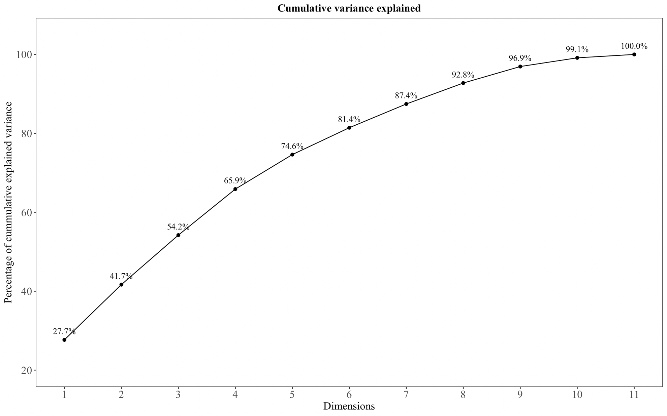
Supplementary Figures
Figure S1. PCA results presenting the cumulative variance explained by the principal components.

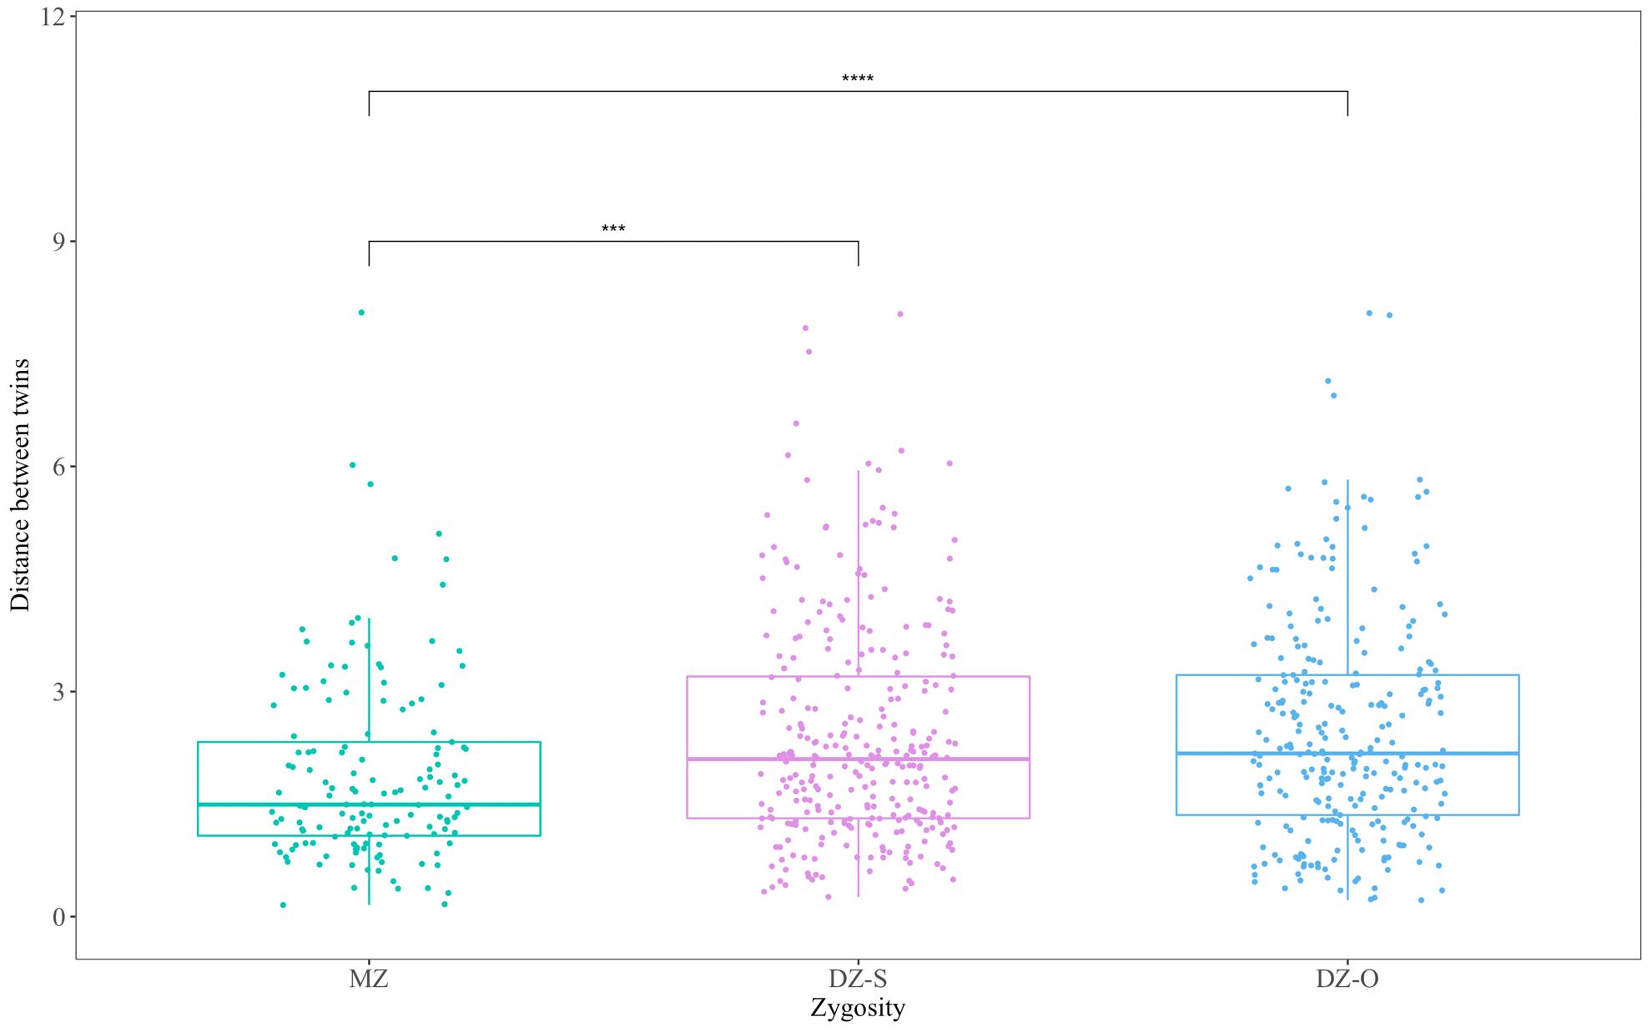
Figure S2. Euclidean distances between twins on the 3-axis environmental susceptibility space, presented by zygosity. MZ = Monozygotic twins. DZ-S = Dizygotic same-sex twins. DZ-O = Dizygotic other-sex twins. *** p < .001.  p < .0001.
References
Benjamini, Y., & Hochberg, Y. (1995). Controlling the false discovery rate: a practical and powerful approach to multiple testing. Journal of the Royal Statistical Society Series B, 57, 289–300. https://doi.org/10.1111/j.2517-6161.1995.tb02031.x.
Kline, R. B. (2016). Principles and practice of structural equation modeling. Guilford Publications.
Mairon, N., Abramson, L., Knafo-Noam, A., Perry, A., & Nahum, M. (under review). The Relationship between Empathy and Executive Functions among Young Adolescents.
Rum, Y., Genzer, S., Markovitch, N., Jenkins, J. M., Perry, A., & Knafo-Noam, A. (2022). Are there positive effects of having a sibling with special needs? Empathy and prosociality of twin siblings of children with non-typical development. Child Development, 93(4), 1121–1128. https://doi.org/https://doi.org/10.1111/cdev.13740

