Supplementary Material

Changes in Tundra Swan Cygnus columbianus bewickii distribution and abundance in the Yangtze River floodplain

PEIHAO CONG, LEI CAO, ANTHONY D. FOX, MARK BARTER, EILEEN REES, YONG JIANG, WEITOU JI, WENZHONG ZHU and GUOXIAN SONG

Contents

Figure S1. The location of Poyang Lake and the Anhui Lakes within the Yangtze River floodplain, in relation to the Three Gorges Dam (inset map, also showing provinces). Main map shows the Anhui Lakes including Shengjin Lake National Nature Reserve and the Anhui Anqing Yangtze Riverine Wetland

Figure S2. Tundra Swan distributions during the 2005/2006–2008/2009 winter counts (mid-date given) in Jiangxi. Small circles: < 1%; medium circles: ≥ 1%; large circles: ≥ 5% of the estimated East Asian Flyway population of 92,000 (Wetlands International 2006).

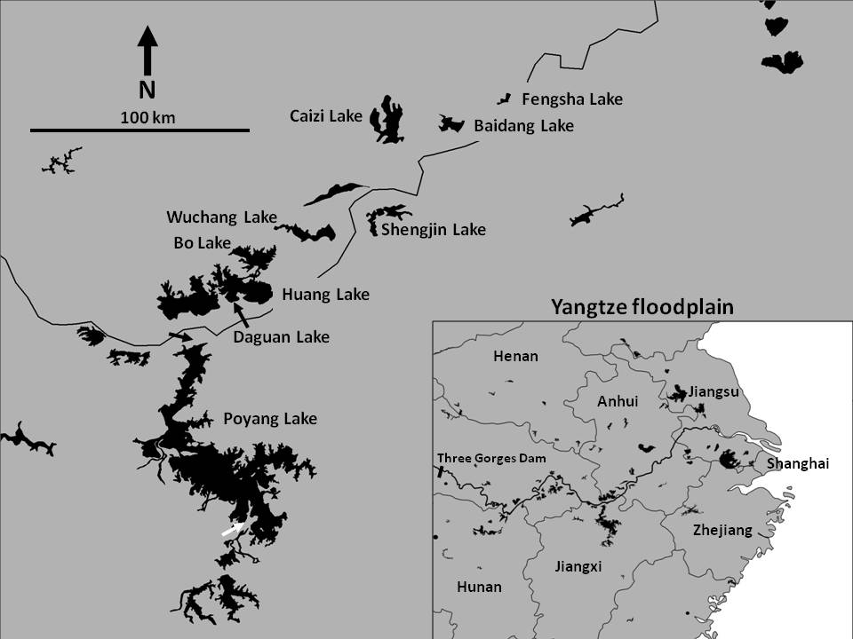Figure S1. The location of Poyang Lake and the Anhui Lakes within the Yangtze River floodplain, in relation to the Three Gorges Dam (inset map, also showing provinces). Main map shows the Anhui Lakes including Shengjin Lake National Nature Reserve and the Anhui Anqing Yangtze Riverine Wetland Nature Reserve (comprising Fengsha Lake, Baidang Lake, Caizi Lake, Wuchang Lake, Bo Lake, Huang Lake and Daguan Lake).
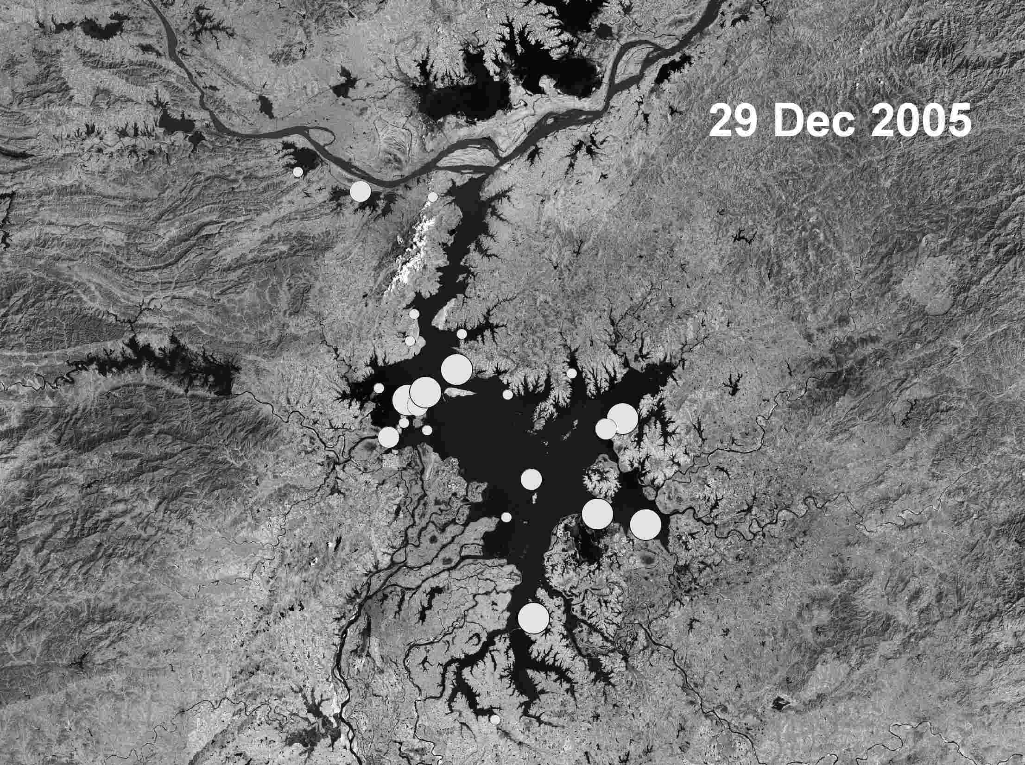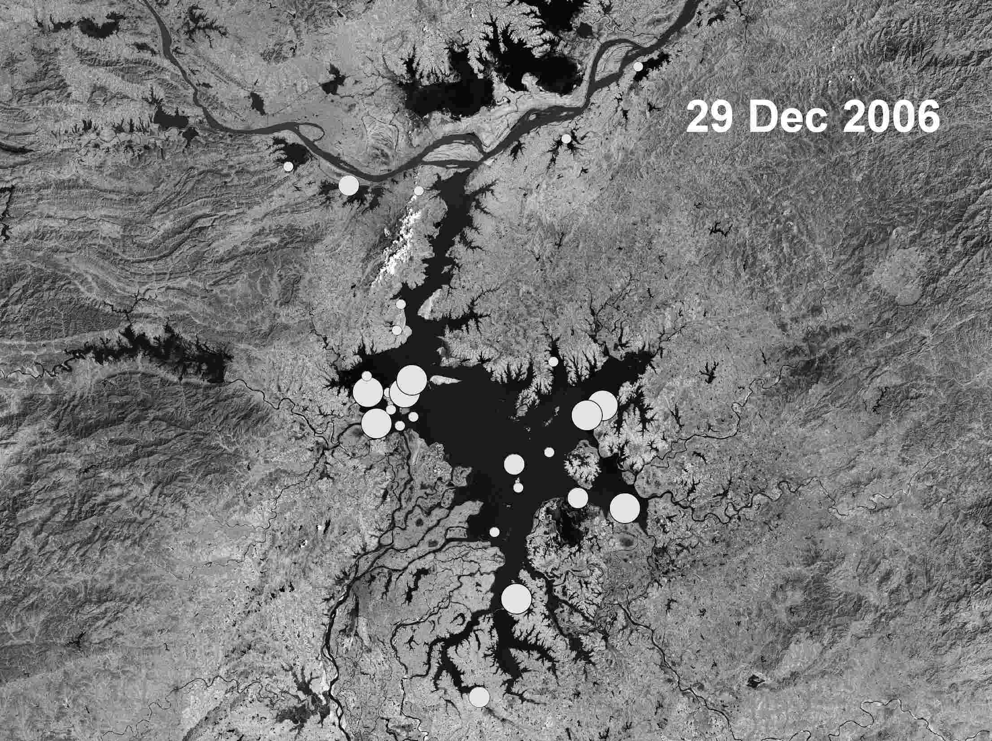
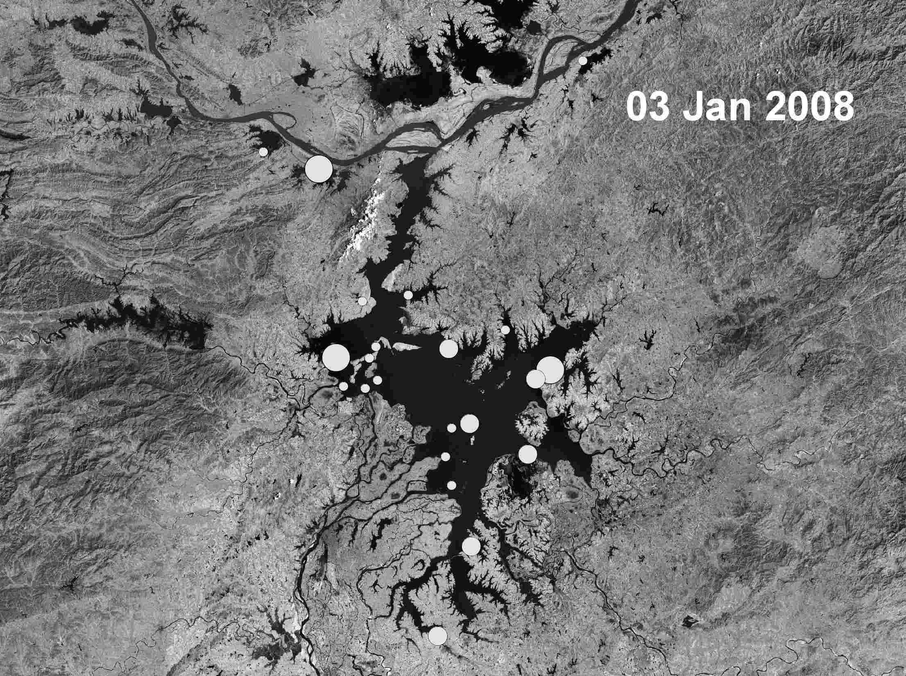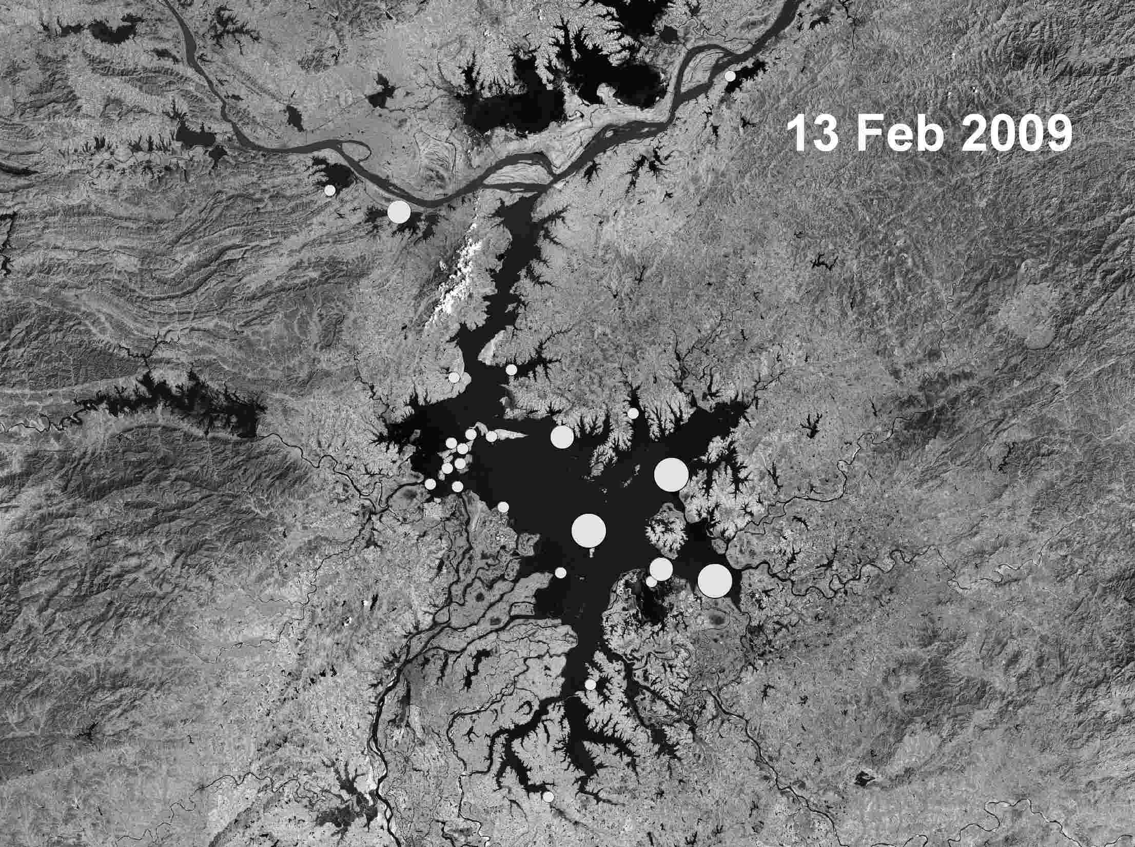
Figure S2. Tundra Swan distributions during the 2005/2006-2008/2009 winter counts (mid-date given) in Jiangxi. Small circles: < 1%; medium circles: ≥ 1%; large circles: ≥ 5% of the estimated East Asian Flyway population of 92,000 (Wetlands International 2006).

