Supplementary Material

Serious contractions in wintering distribution and decline in abundance of Baer’s Pochard Aythya baeri

XIN WANG, MARK BARTER, LEI CAO, JINYU LEI and ANTHONY D. FOX

Contents

Figure S1. Names of provinces and major lakes along the Yangtze Floodplain, eastern China.

Table S1. All recent counts of more than 100 Baer’s Pochard in China from 2006 to 2011. Data sources are as follows: 1: field survey by Barter et al. 2009/10; 2: field survey by Barter et al. 2010/11; 3: field survey by J. Lei 2010/11.

Table S2. Annual maximum counts of Baer’s Pochard from each province of China, for each of three periods during 2002/03 to 2010/11.

References

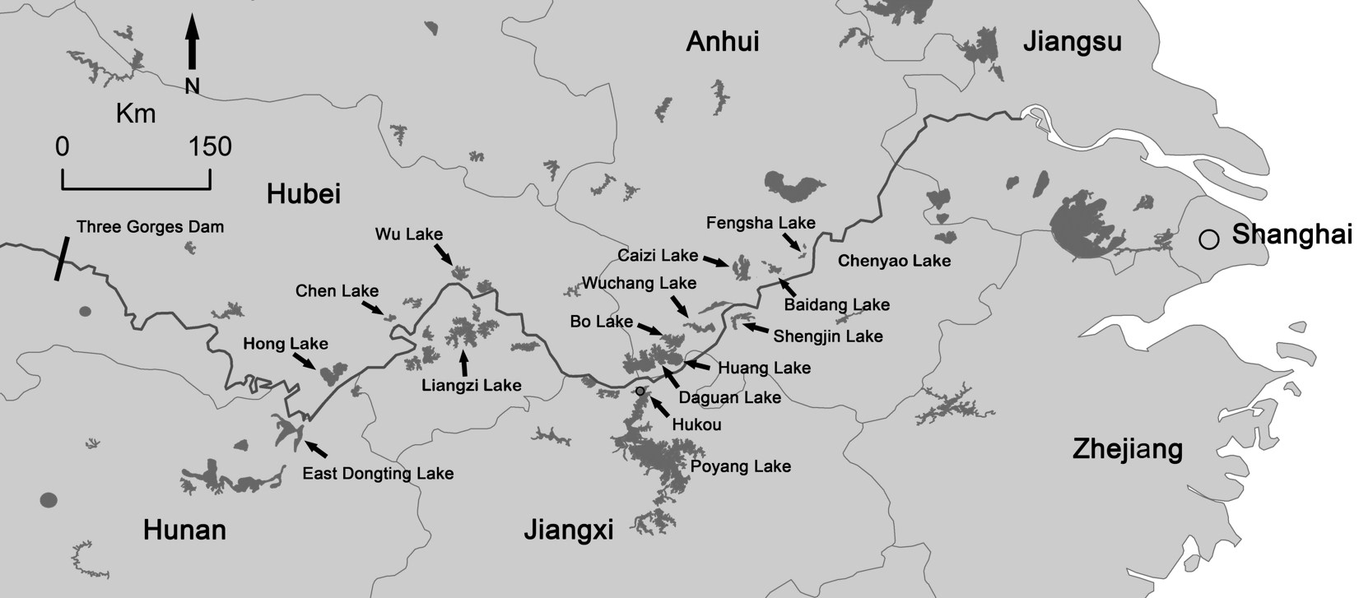
Figure S1. Names of provinces and major lakes along Yangtze Floodplain, eastern China.
Table S1. All recent counts of more than 100 Baer’s Pochard in China from 2006 to 2011. Data sources are as follows: 1: field survey by Barter et al. 2009/10; 2: field survey by Barter et al. 2010/11; 3: field survey by J. Lei 2010/11.

Site | Province | Count | Date
Wuchang Lake | Anhui | 200 ¹ | 17 December 2009
Wuchang Lake | Anhui | 237 ¹ | 5 February 2010
Wuchang Lake | Anhui | 760 ² | 28 November 2010
Wuchang Lake | Anhui | 200 ² | 1 December 2010
Liangzi Lake | Hubei | 131 ³ | 19 January 2011
Fengsha Lake | Anhui | 230 ² | 10 February 2011

Table S2. Annual maximum counts of Baer’s Pochard from each province of China, for each of three periods during 2002/03 to 2010/11. Summing provincial annual maxima across a series of years is likely to overestimate the true numbers present at any time, underlining the seriousness of the decline observed in these values. ‘--‘ indicates no records (either no survey or no birds) in that province; 4: Barter et al. (2004); 5: China Ornithological Society (2004); 6: Tao Xudong, living@birdtalker.net; 7: Cui et al. (1992); 8: field surveys by Barter et al. (2005, 2008, 2010, 2011); 9: Musenlin@birdtalker.net; 10: mmchong@birdtalker.net; 11: Anon (2005); 12: W. Liu (in litt.); 13: Mulinsen@birdtalker.net; 14: Zhang (2007); 15: Wei (2008); 16: midway@birdtalker.net; 17: Hongsun@birdtalker.net; 18: Lading, Wuhan Bird-watching Society, Mulinsen@birdtalker.net; 19: field survey by J. Lei 2010/11; 20: living@birdtalker.net; 21: Mcaribou@birdtalker.net; 22: Gudaoxifeng@birdtalker.net; 23: Hexi17, sunny@birdtalker.net; 24: Jushu@birdtalker.net; 25: Zhang (2008); 26: Xiaobai@birdtalker.net; 27: Shuiqiongchu, migrantsparrow@birdtalker.net.

 | Period
Province | 2002/03–2004/05 | 2005/06–2007/08 | 2008/09–2010/11
Hubei | 11 ⁴ | -- | 272 ^{18,19}
Hunan | 27 ^{5,6,7} | -- | 2 ²⁰
Anhui | 13 ⁸ | 89 ⁸ | 992 ⁸
Jiangsu | 8 ⁸ | -- | --
Jiangxi | 600 ⁴ | -- | 3 ²¹
Shanghai | 6 ⁴ | -- | --
Zhejiang | -- | -- | 1 ²²
Shandong | 1 ⁹ | -- | --
Henan | -- | 2 ¹³ | 3 ²³
Jilin | -- | -- | --
Sichuan | -- | 65 ^{14,15} | 5 ²⁴
Tianjin | 1 ⁵ | -- | --
Hebei | -- | -- | 9 ²⁵
Beijing | -- | 2 ¹⁶ | 2 ²⁶
Yunnan | -- | -- | --
Guangdong | -- | -- | --
Gansu | -- | -- | --
Liaoning | -- | 3 ¹⁷ | --
Xinjiang | -- | -- | --
Shaanxi | 1 ¹⁰ | -- | 3 ²⁷
Hong Kong | 4 ¹¹ | -- | --
Taiwan | 13 ¹² | 11 ¹² | 1 ¹²
Total | 685 | 172 | 1,293

References

Barter, M., Chen, L., Cao, L. and Lei, G. (2004) Waterbird survey of the middle and lower Yangtze River floodplain in late January and early February 2004. Beijing: China Forestry Publishing House.

China Ornithological Society. (2004) China bird report 2003. Beijing: China Ornithological Society.

Cui, X., Yang, L. and Chen, A. (1992) A bird survey at wintering wetland in Lugu Lake and Qionghai. Sichuan J. Zool. 11: 27-28.

Anon (2005) Winter 2004-05 report on waterbird monitoring at the Mai Po Inner Deep Bay Ramsar Site. Report by Hong Kong Bird Watching Society to the Agriculture, Fisheries and Conservation Department. Hong Kong, China: Hong Kong Special Administrative Region Government.

Wei, J. (2008) Bird watching newsletters. China Bird Watch 59: 24.

Zhang, J. (2007) Bird watching newsletters. China Bird Watch 53: 24.

Zhang, L. (2008) Bird watching newsletters. China Bird Watch 63: 24.

