Supplementary Material

Modelling distribution and potential overlap between Boreal Owl Aegolius funereus and Black Woodpecker Dryocopus martius: implications for management and monitoring plans

MATTIA BRAMBILLA, ENRICO BASSI, VALENTINA BERGERO, FABIO CASALE, MARCO CHEMOLL, RICCARDO FALCO, VIOLETTA LONGONI, FABIO SAPORETTI, ENRICO VIGANÒ and SEVERINO VITULANO

Contents
Table S1. Full list of environmental layers used for model building.

Figure S1. Species-habitat relationships for Boreal Owl and Black Woodpecker according to the
respective MaxEnt models.

Table S1. Full list of environmental layers used for model building.

Variable
cover (m² within the 1x1 km cell) of:
arable land
arable land with trees
horticulture
sheltered horticulture (greenhouses)
garden centre
sheltered garden centre (greenhouses)
family horticulture
rice fields
vineyards
orchards
olive grooves
poplar plantations
other woody plantations
permanent grasslands
permanent grassland with scattered trees and shrubs
flooded grasslands
coppiced broadleaved woodland (medium or high tree density)
broadleaved woodland (medium or high tree density)
coppiced broadleaved woodland with low tree density
broadleaved woodland with low tree density
riverine woodland
chestnut woodland
coniferous woodland (medium or high tree density)
coniferous woodland (low tree density)
coppiced mixed woodland (medium or high tree density)
mixed woodland (medium or high tree density)
coppiced mixed woodland with low tree density
mixed woodland with low tree density
newly established woodland (< 15 years)
montane grassland
montane grassland with scattered trees and shrubs
shrubland
riverine shrubland and herbaceous vegetation (shore vegetation)
river bank vegetation
abandoned areas with herbaceous or shrub vegetation
shrubland with trees
sand
rock
sparse vegetation
glaciers and snow-covered areas
wetland vegetation
rivers and channels
natural water bodies
artificial water bodies
artificial water bodies with quarrying
Topographical
elevation: average within the 1x1 km cell

Web source of GIS data used to derive environmental layers: www.cartografia.regione.lombardia.it

Reclassified distribution models (0: unsuitable; 1: suitable) for both species, and location of candidate cells for nest-box positioning, are available as KMZ files:
model for Boreal Owl: suitable_cells_boreal_owl
model for Black Woodpecker: suitable_cells_black_woodpecker
list of cells proposed for nest-box positioning: candidate_cells

Figure S1. Species-habitat relationships for Boreal Owl and Black Woodpecker according to the respective MaxEnt models.

BOREAL OWL Aegolius funereus
variable | % contribution | response curve: overall model |  | response curve: single-variable model
coniferous woodland | 41.7 | 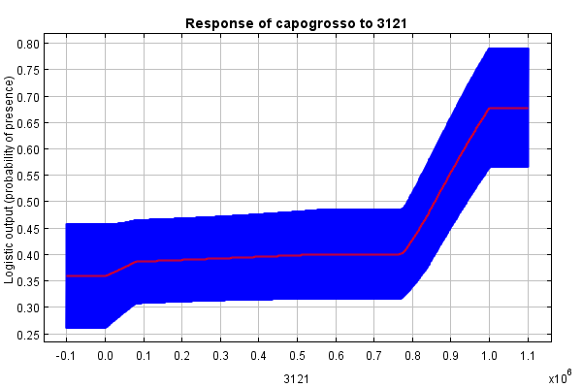 |  | 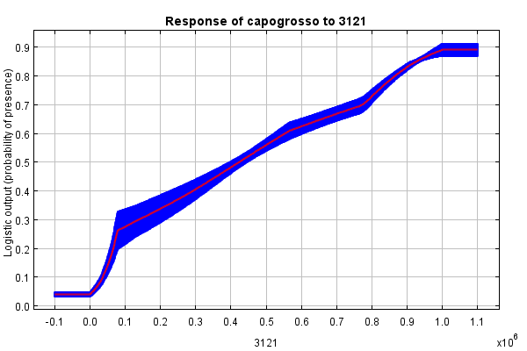
elevation | 14.2 | 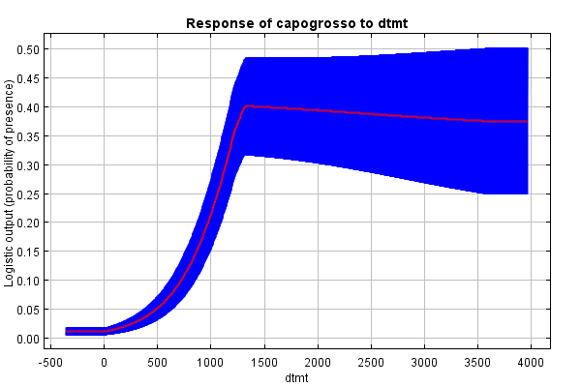 |  | 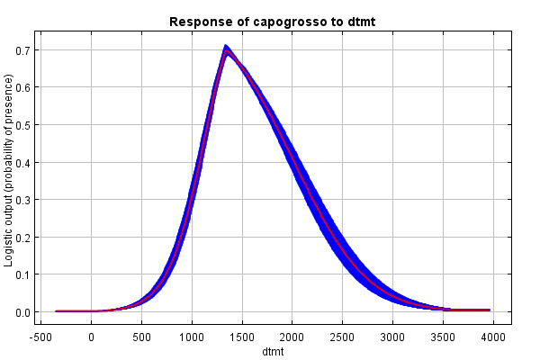
permanent grasslands | 11.9 | 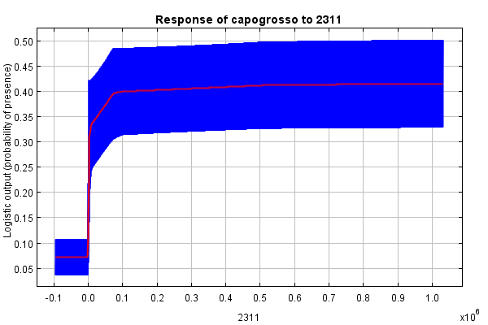 |  | 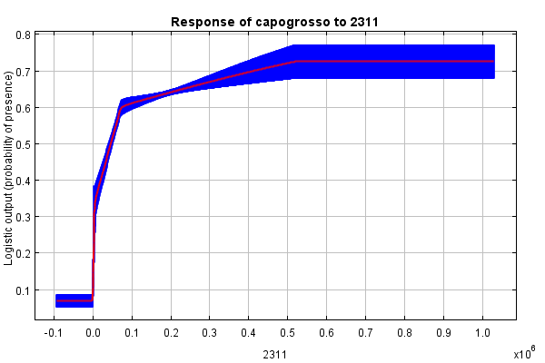
broadleaved woodland | 9.3 | 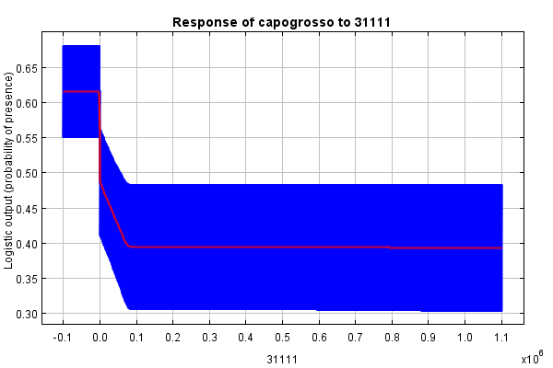 |  | 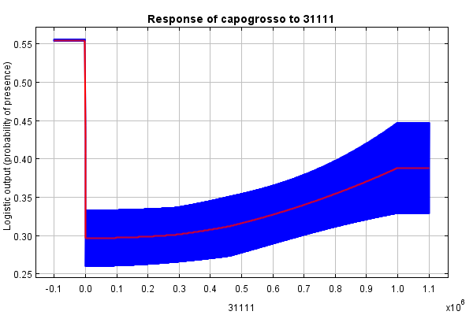
3211 | 6.5 | 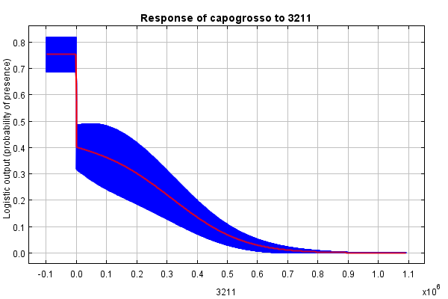 |  | 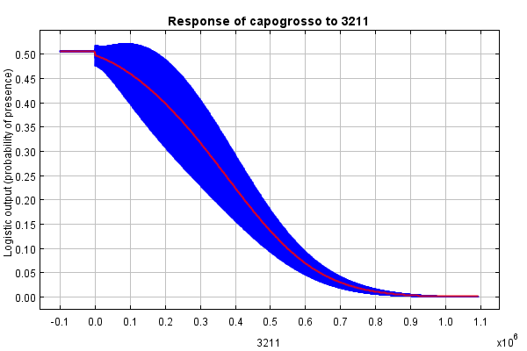
333 | 5.7 | 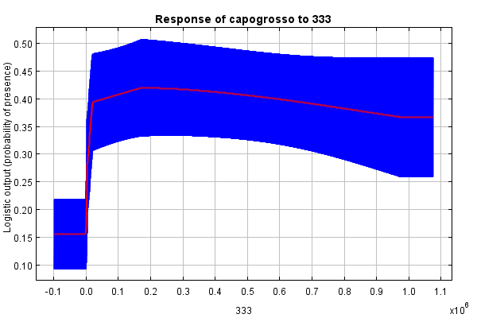 |  | 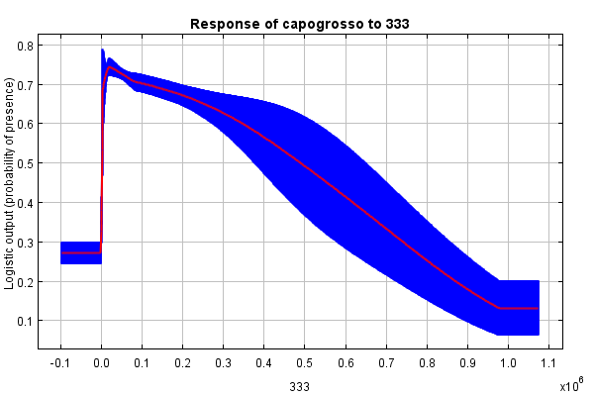

BLACK WOODPECKER Dryocopus martius
variable | % contribution | response curve: overall model |  | response curve: single-variable model
coniferous woodlands | 58.0 | 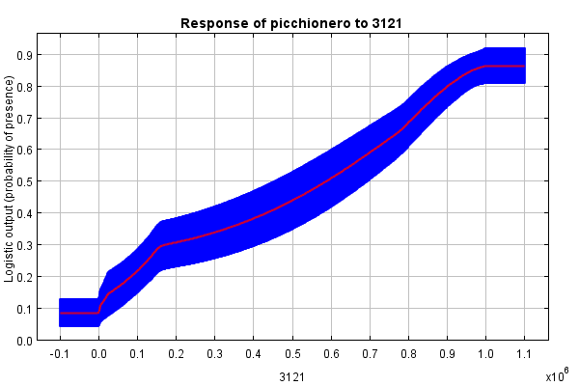 |  | 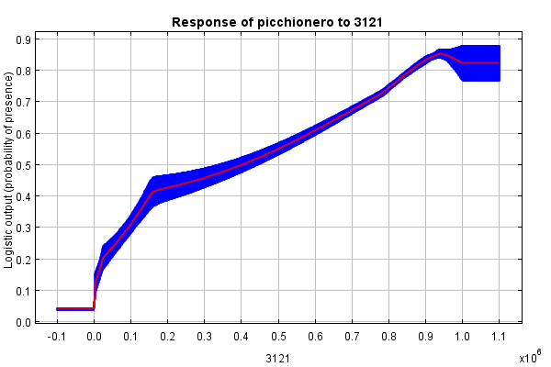
arable land | 15.5 | 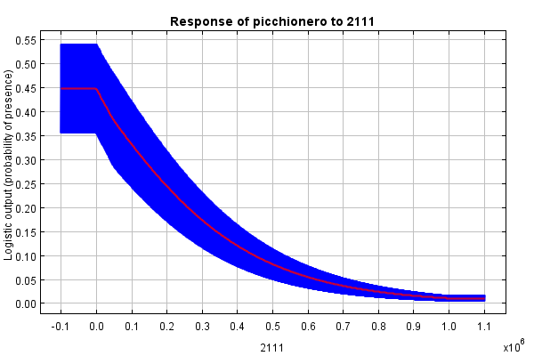 |  | 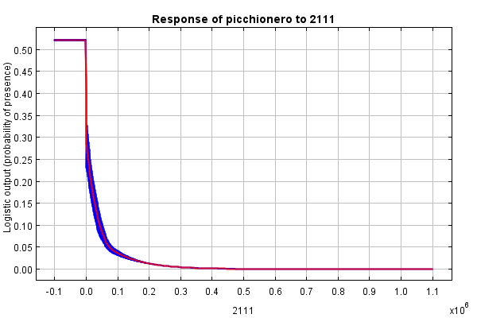
elevation | 11.7 | 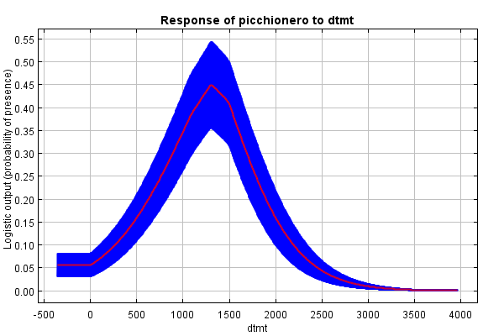 |  | 