Supplementary Material

New Zealand Falcon nests suffer lower predation in agricultural habitat than in natural habitat

Sara M. Kross*, Paul G. M^{c}Donald and Ximena J. Nelson

Contents

Figure S1. Still shots of predators from video cameras up at New Zealand Falcon nests.
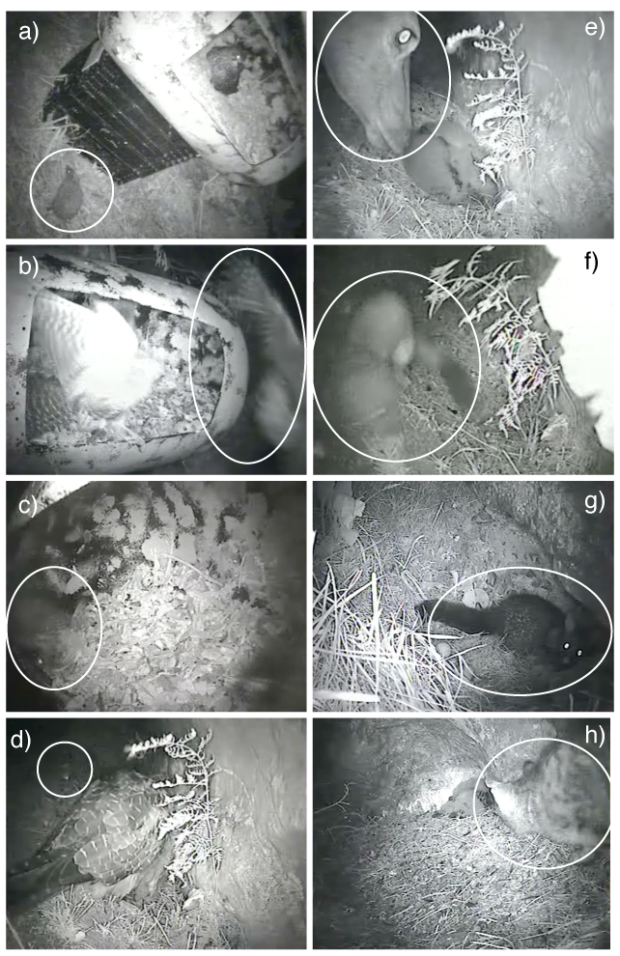

Figure S1. Still shots of predators from video cameras set up at New Zealand Falcon nests; in vineyard habitat (a-c) and unmanaged hill habitat (d-h). All three vineyard images were from the same nest which had been lifted off of the ground in an artificial barrel. Predators included: a) a hedgehog Erinaceus europaeus; b) an Australasian Harrier Circus approximans (wing and spread tail are visible); c) a Little Owl Athene noctua (eye is visible and wing appears as a grey blur); d) a rat Rattus spp. (eye is visible as white spot, species is unknown); e) a red deer Cervus elaphus; f) a stoat Mustela erminea; g) a brushtail possum Trichosurus vulpecula; and h) a feral cat Felis catus. Only the feral cat successfully predated a nest; killing all three chicks. The deer, stoat and rat were all observed at a single hill nest.

