Supplementary Material

Reassessment of the conservation status of Taiwanese birds: How distribution modeling can help species conservation

TSAI-YU WU, BRUNO A. WALTHER, YI-HSIU CHEN, RUEY-SHING LIN and PEI-FEN LEE

Contents

Bird data sources (with references)

Combining habitat data with environmental data (with references)

Building distribution models (with references)

Table S1. Seventeen habitat types as listed in Fang et al. (2008) converted into 11 habitat categories (with references)

Table S2. Comparative model performance of five statistical modelling techniques.

Table S3. List of 71 species whose conservation status may need to be reassessed.

Figure S1. Map of the five different types of protected areas of Taiwan.

Appendix S1. The 145 birds species breeding in Taiwan according to Fang et al. (2008), giving each species’ Latin and English names, endemic status, main habitats, environmental variables used for modeling, the number of 1 x 1 km grid pixels in which the respective species was recorded, and the number of grid pixels in which the respective species was predicted to be present using the final map (with references)

Appendix S2. Conservation status of 145 Taiwanese breeding bird species, giving each species’ global conservation status, Taiwanese conservation status, recorded rarity, range quartile, percentage cover of the study area, and percentage cover for each of our three categories of protected area (with references)

Appendix S3. The probabilistic distributions and the Kappa value for the final maps of the 116 species that were modelled in this study.
Bird data sources
We derived distributional data from a variety of sources to build the first comprehensive distributional dataset of the breeding birds of Taiwan. Specifically, the data were derived from the following sources:
(1) Data from each of Taiwan’s counties collected by both professional researchers of the Endemic Species Research Institute (ESRI) and amateur investigators from local wild bird societies during a series of research projects from 1993 to 2004. Data were collected along road segments 2–3 km length that were covered within two hours in the morning (in general, within 3–4 hours after sunrise) and sampled once a season to once a month.
(2) Data collected by professional researchers during the biological resources survey of Taiwan (1999–2003) organized by the Spatial Ecology Lab of National Taiwan University (Koh et al. 2006). Data were collected during 6-minute point counts at a distance of 150 m from each other along road segments 1–2 km in length (5–10 points as replications in each road segment) that were covered within three hours after sunrise. Each segment was surveyed once.
(3) Data collected by the Water Resources Planning Institute which is part of the Water Resources Agency of the Ministry of Economic Affairs (MOEA) for the Investigation of Current Status of the Lanyang River System (P.-F. Lee unpubl. data). Data were collected by professional researchers once during each of the four seasons using the point count method. Seven sites were covered in 2002 and another seven in 2003. At each site, one observer walked along a river road and made 6-minute point counts at a distance of 200 m from each other, and then, on the return walk, covered the same six locations again. This procedure was done once in the morning and once in the afternoon.
(4) Data from Shei-Pa National Park, including the Kuanwu Recreation Area (Ko 2004) and the Xuejian Recreation Area (P.-F. Lee unpubl. data). Data were collected by Chie-Jen Ko using the point count method three times each during the breeding seasons of 2003 in Kuanwu covering a total of 47 sites and 2004 in Xuejian covering a total of 46 sites.
(5) Data from the Taroko National Park collected by Chun-Yi Peng (Peng 2008) using the point count method twice a month from April 2006 to March 2007 covering a total of 74 sites.
(6) Unpublished data collected by professional researchers Wen-Jay Chih, Chie-Jen Ko and Man-Yu Yang from the Szu-Tsao area during the Ecological Monitoring of Tainan Technology Industrial Park research project in 2008. Data were collected by making total counts of birds resting and feeding on a large number of salt pans and fish ponds.

References
Ko, C.-J. (2004) The relationship between avian community and forest landscapes in Guanwu, Taiwan. Master thesis. National Taiwan University. (In Chinese).
Koh, C.-N., Lee, P.-F. and Lin, R.-S. (2006) Bird species richness patterns of northern Taiwan: Primary productivity, human population density, and habitat heterogeneity. Diversity Distrib. 12: 546-554.
Peng, C.-Y. (2008) Temporal and spatial variations of bird assemblage in the Taroko National Park. Master thesis. National Taiwan University. (In Chinese).

Combining habitat data with environmental data
To build distributional models for each bird species, we used 120 environmental data layers compiled by the Spatial Ecology Lab of National Taiwan University (for details, see Lee et al. 1997) which were updated in 2008 by the same lab. The environmental layers fall into eight categories: (1) temperature, (2) precipitation, (3) elevation, (4) vegetative cover (e.g. forest density, normalized difference vegetation index (NDVI), etc.), (5) ecoregion, (6) geographic information relating to human presence (e.g. population density, road density, etc.), (7) presence of rivers, and (8) distance to the coast. These environmental data layers cover the entire mainland of Taiwan with 36,022 1 x 1 km grid pixels (Figure 1a), all of which overlay perfectly.
Elith and Leathwick (2009) recommended selecting a subset of environmental layers which are relevant to the species’ ecology and habitat choice. Therefore, we used published information (Wang 1991, Fang 2008, Severinghaus 2010, W.-J. Chih pers. comm.) to choose a relevant subset of data layers for each bird species. We first listed the habitats used by each species from Fang (2008) who placed each species into one or several of 17 habitat types which we then re-categorised into 11 habitat types (Table S1). For each habitat type, we then chose between 30 to 36 environmental data layers which were considered relevant for that particular habitat type (Table S1). We then combined all the data layers associated with all of the species’ habitat types (see Appendix S1); e.g., the Little Grebe Tachybaptus ruficollis was found in the habitat categories (1) lakes, ponds, reservoirs, (2) rivers, and (3) wetlands, swamps, and river edges, associated with 35, 35 and 33 environmental data layers, respectively (Table S1), but combining them yielded only a total of 37 data layers.
For each species, we first used a two-tailed t-test to test each of the selected environmental variables (e.g. 37 in the case of the Little Grebe) for significant association with the presence or absence of the species using a P < 0.05 significance level; only significantly associated variables were retained. We then ran an Unweighted Pair Group Method with Arithmetic Mean (UPGMA) Tree in ENFA to avoid autocorrelation between the remaining variables. If two variables were correlated with a correlation coefficient > 0.9, we then retained only one of the two variables, chosen randomly. The remaining variables were used to build the distribution models for each species.

References
Elith, J. and Leathwick, J. (2009) The contribution of species distribution modelling to conservation prioritization. Pp. 70-93 in A. Moilanen, K. A. Wilson and H. P. Possingham, eds. Spatial conservation prioritization -- quantitative methods and computatiional tools. New York: Oxford University Press.
Fang, W.-H. (2008) The complete field guide of the birds of Taiwan. Taipei, Taiwan: Owl Publishing House Co., LTD. (In Chinese).
Lee, P.-F., Liao, C.-Y., Lee, Y.-C., Pan, Y.-H., Fu, W.-H. and Chen, H.-W. (1997) An ecological and environmental GIS database for Taiwan. Taipei, Taiwan: Department of Zoology, National Taiwan University. (In Chinese).
Severinghaus, L. L., Ding, T.-S., Fang, W.-H., Lin, W.-H., Tsai, M.-C. and Yen, C.-W. (2010) The avifauna of Taiwan. Taipei, Taiwan: Forestry Bureau of Council of Agriculture of Executive Yuan. (In Chinese).
Wang, C.-H., Wu, S.-H., Huang, K.-Y., Yang, H.-Y., Tsai, C.-H., Tsai, M.-C. and Hsiao, C.-L. (1991) The field guide of the birds of Taiwan. Taipei, Taiwan: Yashen Press. (In Chinese).

Building distribution models
To produce one modelled distribution (the ‘final map’) for each species, we performed the following four steps:
A) Building models: To produce five probabilistic distributions models for each species, we used the environmental data layers described above (see also Table S1 and Appendix S1) and the following five statistical modelling techniques:
(1) Multiple discriminant analysis (MDA) not only separates but also classifies individual observations into groups (Johnson and Wichern 1998). Observations are used to define the separation rules which are then used to classify unknown (new) objects. We built MDA models using SAS 9.0.
(2) Generalized linear models have been widely used in building species distribution, and logistic regression (LR) is one of the most important modelling methods (Guisan and Zimmermann 2000, Austin 2002). LR describes relationships of continuous and discrete independent variables on discrete dependent variables (especially binary variables) and then transforms these relationships onto a probability scale of 0 to 1 (Kutner et al. 2004). We built LR models using SAS 9.0.
(3) Genetic algorithm for rule-set production (GARP) was first described by Stockwell and Noble (1992) and has been widely used in modelling of species distributions (e.g., Peterson et al. 2002, Stockwell et al. 2006). GARP is based on the concept of evolving genetic algorithms. We built GARP models using the DesktopGARP software (Stockwell 2005).
(4) Ecological niche factor analysis (ENFA) is based on Hutchinson’s ecological niche theory (Hirzel et al. 2002). ENFA evaluates the suitability of unknown habitats of focal species by comparing the differences between the areas with focal species records and the whole study area and defines habitat-suitability by marginality (M) and specialization (S). We built ENFA models using Biomapper 3.1 software (Hirzel et al. 2004).
(5) Maximum-entropy (MAXENT) was derived from statistical mechanics and has previously been used in different research fields (e.g., physics, astronomy, image reconstruction, etc.) but has recently been introduced for modelling species distributions (Phillips et al. 2004, Phillips et al. 2006). We built MAXENT models using maxent 3.3.0 software (Phillips et al. 2009).
B) Ranking model performance: While the performance of distribution models can be measured with a variety of criteria (Fielding and Bell 1997), one criterion which has recently gained widespread popularity is the AUC score because it is not dependent on choosing a probability threshold which differentiates between a site predicted to be occupied and a site predicted to be unoccupied (Pearce and Ferrier 2000, Manel et al. 2001, McPherson et al. 2004, Elith et al. 2006). Therefore, we ranked the performance of the five models for each species using the AUC score (Swets 1988, Fielding and Bell 1997, Pepe 2000).
C) Combining models: Ensemble modelling has recently been used to increase the performance of species modeling, and there are several ways of combining separate models into ensembles (Araújo and New 2007, Barbet-Massin et al. 2009). We chose a variant of the frequency histogram (Araújo and New 2007) by summing up the three best performing models for each species based on their respective AUC scores. To add up the three models, we turned the probability surface of each model into a presence-absence map. To divide pixels into presences and absences, we chose the MaxKappa criterion, which is one of the top two criteria for yielding unbiased estimates of species prevalence, and also has the highest mean kappa (Freeman and Moisen 2008). We then added the three presence-absence maps resulting in a distribution map of each species coded 0, 1, 2 or 3, upon which we recoded codes 0 and 1 into absence (0) and codes 2 and 3 into presence (1).
D) Deleting overprediction: For 11 of the 116 species, it was evident from visual examination that their distributions were overpredicted, i.e. that modelled distributions extended into regions where the species had never been observed (Appendix S1). Therefore, we cut overpredicted areas by comparing the modelled distributions with published distribution maps (Severinghaus et al. 2010) and further expert consultation (W.-J. Chih pers. comm.). Any region of Taiwan where the species had never been observed was converted to absence by using a variety of appropriate shape files (elevation, ecoregions, counties). All further analyses were done on these ‘final maps’ (shown in Appendix S3) created for each species.

References
Araújo, M. B. and New, M. (2007) Ensemble forecasting of species distributions. Trends Ecol. Evol. 22: 42-47.
Austin, M. P. (2002) Spatial prediction of species distribution: An interface between ecological theory and statistical modelling. Ecol. Modell. 157: 101-118.
Barbet-Massin, M., Walther, B. A., Thuiller, W., Rahbek, C. and Jiguet, F. (2009) Potential impacts of climate change on the winter distribution of Afro-Palaearctic migrant passerines. Biol. Lett. 5: 248-251.
Elith, J., Graham, C. H., Anderson, R. P., Dudík, M., Ferrier, S., Guisan, A., Hijmans, R. J., Huettmann, F., Leathwick, J. R., Lehmann, A., Li, J., Lohmann, L. G., Loiselle, B. A., Manion, G., Moritz, C., Nakamura, M., Nakazawa, Y., McC. Overton, J., Peterson, A. T. and Phillips, S. J. (2006) Novel methods improve prediction of species' distributions from occurrence data. Ecography 29: 129-151.
Fielding, A. H. and Bell, J. F. (1997) A review of methods for the assessment of prediction errors in conservation presence/absence models. Envir. Conserv. 24: 38-49.
Freeman, E. A. and Moisen, G. G. (2008) A comparison of the performance of threshold criteria for binary classification in terms of predicted prevalence and kappa. Ecol. Modell. 217: 48-58.
Guisan, A. and Zimmermann, N. E. (2000) Predictive habitat distribution models in ecology. Ecol. Modell. 135: 147-186.
Hirzel, A. H., Hausser, J., Chessel, D. and Perrin, N. (2002) Ecological-niche factor analysis: How to compute habitat-suitability maps without absence data? Ecology 83: 2027-2036.
Hirzel, A. H., Hausser, J. and Perrin, N. (2004) Biomapper 3.1. Lausanne: Laboratory for conservation Biology.
Johnson, R. A. and Wichern, D. W. (1998) Applied multivariate statistical analysis. Prentice-Hall International, Inc.
Kutner, M. H., Nachtsheim, C. J. and Neter, J. (2004) Applied linear regression models. New York: McGraw-Hill Companies, Inc.
Manel, S., Williams, H. C. and Ormerod, S. J. (2001) Evaluating presence-absence models in ecology: the need to account for prevalence. J. Appl. Ecol. 38: 921-931.
McPherson, J. M., Jetz, W. and Rogers, D. J. (2004) The effects of species' range sizes on the accuracy of distribution models: ecological phenomenon or statistical artefact? J. Appl. Ecol. 41: 811-823.
Pearce, J. and Ferrier, S. (2000) Evaluating the predictive performance of habitat models developed using logistic regression. Ecol. Modell. 133: 225-245.
Pepe, M. S. (2000) An Interpretation for the ROC Curve and Inference Using GLM Procedures. Biometrics 56: 352-359.
Peterson, A. T., Ortega-Huerta, M. A., Bartley, J., Sanchez-Cordero, V., Soberon, J., Buddemeier, R. H. and Stockwell, D. R. B. (2002) Future projections for Mexican faunas under global climate change scenarios. Nature 416: 626-629.
Phillips, S. J., Anderson, R. P. and Schapired, R. E. (2006) Maximum entropy modeling of species geographic distributions. Ecol. Modell. 190: 231-259.
Phillips, S. J., Dudik, M. and Schapire, R. E. (2004) A maximum entropy approach to species distribution modeling. Banff, Alberta, Canada: ACM.
Phillips, S. J., Dudik, M. and Schapire, R. E. (2009) Maximum entropy species distribution modeling.
Severinghaus, L. L., Ding, T.-S., Fang, W.-H., Lin, W.-H., Tsai, M.-C. and Yen, C.-W. (2010) The Avifauna of Taiwan. Taipei, Taiwan: Forestry Bureau of Council of Agriculture of Executive Yuan. (In Chinese).
Stockwell, D. (2005) DesktopGarp 1.1.6. San Diego Supercomputer Center.
Stockwell, D. R. B., Beach, J. H., Stewart, A., Vorontsov, G., Vieglais, D. and Pereira, R. S. (2006) The use of the GARP genetic algorithm and Internet grid computing in the Lifemapper world atlas of species biodiversity. Ecol. Modell. 195: 139-145.
Stockwell, D. R. B. and Noble, I. R. (1992) Induction of sets of rules from animal distribution data: a robust and informative method of data analysis. Math. Comput. Simul. 33: 385-390.
Swets, J. (1988) Measuring the accuracy of diagnostic systems. Science 240: 1285-1293.

Table S1. Habitat types as listed on P. 7 in Fang et al. (2008). We converted these 17 habitat types into 11 habitat categories by lumping some (e.g. the four forest types into ‘forests’) and eliminating three types which are difficult if not impossible to associate with definite environmental data layers (e.g. telephone wires). Each breeding bird species was then assigned to one or several of these 11 habitat categories (see Appendix S1). The third column gives the number of environmental data layers which we used for the respective habitat category when modelling bird distributions. Environmental data layers were chosen for each habitat category using expert knowledge within the Spatial Ecology Lab of National Taiwan University (for details, see Lee et al. 1997)

Habitat type from Fang et al. (2008) | Re-categorization | Number of environmental data layers
Buildings, bridges | Used as is | 30
Telephone wires | Not used | Not applicable
Trees in parks and along roads | Used as is | 31
Farmlands | Used as is | 32
Forest edges | Forests | 35
Bush and scrub | Forests | 35
Open forest | Forests | 35
Closed forest | Forests | 35
Grasslands, wildlands | Used as is | 34
Lakes, ponds, reservoirs | Used as is | 35
Streams | Used as is | 36
Rivers | Used as is | 35
Wetlands, swamps, river edges | Used as is | 33
Mountains near urban area | Not used | Not applicable
Open tundra on mountaintops | Used as is | 34
Coastlines, including tidal flats, pelagic | Used as is | 32
Aerial | Not used | Not applicable

References
Fang, W.-H. (2008) The complete field guide of the birds of Taiwan. Taipei, Taiwan: Owl Publishing House Co., LTD. (In Chinese).
Lee, P.-F., Liao, C.-Y., Lee, Y.-C., Pan, Y.-H., Fu, W.-H. and Chen, H.-W. (1997) An ecological and environmental GIS database for Taiwan. Taipei, Taiwan: Department of Zoology, National Taiwan University. (In Chinese).

Table S2. Comparative model performance of five statistical modelling techniques (MDA = multiple discriminant analysis, LR = logistic regression, GARP = genetic algorithm for rule-set production, ENFA = ecological niche factor analysis, MAXENT = maximum-entropy) showing mean AUC and mean Kappa scores (averaging over all modelled species). We couldn’t get the Kappa values for Maxent because all the observed grid cells (present or absent, see Methods for details) were predicted as present in Maxent. The last column shows the Kappa value of the ‘final map’ (see Methods). The 116 modelled species were divided into subcategories (for definitions, see Appendices S1 and S2); therefore, we give the sample size (n) for each subcategory.

Subcategories | Sample size | AUC |  |  |  |  | Kappa |  |  |  |  | Kappa
 | n | MDA | LR | GARP | ENFA | MAXENT | MDA | LR | GARP | ENFA | MAXENT | Final map
Endemic species status
Endemic | 16 | 0.94 | 0.92 | 0.92 | 0.90 | 0.93 | 0.82 | 0.79 | 0.75 | 0.67 | -- | 0.81
Endemic subspecies | 53 | 0.90 | 0.89 | 0.84 | 0.83 | 0.83 | 0.68 | 0.66 | 0.58 | 0.55 | -- | 0.68
Non-endemic | 47 | 0.88 | 0.88 | 0.80 | 0.81 | 0.77 | 0.66 | 0.62 | 0.51 | 0.48 | -- | 0.65
Taiwanese conservation status
Endangered | 1 | 0.81 | 0.90 | 0.81 | 0.74 | 0.76 | 0.62 | 0.45 | 0.37 | 0.27 | -- | 0.61
Rare and valuable | 19 | 0.89 | 0.86 | 0.82 | 0.79 | 0.82 | 0.65 | 0.58 | 0.49 | 0.41 | -- | 0.63
Other conservation-dependent species | 11 | 0.93 | 0.90 | 0.90 | 0.93 | 0.92 | 0.80 | 0.79 | 0.71 | 0.67 | -- | 0.80
Non-threatened | 85 | 0.89 | 0.89 | 0.83 | 0.83 | 0.81 | 0.68 | 0.67 | 0.58 | 0.55 | -- | 0.69
Recorded rarity
Rare (R) | 6 | 0.93 | 0.86 | 0.87 | 0.87 | 0.86 | 0.69 | 0.57 | 0.51 | 0.50 | -- | 0.65
Uncommon (UC) | 23 | 0.91 | 0.91 | 0.83 | 0.83 | 0.83 | 0.70 | 0.66 | 0.55 | 0.49 | -- | 0.69
Common (C) | 87 | 0.89 | 0.89 | 0.84 | 0.83 | 0.81 | 0.69 | 0.66 | 0.59 | 0.55 | -- | 0.69
Range quartile
1st quartile (0-25%) | 22 | 0.89 | 0.88 | 0.85 | 0.85 | 0.86 | 0.68 | 0.64 | 0.56 | 0.51 | -- | 0.70
2nd quartile (25-50%) | 50 | 0.91 | 0.89 | 0.85 | 0.85 | 0.84 | 0.71 | 0.68 | 0.59 | 0.54 | -- | 0.70
3rd quartile (50-75%) | 35 | 0.89 | 0.90 | 0.84 | 0.82 | 0.79 | 0.69 | 0.67 | 0.58 | 0.56 | -- | 0.69
4th quartile (75-100%) | 9 | 0.86 | 0.85 | 0.76 | 0.77 | 0.72 | 0.59 | 0.57 | 0.46 | 0.48 | -- | 0.58
All species | 116 | 0.90 | 0.89 | 0.84 | 0.83 | 0.82 | 0.69 | 0.66 | 0.57 | 0.54 | -- | 0.69

Table S3. List of 71 species whose conservation status may need to be reassessed. For Latin names and more details, see Appendices S1 and S2. The first and second column give the English name and category of reassessment (1 = species of limited distribution and protection, 2 = species of limited distribution, 3 = species of limited protection, 4 = species which may need to be reassessed; see Results for details). For the remaining columns, we use the following abbreviations for our conservation-relevant measures: RQ = range quartile (Q1, Q2, Q3, Q4 = first, second, third and fourth quartile species); Prot cov = % coverage of highest protection (see Appendix S2); RR = recorded rarity (C = common, UC = uncommon, R = rare); TCS = Taiwanese conservation status (RV = rare and valuable, CD = other conservation-dependent species, NT = non-threatened). We only show those comparisons (indicated by vs = versus) where we consider there may be a possible conflict between the respective conservation-relevant measures.

English name | Cat | RQ | Prot cov | RR vs TCS | RR vs RQ | TCS vs RQ | ES vs RQ
Taiwan Partridge | 4 |  |  |  | UC / Q3 | CD / Q3
Common Pheasant | 1 | Q1 | < 5% |  |  |  | ES / Q1
Little Grebe | 3 |  | < 5% |  | C / Q2
Yellow Bittern | 1 | Q1 | < 5% |  | C / Q1 | NT / Q1
Cinnamon Bittern | 1 | Q1 | < 5% | UC / NT | UC / Q1 | NT / Q1
Malaysian Night-heron | 1 | Q1 | < 5% |  | C / Q1 | NT / Q1
Black-crowned Night-Heron | 3 |  | < 5% |  | C / Q2
Cattle Egret | 3 |  | < 5% |  | C / Q2
Little Egret | 3 |  | < 5%
Crested Serpent-Eagle | 4 |  |  | C / RV |  | RV / Q4
Crested Goshawk | 4 |  |  | C / RV |  | RV / Q3
Black Eagle | 2 | Q1
White-breasted Waterhen | 3 |  | < 5% |  | C / Q2
Ruddy-breasted Crake | 1 | Q1 | < 5% |  | C / Q1 | NT / Q1
Common Moorhen | 3 |  | < 5% |  | C / Q2
Barred Buttonquail | 3 |  | < 5% |  | C / Q2
Greater Painted-snipe | 1 | Q1 | < 5% | C / RV | C / Q1
Oriental Pratincole | 1 | Q1 | < 5% | C / CD | C / Q1
Red Collared-Dove | 3 |  | < 5%
Spotted Dove | 3 |  | < 5%
Emerald Dove | 3 |  | < 5% | UC / NT
Large Hawk-Cuckoo | 4 |  |  |  | C / Q2
Lesser Coucal | 3 |  | < 5% |  | C / Q2
Mountain Scops-Owl | 4 |  |  | C / RV |  | RV / Q3
Collared Scops-Owl | 1 | Q1 | < 5% | C / RV | C / Q1 |  | ES / Q1
Savanna Nightjar | 3 |  | < 5% |  | C / Q2
Common Kingfisher | 3 |  | < 5%
Grey-faced Woodpecker | 2 | Q1
Long-tailed Shrike | 3 |  | < 5% |  | C / Q2
Black Drongo | 3 |  | < 5%
Black-naped Monarch | 3 |  | < 5%
Taiwan Magpie | 3 |  | < 5% | C / CD | C / Q2
Black-billed Magpie | 1 | Q1 | < 5% |  | C / Q1 | NT / Q1
Spotted Nutcracker | 2 | Q1 |  |  | C / Q1 | NT / Q1 | ES / Q1
Green-backed Tit | 4 |  |  | C / CD | C / Q2
Coal Tit | 2 | Q1 |  | C / CD | C / Q1 |  | ES / Q1
Plain Martin | 3 |  | < 5% |  | C / Q2
Barn Swallow | 3 |  | < 5% |  | C / Q2
Pacific Swallow | 3 |  | < 5%
Striated Swallow | 3 |  | < 5% |  | C / Q2
Black-throated Tit | 4 |  |  |  | C / Q2
Oriental Skylark | 3 |  | < 5% |  | C / Q2
Zitting Cisticola | 3 |  | < 5% |  | C / Q2
Golden-headed Cisticola | 3 |  | < 5% | UC / NT
Striated Prinia | 4 |  |  |  | C / Q2
Yellow-bellied Prinia | 3 |  | < 5%
Plain Prinia | 3 |  | < 5%
Taiwan Bulbul | 2 | Q1 |  | C / RV | C / Q1 |  | E / Q1
Yellowish-bellied Bush-Warbler | 4 |  |  |  | C / Q2
Taiwan Bush-Warbler | 2 | Q1 |  |  | C / Q1 | NT / Q1 | E / Q1
Scaly-breasted Wren-Babbler | 4 |  |  |  | C / Q2
White-whiskered Laughingthrush | 4 |  |  |  | C / Q2
Taiwan Barwing | 4 |  |  | C / CD | C / Q2
Grey-hooded Fulvetta | 2 | Q1 |  |  | C / Q1 | NT / Q1 | ES / Q1
Taiwan Yuhina | 4 |  |  |  | C / Q2
Vinous-throated Parrotbill | 3 |  | < 5% |  | C / Q2
Flamecrest | 2 | Q1 |  | C / CD | C / Q1 |  | E / Q1
Winter Wren | 2 | Q1 |  |  | C / Q1 | NT / Q1 | ES / Q1
Wood Nuthatch | 4 |  |  |  | C / Q2
Crested Myna | 1 | Q1 | < 5% |  | UC / Q1 |  | ES / Q1
White-browed Shortwing | 4 |  |  |  | C / Q2
White-browed Bush-Robin | 2 | Q1 |  |  |  |  | ES / Q1
Collared Bush-Robin | 2 | Q1 |  |  | C / Q1 | NT / Q1 | E / Q1
Plumbeous Water-redstart | 4 |  |  | C / CD |  | CD / Q3
White-tailed Robin | 4 |  |  |  | UC / Q3 | CD / Q3
Snowy-browed Flycatcher | 4 |  |  |  | C / Q2
Fire-breasted Flowerpecker | 4 |  |  |  | C / Q2
Eurasian Tree Sparrow | 3 |  | < 5%
White-rumped Munia | 3 |  | < 5%
Scaly-breasted Munia | 3 |  | < 5%
Vinaceous Rosefinch | 2 | Q1 |  |  | C / Q1 | NT / Q1 | ES / Q1

Figure S1. Map of the five different types of protected areas of Taiwan (see Methods for details).

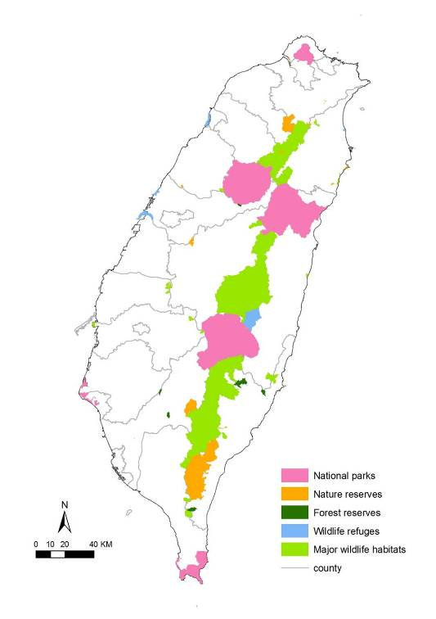

Appendix S1. The 145 bird species breeding in Taiwan according to Fang et al. (2008). Latin names were taken from the Chinese Wild Bird Federation (2010) as well as their endemic species status: endemic = full endemic species status (E); name of subspecies’ trinomial = recognized as endemic subspecies (ES); all other species are not listed as endemic. The superscript * denotes that overpredicted areas were deleted (see Methods for details). English names were taken from BirdLife Checklist (BirdLife International 2011) except for Striated Swallow which was not recognized as a species in the BirdLife Checklist. The fourth column lists each species’ main habitats according to Fang et al. (2008), see Table S1 for use of these habitat categories for distribution modelling: A = farmlands; B = buildings; bridges; C = coastlines, including tidal flats, and pelagic; F = forests; I = grasslands, disturbed open grassy/bushy areas; K = open tundra on mountaintops; L = lakes, ponds, reservoirs; P = trees in parks and along roads; R = rivers; S= streams; W = wetlands, swamps, river edges. The habitat type for the Fork-tailed Swift is still unknown, thus we labeled it as ‘?’ and then used all available 37 environmental variables for modelling. The fifth column gives the number of environmental variables used for modelling the respective species (note that this number may not be the sum of the variables given for each habitat category given in Table S1, because habitat categories often share the same environmental variables). Superscripts 1 and 2 denote two different combinations of 35 and 36 environmental variables, respectively, resulting from different combinations of habitat variables. The number in parentheses is the number of variables remaining after running the t-test and the UPGMA tree (see Methods). The sixth column gives the number of 1 x 1 km grid pixels in which the respective species was recorded to be breeding ≥1 times during the months March to July. The seventh column gives the number of grid pixels in which the respective species was predicted to be present using the final map (see Methods). Note that the White Wagtail Motacilla alba was excluded from all analyses (see Methods). The superscript letters indicate which three of the following five methods for building distribution models were chosen as the best performing models based on their AUC scores to derive at a final distribution model (see Methods): multiple discriminant analysis (D), ecological niche factor analysis (E), genetic algorithm for rule-set production (G), logistic regression (L), and maximum-entropy (M).

Latin Name | Endemic species status | English Name | Habitat | Number of environmental variables used | Number of grid pixels recorded | Number of grid pixels predicted
Coturnix chinensis |  | Blue Quail | AF | 35² | 5 | -
Arborophila crudigularis | endemic | Taiwan Partridge | F | 35² (22) | 234 | 21277^{D,E,L}
Bambusicola thoracicus | sonorivox | Chinese Bamboo-Partridge | F | 35² (18) | 769 | 28301 ^{D,E,L}
Lophura swinhoii | endemic | Swinhoe's Pheasant | F | 35² (21) | 43 | 13099 ^{G,L,M}
Syrmaticus mikado | endemic | Mikado Pheasant | F | 35² | 12 | -
Phasianus colchicus | formosanus | Common Pheasant | AFI | 35² (17) | 51 | 6534 ^{D,L,M}
Aix galericulata |  | Mandarin Duck | FLRS | 37 | 19 | -
Tachybaptus ruficollis |  | Little Grebe | LRW | 37 (25) | 96 | 9137 ^{D,E,L}
Ixobrychus sinensis |  | Yellow Bittern | AFLRW | 37 (17) | 48 | 5103 ^{D,L,M}
Ixobrychus cinnamomeus |  | Cinnamon Bittern | AFLRW | 37 (16) | 74 | 4229 ^{D,E,L}
Gorsachius melanolophus |  | Malaysian Night-heron | FP | 35² (12) | 51 | 5686 ^{D,E,L}
Nycticorax nycticorax |  | Black-crowned Night-Heron | CFLR | 37 (23) | 255 | 13754 ^{D,E,L}
Butorides striata |  | Striated Heron | LS | 36² | 28 | -
Bubulcus ibis |  | Cattle Egret | AFI | 35² (19) | 383 | 16443 ^{D,E,L}
Egretta garzetta |  | Little Egret | ACFLRSW | 37 (22) | 602 | 20673 ^{D,E,L}
Elanus caeruleus |  | Black-winged Kite | FI | 35² | 1 | -
Milvus migrans |  | Black Kite | CFKLR | 37 | 27 | -
Spilornis cheela | hoya | Crested Serpent-Eagle | F | 35² (16) | 555 | 27166 ^{D,E,L}
Accipiter trivirgatus | formosae | Crested Goshawk | FP | 35² (14) | 185 | 23554 ^{D,E,L}
Accipiter virgatus | fuscipectus | Besra | F | 35² (16) | 67 | 10082 ^{D,L,M}
Ictinaetus malayensis |  | Black Eagle | F | 35² (22) | 30 | 6516 ^{D,G,L}
Nisaetus nipalensis |  | Mountain Hawk-Eagle | F | 35² | 14 | -
Rallina eurizonoides | formosana | Slaty-legged Crake | F | 35² | 20 | -
Gallirallus striatus | taiwanus | Slaty-breasted Rail | ACFLW | 37 | 10 | -
Rallus aquaticus |  | Water Rail | ACW | 33 | 0 | -
Amaurornis phoenicurus |  | White-breasted Waterhen | ACFLRW | 37 (24) | 197 | 13006 ^{D,G,L}
Porzana fusca |  | Ruddy-breasted Crake | AFLRW | 37 (16) | 34 | 5790 ^{D,E,L}
Gallicrex cinerea |  | Watercock | ALW | 37 | 3 | -
Gallinula chloropus |  | Common Moorhen | ACLRW | 37 (21) | 217 | 13734 ^{D,E,L}
Turnix sylvaticus |  | Small Buttonquail | AF | 35² | 1 | -
Turnix suscitator* | rostratus | Barred Buttonquail | AFI | 35² (16) | 71 | 11259 ^{D,G,L}
Rostratula benghalensis |  | Greater Painted-snipe | ARW | 37 (17) | 30 | 6571 ^{D,L,M}
Hydrophasianus chirurgus |  | Pheasant-tailed Jacana | AW | 33 | 5 | -
Glareola maldivarum |  | Oriental Pratincole | ACIR | 37 (25) | 60 | 5352 ^{E,L,M}
Columba pulchricollis* |  | Ashy Wood-Pigeon | F | 35² (22) | 85 | 12249 ^{D,E,L}
Streptopelia orientalis | orii | Oriental Turtle-Dove | AFP | 35² (18) | 122 | 21334 ^{D,L,M}
Streptopelia tranquebarica |  | Red Collared-Dove | AFIP | 35² (22) | 620 | 22015 ^{D,E,L}
Streptopelia chinensis |  | Spotted Dove | ABFIP | 34 (21) | 510 | 19241 ^{D,G,L}
Chalcophaps indica* |  | Emerald Dove | F | 35² (18) | 102 | 12685 ^{D,L,M}
Treron sieboldii |  | White-bellied Green-pigeon | F | 35² (19) | 142 | 16843 ^{D,G,L}
Cuculus sparverioides |  | Large Hawk-Cuckoo | F | 35² (22) | 185 | 15245 ^{D,G,L}
Cuculus saturatus |  | Himalayan Cuckoo | F | 35² (25) | 477 | 27195 ^{D,E,L}
Centropus bengalensis |  | Lesser Coucal | AFI | 35² (16) | 302 | 15999 ^{D,G,L}
Tyto longimembris | pithecops | Eastern Grass-owl | FI | 35² | 3 | -
Otus spilocephalus | hambroecki | Mountain Scops-Owl | F | 35² (19) | 178 | 19863 ^{D,E,G}
Otus lettia | glabripes | Collared Scops-Owl | FP | 35² (14) | 68 | 7134 ^{D,G,L}
Ketupa flavipes |  | Tawny Fish-Owl | FS | 37 | 3 | -
Strix leptogrammica |  | Brown Wood-Owl | F | 35² | 7 | -
Strix aluco | yamadae | Tawny Owl | F | 35² | 8 | -
Glaucidium brodiei | pardalotum | Collared Owlet | F | 35² (21) | 119 | 16183 ^{D,E,L}
Ninox japonica |  | Brown Hawk-owl | F | 35² | 17 | -
Caprimulgus affinis | stictomus | Savanna Nightjar | ABIR | 35¹ (12) | 33 | 10047 ^{D,G,M}
Apus pacificus |  | Fork-tailed Swift | ? | 37 (18) | 93 | 16364 ^{D,E,L}
Apus nipalensis | kuntzi | House Swift | B | 30 (9) | 541 | 29737 ^{D,E,L}
Alcedo atthis |  | Common Kingfisher | CLRSW | 37 (17) | 206 | 20466 ^{D,L,M}
Megalaima nuchalis | endemic | Taiwan Barbet | FP | 35² (24) | 1194 | 26744 ^{D,G,L}
Dendrocopos canicapillus |  | Grey-capped Woodpecker | F | 35² (18) | 213 | 22724 ^{D,E,L}
Dendrocopos leucotos | insularis | White-backed Woodpecker | F | 35² (21) | 52 | 10537 ^{D,E,L}
Picus canus* |  | Grey-faced Woodpecker | F | 35² (20) | 52 | 8621 ^{D,E,L}
Pitta nympha |  | Fairy Pitta | F | 35² | 21 | -
Coracina macei |  | Large Cuckooshrike | F | 35² | 15 | -
Pericrocotus solaris |  | Grey-chinned Minivet | F | 35² (22) | 454 | 22924 ^{D,E,L}
Lanius schach |  | Long-tailed Shrike | AIP | 34 (14) | 144 | 9117 ^{D,G,L}
Oriolus chinensis |  | Black-naped Oriole | F | 35² | 4 | -
Oriolus traillii | ardens | Maroon Oriole | F | 35² (21) | 86 | 14976 ^{D,L,M}
Dicrurus macrocercus | harterti | Black Drongo | AIP | 34 (19) | 523 | 19574 ^{D,G,L}
Dicrurus aeneus | braunianus | Bronzed Drongo | AF | 35² (16) | 389 | 23935 ^{D,E,L}
Hypothymis azurea | oberholseri | Black-naped Monarch | FP | 35² (19) | 739 | 22595 ^{D,G,L}
Garrulus glandarius | taivanus | Eurasian Jay | F | 35² (21) | 116 | 20246 ^{D,L,M}
Urocissa caerulea | endemic | Taiwan Magpie | F | 35² (17) | 103 | 12350 ^{D,L,M}
Dendrocitta formosae | formosae | Grey Treepie | FP | 35² (18) | 697 | 29269 ^{D,G,L}
Pica pica |  | Black-billed Magpie | AIP | 34 (22) | 53 | 4319 ^{E,L,M}
Nucifraga caryocatactes | owstoni | Spotted Nutcracker | F | 35² (20) | 71 | 6010 ^{D,E,L}
Corvus macrorhynchos |  | Large-billed Crow | FP | 35² (22) | 386 | 22705 ^{D,E,L}
Parus monticolus | insperatus | Green-backed Tit | F | 35² (22) | 283 | 13576 ^{D,E,L}
Macholophus holsti | endemic | Yellow Tit | F | 35² (23) | 95 | 12262 ^{D,E,L}
Periparus ater | ptilosus | Coal Tit | F | 35² (22) | 124 | 7862 ^{E,L,M}
Sittiparus varius | castaneoventris | Varied Tit | F | 35² (21) | 50 | 10217 ^{D,L,M}
Riparia paludicola |  | Plain Martin | ACILR | 37 (23) | 205 | 17320 ^{D,G,L}
Hirundo rustica |  | Barn Swallow | BILR | 36² (20) | 423 | 17377 ^{D,E,L}
Hirundo tahitica |  | Pacific Swallow | CIKLR | 37 (20) | 653 | 21515 ^{D,G,L}
Delichon dasypus |  | Asian House-Martin | K | 34 (20) | 84 | 13798 ^{D,E,L}
Cecropis striolata |  | Striated Swallow | ABI | 34 (17) | 388 | 14720 ^{D,G,L,}
Aegithalos concinnus* |  | Black-throated Tit | F | 35² (22) | 207 | 16240 ^{D,L,M}
Alauda gulgula |  | Oriental Skylark | AIR | 36² (18) | 177 | 10371 ^{D,E,L}
Cisticola juncidis |  | Zitting Cisticola | AFIW | 36¹ (20) | 228 | 13247 ^{D,G,L}
Cisticola exilis | volitans | Golden-headed Cisticola | AFIW | 36¹ (18) | 147 | 10810 ^{D,G,L}
Prinia crinigera | striata | Striated Prinia | FI | 35² (17) | 91 | 10234 ^{E,G,L}
Prinia flaviventris |  | Yellow-bellied Prinia | AFIR | 37 (21) | 579 | 23446 ^{D,E,L}
Prinia inornata | flavirostris | Plain Prinia | AFIR | 37 (22) | 693 | 25167 ^{E,G,L}
Spizixos semitorques | cinereicapillus | Collared Finchbill | F | 35² (23) | 438 | 23527 ^{D,E,L}
Pycnonotus sinensis* | formosae | Light-vented Bulbul | FP | 35² (19) | 1067 | 24897 ^{D,L,M}
Pycnonotus taivanus* | endemic | Taiwan Bulbul | FP | 35² (19) | 269 | 5500 ^{D,G,M}
Hypsipetes leucocephalus | nigerrimus | Asian Black Bulbul | FP | 35² (18) | 1187 | 30185 ^{D,G,L}
Cettia fortipes | robustipes | Brownish-flanked Bush-Warbler | FI | 35² (22) | 230 | 19635 ^{D,G,L}
Cettia acanthizoides* | concolor | Yellowish-bellied Bush-Warbler | FI | 35² (21) | 126 | 11621 ^{D,L,M}
Bradypterus alishanensis | endemic | Taiwan Bush-Warbler | F | 35² (23) | 122 | 8474 ^{E,L,M}
Abroscopus albogularis |  | Rufous-faced Warbler | F | 35² (22) | 512 | 23076 ^{G,L,M}
Pomatorhinus erythrocnemis | erythrocnemis | Black-necklaced Scimitar-babbler | F | 35² (16) | 692 | 25945 ^{D,G,L}
Pomatorhinus ruficollis | musicus | Streak-breasted Scimitar-Babbler | F | 35² (21) | 942 | 29139 ^{D,G,L}
Pnoepyga albiventer | formosana | Scaly-breasted Wren-Babbler | F | 35² (22) | 176 | 12839 ^{D,E,M}
Stachyris ruficeps | praecognita | Rufous-capped Babbler | F | 35² (19) | 1204 | 27835 ^{D,G,L}
Garrulax albogularis | ruficeps | White-throated Laughingthrush | F | 35² | 17 | -
Garrulax poecilorhynchus | poecilorhynchus | Rusty Laughingthrush | F | 35² (22) | 133 | 17199 ^{D,G,L}
Garrulax taewanus | endemic | Taiwan Hwamei | F | 35² (13) | 276 | 17604 ^{D,L,M}
Garrulax morrisonianus | endemic | White-whiskered Laughingthrush | F | 35² (22) | 135 | 9938 ^{D,L,M}
Liocichla steerii | endemic | Taiwan Liocichla | F | 35² (22) | 407 | 18459 ^{G,L,M}
Actinodura morrisoniana | endemic | Taiwan Barwing | F | 35² (22) | 54 | 9478 ^{D,E,L}
Alcippe cinereiceps | formosana | Grey-hooded Fulvetta | F | 35² (21) | 101 | 8783 ^{E,L,M}
Alcippe brunnea | brunnea | Dusky Fulvetta | F | 35² (19) | 798 | 25504 ^{D,G,L}
Alcippe morrisonia | morrisonia | Grey-cheeked Fulvetta | F | 35² (19) | 1072 | 26777 ^{D,E,L}
Heterophasia auricularis | endemic | White-eared Sibia | F | 35² (22) | 425 | 18530 ^{E,G,L}
Yuhina brunneiceps | endemic | Taiwan Yuhina | F | 35² (23) | 438 | 17147 ^{E,G,L}
Yuhina zantholeuca |  | White-bellied Yuhina | F | 35² (19) | 461 | 20088 ^{D,G,L}
Paradoxornis webbianus | bulomachus | Vinous-throated Parrotbill | FI | 35² (16) | 158 | 15059 ^{D,G,M}
Paradoxornis verreauxi | morrisonianus | Golden Parrotbill | F | 35² | 7 | -
Zosterops japonicus |  | Japanese White-eye | FP | 35² (22) | 972 | 32308 ^{D,E,L}
Regulus goodfellowi | endemic | Flamecrest | F | 35² (21) | 77 | 6071 ^{E,G,M}
Troglodytes troglodytes | taivanus | Winter Wren | F | 35² (24) | 43 | 4535 ^{D,G,L}
Sitta europaea |  | Wood Nuthatch | F | 35² (21) | 121 | 11793 ^{D,G,L}
Acridotheres cristatellus | formosanus | Crested Myna | AFIP | 35² (20) | 168 | 7143 ^{D,G,L}
Myophonus insularis | endemic | Taiwan Whistling-thrush | BFS | 37 (23) | 311 | 20812 ^{D,G,L}
Turdus poliocephalus | niveiceps | Island Thrush | F | 35² | 17 | -
Brachypteryx montana | goodfellowi | White-browed Shortwing | F | 35² (22) | 171 | 12749 ^{D,L,M}
Tarsiger indicus | formosanus | White-browed Bush-Robin | F | 35² (20) | 47 | 5333 ^{D,E,L}
Tarsiger johnstoniae* | endemic | Collared Bush-Robin | F | 35² (21) | 110 | 8289 ^{E,L,M}
Rhyacornis fuliginosa | affinis | Plumbeous Water-redstart | S | 36² (21) | 148 | 20714 ^{D,G,L}
Cinclidium leucurum | montium | White-tailed Robin | F | 35² (23) | 359 | 18274 ^{E,G,L}
Enicurus scouleri | fortis | Little Forktail | S | 36² (22) | 31 | 14639 ^{D,E,M}
Muscicapa ferruginea |  | Ferruginous Flycatcher | F | 35² (22) | 83 | 10589 ^{D,G,L}
Ficedula hyperythra | innexa | Snowy-browed Flycatcher | F | 35² (22) | 132 | 12833 ^{D,E,L}
Niltava vivida | vivida | Vivid Niltava | F | 35² (22) | 254 | 16738 ^{D,E,L}
Cinclus pallasii |  | Brown Dipper | S | 36² (21) | 43 | 14451 ^{D,G,L}
Dicaeum concolor | uchidai | Plain Flowerpecker | F | 35² | 26 | -
Dicaeum ignipectum | formosum | Fire-breasted Flowerpecker | F | 35² (23) | 134 | 14595 ^{E,G,L}
Passer rutilans |  | Russet Sparrow | BF | 35² | 9 | -
Passer montanus |  | Eurasian Tree Sparrow | ABIP | 34 (21) | 819 | 21341 ^{D,G,L}
Lonchura striata |  | White-rumped Munia | AFI | 35² (15) | 265 | 22299 ^{D,G,L}
Lonchura punctulata |  | Scaly-breasted Munia | AFI | 35² (22) | 388 | 24737 ^{D,G,L}
Lonchura atricapilla |  | Chestnut Munia | AFI | 35² | 26 | -
Prunella collaris | fennelli | Alpine Accentor | IK | 34 | 11 | -
Motacilla alba |  | White Wagtail | ABPRS | not used | not used | -
Carpodacus vinaceus* | formosanus | Vinaceous Rosefinch | F | 35² (19) | 39 | 4683 ^{D,E,L}
Pyrrhula nipalensis* | uchidae | Brown Bullfinch | F | 35² (22) | 79 | 12344 ^{E,L,M}
Pyrrhula erythaca | owstoni | Grey-headed Bullfinch | F | 35² (22) | 34 | 9544 ^{D,L,M}

References
BirdLife International (2011) The BirdLife Checklist. http://www.birdlife.info/im/species/checklist.zip (accessed February, 2012)
Chinese Wild Bird Federation (2010) The checklist of the birds of Taiwan. Feather 23: 66-95. (in Chinese)
Fang, W.-H. (2008) The complete field guide of the birds of Taiwan. Taipei, Taiwan: Owl Publishing House Co., LTD. (in Chinese)

Appendix S2. Conservation status of 145 Taiwanese breeding bird species (see Appendix S1 for English names and sources). Global conservation status according to BirdLife International (2010) and the IUCN Red List (IUCN 2011): * = ‘Vulnerable’; $ = ‘Near Threatened’; all other species are listed as ‘Least Concern’. The second column gives the Taiwanese conservation status as scored by the Wildlife Conservation Advisory Committee and published by the Council of Agriculture Executive Yuan (2009) as follows: EN = endangered; RV = rare and valuable; CD = other conservation-dependent species; all other species are not threatened (NT). The third column gives the recorded rarity scored by the Chinese Wild Bird Federation (2010) as follows: R = rare (the respective bird species was recorded in < 20% of suitable habitats), UC = uncommon (the respective bird species was recorded 20–70% of suitable habitats), C = common (the respective bird species was recorded in > 70% of suitable habitats). The fourth column gives range quartile (see Methods) which is based on the percentage coverage of the study area given in the fifth column (which is based on the number of predicted grid pixels (seventh column in Appendix S1) divided by the total number of 36,022 grid pixels that cover mainland Taiwan). The last three columns give the percentage coverage for each of our three categories of protective areas (see Methods) which is equal to the percentage of that species predicted distribution falling within the respective protected areas.

Latin Name | Taiwanese conservation status | Recorded rarity | Range quartile | % coverage of study area | % coverage of highest protection | % coverage of medium-to-high protection | % coverage of low-to-high protection
Coturnix chinensis | RV | R | - | - | - | - | -
Arborophila crudigularis$ | CD | UC | 3 | 59.07 | 15.64 | 20.91 | 36.70
Bambusicola thoracicus | - | C | 4 | 78.57 | 12.13 | 16.28 | 28.32
Lophura swinhoii$ | RV | UC | 2 | 36.36 | 15.12 | 21.60 | 41.48
Syrmaticus mikado$ | RV | R | - | - | - | - | -
Phasianus colchicus | RV | R | 1 | 18.14 | 1.29 | 1.71 | 1.88
Aix galericulata | RV | UC | - | - | - | - | -
Tachybaptus ruficollis | - | C | 2 | 25.37 | 2.45 | 3.40 | 3.73
Ixobrychus sinensis | - | C | 1 | 14.17 | 2.94 | 3.72 | 3.72
Ixobrychus cinnamomeus | - | UC | 1 | 11.74 | 3.03 | 3.62 | 3.62
Gorsachius melanolophus | - | C | 1 | 15.78 | 2.13 | 7.11 | 12.38
Nycticorax nycticorax | - | C | 2 | 38.18 | 1.66 | 2.59 | 2.81
Butorides striata | - | UC | - | - | - | - | -
Bubulcus ibis | - | C | 2 | 45.65 | 2.09 | 3.15 | 3.65
Egretta garzetta | - | C | 3 | 57.39 | 2.39 | 3.76 | 4.55
Elanus caeruleus | RV | R | - | - | - | - | -
Milvus migrans | RV | R | - | - | - | - | -
Spilornis cheela | RV | C | 4 | 75.42 | 12.61 | 16.93 | 29.47
Accipiter trivirgatus | RV | C | 3 | 65.39 | 13.12 | 17.70 | 31.37
Accipiter virgatus | RV | UC | 2 | 27.99 | 12.77 | 19.44 | 38.78
Ictinaetus malayensis | EN | R | 1 | 18.09 | 5.79 | 14.03 | 27.50
Nisaetus nipalensis | EN | R | - | - | - | - | -
Rallina eurizonoides | - | UC | - | - | - | - | -
Gallirallus striatus | - | UC | - | - | - | - | -
Rallus aquaticus | - | R | - | - | - | - | -
Amaurornis phoenicurus | - | C | 2 | 36.11 | 2.38 | 3.89 | 4.38
Porzana fusca | - | C | 1 | 16.07 | 1.28 | 1.97 | 2.11
Gallicrex cinerea | - | R | - | - | - | - | -
Gallinula chloropus | - | C | 2 | 38.13 | 2.68 | 3.75 | 3.96
Turnix sylvaticus | - | R | - | - | - | - | -
Turnix suscitator | - | C | 2 | 31.26 | 1.36 | 2.08 | 2.23
Rostratula benghalensis | RV | C | 1 | 18.24 | 1.60 | 2.60 | 2.66
Hydrophasianus chirurgus | RV | R | - | - | - | - | -
Glareola maldivarum | CD | C | 1 | 14.86 | 3.05 | 3.25 | 3.40
Columba pulchricollis | - | UC | 2 | 34.00 | 21.01 | 28.83 | 54.85
Streptopelia orientalis | - | C | 3 | 59.22 | 10.59 | 15.12 | 27.87
Streptopelia tranquebarica | - | C | 3 | 61.12 | 2.31 | 3.72 | 4.41
Streptopelia chinensis | - | C | 3 | 53.41 | 2.01 | 3.25 | 3.89
Chalcophaps indica | - | UC | 2 | 35.21 | 4.80 | 10.11 | 15.17
Treron sieboldii | - | UC | 2 | 46.76 | 9.43 | 15.23 | 27.26
Cuculus sparverioides | - | C | 2 | 42.32 | 19.12 | 25.76 | 45.31
Cuculus saturatus | - | C | 4 | 75.50 | 11.86 | 16.17 | 28.37
Centropus bengalensis | - | C | 2 | 44.41 | 1.86 | 2.72 | 3.13
Tyto longimembris | EN | R | - | - | - | - | -
Otus spilocephalus | RV | C | 3 | 55.14 | 13.42 | 18.42 | 33.53
Otus lettia | RV | C | 1 | 19.80 | 4.70 | 10.09 | 17.66
Ketupa flavipes | RV | R | - | - | - | - | -
Strix leptogrammica | RV | R | - | - | - | - | -
Strix aluco | RV | R | - | - | - | - | -
Glaucidium brodiei | RV | UC | 2 | 44.93 | 18.95 | 25.38 | 45.68
Ninox japonica | RV | UC | - | - | - | - | -
Caprimulgus affinis | - | C | 2 | 27.89 | 1.75 | 2.56 | 3.10
Apus pacificus | - | UC | 2 | 45.43 | 15.33 | 21.43 | 39.64
Apus nipalensis | - | C | 4 | 82.55 | 5.62 | 9.06 | 16.23
Alcedo atthis | - | C | 3 | 56.82 | 3.75 | 6.19 | 8.69
Megalaima nuchalis | - | C | 3 | 74.24 | 10.82 | 15.18 | 26.87
Dendrocopos canicapillus | - | C | 3 | 63.08 | 13.48 | 18.44 | 32.40
Dendrocopos leucotos | RV | UC | 2 | 29.25 | 22.97 | 31.52 | 57.10
Picus canus | RV | R | 1 | 23.93 | 23.64 | 31.11 | 60.26
Pitta nympha* | RV | UC | - | - | - | - | -
Coracina macei | RV | R | - | - | - | - | -
Pericrocotus solaris | - | C | 3 | 63.64 | 14.84 | 19.82 | 34.54
Lanius schach | - | C | 2 | 25.31 | 1.61 | 2.48 | 2.74
Oriolus chinensis | EN | R | - | - | - | - | -
Oriolus traillii | RV | UC | 2 | 41.57 | 13.05 | 19.38 | 33.43
Dicrurus macrocercus | - | C | 3 | 54.34 | 2.14 | 3.33 | 3.92
Dicrurus aeneus | - | C | 3 | 66.45 | 10.87 | 15.55 | 28.34
Hypothymis azurea | - | C | 3 | 62.73 | 4.12 | 7.68 | 12.00
Garrulus glandarius | - | C | 3 | 56.20 | 16.08 | 21.44 | 37.62
Urocissa caerulea | CD | C | 2 | 34.28 | 4.00 | 10.07 | 15.89
Dendrocitta formosae | - | C | 4 | 81.25 | 9.79 | 13.82 | 24.70
Pica pica | - | C | 1 | 11.99 | 2.18 | 2.69 | 2.69
Nucifraga caryocatactes | - | C | 1 | 16.68 | 35.59 | 41.33 | 75.97
Corvus macrorhynchos | - | C | 3 | 63.03 | 14.64 | 19.67 | 34.50
Parus monticolus | CD | C | 2 | 37.69 | 21.93 | 28.76 | 52.38
Macholophus holsti$ | RV | R | 2 | 34.04 | 23.25 | 30.08 | 55.19
Periparus ater | CD | C | 1 | 21.83 | 32.33 | 37.90 | 69.96
Sittiparus varius | RV | UC | 2 | 28.36 | 16.72 | 25.12 | 44.82
Riparia paludicola | - | C | 2 | 48.08 | 2.08 | 3.55 | 4.20
Hirundo rustica | - | C | 2 | 48.24 | 2.42 | 3.48 | 3.95
Hirundo tahitica | - | C | 3 | 59.73 | 2.51 | 5.60 | 7.43
Delichon dasypus | - | UC | 2 | 38.30 | 18.66 | 24.88 | 43.82
Cecropis striolata | - | C | 2 | 40.86 | 1.75 | 2.93 | 4.22
Aegithalos concinnus | - | C | 2 | 45.08 | 18.27 | 24.78 | 45.25
Alauda gulgula | - | C | 2 | 28.79 | 1.80 | 2.78 | 2.98
Cisticola juncidis | - | C | 2 | 36.77 | 2.11 | 2.91 | 3.29
Cisticola exilis | - | UC | 2 | 30.01 | 1.13 | 1.79 | 1.89
Prinia crinigera | - | C | 2 | 28.41 | 9.02 | 11.59 | 23.04
Prinia flaviventris | - | C | 3 | 65.09 | 2.41 | 4.44 | 5.95
Prinia inornata | - | C | 3 | 69.87 | 2.58 | 4.83 | 6.60
Spizixos semitorques | - | C | 3 | 65.31 | 11.29 | 15.92 | 28.44
Pycnonotus sinensis | - | C | 3 | 69.12 | 6.56 | 8.11 | 12.93
Pycnonotus taivanus* | RV | C | 1 | 15.27 | 7.22 | 13.95 | 17.00
Hypsipetes leucocephalus | - | C | 4 | 83.80 | 11.40 | 15.30 | 26.59
Cettia fortipes | - | C | 3 | 54.51 | 15.70 | 21.22 | 37.91
Cettia acanthizoides | - | C | 2 | 32.26 | 22.04 | 29.33 | 54.77
Bradypterus alishanensis | - | C | 1 | 23.52 | 29.66 | 36.28 | 66.75
Abroscopus albogularis | - | C | 3 | 64.06 | 14.43 | 19.40 | 33.99
Pomatorhinus erythrocnemis | - | C | 3 | 72.03 | 12.48 | 16.98 | 29.65
Pomatorhinus ruficollis | - | C | 4 | 80.89 | 11.42 | 15.52 | 27.11
Pnoepyga albiventer | - | C | 2 | 35.64 | 22.90 | 30.19 | 55.35
Stachyris ruficeps | - | C | 4 | 77.27 | 12.07 | 16.29 | 28.48
Garrulax albogularis | RV | R | - | - | - | - | -
Garrulax poecilorhynchus | RV | UC | 2 | 47.75 | 16.29 | 22.37 | 40.43
Garrulax taewanus$ | RV | UC | 2 | 48.87 | 7.46 | 11.74 | 17.97
Garrulax morrisonianus | - | C | 2 | 27.59 | 25.81 | 33.24 | 62.99
Liocichla steerii | - | C | 3 | 51.24 | 16.95 | 22.64 | 40.48
Actinodura morrisoniana | CD | C | 2 | 26.31 | 24.49 | 33.00 | 59.50
Alcippe cinereiceps | - | C | 1 | 24.38 | 28.79 | 34.42 | 62.81
Alcippe brunnea | - | C | 3 | 70.80 | 12.03 | 16.48 | 28.95
Alcippe morrisonia | - | C | 3 | 74.34 | 12.73 | 17.10 | 29.82
Heterophasia auricularis | - | C | 3 | 51.44 | 17.16 | 23.01 | 41.11
Yuhina brunneiceps | - | C | 2 | 47.60 | 18.21 | 24.41 | 43.81
Yuhina zantholeuca | - | C | 3 | 55.77 | 9.40 | 14.48 | 25.63
Paradoxornis webbianus | - | C | 2 | 41.81 | 1.12 | 2.00 | 2.28
Paradoxornis verreauxi | - | R | - | - | - | - | -
Zosterops japonicus | - | C | 4 | 89.69 | 6.98 | 10.31 | 16.83
Regulus goodfellowi | CD | C | 1 | 16.85 | 38.25 | 42.32 | 74.72
Troglodytes troglodytes | - | C | 1 | 12.59 | 38.13 | 43.70 | 75.24
Sitta europaea | - | C | 2 | 32.74 | 23.66 | 30.26 | 56.26
Acridotheres cristatellus | RV | UC | 1 | 19.83 | 1.51 | 2.16 | 2.16
Myophonus insularis | - | C | 3 | 57.78 | 14.67 | 19.98 | 35.26
Turdus poliocephalus | RV | R | - | - | - | - | -
Brachypteryx montana | - | C | 2 | 35.39 | 22.24 | 29.26 | 52.66
Tarsiger indicus | CD | R | 1 | 14.80 | 36.00 | 41.91 | 79.58
Tarsiger johnstoniae | - | C | 1 | 23.01 | 30.03 | 35.75 | 65.29
Rhyacornis fuliginosa | CD | C | 3 | 57.50 | 14.93 | 20.24 | 35.32
Cinclidium leucurum | CD | UC | 3 | 50.73 | 17.25 | 23.19 | 41.52
Enicurus scouleri | RV | R | 2 | 40.64 | 20.27 | 27.05 | 49.06
Muscicapa ferruginea | - | UC | 2 | 29.40 | 24.76 | 32.90 | 61.21
Ficedula hyperythra | - | C | 2 | 35.63 | 21.96 | 29.58 | 53.72
Niltava vivida | CD | UC | 2 | 46.47 | 18.67 | 24.75 | 44.31
Cinclus pallasii | - | UC | 2 | 40.12 | 18.75 | 25.47 | 47.28
Dicaeum concolor | - | UC | - | - | - | - | -
Dicaeum ignipectum | - | C | 2 | 40.52 | 21.03 | 27.92 | 50.38
Passer rutilans | EN | R | - | - | - | - | -
Passer montanus | - | C | 3 | 59.24 | 2.37 | 3.44 | 4.31
Lonchura striata | - | C | 3 | 61.90 | 3.19 | 7.16 | 11.95
Lonchura punctulata | - | C | 3 | 68.67 | 2.46 | 5.36 | 7.86
Lonchura atricapilla | - | R | - | - | - | - | -
Prunella collaris | - | C | - | - | - | - | -
Motacilla alba | - | C | - | - | - | - | -
Carpodacus vinaceus | - | C | 1 | 13.00 | 36.15 | 40.94 | 74.61
Pyrrhula nipalensis | - | UC | 2 | 34.27 | 22.34 | 28.70 | 51.99
Pyrrhula erythaca | - | UC | 2 | 26.49 | 26.40 | 34.64 | 64.75

References
BirdLife International (2010) BirdLife Data Zone. http://www.birdlife.org/datazone/species/index.html (accessed February, 2011)
Chinese Wild Bird Federation (2010) The checklist of the birds of Taiwan. Feather 23: 66-95. (in Chinese)
Council of Agriculture of Executive Yuan (2009) Schedule of Protected Species. Taipei, Taiwan: Council of Agriculture of Executive Yuan, R.O.C. (Taiwan).
IUCN (2011) The IUCN Red List of threatened species. http://www.iucnredlist.org/ (accessed March, 2011)

Appendix S3. The modelled distribution and Kappa values of 116 of the species listed in Appendix S1 (called ‘final maps’ - see Methods for details). Colour codes for these probability surfaces are light grey (absent) and dark red (present). Given the fact that these are derived from probability surfaces, absent and present really demarcate areas of low or high probability of encountering the species. For a more detailed map of Taiwan with elevational ranges, see Figure 1a.

Taiwan Partridge Arborophila crudigularis (Kappa = 0.723)
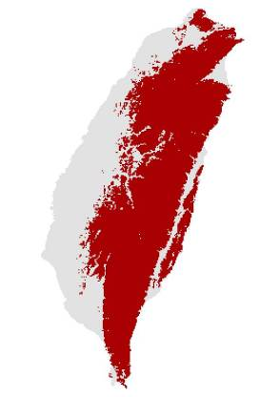
Chinese Bamboo-Partridge Bambusicola thoracicus (Kappa = 0.590)
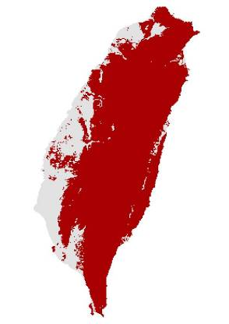
Swinhoe's Pheasant Lophura swinhoii (Kappa = 0.693)
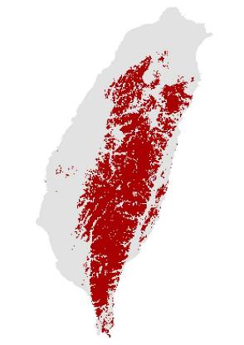
Common Pheasant Phasianus colchicus (Kappa = 0.614)
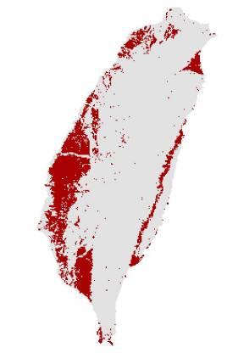
Little Grebe Tachybaptus ruficollis (Kappa = 0.638)
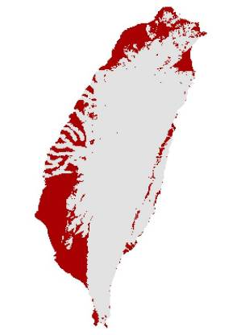
Yellow Bittern Ixobrychus sinensis (Kappa = 0.596)
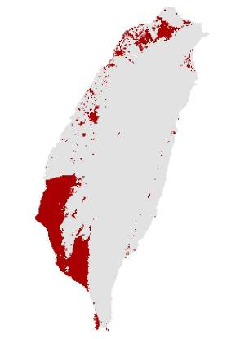
Cinnamon Bittern Ixobrychus cinnamomeus (Kappa = 0.673)
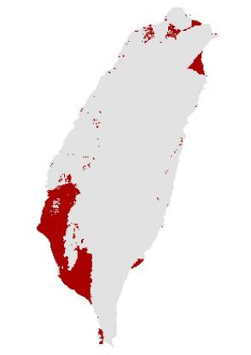
Malaysian Night-heron Gorsachius melanolophus (Kappa = 0.511)
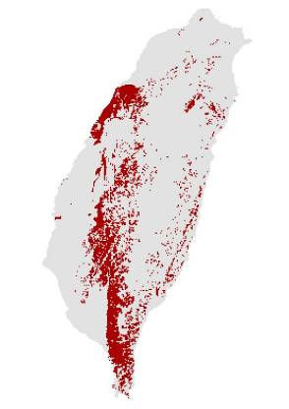
Black-crowned Night-Heron Nycticorax nycticorax (Kappa = 0.703)
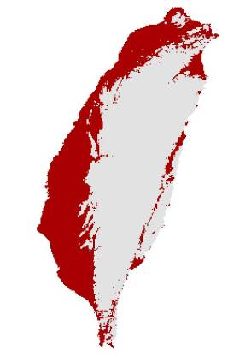
Cattle Egret Bubulcus ibis (Kappa = 0.691)
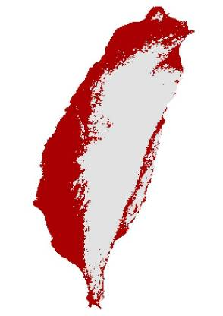
Little Egret Egretta garzetta (Kappa = 0.574)
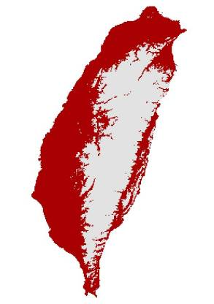
Crested Serpent-Eagle Spilornis cheela (Kappa = 0.574)
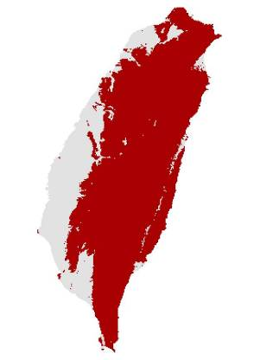
Crested Goshawk Accipiter trivirgatus (Kappa = 0.476)
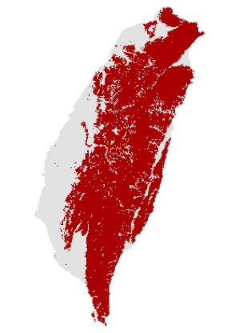
Besra Accipiter virgatus (Kappa = 0.358)
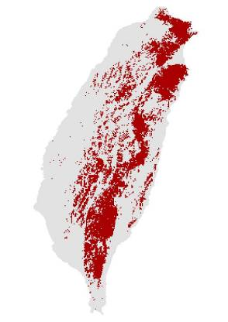
Black Eagle Ictinaetus malayensis (Kappa = 0.614)
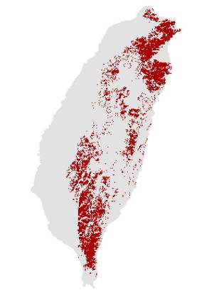
White-breasted Waterhen Amaurornis phoenicurus (Kappa = 0.474)
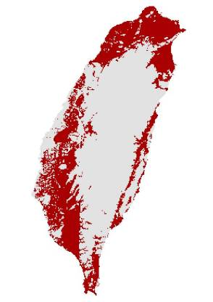
Ruddy-breasted Crake Porzana fusca (Kappa = 0.379)
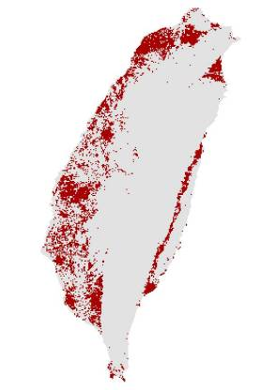
Common Moorhen Gallinula chloropus (Kappa = 0.730)
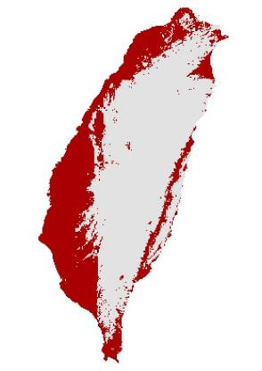
Barred Buttonquail Turnix suscitator (Kappa = 0.469)
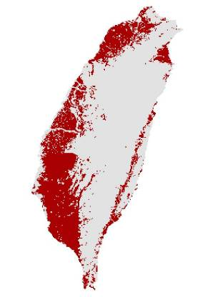
Greater Painted-snipe Rostratula benghalensis (Kappa = 0.712)
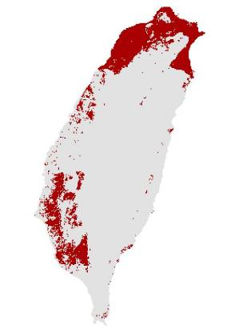
Oriental Pratincole Glareola maldivarum (Kappa = 0.629)
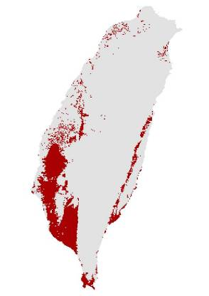
Ashy Wood-Pigeon Columba pulchricollis (Kappa = 0.773)
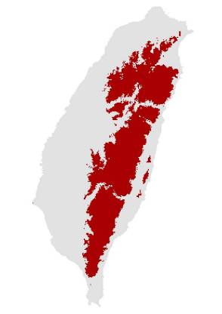
Oriental Turtle-Dove Streptopelia orientalis (Kappa = 0.462)
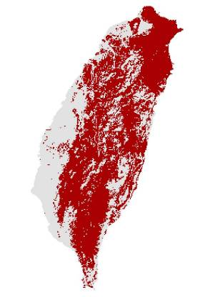
Red Collared-Dove Streptopelia tranquebarica (Kappa = 0.664)
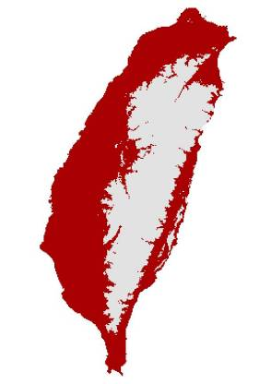
Spotted Dove Streptopelia chinensis (Kappa = 0.706)
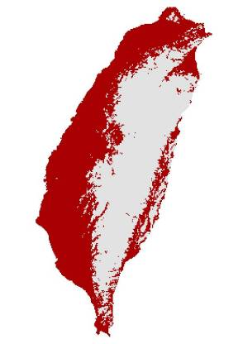
Emerald Dove Chalcophaps indica (Kappa = 0.689)
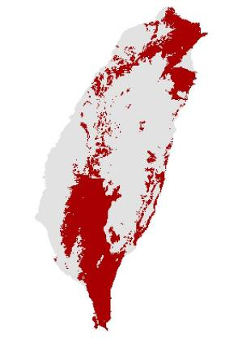
White-bellied Green-pigeon Treron sieboldii (Kappa = 0.663)
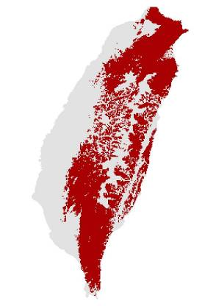
Large Hawk-Cuckoo Cuculus sparverioides (Kappa = 0.851)
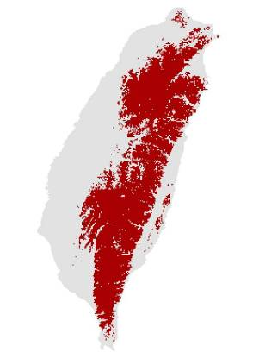
Himalayan Cuckoo Cuculus saturatus (Kappa = 0.586)
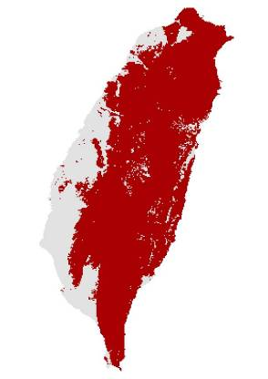
Lesser Coucal Centropus bengalensis (Kappa = 0.607)
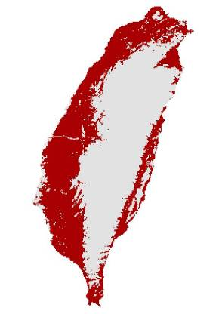
Mountain Scops-Owl Otus spilocephalus (Kappa = 0.628)
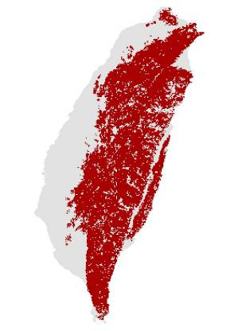
Collared Scops-Owl Otus lettia (Kappa = 0.397)
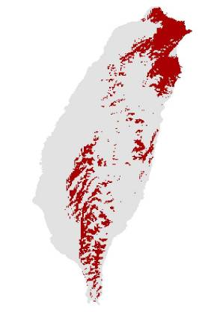
Collared Owlet Glaucidium brodiei (Kappa = 0.764)
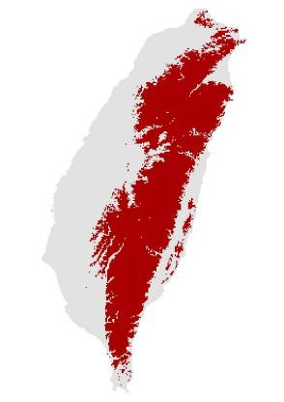
Savanna Nightjar Caprimulgus affinis (Kappa = 0.351)
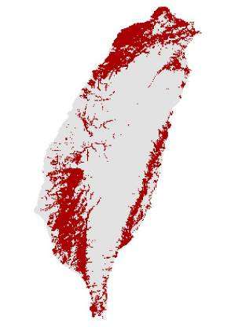
Fork-tailed Swift Apus pacificus (Kappa = 0.526)
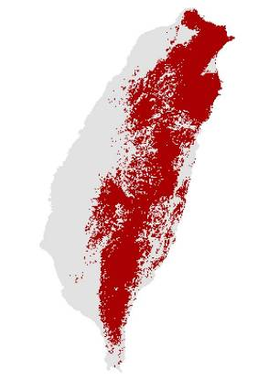
House Swift Apus nipalensis (Kappa = 0.474)
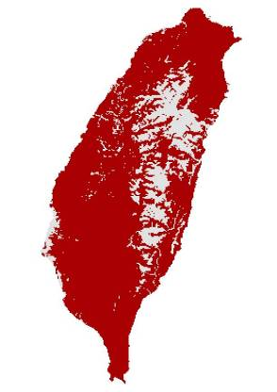
Common Kingfisher Alcedo atthis (Kappa = 0.593)
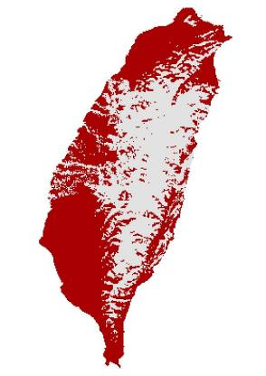
Taiwan Barbet Megalaima nuchalis (Kappa = 0.693)
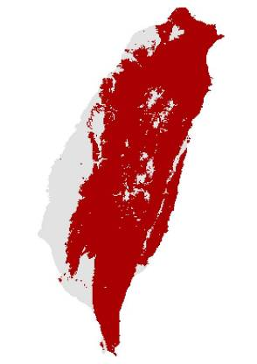
Grey-capped Woodpecker Dendrocopos canicapillus (Kappa = 0.589)
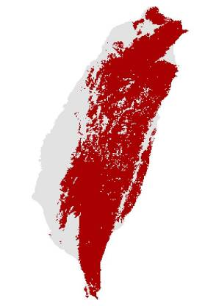
White-backed Woodpecker Dendrocopos leucotos (Kappa = 0.785)
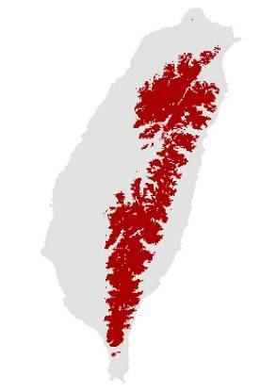
Grey-faced Woodpecker Picus canus (Kappa = 0.603)
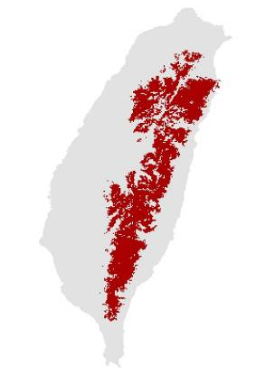
Grey-chinned Minivet Pericrocotus solaris (Kappa = 0.791)
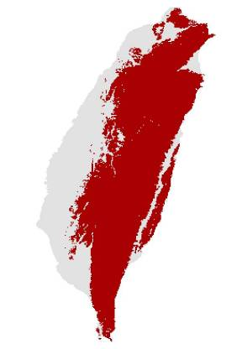
Long-tailed Shrike Lanius schach (Kappa = 0.501)
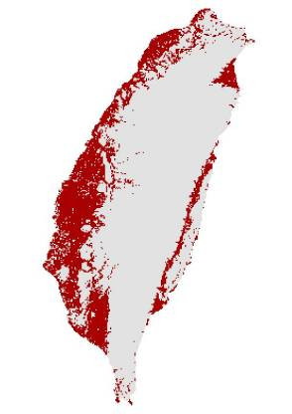
Maroon Oriole Oriolus traillii (Kappa = 0.675)
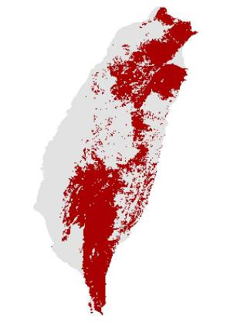
Black Drongo Dicrurus macrocercus (Kappa = 0.593)
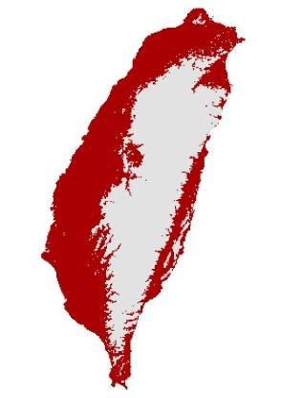
Bronzed Drongo Dicrurus aeneus (Kappa = 0.641)
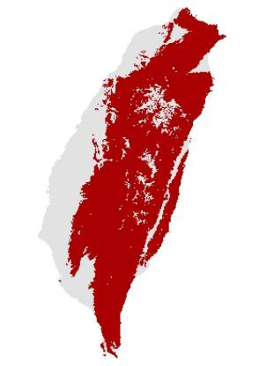
Black-naped Monarch Hypothymis azurea (Kappa = 0.688)
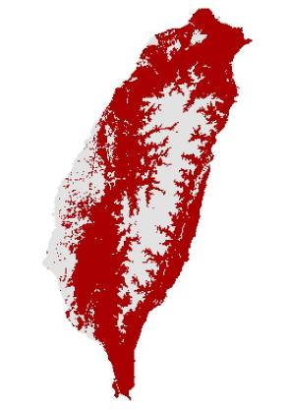
Eurasian Jay Garrulus glandarius (Kappa = 0.696)
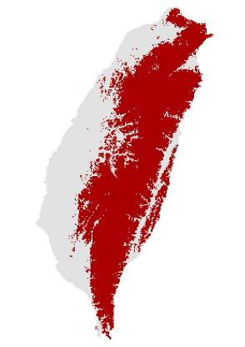
Taiwan Magpie Urocissa caerulea (Kappa = 0.825)
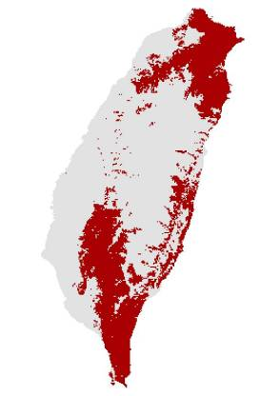
Grey Treepie Dendrocitta formosae (Kappa = 0.594)
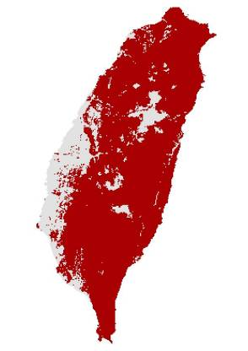
Black-billed Magpie Pica pica (Kappa = 0.534)
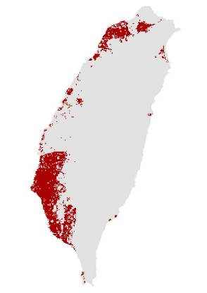
Spotted Nutcracker Nucifraga caryocatactes (Kappa = 0.750)
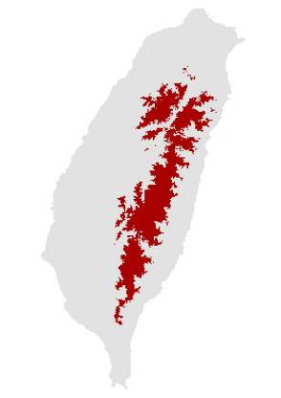
Large-billed Crow Corvus macrorhynchos (Kappa = 0.796)
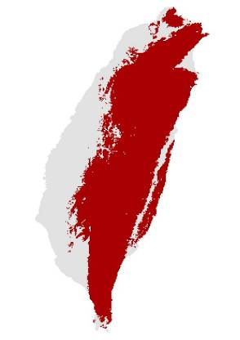
Green-backed Tit Parus monticolus (Kappa = 0.911)
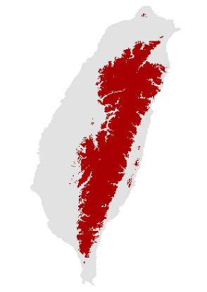
Yellow Tit Macholophus holsti (Kappa = 0.770)
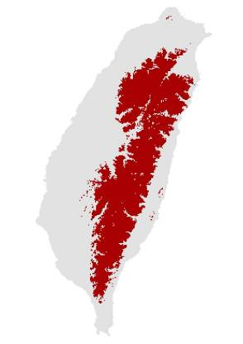
Coal Tit Periparus ater (Kappa = 0.908)
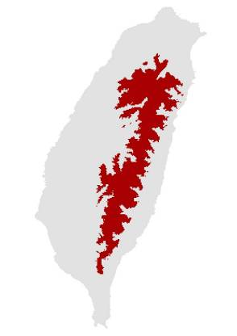
Varied Tit Sittiparus varius (Kappa = 0.708)
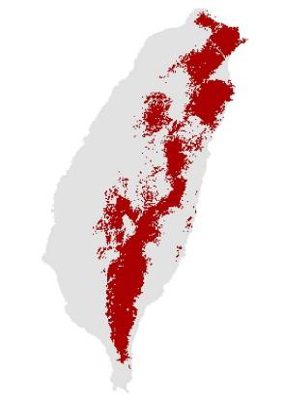
Plain Martin Riparia paludicola (Kappa = 0.502)
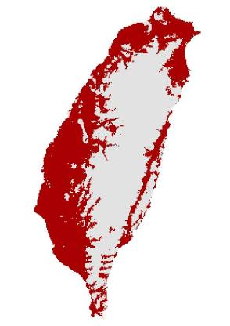
Barn Swallow Hirundo rustica (Kappa = 0.663)
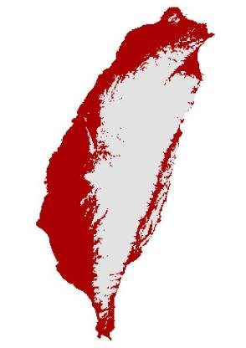
Pacific Swallow Hirundo tahitica (Kappa = 0.611)
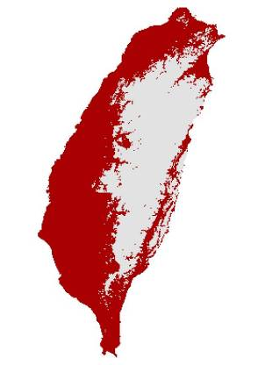
Asian House-Martin Delichon dasypus (Kappa = 0.649)
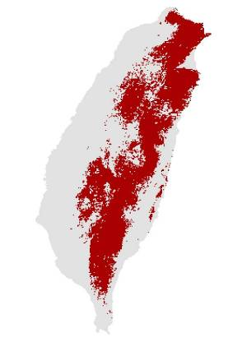
Striated Swallow Cecropis striolata (Kappa = 0.866)
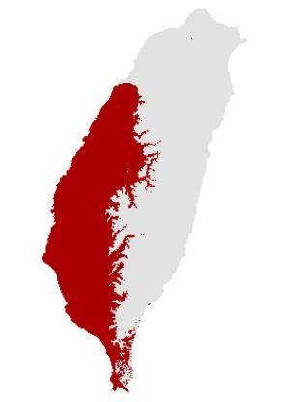
Black-throated Tit Aegithalos concinnus (Kappa = 0.896)
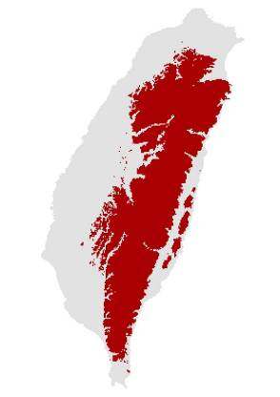
Oriental Skylark Alauda gulgula (Kappa = 0.543)
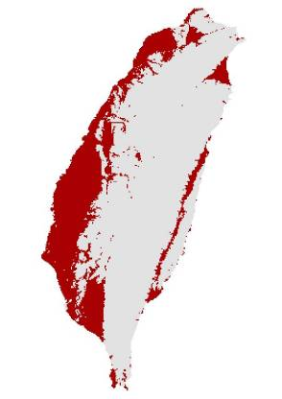
Zitting Cisticola Cisticola juncidis (Kappa = 0.686)
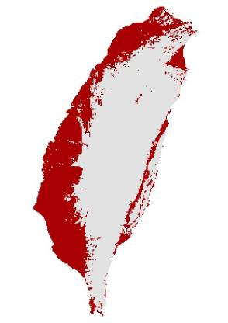
Golden-headed Cisticola Cisticola exilis (Kappa = 0.625)
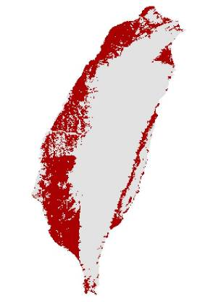
Striated Prinia Prinia crinigera (Kappa = 0.508)
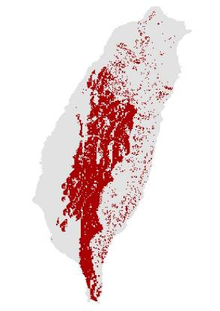
Yellow-bellied Prinia Prinia flaviventris (Kappa = 0.661)
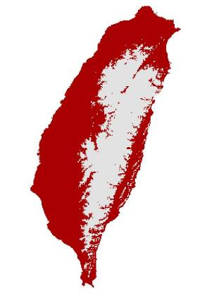
Plain Prinia Prinia inornata (Kappa = 0.578)
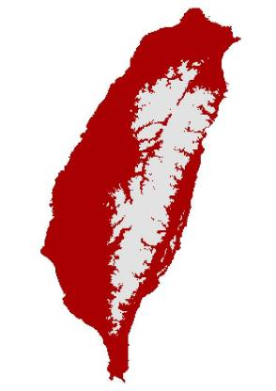
Collared Finchbill Spizixos semitorques (Kappa = 0.628)
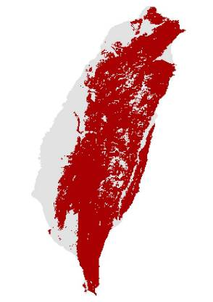
Light-vented Bulbul Pycnonotus sinensis (Kappa = 0.864)
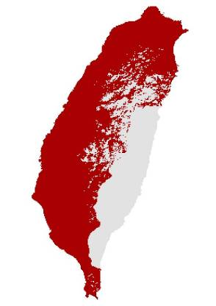
Taiwan Bulbul Pycnonotus taivanus (Kappa = 0.925)
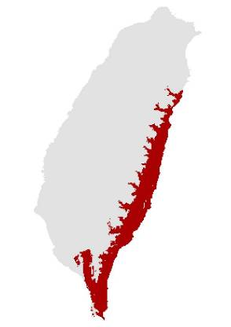
Asian Black Bulbul Hypsipetes leucocephalus (Kappa = 0.609)
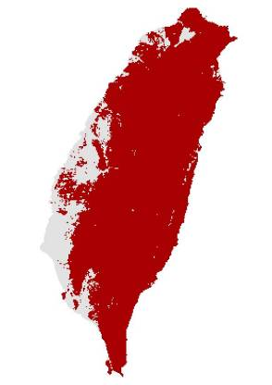
Brownish-flanked Bush-Warbler Cettia fortipes (Kappa = 0.746)
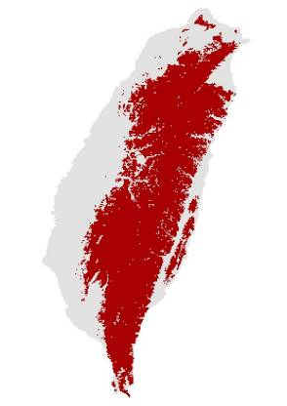
Yellowish-bellied Bush-Warbler Cettia acanthizoides (Kappa = 0.916)
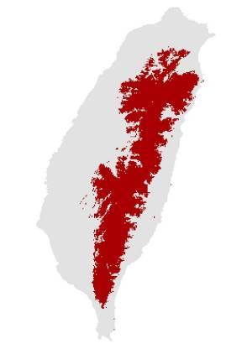
Taiwan Bush-Warbler Bradypterus alishanensis (Kappa = 0.424)
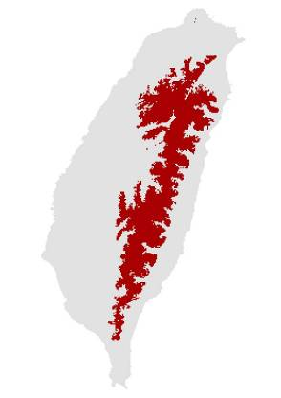
Rufous-faced Warbler Abroscopus albogularis (Kappa = 0.826)
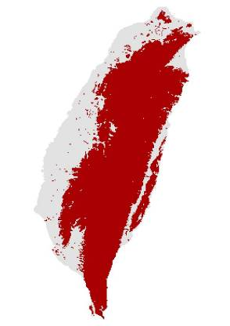
Black-necklaced Scimitar-babbler Pomatorhinus erythrocnemis (Kappa = 0.678)
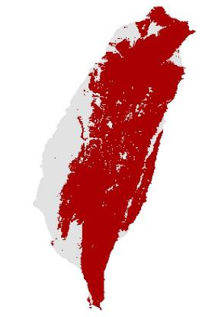
Streak-breasted Scimitar-Babbler Pomatorhinus ruficollis (Kappa = 0.700)
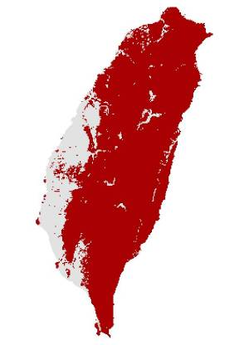
Scaly-breasted Wren-Babbler Pnoepyga albiventer (Kappa = 0.886)
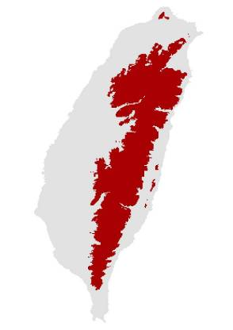
Rufous-capped Babbler Stachyris ruficeps (Kappa = 0.760)
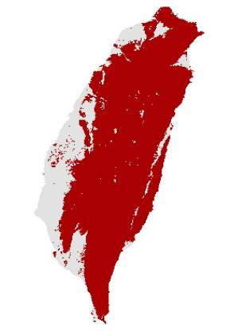
Rusty Laughingthrush Garrulax poecilorhynchus (Kappa = 0.780)
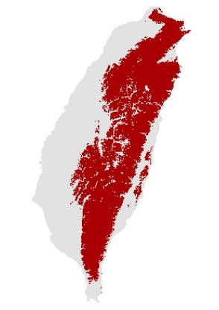
Taiwan Hwamei Garrulax taewanus (Kappa = 0.503)
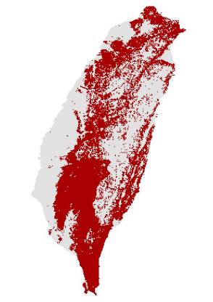
White-whiskered Laughingthrush Garrulax morrisonianus (Kappa = 0.914)
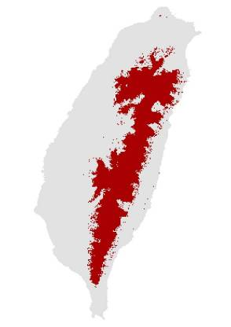
Taiwan Liocichla Liocichla steerii (Kappa = 0.913)
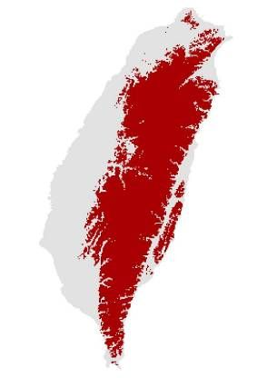
Taiwan Barwing Actinodura morrisoniana (Kappa = 0.801)
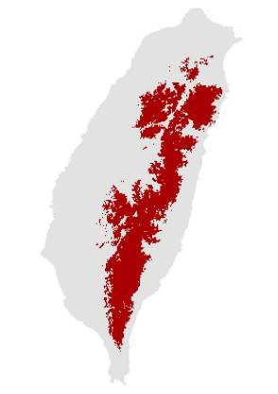
Grey-hooded Fulvetta Alcippe cinereiceps (Kappa = 0.890)
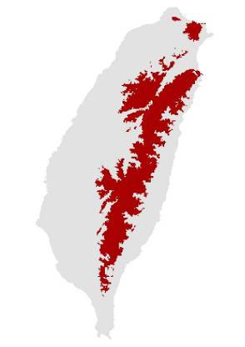
Dusky Fulvetta Alcippe brunnea (Kappa = 0.793)
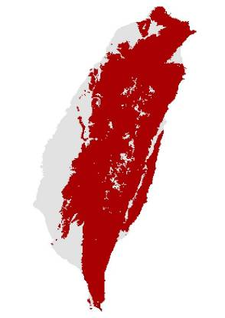
Grey-cheeked Fulvetta Alcippe morrisonia (Kappa = 0.734)
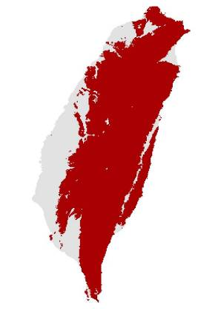
White-eared Sibia Heterophasia auricularis (Kappa = 0.871)
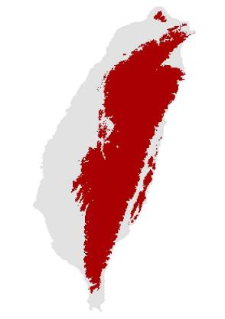
Taiwan Yuhina Yuhina brunneiceps (Kappa = 0.893)
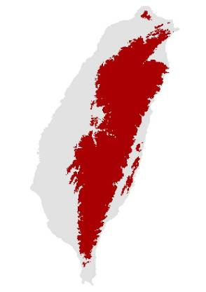
White-bellied Yuhina Yuhina zantholeuca (Kappa = 0.783)
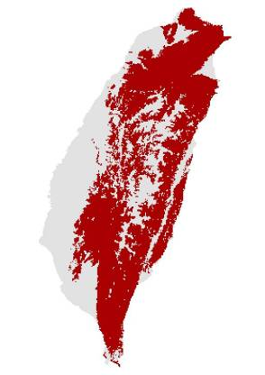
Vinous-throated Parrotbill Paradoxornis webbianus (Kappa = 0.385)
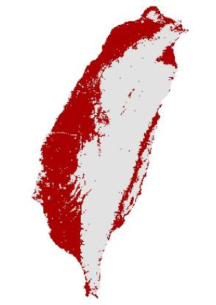
Japanese White-eye Zosterops japonicus (Kappa = 0.361)
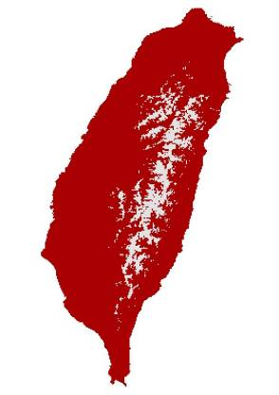
Flamecrest Regulus goodfellowi (Kappa = 0.886)
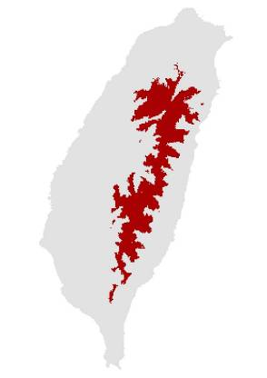
Winter Wren Troglodytes troglodytes (Kappa = 0.773)
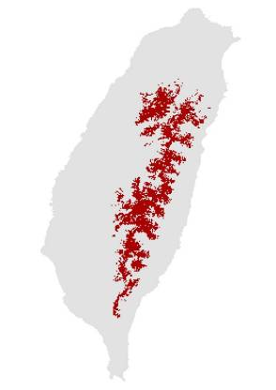
Wood Nuthatch Sitta europaea (Kappa = 0.906)
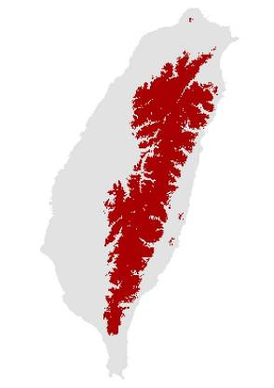
Crested Myna Acridotheres cristatellus (Kappa = 0.514)
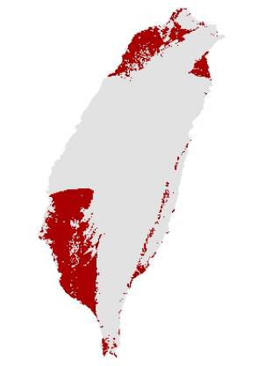
Taiwan Whistling-thrush Myophonus insularis (Kappa = 0.791)
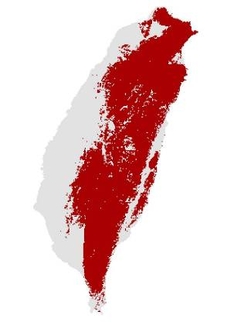
White-browed Shortwing Brachypteryx montana (Kappa = 0.883)
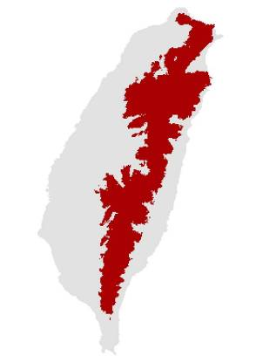
White-browed Bush-Robin Tarsiger indicus (Kappa = 0.827)
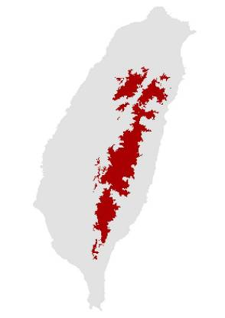
Collared Bush-Robin Tarsiger johnstoniae (Kappa = 0.908)
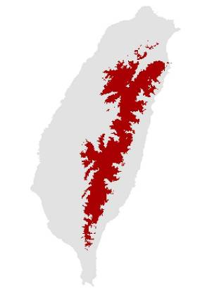
Plumbeous Water-redstart Rhyacornis fuliginosa (Kappa = 0.662)
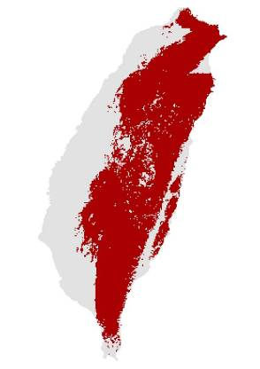
White-tailed Robin Cinclidium leucurum (Kappa = 0.809)
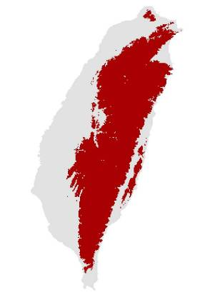
Little Forktail Enicurus scouleri (Kappa = 0.469)
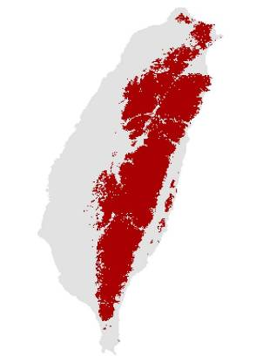
Ferruginous Flycatcher Muscicapa ferruginea (Kappa = 0.804)
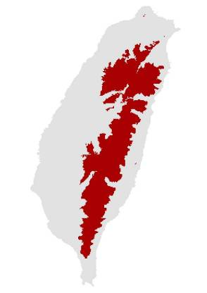
Snowy-browed Flycatcher Ficedula hyperythra (Kappa = 0.877)
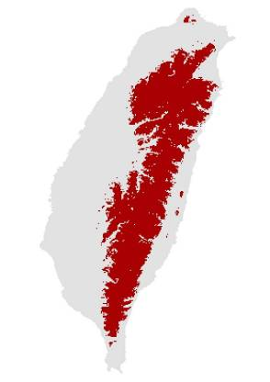
Vivid Niltava Niltava vivida (Kappa = 0.865)
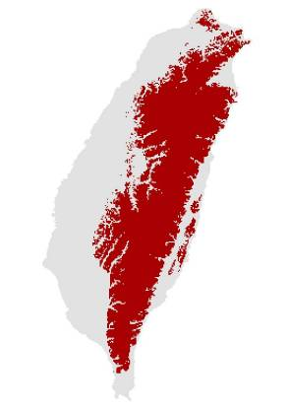
Brown Dipper Cinclus pallasii (Kappa = 0.767)
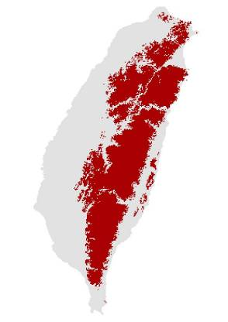
Fire-breasted Flowerpecker Dicaeum ignipectum (Kappa = 0.806)
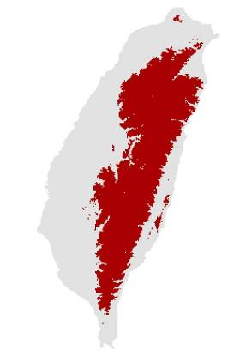
Eurasian Tree Sparrow Passer montanus (Kappa = 0.685)
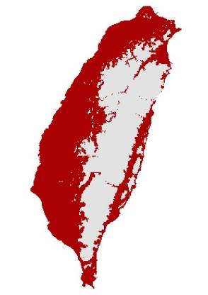
White-rumped Munia Lonchura striata (Kappa = 0.536)
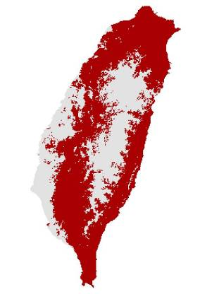
Scaly-breasted Munia Lonchura punctulata (Kappa = 0.533)
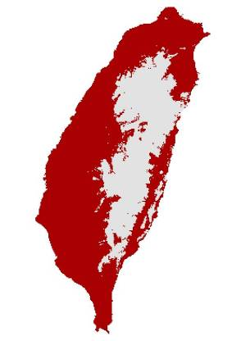
Vinaceous Rosefinch Carpodacus vinaceus (Kappa = 0.897)
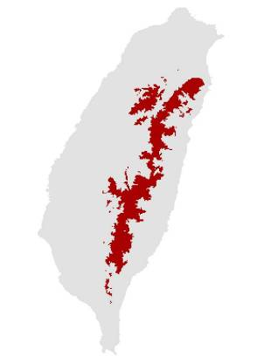
Brown Bullfinch Pyrrhula nipalensis (Kappa = 0.817)
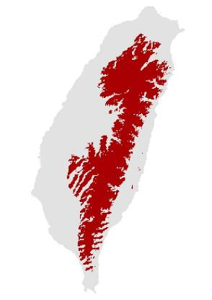
Grey-headed Bullfinch Pyrrhula erythaca (Kappa = 0.749)
