Supplementary Material

The distribution and conservation of Gurney’s Pitta Pitta gurneyi in Myanmar

PAUL F. DONALD, HTIN HLA, LAY WIN, THIRI DAWEI AUNG, SAW MOSES, SAO MYO ZAW, TIN TUN AG, KYAW NAING OO and JONATHAN C. EAMES

Contents

Figure S1. MaxEnt response curves of the five variables that between them contributed over 70% to the final model.

Figure S2. Agro-climatically attainable yield for rain-fed (i.e. non-irrigated) oil palm production in SE Asia in tonnes per hectare.
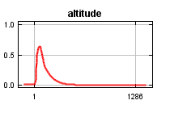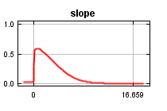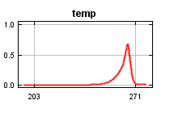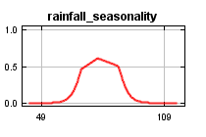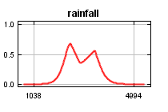

Figure S1. MaxEnt response curves of the five variables that between them contributed over 70% to the final model. Each curve represents the model that includes only that variable. The curves were considered to be sufficiently smooth that no change was needed to the default regularisation multiplier.
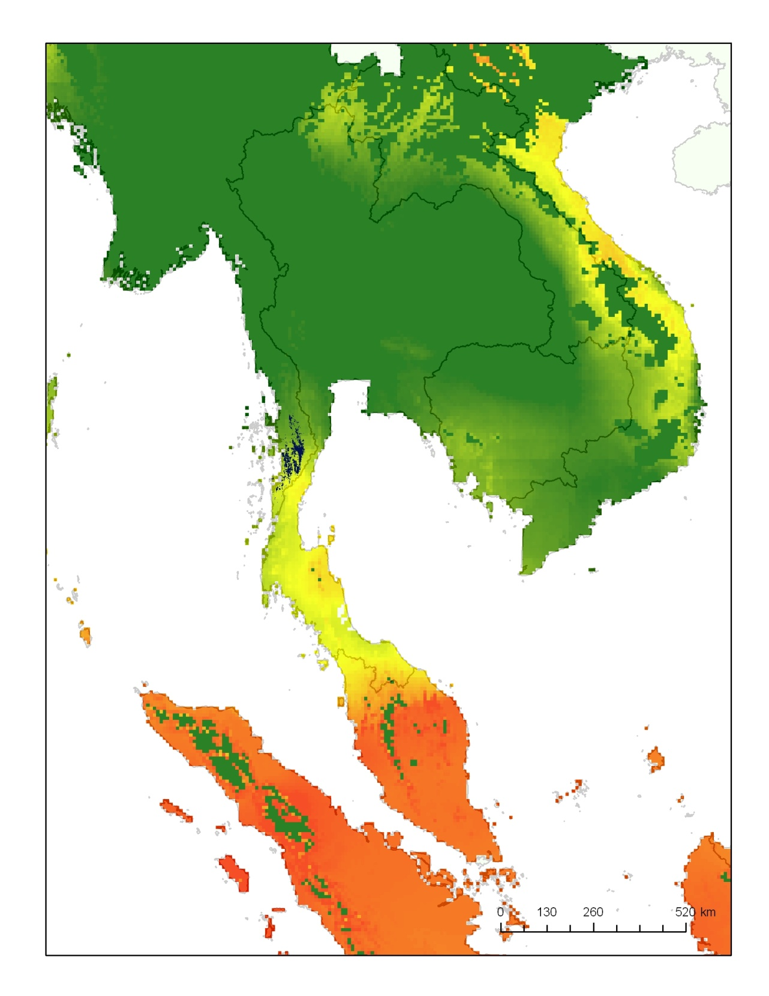
Figure S2. Agro-climatically attainable yield for rain-fed (i.e. non-irrigated) oil palm production in SE Asia in tonnes per hectare estimated by Global Agro-ecological Zones (GAEZ) v3.0 (IIASA/FAO, 2012). Yields range from zero (green) to over 8 tonnes per hectare (red). The modelled range of Gurney’s Pitta in Myanmar is indicated in black.

