Supplementary Material

An assessment of the distribution, population size and conservation status of the Santa Marta Foliage-gleaner Automolus rufipectus: a Sierra Nevada de Santa Marta endemic

ESTEBAN BOTERO-DELGADILLO, NICHOLAS BAYLY, CAMILA GÓMEZ, PAULO C. PULGARÍN-R. and CARLOS ANDRÉS PÁEZ

Contents
Table S1. Geographical records for the Santa Marta Foliage-gleaner used for ecological niche modelling and estimation of its extent of occurrence.
Figure S1. Ecological distribution of the Santa Marta Foliage-gleaner in the Sierra Nevada de Santa Marta.

Table S1. Geographical records for the Santa Marta Foliage-gleaner used for ecological niche modelling and estimation of its extent of occurrence (EOO; see Methods).
Latitude* | Longitude* | Altitude (m) | Locality/Town | Source^
11.1190 | -74.0818 | 1,325 | Hacienda La Victoria, Magdalena | This study
11.1262 | -74.0925 | 920 | Hacienda La Victoria, Magdalena | This study
11.0755 | -74.0369 | 1,550 | La Tagua, Magdalena | This study
11.1448 | -74.1197 | 630 | Minca, Magdalena | This study
11.0819 | -73.9026 | 830 | Buritaca, Magdalena | This study
11.0382 | -73.9253 | 1,100 | Buritaca, Magdalena | This study
11.1123 | -73.8652 | 700 | Buritaca, Magdalena | This study
11.1209 | -74.0723 | 1,560 | Hacienda La Victoria, Magdalena | This study
11.1418 | -74.1075 | 750 | Minca, Magdalena | This study
11.1199 | -74.0913 | 1,150 | Hacienda La Victoria, Magdalena | This study
11.0663 | -73.9160 | 800 | Buritaca, Magdalena | This study
10.4997 | -73.6019 | 1,875 | Chinchicuá, Cesar | GBIF
11.1024 | -74.0809 | 1,480 | Hacienda Cincinati, Magdalena | GBIF
10.9704 | -73.4559 | NA | El Pueblito, Guajira | GBIF
11.0226 | -73.4276 | 800 | La Concepción, Guajira | GBIF
11.2124 | -73.9650 | NA | Las Vegas, Magdalena | GBIF
11.1609 | -74.0578 | 1,760 | Minca, Magdalena | GBIF
10.7697 | -74.0239 | 1,760 | Palmor, Magdalena | GBIF
11.0421 | -73.4613 | 1,050 | San Antonio, Guajira | GBIF
10.9666 | -73.4832 | 1,700 | San Miguel , Guajira | GBIF
10.9021 | -74.0497 | 1,760 | San Pedro de la Sierra | GBIF
11.0841 | -74.0753 | 1,402 | Vista Nieve , Magdalena | GBIF
11.0831 | -74.0841 | 1,225 | Vista Nieve , Magdalena | GBIF
10.9911 | -74.0634 | NA | Estación El Congo, Magdalena | This study
11.0027 | -74.0365 | NA | Vereda Canta Rana, Magdalena | This study

*Coordinates are given in decimal degrees.

^All recordings resulting from secondary sources are available at the site of the public database GBIF (http://www.gbif.org).

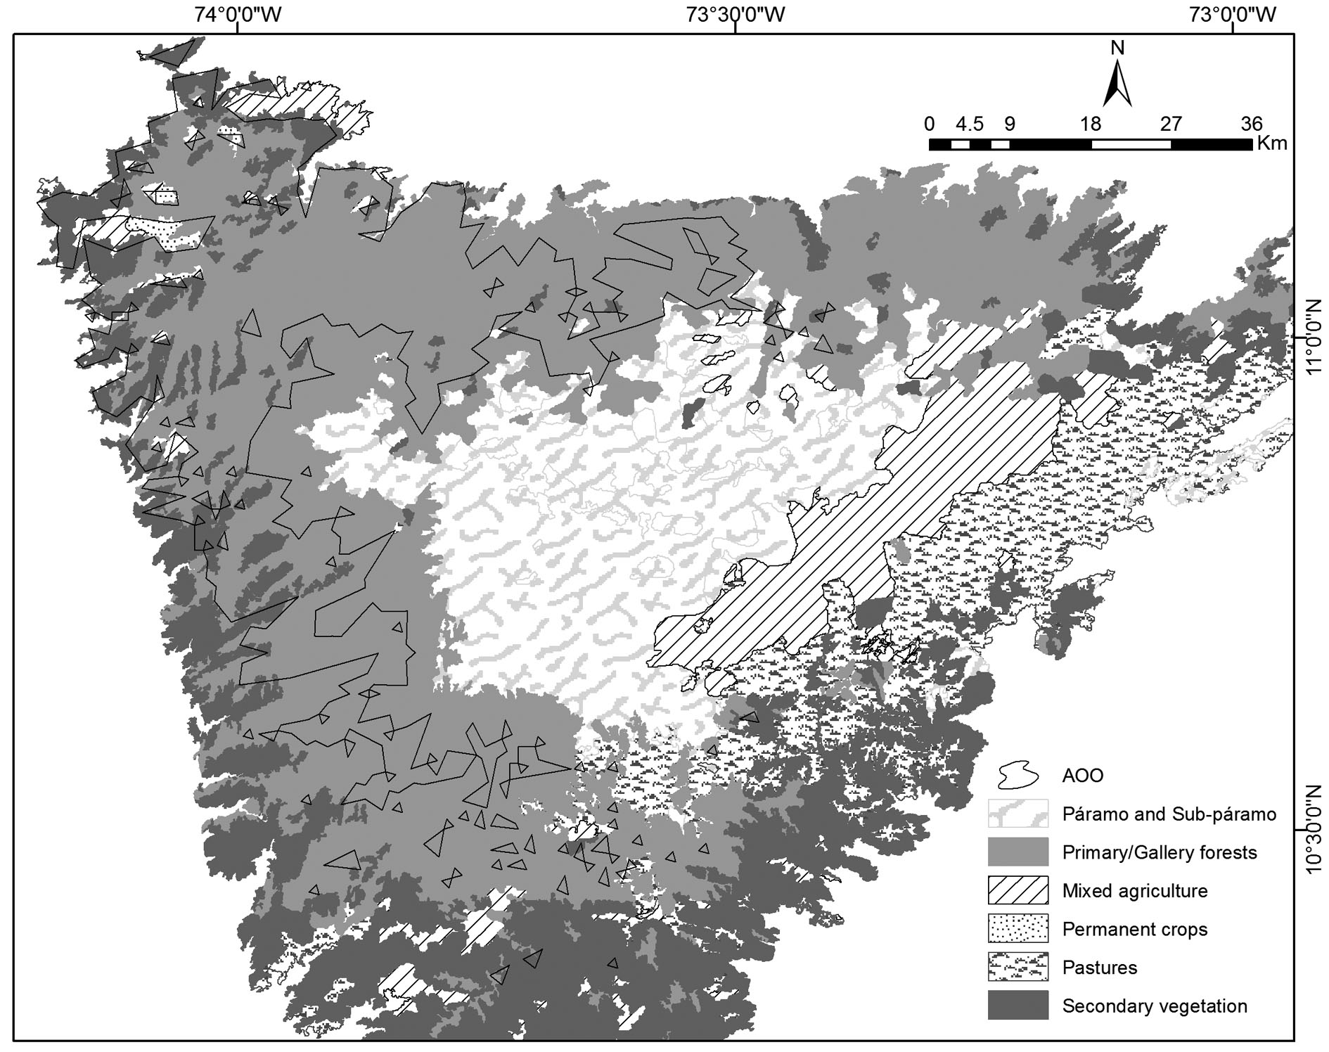
Figure S1. Ecological distribution of the Santa Marta Foliage-gleaner in the Sierra Nevada de Santa Marta. a. Area of occupancy (AOO) over a gradient of annual mean temperature (°C); b. AOO over a gradient of temperature seasonality, expressed as the coefficient of variation (CV) of the annual mean temperature (from 0 to 100); c. AOO over a gradient of annual precipitation (mm); d. AOO over a gradient of precipitation seasonality, expressed as the coefficient of variation (CV; 0–100). All AOO projections are at 1-km² resolution (see Methods for details).

