**Supplementary Material**

DNA barcoding of bird species in Cyprus: a tool for conservation purposes

Andreas C. DIMITRIOU, Giovanni FORCINA, Clairie PAPAZOGLOU, Panicos PANAYIDES, Monica GUERRINI, Alan CRABTREE, Filippo BARBANERA

and Spyros SFENTHOURAKIS

**Contents**

Table S1. Bird taxa investigated in this study.

Figure S1**.** COI phylogenetic signal as inferred by means of the plot of the number of Ti and Tv against TN93-corrected genetic divergence.

Detailed information on PCR procedures followed

References

Table S1. Bird taxa investigated in this study are reported with their common name, type of exploitation (e.g. huntable, served in ‘restaurants’, *ambelopoulia*), status in Cyprus, number of specimens analyzed, haplotype number and GenBank accession numbers. All samples were collected by the authors, except for the domestic chicken (not cooked) used as outgroup.

Abbreviations: G: huntable species; A: species considered as *ambelopoulia* that are served in restaurants; R: huntable species which may also be served in restaurants; n/a: not applicable; Seasonal Presence Status: MB/mb: Migrant Breeder; PM/pm: Passage Migrant; RB/ rb: Resident Breeder; WV: Winter Visitor; OB: Occasional Breeder (capitals in seasonal presence status codes denote large proportion of the species population, whereas small letters indicate small proportion of the species population; BirdLife Cyprus 2013, 2015b).

|  |  |  |  |  |  |  |  |
| --- | --- | --- | --- | --- | --- | --- | --- |
| **Taxon** | **Common name** | **Exploitation status** | **Seasonal Presence Status in**  **Cyprus** | **Haplotype (H)** | **Sample size (n)** | **Primers** | **Gen Bank**  **Acc. No.** |
|  |  |  |  |  |  |  |  |
| *Alectoris chukar* | Chukar partridge | G, R | RB | 5 | 2 | a, a(b) | KT803621 |
| *Francolinus francolinus* | Black francolin | G, R | RB | 4 | 2 | a | KT803620 |
| *Anas platyrhynchos* | Mallard | G | WV, PM, RB | 80 | 1 | a | KT803699 |
| *Columba palumbus* | Woodpigeon | G | RB, WV | 78 | 1 | a | KT803698 |
| *Streptopelia decaocto* | Collared dove | G | RB | 79 | 1 | a | KT803697 |
| *Pterocles orientalis* | Black-bellied sandgrouse | n/a | AV, rb? | 85 | 1 | a | KT803626 |
| *Crex crex* | Corncrake | n/a | pm | 21 | 1 | a | KT803614 |
| *Gallinula chloropus* | Common moorhen | G | PM, WV, RB | 20 | 1 | a | KT803612 |
| *Fulica atra* | Eurasian coot | G | WV, PM, RB | 19 | 1 | a* | KT803613 |
| *Ardea cinerea* | Grey heron | n/a | PM, WV, OB? | 17 | 1 | a | KT803610 |
| *Egretta garzetta* | Little egret | n/a | WV, PM, OB | 18 | 1 | a | KT803611 |
| *Burhinus oedicnemus* | Stone-curlew | n/a | rb, PM, WV | 13 | 1 | a | KT803623 |
| *Himantopus himantopus* | Black winged stilt | n/a | PM, OB | 12 | 1 | a* | KT803624 |
| *Vanellus spinosus* | Spur-winged lapwing | n/a | PM, RB | 11 | 2 | a | KT803625 |
| *Larus audouinii* | Audouin's gull | n/a | rb | 87 | 1 | b | KT803632 |
| *Larus michahellis* | Yellow-legged gull | n/a | RB, WV, PM | 86 | 1 | a | KT803631 |
| *Tyto alba* | Barn owl | n/a | RB | 84 | 1 | a | KT803696 |
| *Athene noctua* | Little owl | n/a | RB | 83 | 1 | a | KT803665 |
| *Otus scops cyprius* | Cypriot scops owl | n/a | RB, mb?,pm | 81 | 2 | a* | KT803674 |
| *Asio otus* | Long-eared owl | n/a | RB, wv?, pm? | 82 | 1 | a | KT803639 |
| *Pernis apivorus* | Honey buzzard | n/a | PM | 10 | 1 | a | KT803619 |
| *Aquila fasciata* | Bonelli’s eagle | n/a | rb, pm | 6 | 1 | a | KT803618 |
| *Circus aeruginosus* | Marsh harrier | n/a | PM, WV | 7 | 1 | a(d)* | KT803617 |
| *Buteo buteo* | Common buzzard | n/a | PM, WV | 9 | 1 | a | KT803616 |
| *Buteo rufinus* | Long-legged buzzard | n/a | RB, pm?, wv | 8 | 2 | a | KT803615 |
| *Alcedo atthis* | Kingfisher | n/a | PM, WV | 3 | 2 | a | KT803622 |
| *Falco tinnunculus* | Kestrel | n/a | RB, PM, WV | 16 | 1 | c | KT803630 |
| *Falco eleonorae* | Eleonora's falcon | n/a | MB, PM | 14 | 1 | a | KT803628 |
| *Falco peregrinus* | Peregrine falcon | n/a | RB, PM, WV | 15 | 1 | a | KT803629 |
| *Lanius collurio* | Red-backed shrike | A | PM, OB | 90 | 1 | a | KT803693 |
| *Lanius nubicus* | Masked shrike | A | MB, PM | 68,69,70 | 3 | a | KT803690/KT803691  /KT803692 |
| *Garrulus glandarius glaszneri* | Eurasian jay | n/a | RB | 66 | 1 | a | KT803688 |
| *Pica pica* | Magpie | G | RB, wv? | 67 | 1 | a(e) | KT803689 |
| *Corvus monedula* | Western jackdaw | G | RB, wv? | 65 | 1 | a | KT803687 |
| *Corvus corone* | Hooded crow | G | RB | 64 | 1 | a | KT803686 |
| *Periparus ater cypriotes* | Coal tit | A | RB | 49 | 1 | a | KT803660 |
| *Parus major* | Great tit | A | RB | 50,51 | 2 | a | KT803659/KT803658 |
| *Hirundo rustica* | Barn swallow | A | MB, PM | 63 | 1 | a | KT803694 |
| *Galerida cristata* | Crested lark | A | RB | 59, 88 | 2 | a | KT803673/KT803675 |
| *Alauda arvensis* | Skylark | A, G, R | WV, PM, OB | 60 | 1 | a | KT803676 |
| *Cisticola juncidis* | Zitting cisticola | A | RB | 62 | 1 | a | KT803695 |
| *Cettia cetti* | Cetti’s warbler | A | RB | 61 | 2 | a, a(d) | KT803678 |
| *Acrocephalus scirpaceus* | Eurasian reed warbler | A | MB, PM | 56 | 1 | a | KT803635 |
| *Acrocephalus arundinaceus* | Great reed warbler | A | PM, OB | 55 | 1 | a | KT803637 |
| *Hippolais pallida* | Eastern olivaceous warbler | A | MB, PM | 57,58 | 1 | a | KT803638 |
| *Phylloscopus trochilus* | Willow warbler | A | PM | 53 | 1 | a* | KT803662 |
| *Phylloscopus collybita* | Chiffchaff | A | PM, WV | 52 | 1 | a | KT803661 |
| *Phylloscopus sibilatrix* | Wood warbler | A | PM | 54 | 1 | a | KT803663 |
| *Sylvia atricapilla* | Blackcap | A | PM, WV, OB? | 71 | 5 | a, a(c), a(d) | KT803684 |
| *Sylvia borin* | Garden warbler | A | PM | 77 | 1 | a | KT803685 |
| *Sylvia communis* | Whitethroat | A | PM | 72 | 1 | a | KT803680 |
| *Sylvia curruca* | Lesser whitethroat | A | PM | 76 | 1 | a | KT803683 |
| *Sylvia melanocephala* | Sardinian warbler | A | RB, WV, PM? | 73 | 1 | a | KT803679 |
| *Sylvia melanothorax* | Cyprus warbler | A | RB, MB | 75 | 1 | a | KT803682 |
| *Sylvia conspicillata* | Spectacled warbler | A | RB | 74 | 1 | a | KT803681 |
| *Troglodytes troglodytes* | Wren | A | RB, wv? | 48 | 1 | a | KT803670 |
| *Certhia brachydactyla* | Short-toed treecreeper | A | RB | 38 | 1 | a | KT803657 |
| *Turdus merula* | Blackbird | G, R | WV, PM, rb | 43 | 1 | a | KT803667 |
| *Turdus iliacus* | Redwing | G, R | wv, pm | 92 | 1 | b | KT803668 |
| *Turdus philomelos* | Song thrush | G, R | WV, PM | 44 | 1 | a | KT803633 |
| *Erithacus rubecula* | Robin | A | WV, PM | 39 | 1 | a | KT803634 |
| *Luscinia luscinia* | Thrush nightingale | A | pm | 41 | 1 | a | KT803672 |
| *Luscinia megarhynchos* | Nightingale | A | MB, PM | 42 | 1 | a | KT803671 |
| *Phoenicurus ochruros* | Black redstart | A | WV, PM | 45 | 1 | a | KT803666 |
| *Phoenicurus phoenicurus* | Common redstart | A | PM | 46 | 1 | a | KT803664 |
| *Oenanthe cypriaca* | Cyprus wheatear | A | MB | 47 | 1 | a | KT803669 |
| *Muscicapa striata* | Spotted flycatcher | A | PM, mb | 40 | 1 | a | KT803635 |
| *Passer domesticus* | House sparrow | A | RB, PM, wv? | 33,34 | 2 | a | KT803648/KT803649 |
| *Passer hispaniolensis* | Spanish sparrow | A | RB, PM, WV | 35,36 | 2 | a* | KT803651/KT803652 |
| *Motacilla alba* | White wagtail | A | WV, PM, OB | 23 | 1 | a | KT803656 |
| *Anthus pratensis* | Meadow pipit | A | WV, PM | 22 | 1 | a | KT803655 |
| *Fringilla coelebs* | Chaffinch | A | RB, PM, WV | 32 | 1 | a | KT803654 |
| *Serinus serinus* | Serin | A | RB, WV, PM | 25 | 1 | a | KT803641 |
| *Carduelis chloris* | Greenfinch | A | RB, WV, PM | 27,28,29 | 3 | a* | KT803643/KT803650  /KT803645 |
| *Carduelis carduelis* | Goldfinch | A | RB, WV, PM, | 26 | 2 | a | KT803642 |
| *Carduelis cannabina* | Linnet | A | RB, WV, PM | 24 | 1 |  | KT803640 |
| *Loxia curvirostra guillemardi* | Red crossbill | A | RB, wv? | 91 | 1 | a(b) | KT803644 |
| *Coccothraustes coccothraustes* | Hawfinch | A | wv | 31 | 1 | a | KT803646 |
| *Emberiza calandra* | Corn bunting | A | RB, PM, WV | 30,89 | 3 | a | KT803647/KT803677 |
| *Emberiza melanocephala* | Black-headed bunting | A | MB, PM | 37 | 1 | a | KT803653 |
| *Gallus gallus* | Domestic chicken | n/a | − | 1 | 1 | a | AP003317.1 |
| *Gallus gallus* (cooked meat) | Domestic chicken | n/a | − | 2 | 1 | a | KT803627 |
|  |  |  |  |  |  |  |  |
| 81 taxa |  |  |  |  | 104 |  |  |

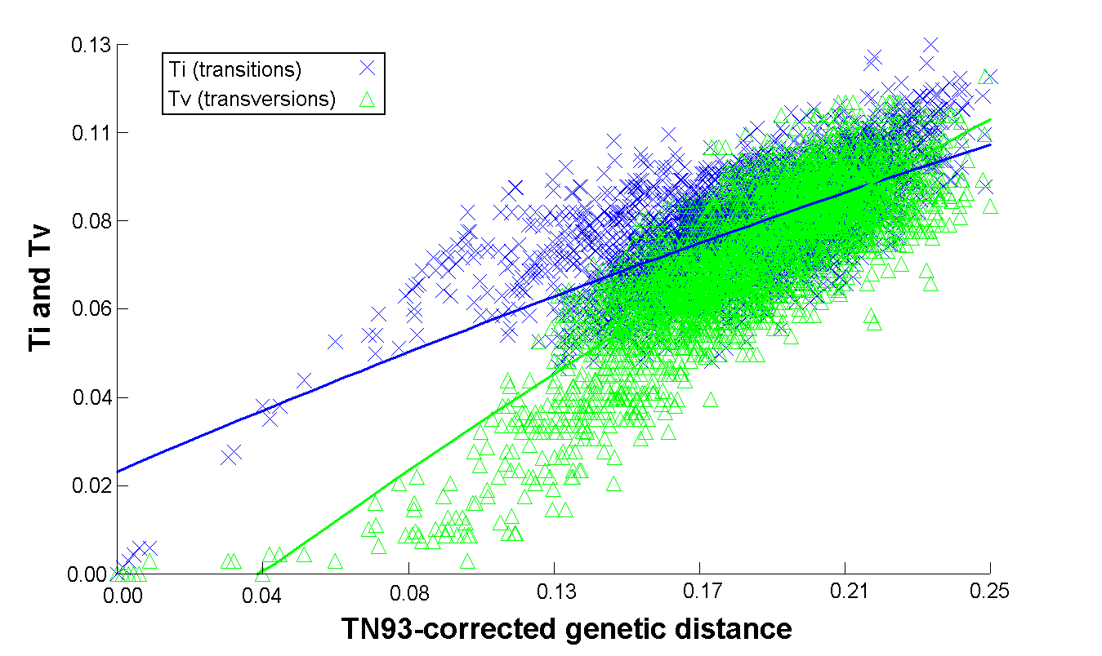

Figure S1**.** COI phylogenetic signal as inferred by means of the plot of the number of Ti and Tv against TN93-corrected genetic divergence.

**Detailed information on PCR procedures followed**

Touchdown PCR (5 cycles at 62 oC, 5 cycles at 60 oC, 10 cycles at 58 oC, 10 cycles at 55 oC, 9 cycles at 50 oC) using the primer pair listed in Table S1 was applied in cases where elimination of aspecific PCR products arising from the standard thermal profile (at 47 oC, 50 oC or 55 oC annealing temperature, depending on the primer pair used; see Table 1) was necessary. This procedure was employed for the following species: Eurasian Coot,Fulica atra, Black-winged Stilt Himantopus himantopus, Eurasian Scops Owl Otus scops, Marsh Harrier *Circus aeruginosus*, Eleonora's Falcon Falco eleonorae, Willow Warbler Phylloscopus trochilus, Spanish Sparrow Passer hispaniolensis, and European Greenfinch Carduelis chloris.

The first attempt to amplify the target gene using the external primer pair L6615(tTyr)_COI/ H7548 (COI) for Blackcap *Sylvia atricapilla*, and Chukar Partridge *Alectoris chukar,* samples preserved in vinegar for more than 12 months, failed. The PCR product was used further in nested and semi-nested reactions. More specifically, the chukar partridge was amplified with nested PCR, using the BirdF1/COIbirdR2 primer pair.

Two primer pairs, L6615(tTyr)_COI/ HCO2198 and LCO1490/ H7548 (COI), were next applied to the three processed blackcap samples, in a semi-nested PCR approach. These reactions resulted to faint bands and smear in electrophoresis. Hence, nested PCR was then successfully employed, using the LCO1490/ HCO2198 primer pair.

A semi nested PCR approach was followed for COI fragment amplification of the Eurasian Marsh Harrier, *Circus aeruginosus*, one of the two unprocessed Blackcaps and one of the two Cetti's Warblers *Cettia cetti,* using the L6615(tTyr)_COI/ HCO2198 primer pair, as well as of the Eurasian magpie, *Pica pica,* using LCO1490/ H7548 (COI).

For all nested and semi nested PCR reactions annealing point was set at 47 oC keeping constant the reagents concentration and time for each step. In cases where the product was a faint band, the reaction was redesigned using larger template volumes (5-7μl).

**References**

BirdLife Cyprus (2013) *Cyprus bird report 2013.* Nicosia, Cyprus: BirdLife Cyprus. ISSN 1450-300.

BirdLife Cyprus (2015b) *Birds of Cyprus checklist* *2009-2014*. Nicosia, Cyprus: BirdLife Cyprus ISSN 1450-2992.