Supplementary Material

Suitable breeding habitat distribution modelling and GAP analysis in the endangered Scaly-sided Merganser Mergus squamatus: implications for conservation
WENYU XU, DIANA SOLOVYEVA, SERGEY VARTANYAN, HAIFENG ZHENG, VLADIMIR PRONKEVICH, YE GONG and HAITAO WANG

Contents

Table S1. Dataset of original breeding SSM presence points input in the SDM.
Table S2. Climate variables in the SDM.
Table S3. Protected areas contain highly suitable habitats in Russia and China.
N- National, L- Local.
Figure S1. ROC curve of the MaxEnt prediction.
Figure S2. Results of the jackknife test of variable importance in the MaxEnt.
Figure S3. Response curves of the four highly influential variables.
Figure S4. Predictive and known map (Solovyeva et al. 2014) identifying suitable habitats for breeding SSME in north-east Asia.
Figure S5. Conservation gaps and distribution of human influence in the highly suitable breeding habitats of the SSME in north-east Asia.

Table S1. Dataset of original breeding SSM presence points input in the SDM.

Longitude | Latitude | Altitude/m | Source
134.8 | 43.94729 | 174 | Solovyeva et al. (2014)
139.597 | 48.61407 | 131 | Solovyeva et al. (2014)
139.6604 | 48.58 | 113 | Solovyeva et al. (2014)
139.7818 | 48.54086 | 78 | Solovyeva et al. (2014)
135.0996 | 44.24229 | 168 | Solovyeva et al. (2014)
135.2486 | 44.24993 | 102 | Solovyeva et al. (2014)
135.3483 | 44.26254 | 70 | Solovyeva et al. (2014)
135.2393 | 43.84528 | 53 | Solovyeva et al. (2014)
135.1748 | 43.79515 | 18 | Solovyeva et al. (2014)
134.9338 | 43.56037 | 186 | Solovyeva et al. (2014)
135.0491 | 43.58746 | 109 | Solovyeva et al. (2014)
135.0712 | 43.69417 | 38 | Solovyeva et al. (2014)
134.8497 | 43.88961 | 137 | Solovyeva et al. (2014)
135.0136 | 43.82266 | 39 | Solovyeva et al. (2014)
134.6611 | 43.51564 | 111 | Solovyeva et al. (2014)
134.7621 | 43.39763 | 13 | Solovyeva et al. (2014)
134.5497 | 43.35596 | 65 | Solovyeva et al. (2014)
134.2604 | 43.27274 | 80 | Solovyeva et al. (2014)
134.0243 | 43.35995 | 270 | Solovyeva et al. (2014)
133.9148 | 43.36407 | 219 | Solovyeva et al. (2014)
133.8562 | 43.30012 | 176 | Solovyeva et al. (2014)
133.7915 | 43.20176 | 141 | Solovyeva et al. (2014)
133.6432 | 42.98264 | 34 | Solovyeva et al. (2014)
133.6776 | 42.92041 | 8 | Solovyeva et al. (2014)
134.0281 | 43.25124 | 370 | Solovyeva et al. (2014)
133.3269 | 43.30635 | 168 | Solovyeva et al. (2014)
133.342 | 43.35634 | 189 | Solovyeva et al. (2014)
136.9667 | 50.09379 | 26 | Solovyeva et al. (2014)
137.2313 | 50.02762 | 42 | Solovyeva et al. (2014)
137.0998 | 50.05783 | 33 | Solovyeva et al. (2014)
137.245 | 49.24862 | 115 | Solovyeva et al. (2014)
137.1671 | 49.2318 | 110 | Solovyeva et al. (2014)
137.0702 | 49.24364 | 94 | Solovyeva et al. (2014)
138.1796 | 49.25797 | 361 | Solovyeva et al. (2014)
138.0869 | 49.28905 | 303 | Solovyeva et al. (2014)
136.0832 | 46.70872 | 223 | Solovyeva et al. (2014)
135.8882 | 46.71267 | 198 | Solovyeva et al. (2014)
135.6528 | 46.70666 | 174 | Solovyeva et al. (2014)
135.4719 | 46.68022 | 148 | Solovyeva et al. (2014)
134.484 | 45.07793 | 258 | Solovyeva et al. (2014)
134.6504 | 45.09373 | 310 | Solovyeva et al. (2014)
135.5239 | 44.87385 | 512 | Solovyeva et al. (2014)
135.5647 | 44.92902 | 493 | Solovyeva et al. (2014)
135.5893 | 44.98858 | 480 | Solovyeva et al. (2014)
135.9344 | 46.4029 | 454 | Solovyeva et al. (2014)
135.8652 | 46.42599 | 419 | Solovyeva et al. (2014)
135.7653 | 46.40024 | 361 | Solovyeva et al. (2014)
137.0901 | 48.63184 | 403 | Solovyeva et al. (2014)
137.05 | 48.58137 | 385 | Solovyeva et al. (2014)
137.0776 | 48.47391 | 376 | Solovyeva et al. (2014)
136.9909 | 48.30997 | 340 | Solovyeva et al. (2014)
136.9109 | 48.15994 | 307 | Solovyeva et al. (2014)
135.9998 | 47.55775 | 153 | Solovyeva et al. (2014)
135.8061 | 47.62745 | 134 | Solovyeva et al. (2014)
135.6396 | 47.73251 | 111 | Solovyeva et al. (2014)
136.1055 | 47.53716 | 158 | Solovyeva et al. (2014)
136.1374 | 47.37494 | 195 | Solovyeva et al. (2014)
136.5135 | 47.7174 | 238 | Solovyeva et al. (2014)
136.3333 | 47.69989 | 198 | Solovyeva et al. (2014)
136.1843 | 47.62264 | 176 | Solovyeva et al. (2014)
136.7073 | 47.84735 | 262 | Solovyeva et al. (2014)
136.6382 | 47.74796 | 232 | Solovyeva et al. (2014)
134.7276 | 44.32365 | 343 | Solovyeva et al. (2014)
134.5914 | 44.37232 | 303 | Solovyeva et al. (2014)
134.4762 | 44.35593 | 264 | Solovyeva et al. (2014)
134.0711 | 43.88068 | 430 | Solovyeva et al. (2014)
133.8237 | 43.77644 | 392 | Solovyeva et al. (2014)
133.8633 | 43.82755 | 389 | Solovyeva et al. (2014)
134.4154 | 44.74431 | 238 | Solovyeva et al. (2014)
134.2708 | 44.73839 | 200 | Solovyeva et al. (2014)
132.9387 | 43.78786 | 245 | Solovyeva et al. (2014)
132.4855 | 48.98036 | 134 | Solovyeva et al. (2014)
133.4869 | 49.11215 | 117 | Solovyeva et al. (2014)
133.4403 | 48.98323 | 100 | Solovyeva et al. (2014)
129.5099 | 42.06941 | 755 | BirdLife International (2017)
127.4941 | 42.19849 | 691 | Liu et al. (2010), Gong et al. (2020)
127.6407 | 42.3541 | 822 | Gong et al. (2020)
127.7602 | 42.36079 | 926 | Gong et al. (2020)
127.9377 | 44.05234 | 641 | Gong et al. (2020)
127.6131 | 41.93175 | 823 | Gong et al. (2020)
127.429 | 42.30884 | 582 | Liu et al. (2010), Mi et al. (2020)
127.4283 | 42.25562 | 601 | Liu et al. (2010), Mi et al. (2020)
127.7636 | 42.99481 | 568 | Liu et al. (2010) Mi et al. (2020)
128.4369 | 42.47589 | 609 | Gong et al. (2020), Luo et al. (2019)
127.605 | 42.26277 | 769 | Liu et al. (2010)
127.6547 | 42.27606 | 813 | Liu et al. (2010)
127.6725 | 43.25017 | 759 | Liu et al. (2010)
127.6493 | 43.30459 | 897 | Liu et al. (2010)
127.4439 | 42.2226 | 688 | Liu et al. (2010)
128.7437 | 42.36397 | 837 | Liu et al. (2010)
129.5134 | 42.0651 | 756 | BirdLife International (2017)
127.5366 | 41.98089 | 790 | Websites of local government (http://lyt.jl.gov.cn/xjly/fsx/fsx_xwzx/201807/t20180727_4929549.html)
127.8504 | 42.93151 | 554 | Liu et al. (2010), Websites of local government (http://lyt.jl.gov.cn/xwgg_lyt/lyxw_lyt/tpxw_lyt/201607/t20160729_2380559.html)
127.7037 | 43.00345 | 582 | Liu et al. (2010), Websites of local government (http://www.dhlyj.cn/whdt.asp?id=857&sortid=9)
127.8282 | 42.96109 | 564 | Liu et al. (2010), Websites of news (http://jl.sina.com.cn/yanbian/senlin_psb/2020-05-13/detail-iirczymk1438021.shtml)
127.7412 | 42.9915 | 571 | Liu et al. (2010), Websites of news (http://news.youth.cn/gn/201605/t20160509_7968686.htm)
127.5182 | 42.17561 | 692 | Gong et al. (2020),  Websites of news (https://www.sohu.com/a/160150602_555888)
127.8121 | 42.97179 | 559 | Gong et al. (2020, Websites of news (http://jl.sina.com.cn/yanbian/senlin_psb/2020-05-13/detail-iirczymk1438021.shtml)
127.6562 | 41.89398 | 860 | Websites of news (https://www.sohu.com/a/319120662_343808)
127.5021 | 42.01222 | 724 | Websites of news (http://www.rmsznet.com/video/d180039.html)
127.5963 | 41.94092 | 813 | Gong et al. (2020), Expert (Changbai Mountain Academy of Sciences)
127.5827 | 42.13941 | 756 | Expert (Changbai Mountains Natural History Museum)
127.2299 | 42.35843 | 426 | Expert (Changbai Mountains Natural History Museum)
128.0402 | 42.4018 | 739 | Expert (Changbai Mountains Natural History Museum)
128.0243 | 42.3808 | 764 | Expert (Changbai Mountains Natural History Museum)
127.5789 | 41.95233 | 807 | Birdwatcher（Manjiang, Jilin Province）
128.4531 | 42.3884 | 655 | Birdwatcher (Wudaobaihe, Jilin Province)
128.2286 | 42.80209 | 518 | Websites of news (https://www.meipian.cn/bc9k5ha)
127.8557 | 42.51949 | 696 | Gong et al. (2020), Birdwatcher.
128.4461 | 42.52365 | 586 | Liu et al. (2010), Birdwatcher
128.9744 | 47.10208 | 291 | Zeng et al. (2013)
128.8689 | 47.14147 | 296 | Zeng et al. (2013)

References

BirdLife International. (2017) Mergus squamatus. The IUCN Red List of Threatened Species 2017: e.T22680488A118860238.

Gong, Y. (2020) Scaly-sided Merganser survey in Jilin Provinces, 2018-2020. Unpublished data.

Liu, P. Q., Song, H. D., Wang, Q., Song, Y. W., Liu, Y. S. and Piao, Z. J. (2010) A survey to the distribution of the Scaly-sided Merganser (Mergus squamatus) in Changbai Mountains (Chinese side). Chinese Birds 1: 148-155.

Luo et al. (2019) The interrelationship of Scaly-sided Merganser and other animals in Changbai Mountain. J. BeiHua University 20: 6.

Mi, H. X. (2012) Nest site selection of Scaly-sided Merganser in Changbai Mountain during breeding season. Master dissertation, Northeast Forestry University, Haerbin, China. (In Chinese).

Solovyeva, D. V., Liu, P. Q., Antonov, A. I., Averin, A. A., Pronkevich, V. V., Shokhrin, V. P. and Cranswick, P. A. (2014) The population size and breeding range of the Scaly-sided Merganser Mergus squamatus. Bird Conserv. Internatn. 24: 393-405.

Zeng et al. (2013) Scaly-sided Merganser survey in Heilongjiang Provinces. Unpublished data.

Table S2. Climate variables in the SDM.
Class Name | Class Name
BIO1 | Annual Mean Temperature
BIO2 | Mean Diurnal Range
BIO3 | Isothermality
BIO4 | Temperature Seasonality
BIO5 | Max Temperature of Warmest Month
BIO6 | Min Temperature of Coldest Month
BIO7 | Temperature Annual Range
BIO8 | Mean Temperature of Wettest Quarter
BIO9 | Mean Temperature of Driest Quarter
BIO10 | Mean Temperature of Warmest Quarter
BIO11 | Mean Temperature of Coldest Quarter
BIO12 | Annual Precipitation
BIO13 | Precipitation of Wettest Month
BIO14 | Precipitation of Driest Month
BIO15 | Precipitation Seasonality
BIO16 | Precipitation of Wettest Quarter
BIO17 | Precipitation of Driest Quarter
BIO18 | Precipitation of Warmest Quarter
BIO19 | Precipitation of Coldest Quarter

Table S3. Protected areas contain highly suitable habitats in Russia and China.
N- National, L- Local
Name of PA | Country | Area of suitable habitat in the PA/km² | Total PA area/km² | Percentage
Bikin National Park (N) | RU | 1161 | 11605 | 10.00%
Zemlya Leoparda National Park (N) | RU | 1101 | 2619 | 42.05%
Anyuiskiy National Park (N) | RU | 969 | 4294 | 22.57%
Horskiy Ecological corridor (L) | RU | 534 | 614 | 87.02%
Mataiskiy Ecological corridor (L) | RU | 506 | 1404 | 36.02%
Lazovskiy Zapovednik (N) | RU | 289 | 1210 | 23.86%
Hehcir National Wildlife Refuge (N) | RU | 214 | 560 | 38.28%
Poltavskii Provincial Wildlife Refuge (L) | RU | 199 | 1190 | 16.73%
Vasilkovskii Provincial Wildlife Refuge (L) | RU | 131 | 340 | 38.65%
Chukenskii Provincial Wildlife Refuge (L) | RU | 128 | 2197 | 5.81%
Bobrovyi Provincial Wildlife Refuge (L) | RU | 113 | 837 | 13.50%
Ussuriiskiy Zapovednik (N) | RU | 96 | 404 | 23.84%
Sikhote-Alinskiy Zapovednik and buffer zone (N) | RU | 94 | 4014 | 2.34%
Udegeyskaya Legenda National Park (N) | RU | 75 | 1037 | 7.28%
Kedrovaya Pad Zapovednik (N) | RU | 55 | 180 | 30.66%
Tihiy Provincial Wildlife Refuge (L) | RU | 36 | 126 | 21.5%
Khasanskiy Nature Park (L) | RU | 32 | 95 | 34.04%
Zov Tigra National Park (N) | RU | 29 | 822 | 3.50%
Goraliy Provincial Wildlife Refuge (L) | RU | 15 | 47 | 32.50%
Sanhu National Nature Reserve (N) | CH | 1211 | 11450 | 10.58%
Changbaishan National Nature Reserve (N) | CH | 358 | 1965 | 18.22%
Hunchun National Nature Reserve (N) | CH | 139 | 1087 | 12.75%
Toudaobaihe National Nature Reserve (N) | CH | 134 | 127 | 95.04%
Fusong Provincial Nature Reserve (L) | CH | 82 | 83 | 98.37%
Yuanchishidi Provincial Nature Reserve (L) | CH | 52 | 307 | 16.97%
Changbaisong Provincial Nature Reserve (L) | CH | 2 | 4 | 48.57%

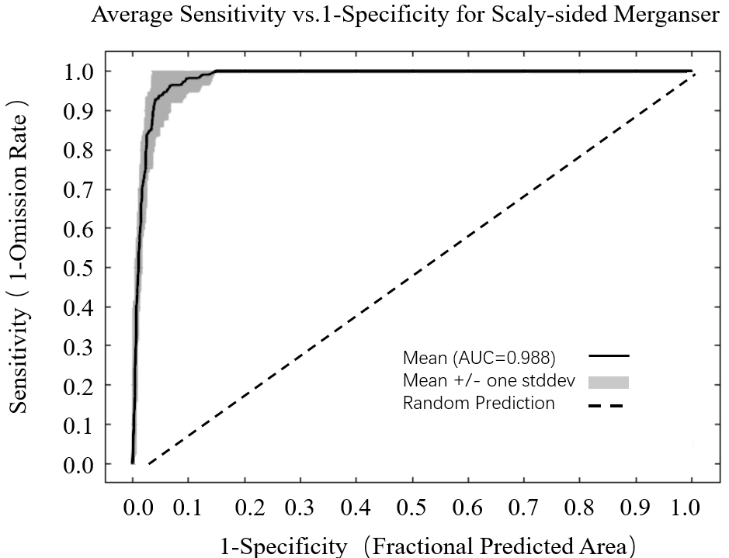

Figure S1. ROC curve of the MaxEnt prediction.
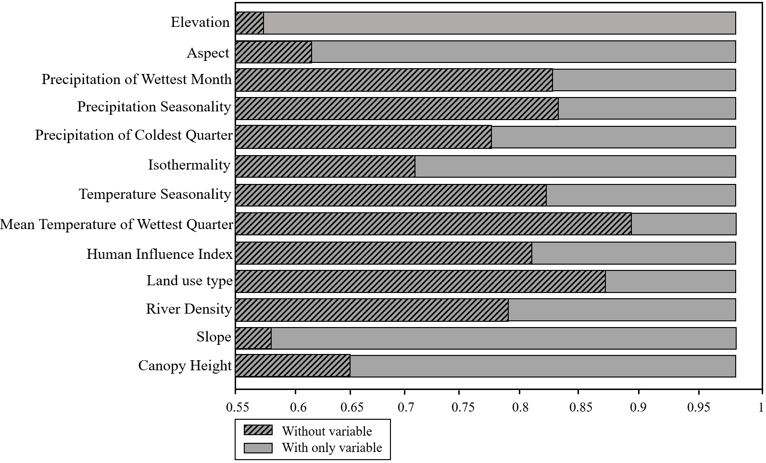
Figure S2. Results of the jackknife test of variable importance in the MaxEnt.

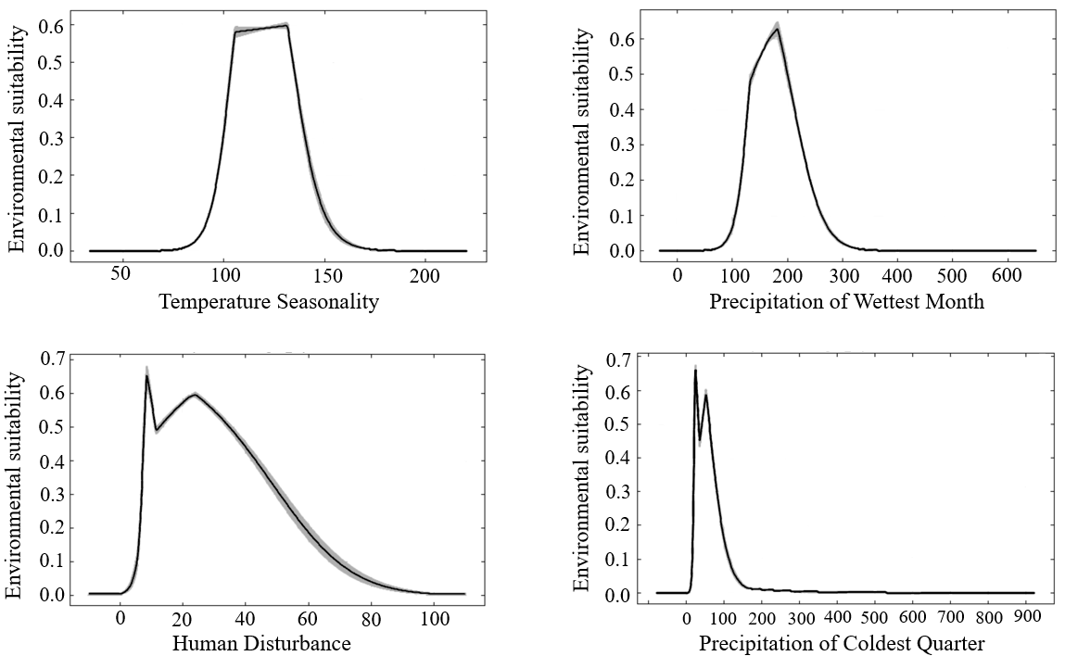

Figure S3. Response curves of the four highly influential variables.

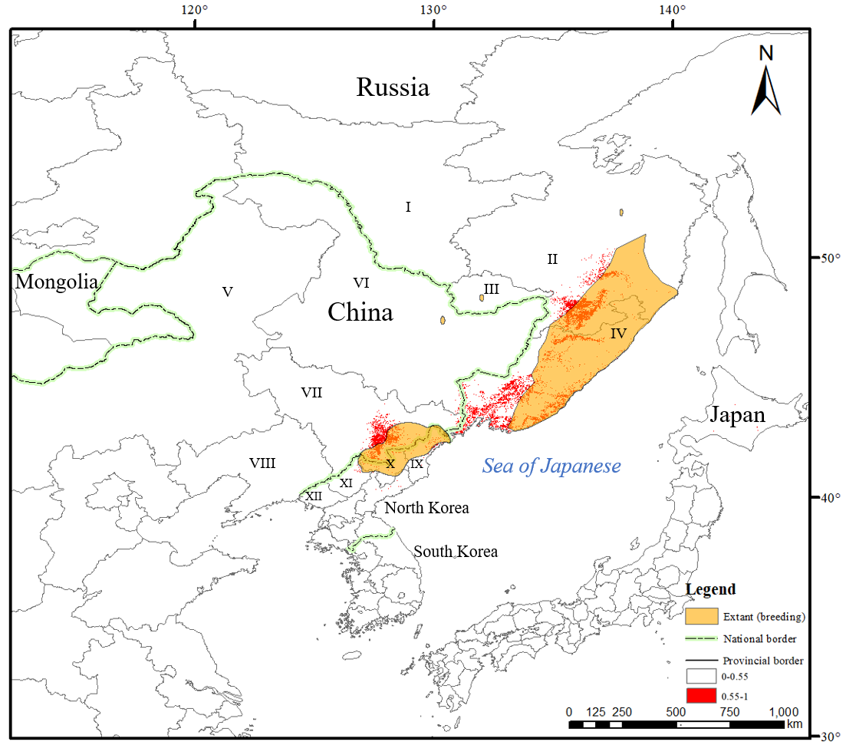
Figure S4. Predictive and known map (Solovyeva et al. 2014) identifying suitable habitats for breeding SSME in northeast Asia; I=Amurskaya Oblast; II= Khabarovsky Krai; III= Jewish Autonomous Oblast; IV= Primorsky Krai; V= Inner Mongolia; VI=Heilongjiang Province; VII=Jilin Province; VIII=Liaoning Province; IX = North Hamgyong; X= Ryanggang; XI= Chagang Province; XII= North Pyongan

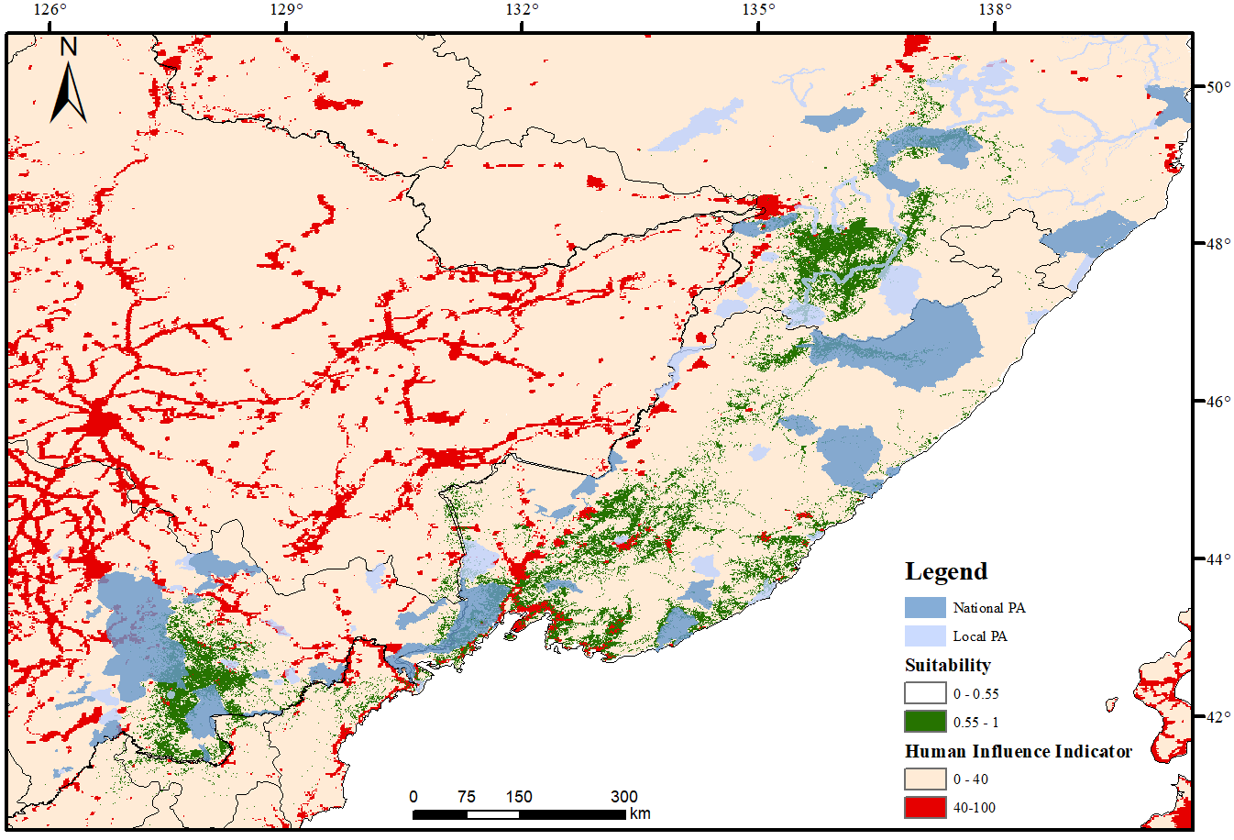
Figure S5. Conservation gaps and distribution of human influence in the highly suitable breeding habitats of the SSME in northeast Asia.

