**Supplementary Material**

The endangered Brown Shrike subspecies *Lanius cristatus superciliosus* has a male-biased sex ratio and only early arriving males are paired

HARUKA MIZUMURA, KOHEI KUBOTA and HIROYOSHI HIGUCHI

**Contents**

Table S1. Brown Shrike unpaired males (unpaired), pairs (pair), and total males (total) seen during each observation day from 2017–2019 by territory mapping.

Table S2. Brown Shrike unpaired males (unpaired), pairs (pair), and total males (total) seen during each observation day from 2018–2019 by roadside survey.

Table S3. Bull-headed Shrike unpaired males (unpaired), pairs (pair), and total males (total) seen each observation day between 2017 and 2018.

Figure S1. The study site.

Table S1. Brown Shrike unpaired males (unpaired), pairs (pair), and total males (total) seen during each observation day from 2017–2019 by territory mapping.

|  |  |  |  |  |  |  |  |  |  |  |  |  |  |  |  |  |  |  |  |  |  |  |
| --- | --- | --- | --- | --- | --- | --- | --- | --- | --- | --- | --- | --- | --- | --- | --- | --- | --- | --- | --- | --- | --- | --- |
|  |  | **May** | |  |  |  |  |  |  |  |  |  |  |  |  |  |  | **June** | |  | **July** | |
|  |  | **9** | **10** | **11** | **12** | **13** | **17** | **18** | **19** | **20** | **22** | **23** | **25** | **26** | **28** | **29** | **30** | **14** | **19** | **28** | **10** |  | |
| **2017** | **unpaired** | **0** |  | **1** |  |  |  | **0** |  |  |  |  |  |  |  |  | **0** |  |  | **0** |  |  | |
|  | **pair** | **1** |  | **1** |  |  |  | **1** |  |  |  |  |  |  |  |  | **1** |  |  | **0** |  |  | |
|  | **total** | **1** |  | **2** |  |  |  | **1** |  |  |  |  |  |  |  |  | **1** |  |  | **0** |  |  | |
| **2018** | **unpaired** |  |  | **0** | **1** | **0** |  | **0** |  |  | **0** | **1** |  | **0** |  | **0** |  |  |  |  |  |  | |
|  | **pair** |  |  | **2** | **0** | **1** |  | **1** |  |  | **1** | **0** |  | **0** |  | **0** |  |  |  |  |  |  | |
|  | **total** |  |  | **2** | **1** | **1** |  | **1** |  |  | **1** | **1** |  | **0** |  | **0** |  |  |  |  |  |  | |
| **2019** | **unpaired** |  | **0** |  |  |  | **0** |  | **2** | **1** |  |  | **2** |  | **1** |  |  | **1** | **1** |  | **1** |  | |
|  | **pair** |  | **1** |  |  |  | **2** |  | **1** | **0** |  |  | **0** |  | **0** |  |  | **0** | **0** |  | **0** |  | |
|  | **total** |  | **1** |  |  |  | **2** |  | **3** | **1** |  |  | **2** |  | **1** |  |  | **1** | **1** |  | **1** |  | |

We calculated the number of unpaired males and pairs each day and compiled them each season. To avoid overlap in counting territories, after the first recording of territory construction and pairing, we only recorded a status change from territory construction to pairing. Thus, after a territory of the unpaired male was recorded, only a newly formed territory of other male would be recorded (see Methods).

Table S2. Brown Shrike unpaired males (unpaired), pairs (pair), and total males (total) seen during each observation day from 2018–2019 by roadside survey.

|  |  |  |  |  |  |  |  |  |  |  |  |  |  |  |  |  |  |  |  |  |  |  |
| --- | --- | --- | --- | --- | --- | --- | --- | --- | --- | --- | --- | --- | --- | --- | --- | --- | --- | --- | --- | --- | --- | --- |
|  |  | **May** | |  |  |  |  |  |  |  |  |  |  |  |  |  |  | **June** | |  | **July** | |
|  |  | **9** | **10** | **11** | **12** | **13** | **17** | **18** | **19** | **20** | **22** | **23** | **25** | **26** | **28** | **29** | **30** | **14** | **19** | **28** | **10** |  | |
| **2018** | **unpaired** |  |  | **0** | **0** | **0** |  | **0** |  |  | **1** | **1** |  | **4** |  | **1** |  |  |  |  |  |  | |
|  | **pair** |  |  | **0** | **0** | **0** |  | **0** |  |  | **0** | **0** |  | **0** |  | **0** |  |  |  |  |  |  | |
|  | **total** |  |  | **0** | **0** | **0** |  | **0** |  |  | **1** | **1** |  | **4** |  | **1** |  |  |  |  |  |  | |
| **2019** | **unpaired** |  | **0** |  |  |  | **0** |  | **0** | **0** |  |  | **0** |  | **1** |  |  | **1** | **1** |  | **1** |  | |
|  | **pair** |  | **0** |  |  |  | **0** |  | **1** | **0** |  |  | **0** |  | **0** |  |  | **0** | **0** |  | **0** |  | |
|  | **total** |  | **0** |  |  |  | **0** |  | **1** | **0** |  |  | **0** |  | **1** |  |  | **1** | **1** |  | **1** |  | |

We calculated the number of unpaired males and pairs each day and compiled them each season. To avoid overlap in counting territories, after the first recording of territory construction and pairing, we only recorded a status change from territory construction to pairing. Thus, after a territory of the unpaired male was recorded, only a newly formed territory of other male would be recorded (see Methods).

Table S3. Bull-headed Shrike unpaired males (unpaired), pairs (pair), and total males (total) seen each observation day between 2017 and 2018.

|  |  |  |  |  |  |  |  |  |  |  |  |  |  |  |  |  |  |  |  |  |  |  |  |  |  |  |  |  |  |  |  |  |  |  |  |  |  |  |  |  |  |  |  |  |  |  |  |  |  |  |  |  |  |  |  |  |  |  |  |  |  |  |  |  |  |  |  |  |  |  |  |  |
| --- | --- | --- | --- | --- | --- | --- | --- | --- | --- | --- | --- | --- | --- | --- | --- | --- | --- | --- | --- | --- | --- | --- | --- | --- | --- | --- | --- | --- | --- | --- | --- | --- | --- | --- | --- | --- | --- | --- | --- | --- | --- | --- | --- | --- | --- | --- | --- | --- | --- | --- | --- | --- | --- | --- | --- | --- | --- | --- | --- | --- | --- | --- | --- | --- | --- | --- | --- | --- | --- | --- | --- | --- |
|  |  | | **April** | | | |  | |  | |  | |  | |  | **May** | | |  | |  | |  | |  | |  | |  | |  | |  | |  | |  | |  | |  | |  | |  | | **June** | | |  | |  | |  | |  | |  | |  | |  | |  | | **July** | | |  | |  | |
|  | |  | | **1** | **4** | **10** | | **19** | | **25** | | **26** | | **27** | | | **1** | **2** | | **4** | | **5** | | **7** | | **9** | | **11** | | **12** | | **16** | | **18** | | **24** | | **25** | | **26** | | **28** | | **30** | | **31** | | **1** | **2** | | **3** | | **9** | | **13** | | **15** | | **22** | | **28** | | **29** | | **30** | | **7** | **18** | | **25** | | **26** |
| **2017** | | **unpaired** | |  |  |  | | **3** | | **6** | |  | | **3** | | |  | **2** | |  | |  | | **6** | | **6** | | **2** | |  | | **2** | | **0** | | **0** | | **1** | |  | | **1** | | **0** | | **0** | | **0** |  | | **0** | | **0** | | **1** | |  | | **1** | | **1** | | **2** | |  | | **0** | **1** | | **1** | | **0** |
|  | | **pair** | |  |  |  | | **2** | | **2** | |  | | **0** | | |  | **1** | |  | |  | | **1** | | **0** | | **1** | |  | | **2** | | **1** | | **1** | | **0** | |  | | **2** | | **1** | | **4** | | **4** |  | | **6** | | **8** | | **1** | |  | | **2** | | **1** | | **1** | |  | | **1** | **1** | | **0** | | **1** |
|  | | **total** | |  |  |  | | **5** | | **8** | |  | | **3** | | |  | **3** | |  | |  | | **7** | | **6** | | **3** | |  | | **4** | | **1** | | **1** | | **1** | |  | | **3** | | **1** | | **4** | | **4** |  | | **6** | | **8** | | **2** | |  | | **3** | | **2** | | **3** | |  | | **1** | **2** | | **1** | | **1** |
| **2018** | | **unpaired** | | **1** | **6** | **0** | |  | |  | | **1** | | **8** | | | **2** | **5** | | **4** | | **2** | |  | | **0** | | **1** | | **3** | | **4** | |  | |  | |  | | **2** | |  | | **0** | |  | |  | **0** | |  | | **1** | |  | | **0** | | **1** | |  | |  | | **0** | |  |  | |  | |  |
|  | | **pair** | | **0** | **2** | **1** | |  | |  | | **2** | | **2** | | | **0** | **1** | | **3** | | **1** | |  | | **2** | | **2** | | **2** | | **1** | |  | |  | |  | | **0** | |  | | **2** | |  | |  | **1** | |  | | **3** | |  | | **2** | | **2** | |  | |  | | **1** | |  |  | |  | |  |
|  | | **total** | | **1** | **8** | **1** | |  | |  | | **3** | | **10** | | | **2** | **6** | | **7** | | **3** | |  | | **2** | | **3** | | **5** | | **5** | |  | |  | |  | | **2** | |  | | **2** | |  | |  | **1** | |  | | **4** | |  | | **2** | | **3** | |  | |  | | **1** | |  |  | |  | |  |

We calculated the number of unpaired males and pairs each day and compiled them each season. To avoid overlap in counting territories, after the first recording of territory construction and pairing, we only recorded a status change from territory construction to pairing. Thus, after a territory of the unpaired male was recorded, only a newly formed territory of other male would be recorded (see Methods).

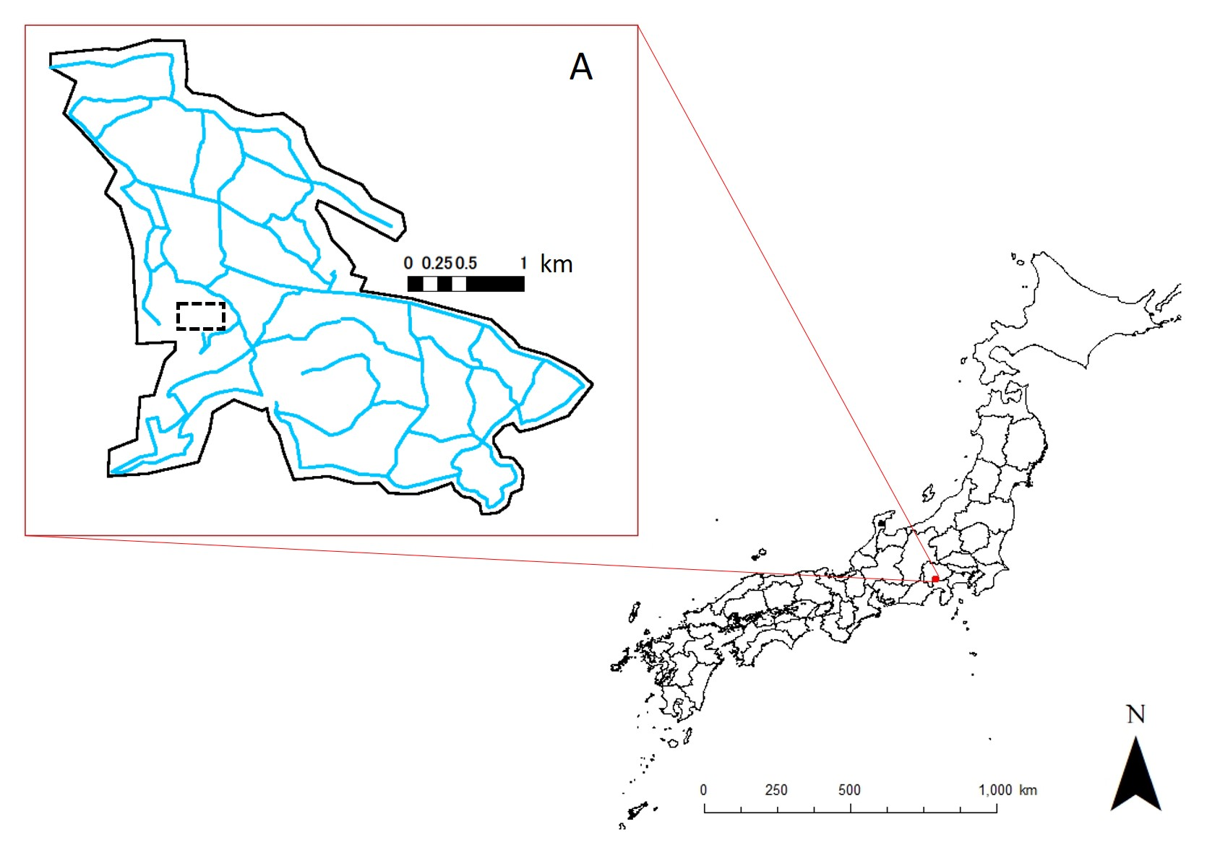

Figure S1. The study site (bold black polygon). The dashed rectangle shows the territory mapping survey area (18.8 ha), and the light blue lines show the observation routes by car (see Methods).