*Bird Conservation International*

**Online Supplementary Material**

Assessment of suitable habitats using satellite imagery : example of the Northern Bald Ibis *Geronticus eremita* in south-eastern Turkey

ANDRE SCHENKER

**Content**

Appendices S1-S3 show the areas around Derik, Yesilli and Yarbasi, each with a section from Google Earth Pro 2021. The potential breeding sites are indicated with the abbreviations Der, Yes and Yar together with information on altitude (1-3) and the extent of the cliffs (a-f) as indicated in Table 3.

**Appendix S1 :**Derik area, potential breeding sites (AS-211115), Google Earth 2021

**Appendix S2 :**Yesilli area, potential breeding sites (AS-211115), Google Earth 2021

**Appendix S3 :**Yarbasi area, potential breeding sites AS-211115), Google Earth 2021

**S1**

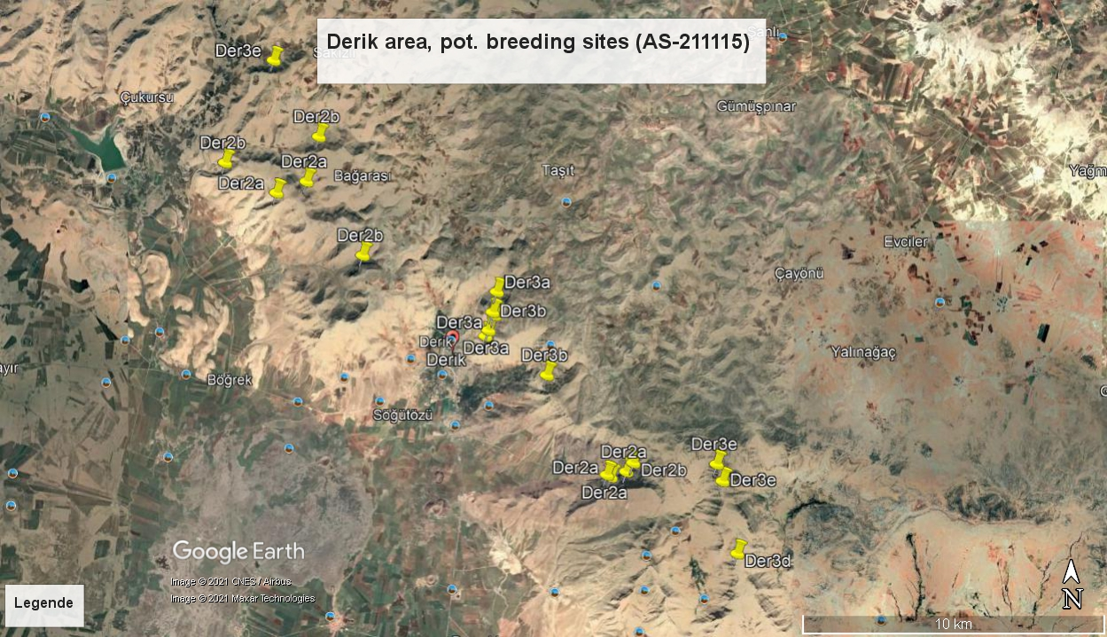

**S2**

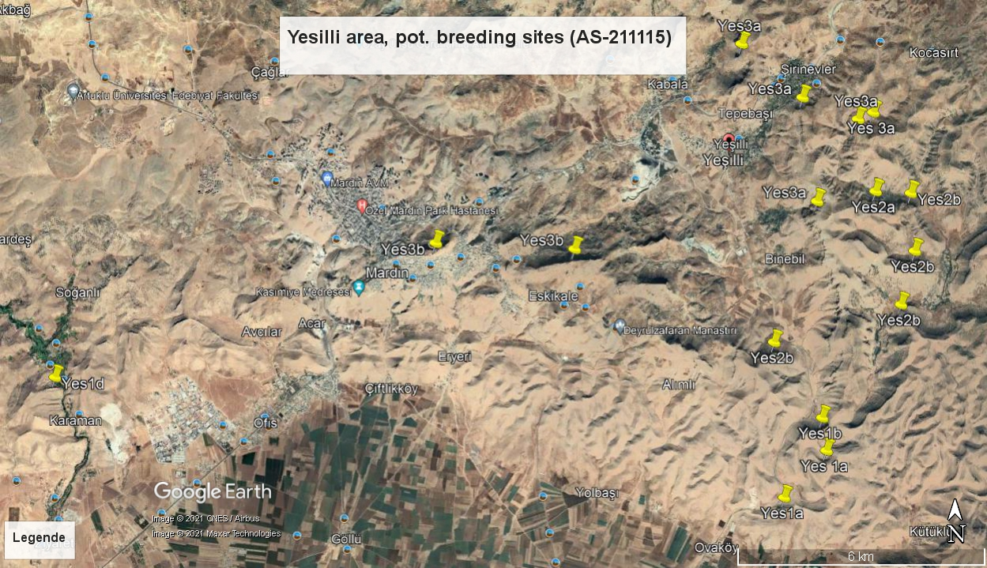

**S3**

