Table S1. Habitat and life-history traits of the 50 Melastomataceae species screened for the evolution of seed dormancy
Tribe | Species | Growth-form | Habitat | Dispersal | Phenology | Geographic distribution
Melastomeae | Acisanthera alsinaefolia | Shrub | Mesic | abiotic | Continuous | Endemic
Melastomeae | Acisanthera punctatissima** | Sub-shrub | Xeric | abiotic | Rainy-dry | Endemic
Melastomeae | Cambessedesia hilariana | Sub-Shrub | Xeric | abiotic | Continuous | Endemic
Microlicieae | Chaetostoma armatum* | Sub-Shrub | Xeric | abiotic | Rainy-dry | Widespread
Miconieae | Clidemia capitellata | Shrub | Xeric | biotic | Rainy | Widespread
Miconieae | Clidemia urceolata | Shrub | Xeric | biotic | Continuous | Widespread
Melastomeae | Comolia sertularia* | Shrub | Xeric | abiotic | Rainy-dry | Endemic
Melastomeae | Comolia sessilis | Shrub | Xeric | abiotic | Dry | Endemic
Microlicieae | Lavoisiera campos-portoana† | Shrub | Xeric | abiotic | Dry | Endemic
Microlicieae | Lavoisiera caryophyllea**† | Sub-shrub | Mesic | abiotic | Rainy-dry | Endemic
Microlicieae | Lavoisiera confertiflora | Sub-Shrub | Xeric | abiotic | Rainy | Endemic
Microlicieae | Lavoisiera cordata† | Shrub | Xeric | abiotic | Dry | Endemic
Microlicieae | Lavoisiera imbricata | Shrub | Mesic | abiotic | Rainy | Endemic
Microlicieae | Lavoisiera pulcherrima | Shrub | Mesic | abiotic | Dry | Endemic
Microlicieae | Lavoisiera subulata† | Sub-Shrub | Mesic | abiotic | Dry | Endemic
Miconieae | Leandra aurea | Shrub | Xeric | biotic | Rainy | Widespread
Miconieae | Leandra coriacea | Shrub | Xeric | Biotic | Rainy | Widespread
Microlicieae | Lithobium cordatum**† | Sub-Shrub | Xeric | abiotic | Rainy-dry | Endemic
Melastomeae | Macairea radula | Shrub | Mesic | abiotic | Rainy | Widespread
Melastomeae | Marcetia taxifolia | Shrub | Xeric | abiotic | Dry | Widespread
Merianeae | Merianthera sipolisii | Tree | Xeric | abiotic | Rainy-dry | Endemic
Miconieae | Miconia albicans | Shrub | Xeric | biotic | Rainy | Widespread
Miconieae | Miconia alborufescens | Shrub | Xeric | biotic | Rainy | Endemic
Miconieae | Miconia cipoensis† | Shrub | Xeric | biotic | Rainy | Endemic
Miconieae | Miconia chamissois | Shrub | Mesic | biotic | Rainy | Widespread
Miconieae | Miconia corallina* | Shrub | Xeric | biotic | Rainy-dry | Widespread
Miconieae | Miconia elegans | Tree | Mesic | biotic | Rainy | Widespread
Miconieae | Miconia ferruginata | Tree | Xeric | biotic | Dry-rainy | Widespread
Miconieae | Miconia ibaguensis | Shrub | Mesic | biotic | Rainy | Widespread
Miconieae | Miconia irwinii | Tree | Xeric | biotic | Dry | Endemic
Miconieae | Miconia ligustroides | Shrub | Xeric | biotic | Rainy-dry | Widespread
Miconieae | Miconia stenostachya | Shrub | Xeric | biotic | Rainy | Widespread
Miconieae | Miconia rubiginosa | Tree | Xeric | biotic | Rainy | Widespread
Miconieae | Miconia theaezans | Shrub | Mesic | biotic | Rainy-dry | Widespread
Microlicieae | Microlicia avicularis** | Sub-Shrub | Xeric | abiotic | Dry | Endemic
Microlicieae | Microlicia fulva | Sub-Shrub | Xeric | abiotic | Dry | Widespread
Microlicieae | Microlicia graveolens | Sub-Shrub | Mesic | abiotic | Dry | Endemic
Microlicieae | Microlicia sp** | Sub-Shrub | Xeric | abiotic | Rainy-dry | Endemic
Microlicieae | Microlicia sp2** | Sub-Shrub | Xeric | abiotic | Dry | Endemic
Microlicieae | Microlicia tetrasticha** | Sub-Shrub | Xeric | abiotic | Rainy-dry | Endemic
Melastomeae | Pterolepis alpestris | Sub-Shrub | Mesic | abiotic | Dry-rainy | Endemic
Microlicieae | Rhynchanthera cordata | Shrub | Mesic | abiotic | Dry-rainy | Widespread
Microlicieae | Rhynchanthera grandiflora | Shrub | Mesic | abiotic | Rainy | Widespread
Melastomeae | Tibouchina candolleana | Tree | Mesic | abiotic | Rainy | Widespread
Melastomeae | Tibouchina cardinalis* | Shrub | Xeric | abiotic | Rainy-dry | Endemic
Melastomeae | Tibouchina heteromalla | Shrub | Xeric | abiotic | Continuous | Widespread
Melastomeae | Tibouchina martiusiana | Shrub | Xeric | abiotic | Dry-rainy | Widespread
Melastomeae | Tibouchina sp. | Tree | Xeric | abiotic | Dry | Endemic
Microlicieae | Trembleya laniflora | Shrub | Xeric | abiotic | Dry-rainy | Endemic
Microlicieae | Trembleya parviflora | Shrub | Mesic | abiotic | Rainy | Endemic
* Denotes species with confirmed seed dormancy.
** Denotes likely dormant species.
† Included in the list of rare plants of Brazil or threatened by extinction by Red Lists.
Phylogenetic reconstruction method
For understanding the evolution of seed dormancy in Melastomataceae, a phylogenetic tree showing relationships among the studied taxa was built. Nomenclature was checked against the Missouri Botanical Garden’s nomenclatural database (http://www.tropicos.org/Home.aspx) and a pruned tree was built with the study species as terminal tips using the maximally resolved tree with the use of Phylomatic (http://www.phylodiversity.net/phylomatic/).
The occurrence of several polytomies in our tree may prevent the correct interpretation of the evolution of seed dormancy. However, most polytomies were in terminal taxa and thus, considered soft polytomies (Webb et al., 2006), which are likely to cause low interference in interpretation. Polytomies in the tree were resolved by randomly generating 50 fully resolved trees using Mesquite (Maddison and Maddison, 2008). Species relationships were improved and polytomies were resolved based on available and published data for the taxa relationships in the family (Renner, 1993; Clausing and Renner, 2001; Fritsch et al., 2004; Goldenberg et al., 2008; Michelangeli et al., 2008). Unpublished theses were also used to determine relationships at generic and specific levels.

Seed anatomy and histochemistry
Seeds of the four species were fixed in formalin–acetic acid–50% ethanol (Johansen, 1940) for 48 h, including 24 h with a vacuum passage. Seeds were kept in Franklin solution (glacial acetic acid and hydrogen peroxide 30%, 1:1 v/v) for 4–10 h at 60°C until clearing (Franklin, 1945, modified). The samples were washed in running tap water to remove the solution, and seeds were dehydrated in an increasing ethanol series (10, 20, 30, 40, 50, 60, 70%) with 1% glycerine. Seeds were stored in ethanol 70% + 1% glycerine for 3 d and then another ethanol series (80, 90 and 95%) was carried out. The seeds were infiltrated in the refrigerator at 4°C for a week and embedded in 2(hydroxy-ethyl)-methacrylate (Leica™). The samples were kept in the embedding solution for another week in a freezer (–20ºC), according to Paiva et al. (2011).
Longitudinal and transverse sections with 6 µm thickness were prepared with a rotary microtome (Jung Biocut mod. 2035). The sections were stained with toluidine blue 0.05%, pH 4.7 (O’Brien et al., 1964, modified) and mounted in Entellan™.
Histochemical tests were carried out in order to detect phenolics in the seed coat of the studied species. Tests were prepared on the 6 μm sections by using 10% aqueous ferric chloride plus a little sodium carbonate, or by ﬁxing in aqueous solution formalin and 10% ferrous sulphate (Johansen, 1940) and toluidine blue (Briggs et al. 2005).
Mature seeds are exarillate and exalbuminous (Fig. S1A). In all species, the embryos are well developed, filling the whole seed and showing a conspicuous embryonic axis and two fleshy cotyledons. In Chaetostoma (Fig. S1B), Comolia (Fig. S1C) and Tibouchina (Fig. S1D), the embryo is curved, following the shape of the seeds, while the embryo of Miconia (Fig. S1A) is folded, with cotyledons parallel to the embryo axis.
The cotyledons are symmetrical and well developed, and the hypocotyls–radicle axis varies from one (Tibouchina) to three (Chaetostoma) times the length of the cotyledons. The embryo has uniseriate protoderm (Fig. S1E), with small cells, cuboidal in longitudinal section. These cells have pectic–cellulosic walls, dense cytoplasm and evident nuclei. The ground meristem is composed by approximately isodiametric cells larger than the protoderm. The procambium has slightly longitudinally elongated cells in a standard organization (Fig. S1D). The radicle is short and hardly distinguishable from the hypocotyl (Fig. S1A–D). Its apex has standard organization. The cotyledon node is relatively large and the epicotyl is indistinct. The plumule is undifferentiated, consisting of only the shoot meristem (Fig. S1D).
In the seed coat of all four species, the epidermis is uniseriate (Chaetostoma, Comolia and Tibouchina) or multiseriate (Miconia). The epidermis in the seed coat contains dead cells with walls that are thin in Chaetostoma (Fig. S1B, E–F), irregular and thick in Comolia (Fig. S1C) and homogeneous and thick in Miconia (Fig. S1A, H) and Tibouchina (Fig. S1D, I). Phenolic compounds were observed in all seed coats, in cell walls (Fig. S1E–F, H) or in the vacuoles (Fig. S1G, I). Parenchymic layers occur in the inner epidermis, which can be distinguishable in Miconia and Tibouchina by the presence of protoplast remains. In the other species, the parenchyma in the seed coat is completely compressed. In the raphe, the parenchyma is multi-layered (Fig. S1B).
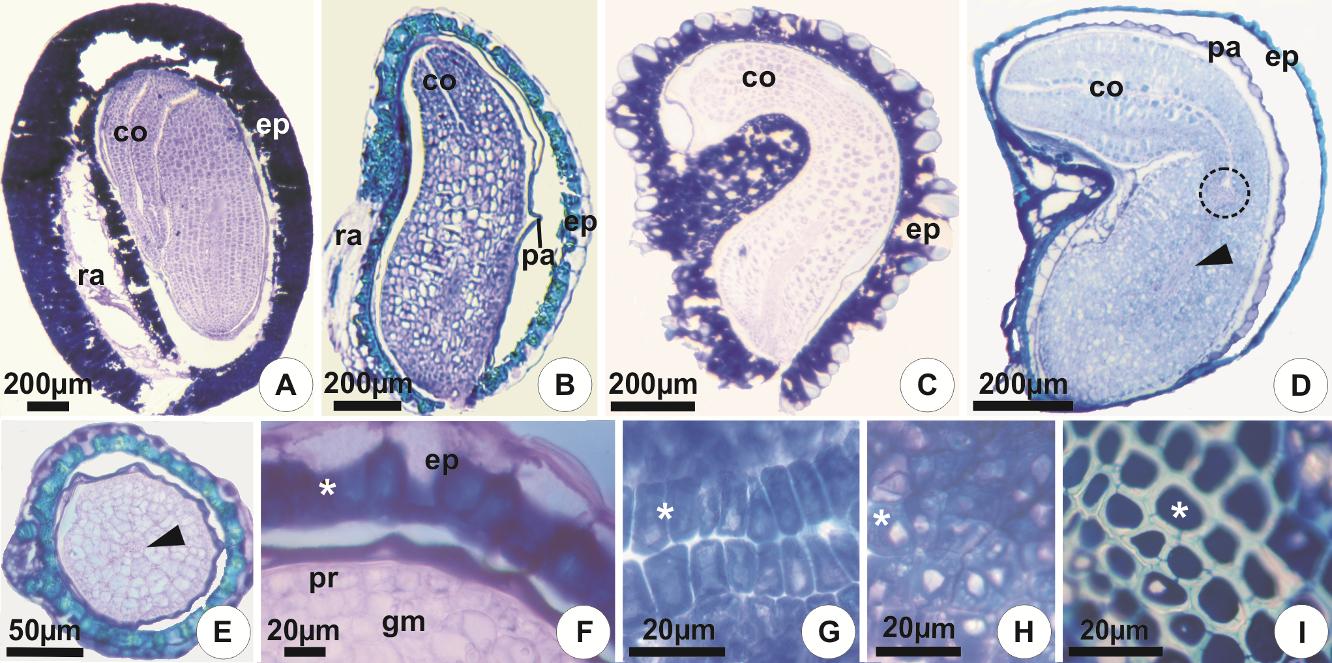
Figure S1. Longitudinal (A–D, G–I) and transverse (E–F) sections of dormant seeds. (A, H) Miconia corallina; (B, E–F) Chaetostoma armatum; (C, G) Comolia sertularia; (D, I) Tibouchina cardinalis (circle, shoot meristem). Asterisk, phenolic compounds; arrowhead, procambium; co, cotyledon; ep, epidermis; gm, ground meristem; pa, parenchyma; pr, protoderm; ra, raphe.

References
Briggs, C.L., Morris, E.C. and Ashford, A.E. (2005) Investigations into seed dormancy in Grevillea linearifolia, G. buxifolia and G. sericea: anatomy and histochemistry of the seed coat. Annals of Botany 96, 965–980.
Clausing, G. and Renner, S.S. (2001) Molecular phylogenetics of Melastomataceae and Memecylaceae: implications for character evolution. American Journal of Botany 88, 486–498.
Franklin, G.L. (1945) Preparation of thin sections of synthetic resins and wood-resin composites, and a new macerating method for wood. Nature 155, 51.
Fritsch, P.W., Almeda, F., Renner, S.S., Martins, A.B. and Cruz, B.C. (2004) Phylogeny and circumscription of the near-endemic Brazilian tribe Microlicieae (Melastomataceae). American Journal of Botany 91, 1105–1114.
Goldenberg, R., Penneys, D.S., Almeda, F., Judd, W.S. and Michelangeli, F.A. (2008) Phylogeny of Miconia (Melastomataceae): patterns of diverse in a megadiverse Neotropical genus. International Journal of Plant Sciences 169, 963–979.
Johansen, D.A. (1940) Plant microtechnique. New York, McGraw-Hill Book.
Maddison, W.P. and Maddison, D.R. (2008) Mesquite: A modular system for evolutionary analysis. Version 2.5. Available at website http://mesquiteproject.org (accessed 22 September 2011).
Michelangeli, F.A., Judd, W.S., Penneys, D.S., Skean, D., Becquer, E.R., Goldenberg, R. and Martin, C.V. (2008) Multiple events of dispersal and radiation of the tribe Miconieae (Melastomataceae) in the Caribbean. The Botanical Review 74, 53–77.
O’Brien, T.P., Feder, N. and McCully, M.E. (1964) Polychromatic staining of plant cell walls by toluidine blue O. Protoplasma 59, 368–373.
Paiva, E.A.S, Pinho, S.Z. and Oliveira, D.M.T. (2011) Large plant samples: how to process for GMA embedding? pp. 37–49 in Chiarini-Garcia, H. and Melo, R.C.N. (Eds) Light microscopy: methods and protocols. New York, Spinger/Humana Press.
Renner, S.S. (1993) Phylogeny and classification of the Melastomataceae and Memecylaceae. Nordic Journal of Botany 13, 519–540.
Webb, C.O., Ackerly, D.D. and Kembel, S.W. (2006) Phylocom: software for the analysis of community phylogenetic structure and trait evolution. Version 4.0. Available at website http://www.phylodiversity.net/phylocom (accessed 22 September 2011).

