Supplementary Fig. S1. Relationships of the number of seeds in the largest clump of an individual run and the estimated velocity in 28 orchid species. Note the logarithmic scales. The results of the linear regression analyses are given in supplementary Table S1. In the case of *Dimerandra emarginata*, three different batches are combined.

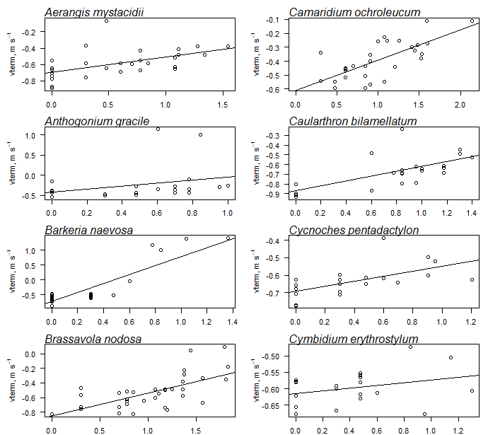

Log (seed group size)

Fig. 1s.cont.

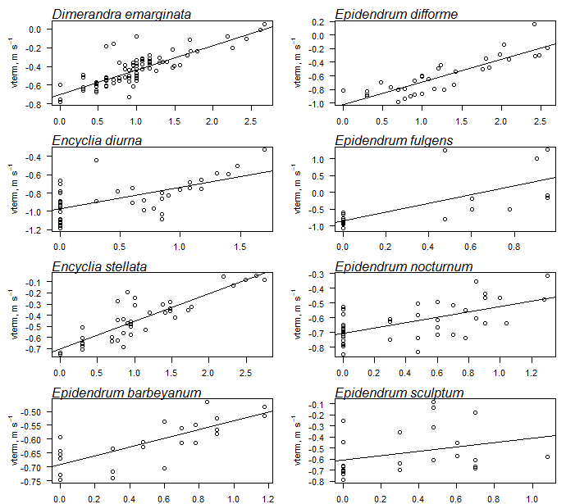

Log (seed group size)

Fig. 1s.cont.

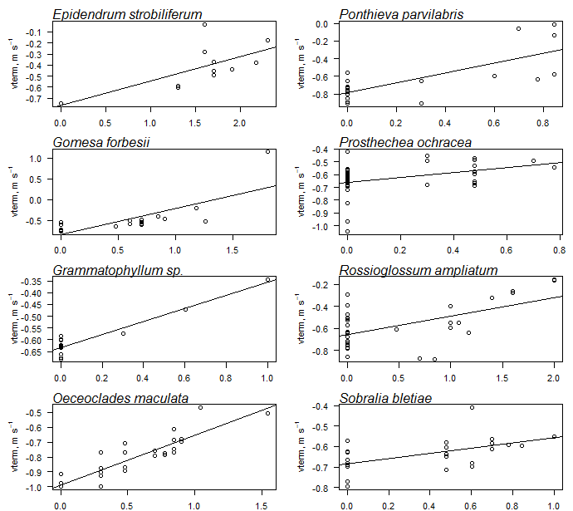

Log (seed group size)

Fig. 1s.cont.

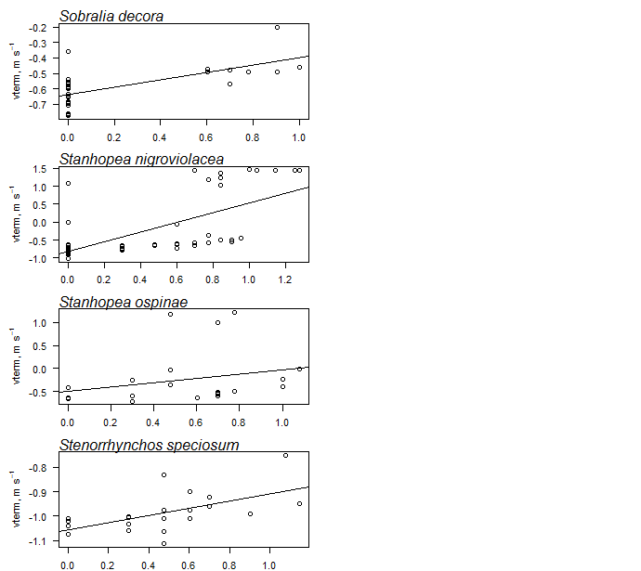

Log (seed group size)

Supplementary Table S1. Details of the regression equations as shown in supplementary Fig. S1 of the relationship of the number of seeds in the largest clump of an individual measurement and the estimated velocity in the 28 orchid species, in which seeds usually fell in clumps. In the case of *Dimerandra emarginata* there are three independent batches.

|  |  |  |
| --- | --- | --- |
| Species | Regression equation | R2 |
| *Aerangis mystacidii* | y = 0.203x0.183 | 0.27 |
| *Anthogonium gracile* | y = 0.390x0.179 | 0.14 |
| *Barkeria naevosa* | y = 0.223x0.751 | 0.79 |
| *Brassavola nodosa* | Y = 0.145x0.316 | 0.43 |
| *Camaridium ochroleucum* | y = 0.24x0.217 | 0.51 |
| *Caularthron bilamellatum* | y = 0.135x0.250 | 0.43 |
| *Cycnoches pentadactylon* | y = 0.203x0.144 | 0.36 |
| *Cymbidium erythrostylum* | y = 0.243x0.042 | 0.09 |
| *Dimerandra emarginata* (1) | y = 0.190x0.315 | 0.62 |
| *Dimerandra emarginata* (2) | y = 0.168x0.288 | 0.91 |
| *Dimerandra emarginata* (3) | y = 0.1816x0.38 | 0.33 |
| *Encyclia diurna* | y = 0.106x0.237 | 0.4 |
| *Encyclia stellata* | y = 0.197x0.248 | 0.75 |
| *Epidendrum barbeyanum* | y = 0.204x0.157 | 0.56 |
| *Epidendrum difforme* | y = 0.095x0.333 | 0.74 |
| *Epidendrum fulgens* | y = 0.143x0.866 | 0.71 |
| *Epidendrum nocturnum* | y = 0.198x0.180 | 0.39 |
| *Epidendrum sculptum* | y = 0.248x0.194 | 0.09 |
| *Epidendrum strobiliferum* | y = 0.145x0.258 | 0.49 |
| *Gomesa forbesii* | y = 0.185x0.353 | 0.71 |
| *Grammatophyllum* sp. | y = 0.232x0.278 | 0.90 |
| *Oeceoclades maculata* | y = 0.120x0.334 | 0.74 |
| *Ponthieva parvilabris* | y = 0.165x0.561 | 0.57 |
| *Prosthechea ochracea* | y = 0.219x0.192 | 0.22 |
| *Rossioglossum ampliatum* | y = 0.156x0.276 | 0.66 |
| *Sobralia bletiae* | y = 0.207x0.126 | 0.29 |
| *Sobralia decora* | y = 0.236x0.309 | 0.43 |
| *Stanhopea nigroviolacea* | y = 0.165x0.765 | 0.51 |
| *Stanhopea ospinaea* | y = 0.283x0.318 | 0.13 |
| *Stenorrhynchos speciosum* | y = 0.088x0.147 | 0.37 |