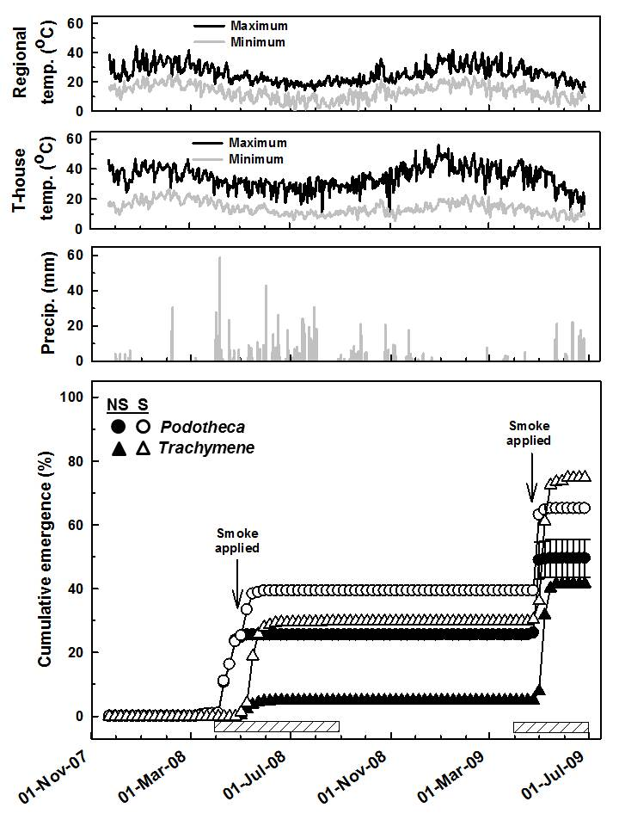**Figure S1.** Temperatures from a regional weather station (Perth, Western Australia) and from a tunnel-house, regional total daily precipitation, and emergence of seedlings from two fire ephemerals.

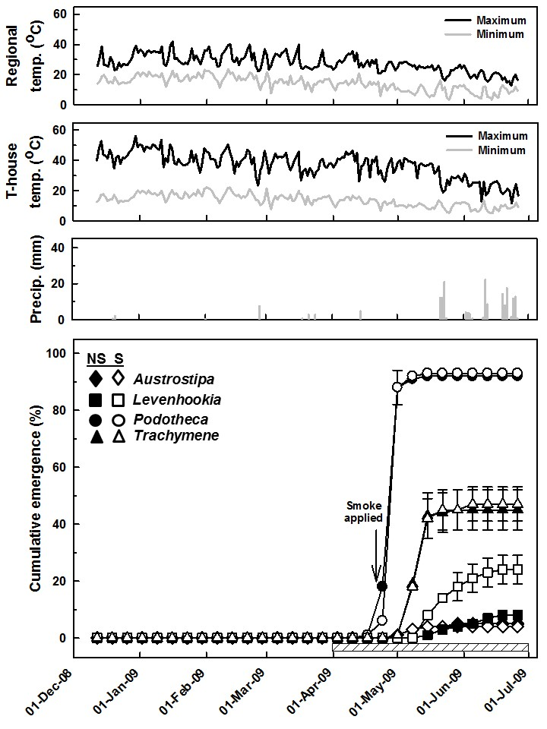**Figure S2.** Temperatures from a regional weather station (Perth, Western Australia) and from the tunnel-house, regional total daily precipitation, and emergence of seedlings from four fire ephemerals.