Supporting information

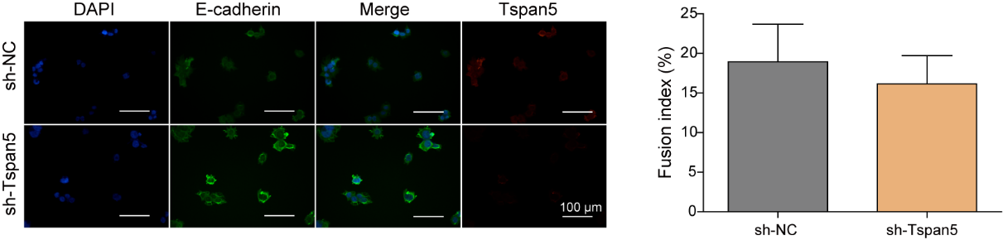

**Figure S1** Fusion of BeWo cells and EMT-related factors were detected after knockdown of Tspan5.