Figure 1
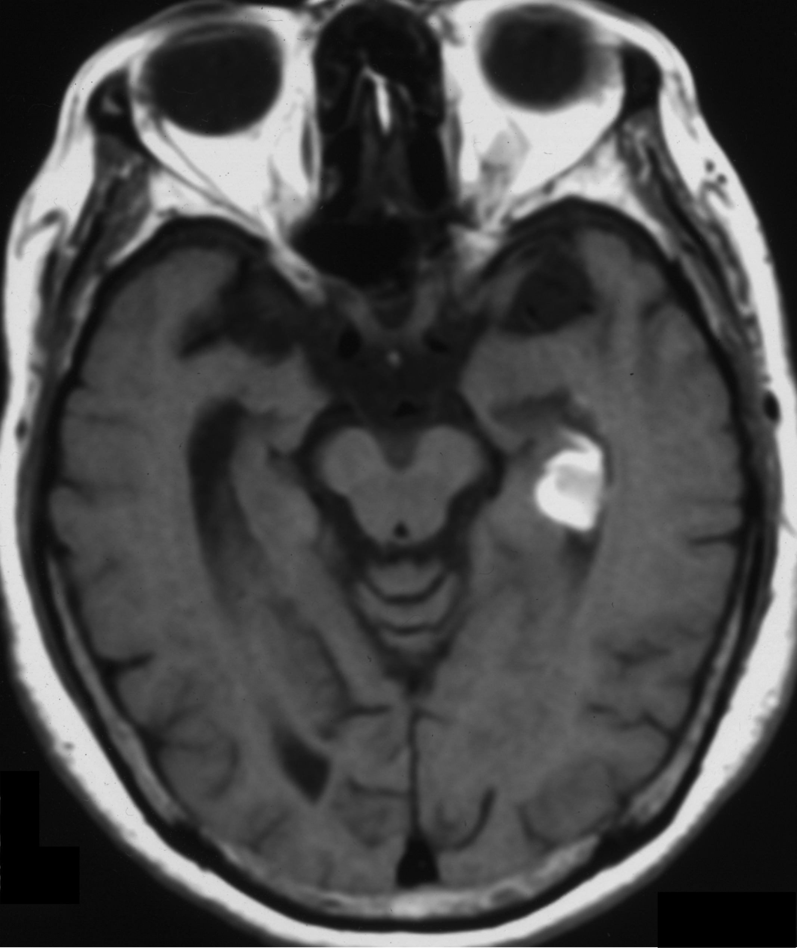
T1-weighted magnetic resonance imaging of the brain shows abnormal hyperintensity of a localized region adjacent to hippocampus in the left medial temporal lobe.

