Figure 1a. Ratio of IL-6 release with LPS stimulation to IL-6 release without LPS stimulation, +/- A-β₁₋₄₂ 20 υg/ml, vs. category fluency (animals).

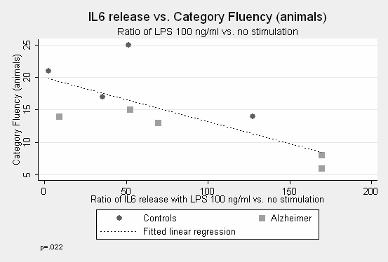

Figure 1b. Ratio of IL-6 release with LPS stimulation to IL-6 release without LPS stimulation, +/- Aβ₁₋₄₂ 20 υg/ml, vs. NPI Total.

