Supplementary Figure 2. Word file (145 KB)
Summary text: Six graphs showing the relationship between MMSE score and (a) ADL total scores (b) BADL scores and (c) IADL scores, and the ADL subdomains: basic activities (d), domestic/household activities (e), communication/engagement with the environment activities (f) and outside activities (g) at GERAS baseline visit.

Supplementary Figure 2. Relationship between MMSE score and (a) ADL total scores (b) BADL scores and (c) IADL scores, and the ADL subdomains: basic activities (d), domestic/household activities (e), communication/engagement with the environment activities (f) and outside activities (g) at GERAS baseline visit. ADCS-ADL = Alzheimer’s Disease Cooperative Study – Activities of Daily Living Scale; BADL = basic activities of daily living; IADL = instrumental activities of daily living; MMSE = Mini-Mental State examination.

- Total ADL score = 11.19 (intercept) + 2.03 (slope) MMSE score (R² = 0.44) (total ADL score can be calculated as 11.19 when the MMSE score is zero; for every 1 point increase in MMSE the ADL score increases by 2.03)
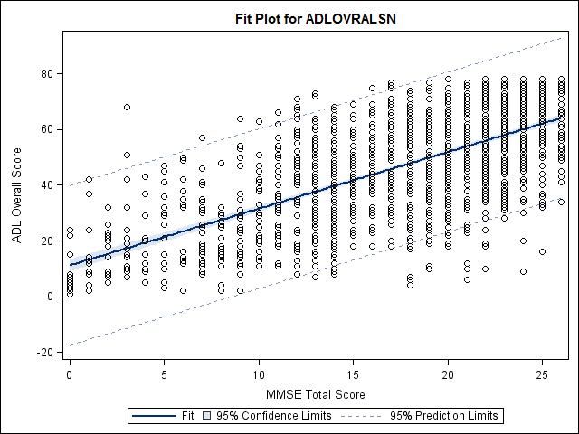
(b) BADL score = 8.62 + 0.50 MMSE score (R² = 0.37)
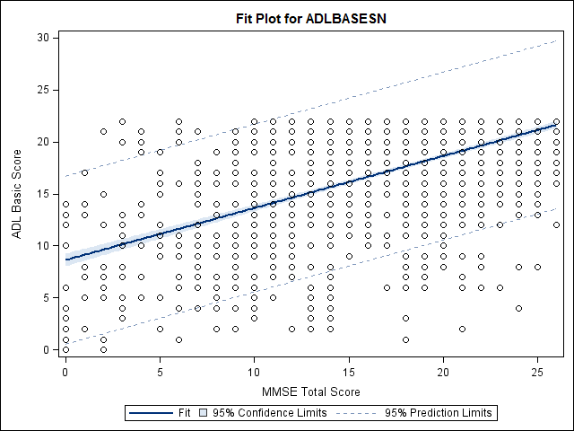
(c) IADL score = 2.41 + 1.54 MMSE (R² = 0.41)
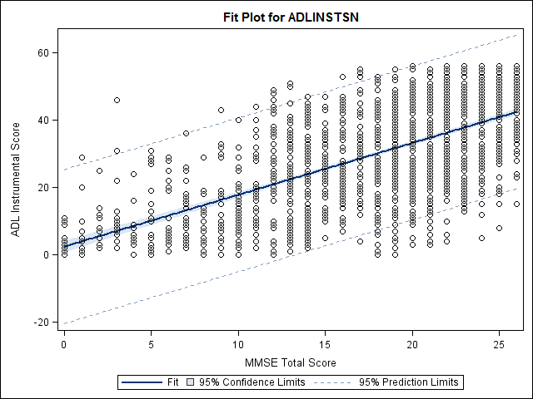
(d) Basic activities score = 8.25 + 0.41 MMSE (R² = 0.37)
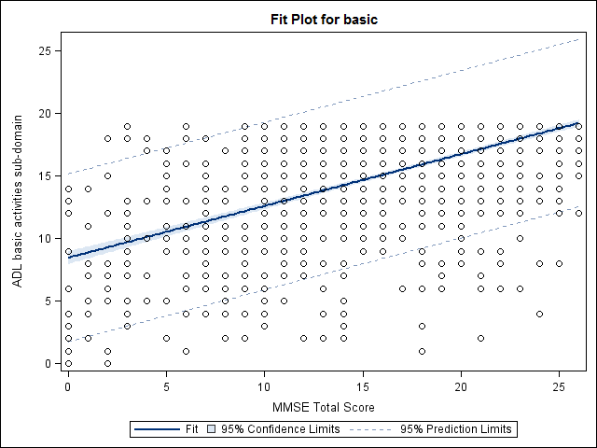
(e) Domestic/household score = 1.21 + 0.82 MMSE (R² = 0.34)
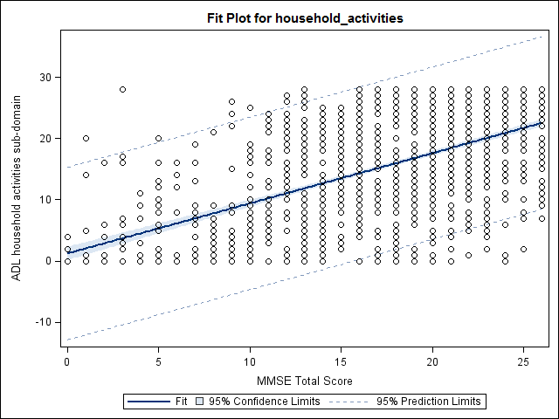
(f) Communication/engagement with the environment score = 0.09 + 0.51 MMSE (R² = 0.36)
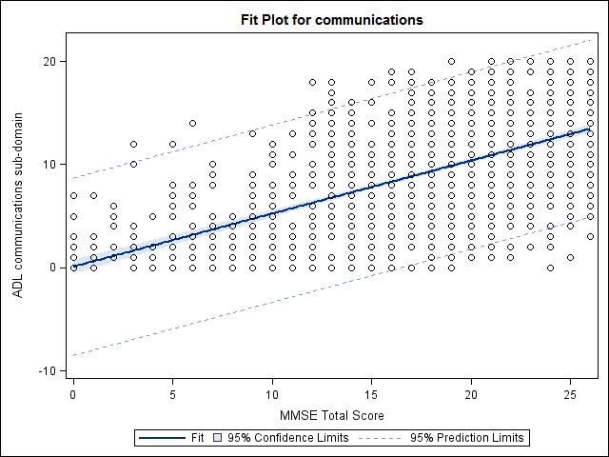
(g) Outside activities score = 1.37 + 0.27 MMSE (R² = 0.27)
