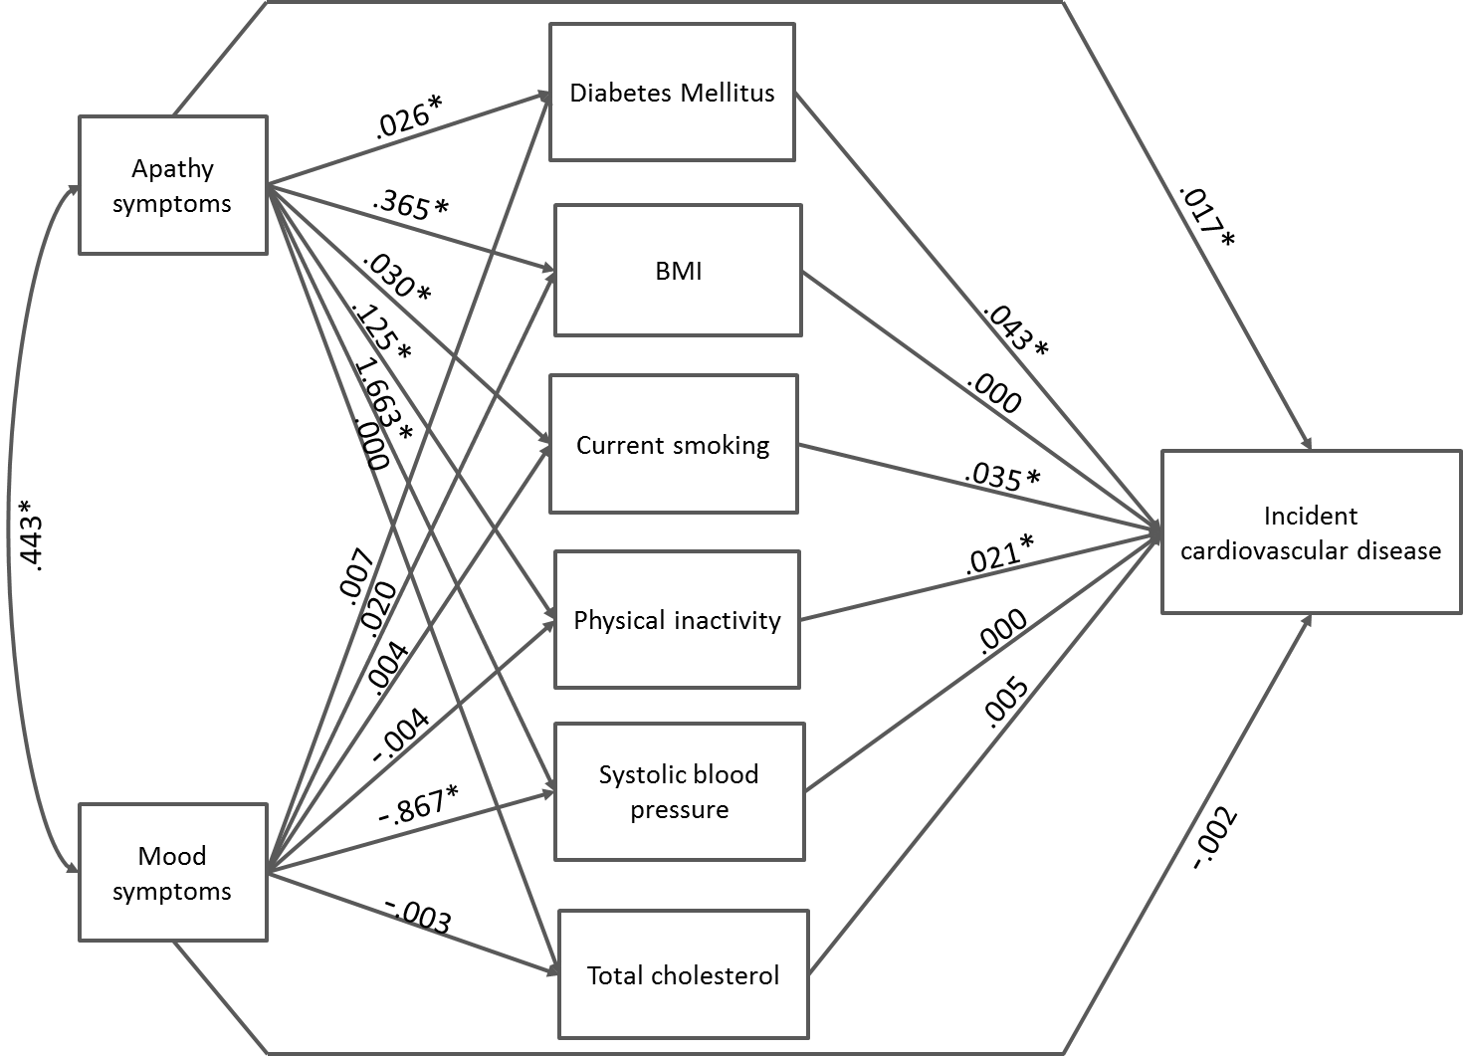

Figure S2. Unstandardized path coefficients for the relationships between baseline apathy and mood symptoms, cardiovascular risk factors, and incident cardiovascular disease after two years of follow-up in the 1790 study participants. The relation between apathy and mood symptoms is expressed as a correlation. Age, gender, level of education, and treatment status are included as covariates for all endogenous variables and are correlated with apathy and mood symptoms (not shown). Error terms of all cardiovascular risk factors are correlated with each other (not shown). *Paths significant at the p≤.05 level. BMI = body mass index.

