Supplementary Material
Table of contents

 | Page
Edge weights matrix of estimated network (Table S1) | 2
Unstandardized values of centrality measures (Figure S1) | 3
Network stability (Appendix A1) | 4
- Stability of centrality indices (Figure S2) | 4
- Bootstrapped 95% confidence intervals of estimated edge weights (Figure S3) | 5
- Bootstrapped difference tests between non-zero edge weights (Figure S4) | 6
- Bootstrapped difference tests on node strength (Figure S5) | 7
- Bootstrapped difference tests on node closeness (Figure S6) | 8
- Bootstrapped difference tests on node betweenness (Figure S7) | 9
References | 10

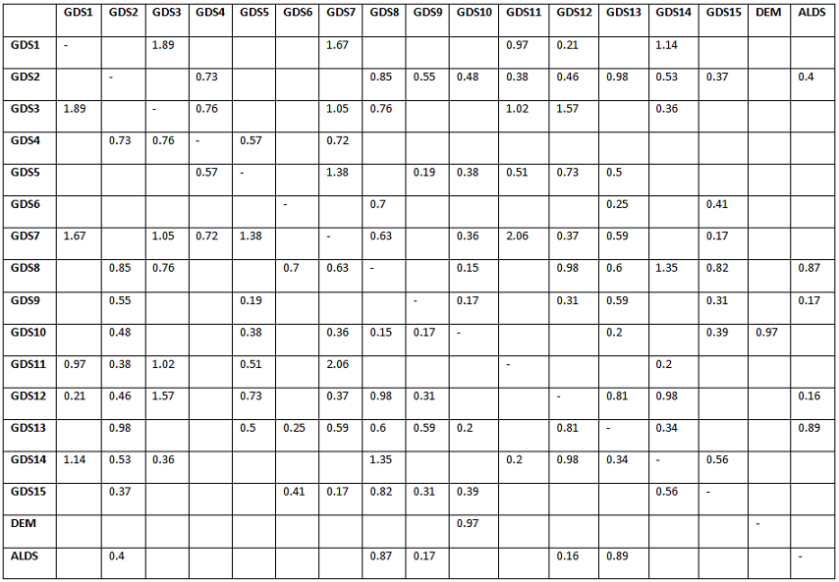
Table S1: Edge weights matrix of the GDS items, ALDS score and dementia follow-up

up.

Abbreviation | Meaning
GDS1 | Unsatisfied
GDS2 | Dropping activities
GDS3 | Life empty
GDS4 | Often bored
GDS5 | Bad spirits
GDS6 | Afraid
GDS7 | Unhappy
GDS8 | Helpless
GDS9 | Staying at home
GDS10 | Memory problems
GDS11 | Awful being alive
GDS12 | Worthless
GDS13 | Lack of energy
GDS14 | Hopeless
GDS15 | Others better off
DEM | Dementia at follow-up
ALDS | Decreased functional ability

*Numbers reflect the edge weights between two nodes. Blanks indicate two nodes are not connected in the sparse network. Abbreviations: GDS = Geriatric Depression Scale; ALDS = Decreased functional ability measured using the Academic Medical Center Linear Disability Scale; DEM = Dementia at follow-up

Figure S1 : Unstandardized values of centrality measures.

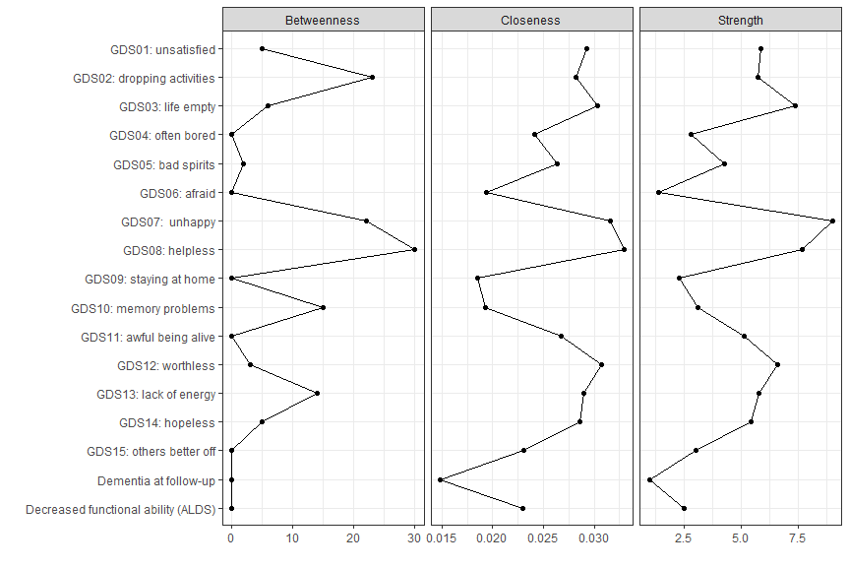

Appendix A1 on methods: Network stability
To assess the stability of the network we used two bootstrapping methods implemented in the R package “bootnet” (Epskamp et al., 2017; Epskamp and Fried, 2017). At first a case-dropping subset bootstrap was used, in which 1000 subsets of rows were used to estimate the network and its parameters. With this method the stability of centrality indices was checked, which were then quantified by calculating correlation stability coefficients between centrality indices obtained for the full network with those obtained for networks of subsets of the data.
Strength and closeness reached high values, meaning the direct and indirect connectivity in the network can be replicated well by running the analysis over samples of the study population (Figure S2). Betweenness has a lower correlation stability, which implies it is less certain which items are most important in connecting other nodes with each other. Correlation stability for strength was 0.75, which means that 75% of the cases could be dropped to retain a correlation of at least 0.7 with the original strength parameter when applying a significance level of 0.05. For closeness this correlation stability was 0.44, and for betweenness 0.28.
Figure S2: Stability of centrality indices of the estimated network

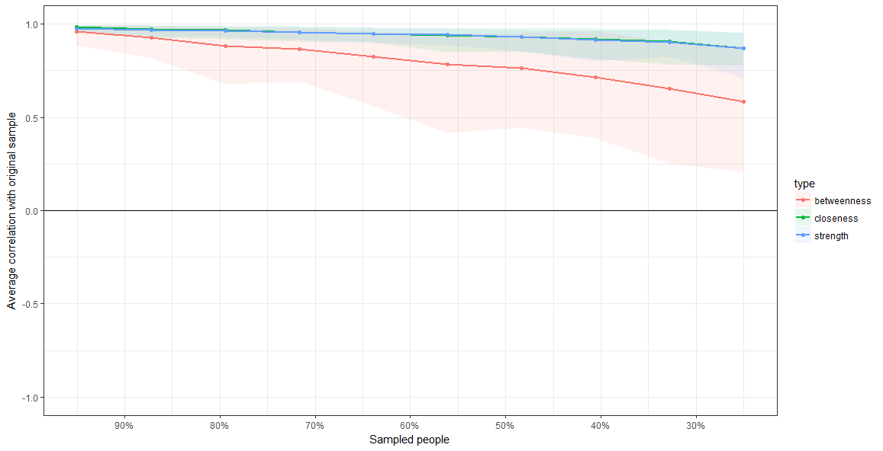
Secondly, we used a non-parametric bootstrap, in which data rows are resampled with replacement, to investigate the accuracy of the network by assessing sampling variability in edge-weights (Figure S3). Subsequently, this non-parametric bootstrap was used to test (1) which edge-weights differ significantly from each other (Results in Figure S4), and secondly, to test differences in nodes’ centrality indices for significance (Results in Figure S5-7). For further details on these bootstrapping methods we refer to literature (Epskamp et al., 2017).

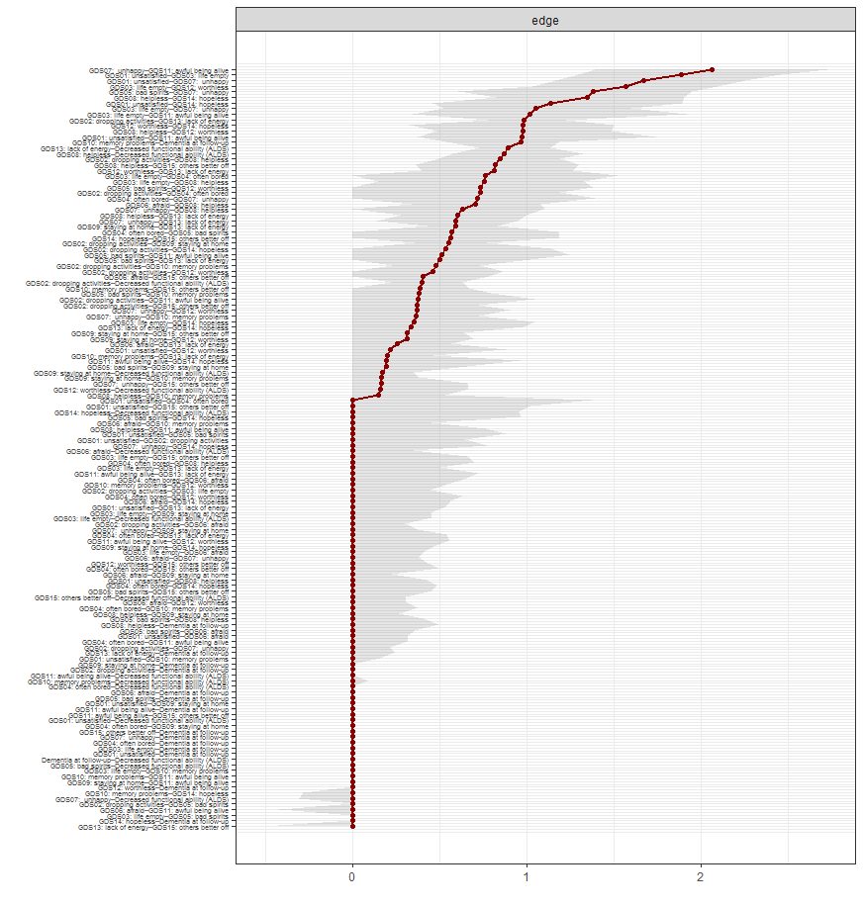
Figure S3: Bootstrapped 95% confidence intervals of estimated edge weights.

Figure S4: Bootstrapped difference tests between non-zero edge weights (α = .05)
Black boxes indicate significant differences in edge weights.
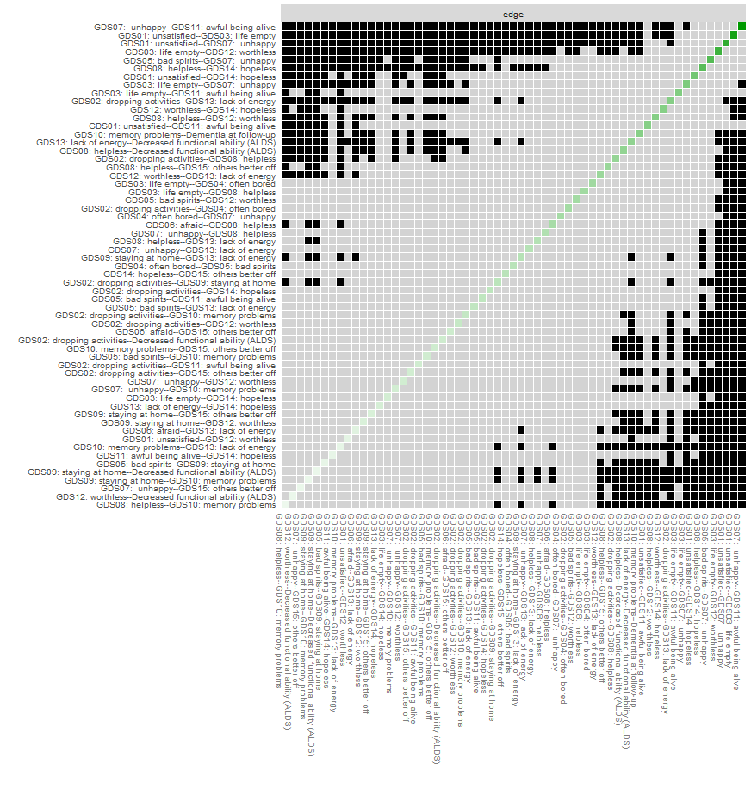

Figure S5: Bootstrapped difference tests on node strength (α = .05)
Black boxes indicate significant differences with regard to strengh of nodes; on the diagonal the unstandardized strength values of the individual nodes are shown.
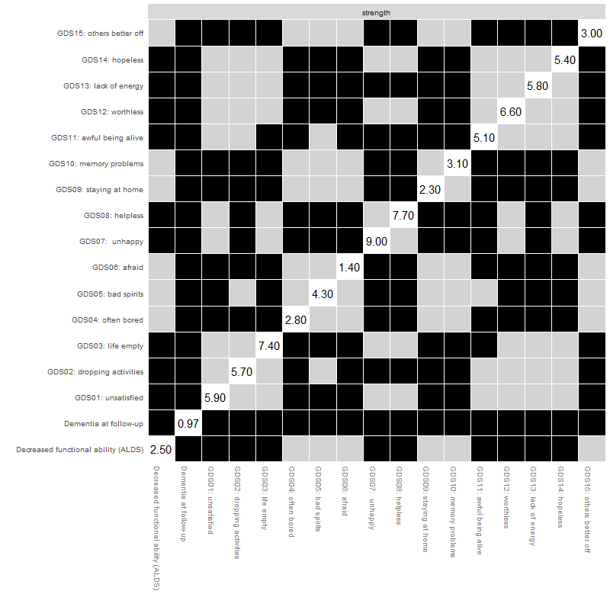

Figure S6: Bootstrapped difference tests on node closeness (α = .05)
Black boxes indicate significant differences with regard to closeness of nodes; on the diagonal the unstandardized closeness values of the individual nodes are shown.
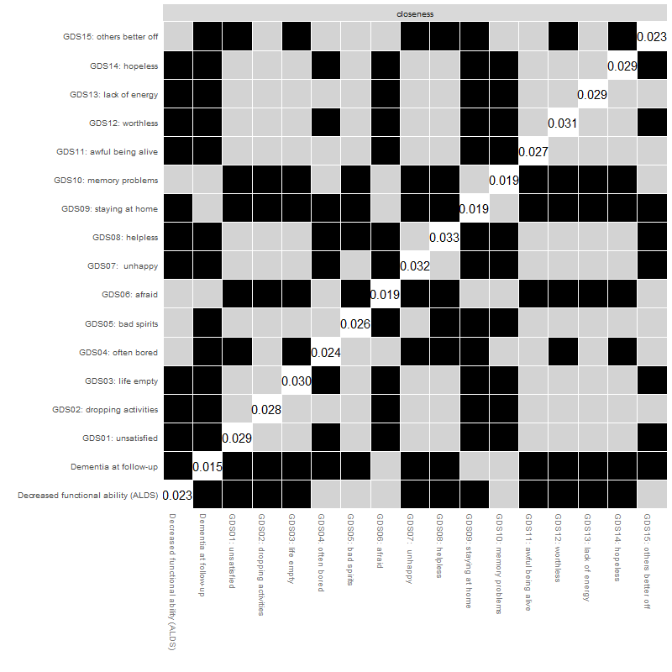

Figure S7: Bootstrapped difference tests on node betweenness (α = .05)
Black boxes indicate significant differences with regard to betweennes of nodes; on the diagonal the unstandardized betweenness values of the individual nodes are shown.
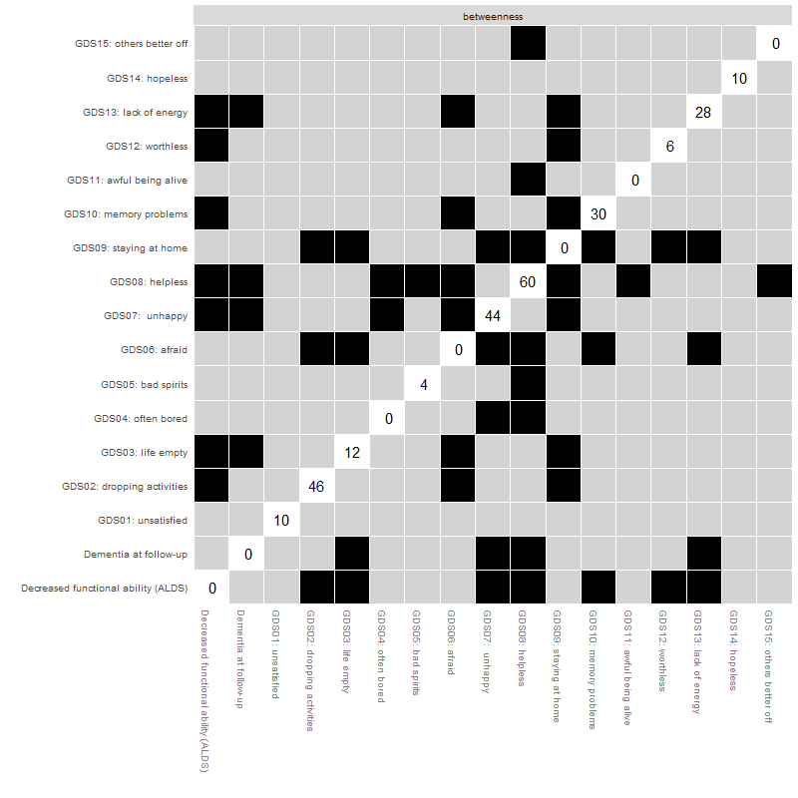

References
Epskamp, S., Borsboom, D. and Fried, E. I. (2017). Estimating psychological networks and their accuracy: A tutorial paper. Behavior Research Methods.
Epskamp, S. and Fried, E. (2017). Bootstrap Methods for Various Network Estimation Routines.

