Supplementary File
Clinical characteristics of early-onset versus late-onset Alzheimer’s disease – A systematic review and meta-analysis
Contents
Methods 2
QUIPS Domains 2
Tables 3
Supplementary Table 1. n, M, and SDs for each variable in each included study 3
Figures 7
Supplementary Figure 1. QUIPS summary plot 7
Supplementary Figure 2. QUIPS traffic light plot 8
Supplementary Figure 3. Forest plot comparing mean NPI sub-domain scores for EO-AD and LO-AD 9
References 10

Methods

QUIPS Domains
The Study Participation domain was classified as important because the aim of this review is to describe the overall EO-AD and LO-AD populations, so, studies that do not have adequate or representative samples produce a risk of the results not applying to our population of interest. The Study Attrition domain was categorized as important because this review looked at single measurements and longitudinal measures. The Prognostic Factor Measurement domain was deemed important because the prognostic factor age of onset is the variable separating our groups of interest, so, it is important that age of onset is determined and recorded with minimal bias so that we truly are comparing YO- and LO-AD patients. The Outcome Measurement domain was also deemed important because it is central that outcomes are measured validly and reliably so that we can be more confident that the reported results we have extracted actually describe our variables of interest. For a similar reason, the Study Confounding domain was classified as important because we want age of onset to be the only characteristic that explains any differences in outcomes, therefore, it is important that we are aware of whether the studies we included have addressed other potentially disruptive variables. Finally, the Statistical Analysis and Reporting domain was categorised as not important because our review is primarily concerned with basic summary statistics and, therefore, mostly, does not concern complexly analysed data or models. Studies’ risk of bias in the domains deemed important were weighted greater when assessing their overall risk of bias and authors used their own fair judgement for the global ratings (Grooten et al., 2019).

Tables

Supplementary Table 1. n, M, and SDs for each variable in each included study
Clinical characteristic | Author and Year | EO-AD |  | LO-AD
 |  | n | M (SD) | n | M (SD)
Time to diagnosis | Falgàs et al. (2019) | 58 | 2.75 (1.435) | 30 | 2.4 (2.2)
 | Mendez et al. (2012) | 125 | 3.72 (2.44) | 56 | 4.71 (3.2)
 | Park et al. (2015) | 616 | 3.8 (3.7) | 2351 | 2.3 (1.9)
 | Stanley et al. (2019) | 56 | 2.62 (2.17) | 249 | 2.73 (2.07)
 | van Vliet et al. (2013 | 99 | 3.2 (2) | 192 | 2.7 (2.2)
Cognition at presentation (MMSE) | Baillon et al. (2019) | 24 | 20.1 (7.3) | 56 | 21.5 (3.2)
 | Carotenuto et al. (2012) | 13 | 20.8 (4.17) | 82 | 19.9 (4.62)
 | Chagué et al. (2020) | 34 | 19.31 (6.43) | 49 | 22.38 (5.38)
 | Chang et al. (2017) | 331 | 17.8 (6) | 3280 | 17.3 (5.4)
 | Chishiki et al. (2020) | 12 | 17 (8.5) | 65 | 21.2 (5.3)
 | Cho et al. (2013) | 14 | 20.2 (3.7) | 22 | 21.4 (2.9)
 | Contador et al. (2021) | 14 | 26.07 (3.08) | 55 | 26.55 (2.73)
 | Dourado et al. (2016) | 52 | 20.5 (3.8) | 155 | 20.3 (3.9)
 | Eckerström et al. (2018) | 24 | 21.8 (5.4) | 39 | 22.1 (4.5)
 | Elahi et al. (2020) | 29 | 23 (3.7) | 23 | 25 (3.7)
 | Falgàs et al. (2019) | 54 | 24.61 (2.65) | 26 | 24.04 (3.09)
 | Ferreira et al. (2018) | 35 | 16.2 (8.1) | 35 | 16.8 (8)
 | Frisoni et al. (2005) | 9 | 18 (5) | 9 | 20 (5)
 | Gerritsen et al. (2016) | 145 | 19.2 (6.5) | 155 | 22 (3.4)
 | Gour et al. (2014) | 14 | 18.9 (4.2) | 14 | 21.5 (3.2)
 | Grønning et al. (2012) | 21 | 23.1 (3.6) | 21 | 24 (4.5)
 | Guven et al. (2020) | 22 | 15 (8.4) | 35 | 17.9 (5.9)
 | Jacobs et al. (1994) | 44 | 38 (5.89) | 83 | 38.3 (5.78)
 | Kimura et al. (2018) | 53 | 20 (3.5) | 57 | 20.6 (4)
 | Licht et al. (2007) | 44 | 20.4 (7) | 44 | 19.03 (6.32)
 | Mendez et al. (2012) | 125 | 21.01 (6.33) | 56 | 23.41 (2.12)
 | Migliaccio et al. (2015) | 15 | 22.3 (4) | 10 | 22.9 (6.9)
 | Palasí et al. (2015) | 38 | 22 (3.3) | 143 | 21.6 (3.1)
 | Panegyres & Chen (2013) | 7 | 19.3 (3.55) | 56 | 20.9 (3.42)
 | Park et al. (2015) | 616 | 19.3 (5.3) | 2351 | 18.4 (5)
 | Picard et al. (2011) | 181 | 15.3 (8.1) | 1277 | 19.9 (5.8)
 | Robbins et al. (2011) | 14 | 19.36 (5.18) | 49 | 21.61 (4.92)
 | Sá et al. (2012) | 109 | 21.8 (5.17) | 171 | 21.19 (3.5)
 | Smirnov et al. (2021) | 474 | 17.6 (8.2) | 1259 | 20.3 (7.6)
 | Stage et al. (2020) | 50 | 22.5 (3.3) | 148 | 23 (2.8)
 | Stanley et al. (2019) | 56 | 18.34 (6.12) | 249 | 23.04 (3.28)
 | Toyota et al. (2007) | 46 | 17.4 (7.6) | 261 | 19 (6)
 | van der Vlies et al. (2009) | 99 | 21.1 (4.5) | 192 | 22 (4)
 | van Vliet et al. (2012) | 98 | 18.5 (6.4) | 123 | 18.3 (4.4)
 | Wattmo & Wallin (2017) | 143 | 21.4 (3.8) | 874 | 21.4 (3.7)
Annual MMSE change | Cho et al. (2013) | 14 | -3.7 (3.9) | 22 | -0.7 (2.89)
 | Grønning et al. (2012) | 21 | -0.82 (4.6) | 21 | -1 (4.5)
 | Migliaccio et al. (2015) | 15 | -4.5 (4.12) | 7 | -3.5 (6.13)
 | Panegyres & Chen (2013) | 4 | -7.3 (3.97) | 39 | -1.8 (4.57)
 | Spina et al. (2021) | 92 | -2.7 (2.2) | 45 | -1.2 (1.83)
 | van der Vlies et al. (2009) | 99 | -2.4 (1.00) | 192 | -1.7 (1.39)
 | Wattmo & Wallin (2017) | 111 | -1 (4.25) | 669 | -0.5 (3.95)
NPI total score | Baillon et al. (2019) | 24 | 12.75 (17.72) | 56 | 6.88 (9.8)
 | Ferreira et al. (2018) | 35 | 80.1 (77) | 35 | 76.4 (81.8)
 | Mushtaq et al. (2016) | 40 | 17.37 (1.21) | 40 | 21.7 (1.3)
 | Park et al. (2015) | 435 | 13.9 (16.8) | 435 | 14.9 (19.1)
 | Smirnov et al. (2021) | 469 | 3.8 (2.6) | 1223 | 3 (2.5)
 | Toyota et al. (2007) | 46 | 10.3 (10.9) | 261 | 17.8 (17)
NPI: Delusions | Baillon et al. (2019) | 24 | 0.96 (2.33) | 56 | 0.5 (1.14)
 | Mushtaq et al. (2016) | 40 | 0.97 (0.42) | 40 | 1.37 (0.49)
 | Toyota et al. (2007) | 46 | 0.5 (1.59) | 261 | 2.99 (3.97)
NPI: Hallucinations | Baillon et al. (2019) | 24 | 0.96 (2.27) | 56 | 0.37 (1.07)
 | Mushtaq et al. (2016) | 40 | 0.3 (0.46) | 40 | 0.47 (0.5)
 | Toyota et al. (2007) | 46 | 0.15 (0.73) | 261 | 1.13 (2.72)
NPI: Dysphoria | Baillon et al. (2019) | 24 | 1.42 (2.28) | 56 | 0.75 (1.39)
 | Mushtaq et al. (2016) | 40 | 2.57 (0.81) | 40 | 2.58 (0.74)
 | Toyota et al. (2007) | 46 | 1.87 (2.83) | 261 | 1.3 (2.3)
NPI: Anxiety | Baillon et al. (2019) | 24 | 1 (1.59) | 56 | 0.52 (1.49)
 | Mushtaq et al. (2016) | 40 | 2.57 (0.5) | 40 | 3.03 (0.91)
 | Toyota et al. (2007) | 46 | 1.2 (2.37) | 261 | 1.72 (2.8)
NPI: Euphoria | Baillon et al. (2019) | 24 | 0.25 (0.68) | 56 | 0.18 (0.51)
 | Mushtaq et al. (2016) | 40 | 0.45 (0.5) | 40 | 0.45 (0.5)
 | Toyota et al. (2007) | 46 | 0.2 (0.75) | 261 | 0.19 (0.76)
NPI: Apathy | Baillon et al. (2019) | 24 | 0.96 (2.76) | 56 | 1.2 (2.28)
 | Mushtaq et al. (2016) | 40 | 3.32 (0.79) | 40 | 3.45 (0.71)
 | Toyota et al. (2007) | 46 | 3.17 (3.8) | 261 | 3.53 (3.62)
NPI: Aberrant motor behaviour | Baillon et al. (2019) | 24 | 0.92 (2.89) | 56 | 0.63 (1.45)
 | Mushtaq et al. (2016) | 40 | 1 (0.18) | 40 | 1.78 (0.188)
 | Toyota et al. (2007) | 46 | 1.41 (2.66) | 261 | 2.94 (4.09)
Functional status (FAQ) | Dourado et al. (2016) | 52 | 17.6 (7.6) | 155 | 15.9 (8.8)
 | Kimura et al. (2018) | 53 | 18.6 (6.9) | 57 | 15.3 (8.5)
 | Smirnov et al. (2021) | 483 | 23.50 (10.01) | 1242 | 23.49 (10.02)
Survival | Rhodus-Meester et al. (2019) | 608 | 7.8 (5.66) | 1257 | 6.4 (4.2)
 | Smirnov et al. (2021) | 481 | 10.4 (4) | 1153 | 9.7 (3.7)
 | Spina et al. (2021) | 96 | 11.2 (3.9) | 48 | 9 (3.4)
n = Number of participants, M = Mean, SD = Standard deviation, MMSE = Mini Mental State Examination, NPI = Neuropsychiatric Inventory, FAQ = Functional Assessment Questionnaire

Figures

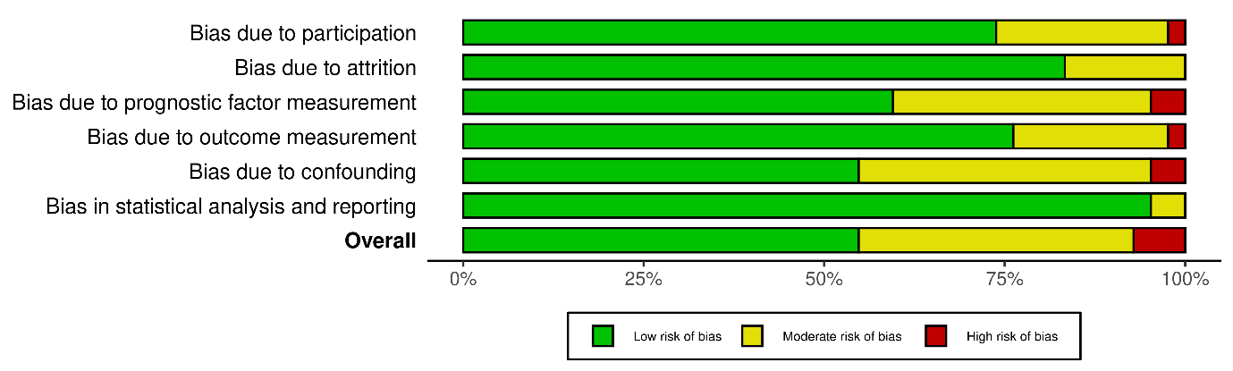
Supplementary Figure 1. QUIPS summary plot

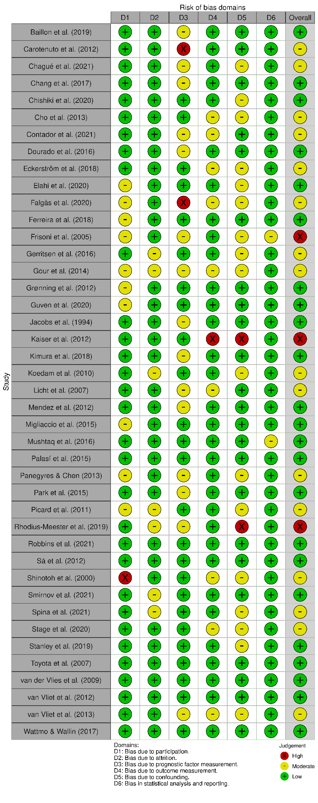
Supplementary Figure 2. QUIPS traffic light plot

Supplementary Figure 3. Forest plot comparing mean Neuropsychiatric Inventory sub-domain scores for early-onset Alzheimer’s disease (EO-AD) and late-onset Alzheimer’s disease (LO-AD).

References

Grooten, W. J. A., et al. (2019). Elaborating on the assessment of the risk of bias in prognostic studies in pain rehabilitation using QUIPS—Aspects of interrater agreement. Diagnostic and prognostic research, 3.

