**Appendix**

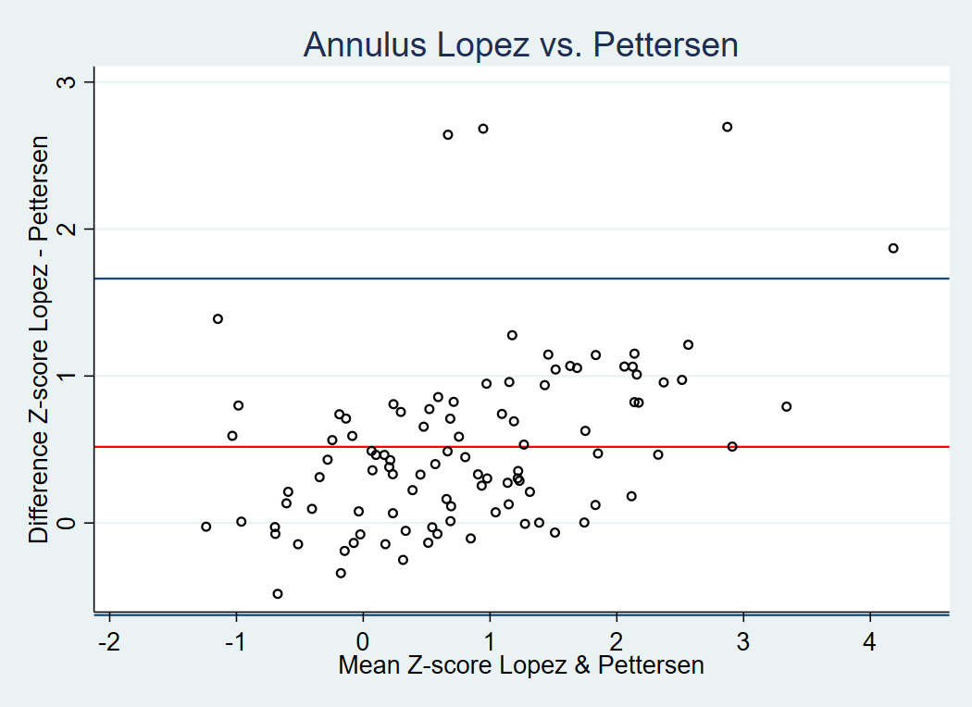

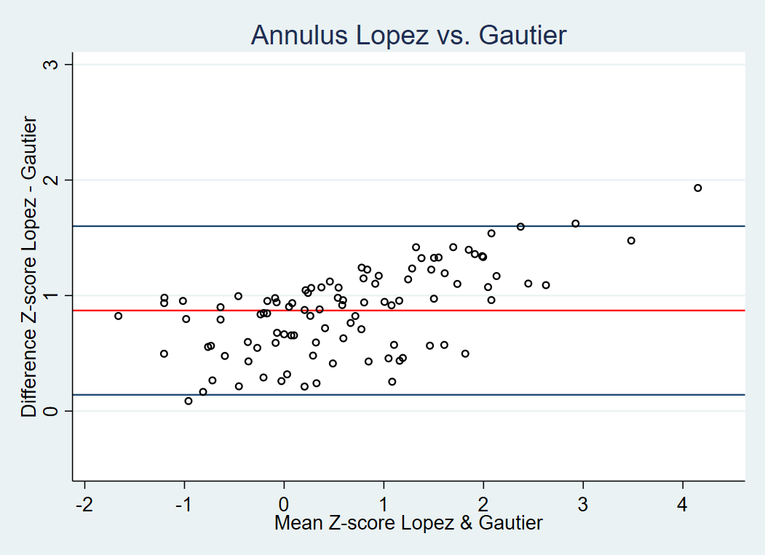

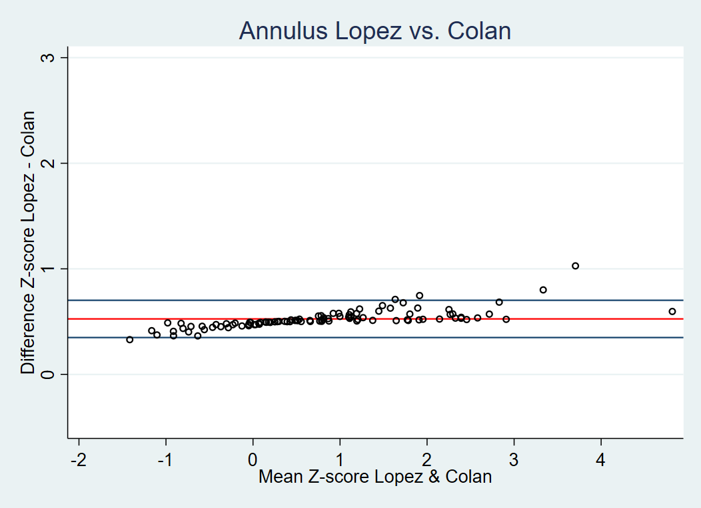

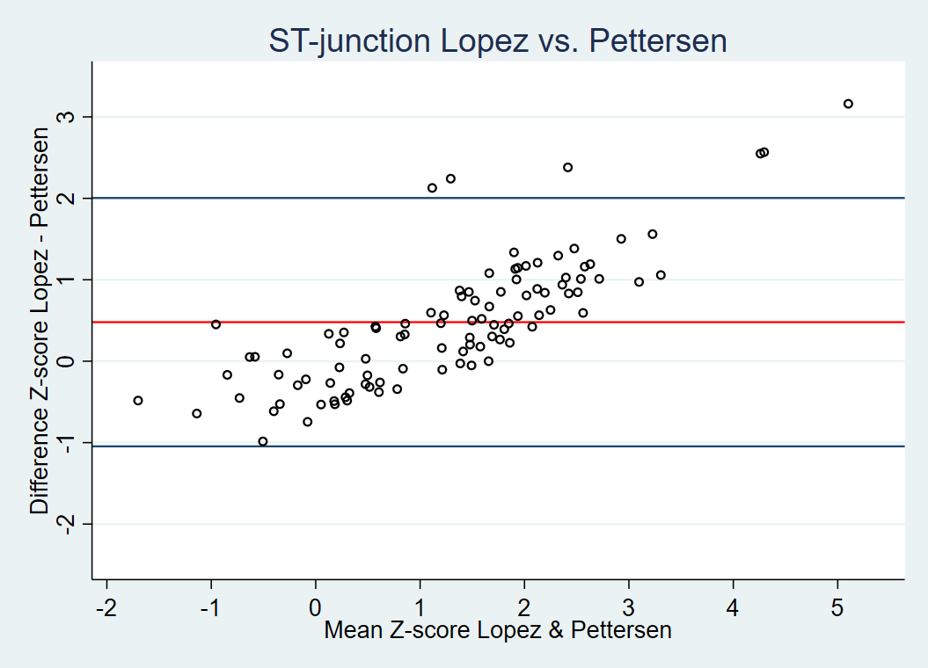

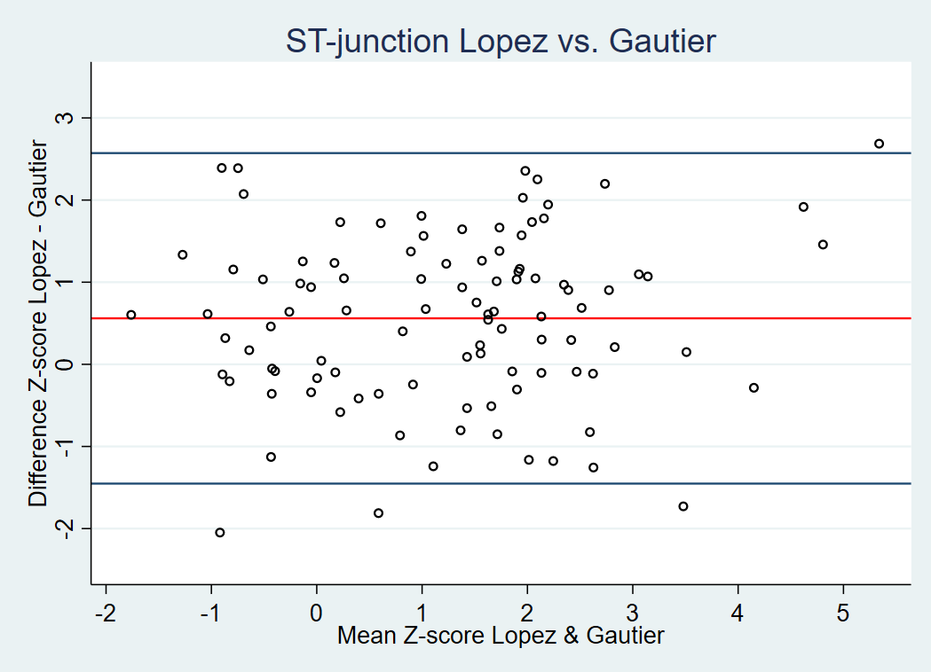

*Figure S1: Bland Altman plots of the mean differences in Z-scores for the annulus and sinotubular junction for for Lopez et al. [12] vs. Pettersen et al. [7], Lopez et al. [12] vs. Gautier et al. [8] and Lopez et al. [12] vs. Colan et al. [5].*