Supplementary figure S1: Column graph with error bars depicting the mean and Standard deviation (SD) of Portal vein Pulsatility Fraction (PVPF) in all patients

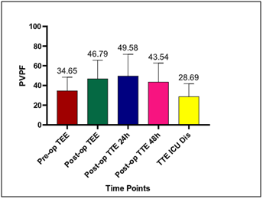

Supplementary figure S2: **Graph showing the difference in PVPF between different time points in the study population. Significant timepoints are marked with \***

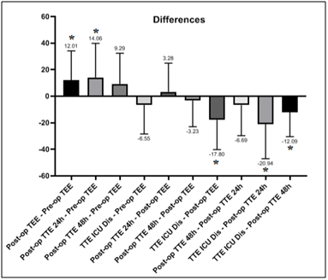

Supplementary figure S3: Scatter Plot depicting the relationship between PVPF max and mechanical ventilation duration in hours (MV)

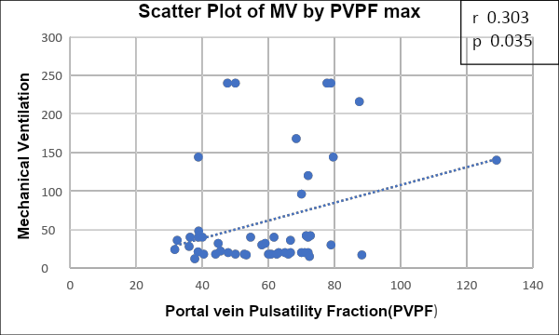

Supplementary figure S4: Scatter Plot depicting the relationship between PVPFmax and intensive care unit(ICU) stay (in days)

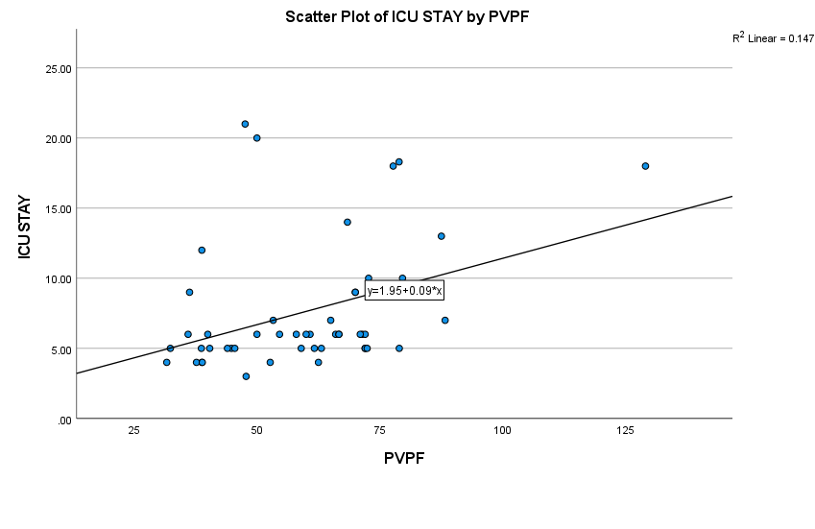

Supplementary table 1: Comparison of PVPFmax and other echocardiographic and clinical parameters between patients who underwent intracardiac repair with transannular patch and patients who underwent conduit or valve sparing procedures. Data are represented as Median [IQR].

|  |  |  |  |
| --- | --- | --- | --- |
| **Parameter** | **Transannnular patch**  **N= 28** | **Others**  **N=24** | **P value** |
| PVPFmax | 62.8 [48.9,72] | 55.6 [42.7,71.6] | 0.465 |
| Right ventricle fractional area change (%) | 28.8 [24.1,32.6] | 32.6 [22.4,38.2] | 0.373 |
| Tricuspid annular plane systolic excursion (mm) | 5.0 [4.0,6.2] | 5.0 [4.0,6.0] | 0.881 |
| Tricuspid E/A | 1.2 [1.0,1.6] | 1.1 [1.0,1.4] | 0.490 |
| Tricuspid E/e’ | 11.8 [8.1,14.8] | 17.7 [11.8,19.2] | **0.028** |
| Right ventricle global longitudinal strain (%) | -14.0 [-16.7,-12.0] | -13.5 [-15.6,-11.6] | 0.631 |
| Tricuspid s’ (cm/s) | 5.0 [4.0,6.0] | 5.0 [4.0,5.8] | 0.944 |
| Inferior vena cava diameter (mm) | 1.4 [1.2,1.7] | 1.2 [0.9,1.4] | **0.03** |
| Hepatic venous waveform (grade) | 3 [2,3] | 2 [1.75,3] | 0.119 |
| Left ventricle dysfunction (grade) | 0 [0,1] | 0 [0,1] | 0.896 |
| Tricuspid regurgitation severity (grade) | 2 [0,2] | 2 [0,3] | 0.418 |
| Pulmonary regurgitation severity (grade) | 2 [0,3] | 3 [2,3] | 0.190 |
| Central venous pressure (mm Hg) | 13 [11,14] | 12 [10,14] | 0.582 |
| Vasoactive inotropic score | 14.5 [9.0,26.9] | 13.0 [8.8,17.4] | 0.332 |
| Lactate (mmol/l) | 2.4 [1.9,3.2] | 2.0 [1.9,2.4] | 0.073 |
| PaO2/FiO2 (mm Hg) | 76.0 [55.8,94.0] | 80.0 [60.0,92.5] | 0.412 |