Supplemental Figure 1. PreAct algorithm effect on PPV by medical center demonstrates decreased variability between centers (a) Post-Intervention PPV as a function of Pre-Intervention PPV; (b) Change in PPV by center.

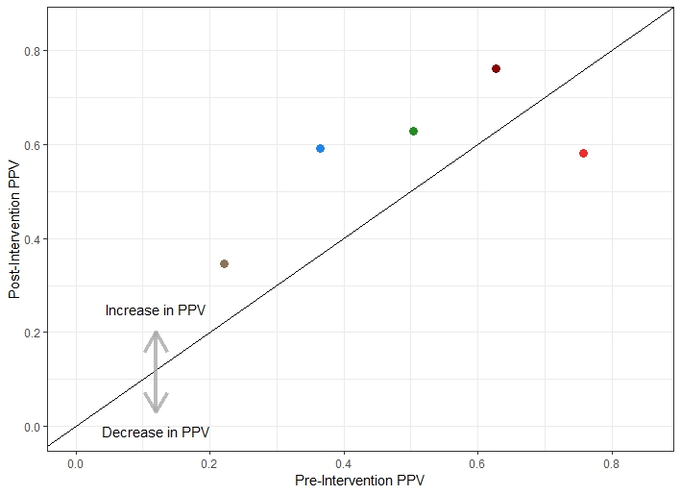
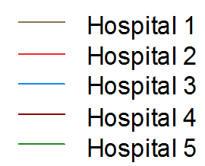
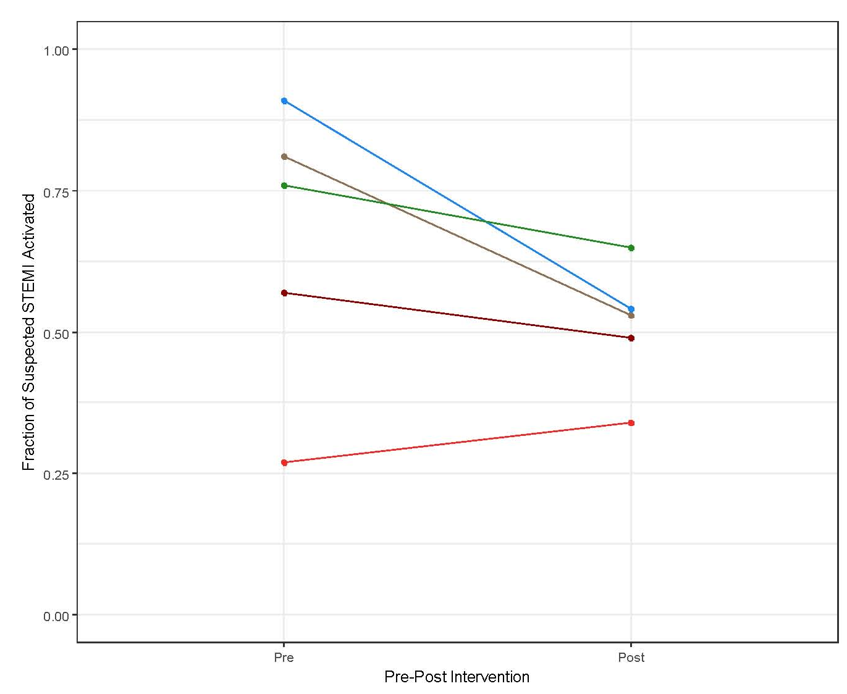
Supplemental Figure 2. Histogram of Abnormal Troponin values. Truncated for clarity: excludes 16 patients who had values > 200 ng/mL. n= 386. Inset: Histogram of patients with troponin values <10.
Supplemental Figure 3. Mission: Lifeine PreAct STEMI Algorithm 2018.
