Appendix 2
CPR Performance Checklist
Assessment Criteria
Time to initiate first chest compression  Definition: Time since the participant entered the room until pressed down on the chest of the manikin | Time = ____________________ sec.
Checking for the victim’s response  Definition: Use both hands to clap the shoulders of the manikin and shouts to the manikin. | Correct  c | Incorrect  c
Proper chest compression posture  Definition: Kneeling by the side of manikin. The knee is near by the manikin’s head and at the same level of the manikin’s shoulder. | Correct  c | Incorrect  c
Proper chest compression hand placement  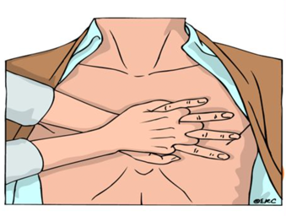  Definition: Places firsthand on the lower half of the sternum along the midline. And places other hand on top of the first with fingers interlocked. | Correct  c | Incorrect  c
Mean chest compression depth | Depth = __________________ mm.
Mean chest compression rate | Rate = ___________________ bpm.
Percentage of complete chest recoil | Recoil = ____________________ %
Percentage of correct hand placement | Correct = __________________ %
Mean hands-off duration | Hands-off = _______________ sec.

Signature ______________________
Investigator

