**Supplemental Appendices**

**Best Pasture Management Practice Adoption and Sediment Abatement**

**Supplemental Appendix I. Best Management Practice Information**

The following information was provided to survey respondents before they participated in the choice experiment.

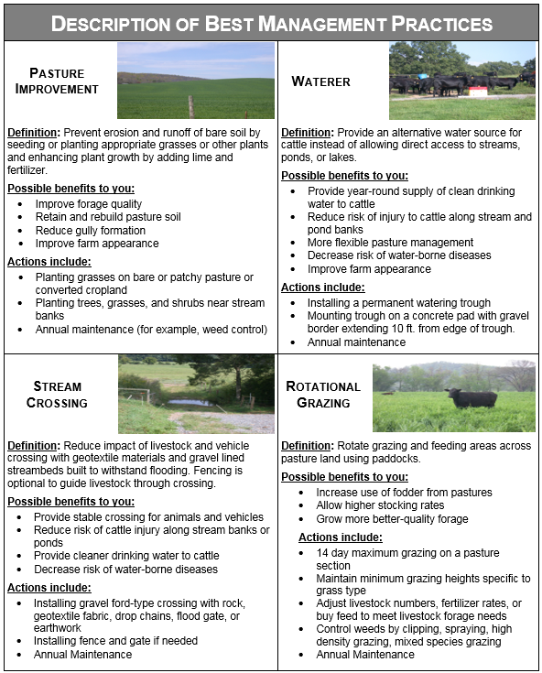

**Supplemental Appendix II**

**Watershed Model Development, Calibration, and Validation**

The ArcSWAT (Version 2012 Release 10.21) graphical user interface was used to develop a Soil Water Assessment Tool (SWAT) model of the Oostanaula Creek watershed in ArcGIS Desktop (ESRI, Version 10.5) (Arnold, Srinivasan et al. 1998). Land use, soils, and digital elevation data were downloaded from the USDA Geospatial Data Gateway (<https://datagateway.nrcs.usda.gov/>). Soil data were a slightly modified version of the State Soil Geographic (STATSGO) dataset (Wang and Melesse 2006).

Land use corresponded to the 2009 Croplands Data Layer (CDL) (Johnson and Mueller, 2010 (Johnson and Mueller 2010). A custom lookup table was used to classify grass/pasture/hay land uses (CDL attribute codes 37, 59, and 176) as a FESC crop because this cool season forage dominates beef cattle pastures in the watershed (Ball et al. 2002). Important CDL predicted land uses within the watershed were pasture (FESC) and deciduous forest (FRSD), and less important land uses were for soybean (SOYB) and corn (CORN) production, accounting for 38%, 31%, 2% and 2% of the watershed land area, respectively. A central urban area of varying density, corresponding to the city of Athens, TN, accounted for 12% of the watershed area (URLD, URML, URMD, and URHD land use categories). As expected, the watershed land use was dominated by pasture-based beef cattle operations.

Slope classifications (0-2%, 2-8%, 8-16%, and > 16%) were established using the National Elevation Dataset (10-meter resolution) (Gesch, Oimoen et al. 2002). Stream and sub-basin definitions were-DEM based with flow direction and accumulation set at 344 hectares. The watershed outlet was located at a USGS gaging station near Sandford, TN (03565500) for streamflow calibration and validation (Gali et al. 2012), taking in the majority (78%) of the total watershed area. The resulting watershed model included 15 sub-basins with maximum, minimum, and average elevations of 399, 218, and 285±29 meters above sea level.

HRUs were defined using a rejection threshold of 5% for slope class, soil type, and land use areas. The resulting modeled land areas for pasture (FESC), forested areas (FRSD, FRSE and FRST), and urban/residential areas (URLD, URML, URMD), corn, and soybeans represented 45, 39, 11, 1, 0.5% of the watershed area, respectively. The final modeled land use-slope-soil combinations resulted in 466 HRUs, 207 of which were pasture (FESC).

Rainfall and temperature input data were obtained from the National Weather Station Coop database for Athens and Cleveland, Tennessee (Leeper et al. 2015) for model runs from January 1990 to December 2016 with a daily time step and a 17-year warmup period ending at the measured flow dataset used for calibration and validation (2007-2016). The 1990-2010 WGEN US-COOP database was used to provide missing rainfall (skewed normal distribution) and temperature data, as well as estimates of relative humidity, solar radiation, and wind speed.

Management fields for all FESC HRUs were modified to include fertilization on March 1 at a rate of 426 kg/ha of a 15-15-15 fertilizer, mimicking the local beef producer practice of applying 300 lbs/ac of 19-19-19 fertilizer in early spring (FRT_SURFACE=1) (Ball et al. 2002). A grazing management practice was added starting March 15 and lasting 255 days. Grazing intensity (BIO_EAT) and trampling (BIO_TRMP) forage consumption rates were set at 17 and 8 kg/ha/day, respectively, reflecting local beef producer stocking densities of approximately 1 cow/calf pair per 2 acers (≈ 0.75 1,000 lb animal units (AU) per acre) (Ball et al. 2008). Manure production was set at 6 kg/ha/day assuming a production of approximately 90 kg-wet manure/AU at 90% moisture content.

For model calibration (reflecting existing conditions), FESC HRUs were modified as follows: the minimum dry biomass for grazing (BIO_MIN) was set at 800 kg/ha, runoff curve numbers for soil moisture condition II (CN2) were set to 69 and 79 for hydrologic class B and C soils, respectively, Manning’s N for overland flow (OV_N) was set to 0.15, and the minimum universal soil loss equation cover factor (USLE_C) was set to 0.03. A BIO_MIN value of 800 reflects the potential for moderate overgrazing (White et al. 2010), with an average sward height of approximately 4 cm (Barnhart 1998). The assigned CN2 values reflect “fair” pasture forage conditions with 50-75% maintenance of ground cover (Neitsch et al. 2005). A FESC OV_N value of 0.15 is reflective of a “short grass” hydrologic condition expected with moderate overgrazing (Neitsch et al. 2005). A FESC USLE_C value of 0.03 reflects approximately 60-70% ground cover which is expected with moderate overgrazing (Kassam et al. 1991).

As is typically the case, sediment concentration data were not available to calibrate the Oostanaula Creek watershed model. The model was instead flow calibrated using the SWAT-CUP executable by modifying 9 flow related model parameters (CN2, ALPHA_BF, GW_DELAY, GWQMN, GW_REVAP, ESCO, CH_N2, CH_K2, and ALPHA_BNK) using the sequential uncertainty fitting (SUFI2) calibration routine (Abbaspour, Vejdani et al. 2007). Random values of the flow related model parameters were taken from default ranges during a calibration run that included 1,000 iterations. Eight sensitive model parameters were identified using a post-calibration global sensitivity analysis: ALPHA_BNK, ESCO, CN2, CH_N2, CH_K2, GW_DELAY, GW_REVAP, and GWQMN (Table 1). The “best fit” calibrated model, using flow data from 2007-2011, displayed a Nash-Sutcliffe (NS) goodness of fit of 0.62, a coefficient of determination (R2) of 0.66, a ratio of the root square mean of error to measured data standard deviation (RSR) of 0.62, and a PBIAS of -22% (Figure 1). All of the resulting model fit parameters were indicative of good performance during the calibration period (Moriasi et al. 2007). The calibrated model was validated with flow data from 2012-2016, yielding a NS of 0.66, R2 of 0.70, RSR of 0.62, and PBIA of -22%, values that validate good model performance (Moriasi et al. 2007). Sediment loss from the FESC land use category predicted by the calibrated model averaged 12.2 ton/ha, reflecting relatively poor forage management and high pasture erosion rates (Walling et al. 2014).

Supplemental Appendix II, Table 1. SWAT-CUP model calibration parameters (best-fit model).

|  |  |  |  |  |  |
| --- | --- | --- | --- | --- | --- |
| Parameter | Description | Unit | Calibration Method | Range | Calibrated Value |
| ALPHA_BF | Baseflow α | days | Replace | 0.0 - 1.0 | 0.69 |
| ALPHA_BNK | Baseflow α, bank storage | days | Replace | 1. - 1.0 | 0.87*** |
| CH_K2 | Main channel hydraulic conductivity | mm/hr | Replace | 60 - 130 | 60*** |
| CH_N2 | Main channel Manning’s n | - | Replace | 0.2 – 0.3 | 0.26*** |
| CN2 | SCS Curve Number, Moisture Condition II | - | Multiply | -20% – 0% | -17%*** |
| ESCO | Soil evaporation compensation factor | - | Replace | 0.8 – 1.0 | 0.84*** |
| GW_DELAY | Groundwater delay time | days | Replace | 30 - 450 | 161*** |
| GWQMN | Shallow aquifer return flow threshold | mm | Replace | 0.0 - 2.0 | 1.8* |
| GW_REVAP | Groundwater “revap” coefficient | - | Replace | 0.0 – 0.2 | 0.16** |

Notes: SWAT-CUP global sensitivity *t* statistics; ***, **, * significant at the 1%, 5%, and 10% levels, respectively.

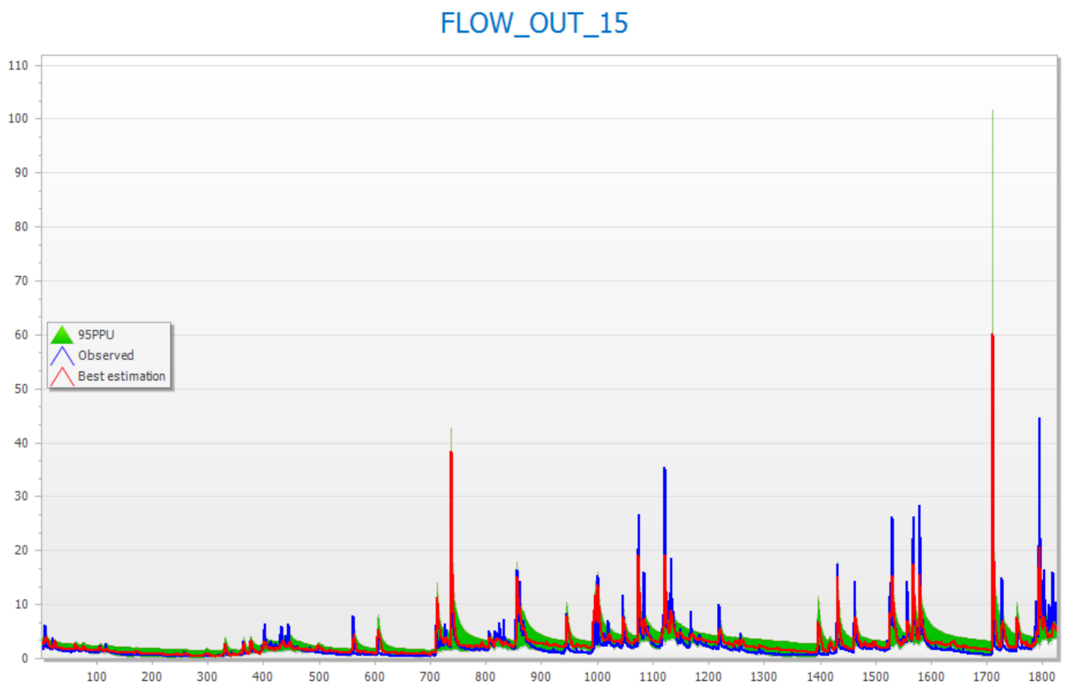

Supplemental Appendix II, Figure 1. SWAT-CUP calibration parameter runs (500) of the Oostanaula Creek watershed SWAT model using the SUFI2 calibration method with Nash-Sutcliff goodness of fit.

Supplemental Appendix II, References

Abbaspour, K. C., M. Vejdani, and S. Haghighat. *SWAT-CUP Calibration and Uncertaity Programs for SWAT*. Christchurch, Modelling & Simulation Soc Australia & New Zealand Inc. 2007.

Arnold, J. G., R. Srinivasan, R. S. Muttiah, and J. R. Williams. ‘Large Area Hydrologic Modeling and Assessment Part I: Model Development’. *Journal of the American Water Resources Association* 34,1(February 1998):73–89.

Ball, D., E. Ballard, M. Kennedy, G. Lacefield, and D. Undersander. ‘Extending Grazing and Reducing Stored Feed Needs’ (2008):20.

Ball, D. M., C. S. Hoveland, and G. D. Lacefield. *Southern Forages*. Norcross, GA, Phosphate & Potash Institute and the Foundation for Agronomic Research. 2002.

Chow, V. T. *Open Channel Hydraulics*. New York, NY, McGraw-Hill. 1959.

Gali, R. K., K. R. Douglas-Mankin, X. Li, and T. Xu. ‘Assessing NEXRAD P3 Data Effects on Stream-Flow Simulation Using SWAT Model in an Agricultural Watershed’. *Journal of Hydrologic Engineering* 17,11(November 2012):1245–1254.

Gesch, D. B., M. J. Oimoen, S. K. Greenlee, C. A. Nelson, M. J. Steuck, and D. J. Tyler. ‘The National Elevation Dataset’. *Photogrammetric Engineering and Remote Sensing* 68,1(2002):5–11.

Hagen, J., and F. R. Walker. ‘Oostanaula Creek Watershed Restoration Plan’. *B. E. a. S. Science. Knoxville, TN, University of Tennessee Extension* (2007).

Johnson, D. M., and R. Mueller. ‘The 2009 Cropland Data Layer’. *Photogrammetric Engineering and Remote Sensing* 76,11(2010):1201–1205.

Kassam, A. H., H. T. van Velthuzen, G. W. Fischer and M. M. Shah (1991). Soil erosion and productivity. Agro-ecological land resources assessment for agricultural development planning. A case study of Kenya. FAO/IIASA, Rome, Italy.

Leeper, R. D., J. Rennie, and M. A. Palecki. ‘Observational Perspectives from U.S. Climate Reference Network (USCRN) and Cooperative Observer Program (COOP) Network: Temperature and Precipitation Comparison’. *Journal of Atmospheric and Oceanic Technology* 32,4(April 2015):703–721.

Medwid, L. J. ‘Incentives for Best Management Practice Adoption among Beef Cattle Producers and Effects on Upland Sediment Loss: A Case Study in Southeastern Tennessee’ (2016):100.

Moriasi. D. N., J. G. Arnold, M. W. Van Liew, R. L. Bingner, R. D. Harmel, and T. L. Veith. ‘Model Evaluation Guidelines for Systematic Quantification of Accuracy in Watershed Simulations’. *Transactions of the ASABE* 50,3(2007):885–900.

Neitsch, S. L., J. G. Arnold, J. R. Kiniry and J. R. Williams (2005). Soil and Water Assessment Tool Input/Output File Documentation. A. R. Service. Temple, TX, United States Department of Agriculture. Version 2005.

Walling, D., P. Porto, Y. Zhang and P. Du. “Upscaling the Use of Fallout Radionuclides in Soil Erosion and Sediment Budget Investigations: Addressing the Challenge.” *International Soil and Water Conservation Research* 2,3 (2014): 1-21.

Wang, X. and A. M. Melesse. “Effects of STATSGO and SSURGO as inputs on SWAT Model's Snowmelt Simulation.” *Journal of the American Water Resources Association* 42,5 (2006): 1217-1236.

White, M. J., D. E. Storm, P. Busteed, S. Stoodley and S. J. Phillips. “Evaluating Conservation Program Success with Landsat and SWAT.” *Environmental Management* 45,5 (2010): 1164-1174.

**Supplemental Appendix III**

**Cost share amounts and frequency across respondents**

|  |  |  |  |  |  |  |  |  |
| --- | --- | --- | --- | --- | --- | --- | --- | --- |
|  | Pasture improvement | | Rotational grazing | | Stream crossing | | Water tank | |
| Cost share (%) | Amount ($/ac) | Frequency | Amount ($/ac) | Frequency | Amount ($/ft2) | Frequency | Amount ($/unit) | Frequency |
| 50.0 | 127 | 37 | 16 | 28 | 1.94 | 35 | 767 | 21 |
| 62.5 | 158 | 29 | 20 | 32 | 2.42 | 29 | 958 | 22 |
| 75.0 | 190 | 25 | 24 | 26 | 2.9 | 25 | 1150 | 36 |
| 87.5 | 222 | 22 | 28 | 29 | 3.39 | 27 | 1342 | 37 |
| 100.0 | 253 | 25 | 32 | 19 | 3.87 | 32 | 1533 | 27 |
| 112.5 | 285 | 31 | 36 | 40 | 4.35 | 26 | 1725 | 19 |
| 125.0 | 317 | 26 | 40 | 21 | 4.84 | 21 | 1917 | 33 |

Notes: The sum of the frequencies equals the number of producers responding to the survey. The survey presented respondents with the dollar/unit amounts. Respondents were unaware that the dollar/unit amount corresponded with a specific cost share.