Supplementary Information
(for online publication only)

Implicit facial expression neuroimaging tasks
The display of facial stimuli in the series Pictures of Facial Affect (POFA)⁽¹⁾ is based on specified facial muscle movements according to the Facial Action Coding System ⁽²⁾. Facial identities (6 females, 4 males) are depicted that pose facial muscle configurations which have been demonstrated to constitute inter-culturally universal expressions ⁽³⁾ for basic emotions ^{(4; 5)}. The original POFA stimuli have been computer-morphed to conform artificially to 6 levels of expression intensity (0 through 150%). The different identities of the computer-enhanced POFA stimuli (FEEST)⁽⁶⁾ are only discernible by means of features indicating sex, emotion category, and expression intensity. Previous studies have demonstrated that neural responses to emotional stimuli are dependent on the nature of the task performed during viewing of the stimuli ⁽⁷⁾. Usually, implicit tasks (e.g. sex decision) have sparser overall responses and are thus more conservative. Subjects in this study were requested to decide upon the sex of each face and press one of two buttons accordingly with their index and middle fingers. fMRI data were acquired for each emotional expression at three different intensities (0%-50%-100%) in a randomized order. In each implicit emotion processing task, 72 stimuli in total were presented with an inter-stimulus interval (ISI) of 2,000 ms. The order of the experiments was counterbalanced across all subjects, and both were embedded into sessions with other experiments. Subjects responded by button press and reaction times and response type were recorded. The computer presentation of the experiments was performed through back-projection using an LCD-projector and a translucent screen, which subjects watched in supine position through a mirror mounted on the MRI head coil. The display subtended a visual angle of ≥8°.

fMRI data processing
The statistical inference software package Brain Activation Mapping (XBAM, Version 4.1; Brain Image Analysis Unit, Institute of Psychiatry, London, UK; www.brainmap.it) was used to analyze the EPI images. The data were first realigned ⁽⁸⁾ to minimize motion related artifacts and smoothed using a Gaussian filter (FWHM 7.2 mm). Responses to the experimental paradigm were then detected by time-series analysis using Gamma variate functions (peak responses at 4 and 8 s) to model the BOLD response. The analysis was implemented as follows: First, each experimental condition was convolved separately with the 4 and 8 s Poisson functions to yield two models of the expected hemodynamic response to that condition. The weighted sum of these two convolutions that gave the best fit to the time series at each voxel was then computed. This weighted sum effectively allows voxel-wise variability in time to peak hemodynamic response. In order to constrain the possible range of fits physiologically plausible BOLD responses, the constrained fitting procedure suggested by Friman ⁽⁹⁾ was adopted. Following this fitting operation, a goodness of fit statistic was computed at each voxel. This was the ratio of the sum of squares (SSQ) of deviations from the mean intensity value due to the model (fitted time series) divided by the sum of squares due to the residuals (original time series minus model time series). The percentage BOLD signal change at each voxel was also calculated. This was ((fitmax – fitmin)/mean signal intensity)*100, where fitmax and fitmin were the maximum and minimum values of the fitted response for the time series in question. In order to sample the distribution of SSQ ratio under the null hypothesis that observed values of SSQ ratio were not determined by experimental design (with minimal assumptions), the time series at each voxel was permuted using the Daubechies wavelet resampling method described in detail in Bullmore ⁽¹⁰⁾ and extended by Breakspear ^{(11; 12)}. Combining the randomized data over all voxels yields the distribution of SSQ ratio under the null hypothesis. A test that any given voxel is activated at any required type I error can then be carried out by obtaining the appropriate critical value of SSQ ratio from the null distribution. For example, SSQ ratio values in the observed data lying above the 99th percentile of the null distribution have a probability under the null hypothesis of p<0.01. We have shown that this permutation method gives very good type I error control with minimal distributional assumptions ^{(see 10; 11)}.

Group mapping
The median observed SSQ ratio over all subjects at each voxel (median values were used to minimize outlier effects) can then be tested at each intracerebral voxel in standard space ⁽¹³⁾ against a critical value of the permutation distribution for median SSQ ratio ascertained from the spatially transformed wavelet-permuted data ⁽¹⁴⁾. Image-wise expectation of the number of false positive clusters under the null hypothesis was set for each analysis at <0.5.

Correlation images
Under the assumption that the subtraction map reflects pure emotion-induced cerebral activation at higher intensity levels, aggregate images 100%-50% were computed, after removing neutral facial expression activation. The aggregate images were used as a basis for correlation analysis with clinical trait scales. The method herein used was first to compute the Pearson product-moment correlation coefficient r between the measured self-report scales and BOLD effect data, and then to compute the null distribution of correlation coefficients by permuting the BOLD data at each voxel a minimum of 50 times, and combining the data over all voxels. Age and sex were entered into all correlations as covariates. Threshold cluster level maps, where r is significant, could then be computed at the expected level of type I error clusters as described. Comparative peak signal levels (for the two groups) of BOLD signal changes in these regions were determined by extracting the effect sizes of the peak active voxels for each of the two groups.

Images of differences in regression slopes
The aggregate activation maps and correlation images served as a basis for the ascertainment of regions in which the two groups significantly differ for a trait taxon. Differential linear regression models were set up by inclusion of age and sex as covariates of no interest, and used 50 permutations per voxel to test the regression slope difference between the two groups. The α-level for the 3D cluster difference of the regression slopes was set at p<0.05 voxel-wise followed by a cluster level of 0.01. For individual measures of clinical traits, the extent of the difference in regression of the behavioral data and individual fMRI contrasts between two groups were computed and tested for significance. Group differences in regression slopes can be calculated at each voxel by first computing, for each group independently, the regression coefficient between the behavioral clinical data for each subject and the BOLD signal, and then by subtracting the resulting two values. To determine the significance of these differences in linear regression slopes, the appropriate null distribution was generated by randomly permuting subjects between the groups (without replacement), therefore removing group differences. For each of the permutations, the difference in regression slopes between the permuted groups was calculated and the resulting values were combined over all voxels to produce a whole brain null distribution of differences in regression. The critical value for significance at any particular P value was then obtained from this distribution after simply sorting it and selecting the appropriate point from the sorted distribution. E.g. the critical value for a one-tailed test at P=0.05 would be the value of the difference in regression coefficients in the null distribution chosen such that 95% of all the null values lay below that point. Testing can then be extended to cluster level as described previously. The cluster probability under the null hypothesis can be chosen to set the level of expected type I error clusters at an acceptable level (e.g.<1 3D cluster per whole brain). Signal levels for the differential regions so ascertained used as masks were then extracted at 6 s post-stimulus (the peak hemodynamic response time) using the aggregate activation, by choosing the most activated voxel. The extraction was done for descriptive purposes to inform about signal levels, without re-analysis of the data.

Supplementary Text 1,360 words

Supplementary Table 1 Comparisons of control vs. depersonalization patient groups – self-report questionnaire data

Control Depersonalization Student’s t P Value
Instruments and taxons M S.E.M. M S.E.M.

Beck Depression Inventory 3.5830 1.3951 17.444 2.9302 -4.291 0.001
Dissociative Exp Scale Tot Sc 185.83 44.830 518.89 120.81 -2.870 0.010
SOMS-2 Complaint Index 1.4167 0.5961 10.111 3.2843 -2.994 0.007
Spielberger State STAI-Y1 1.8292 0.1371 2.438 0.2875 -2.075 0.052
Spielberger Trait STAI-Y2 2.0208 0.1285 2.472 0.2666 -2.383 0.028

Note: — df = 19. Unequal between-group variances were assumed in computation of t-tests.

86 words

Supplementary Figure 1 BOLD signal levels for discriminative regions in happy condition
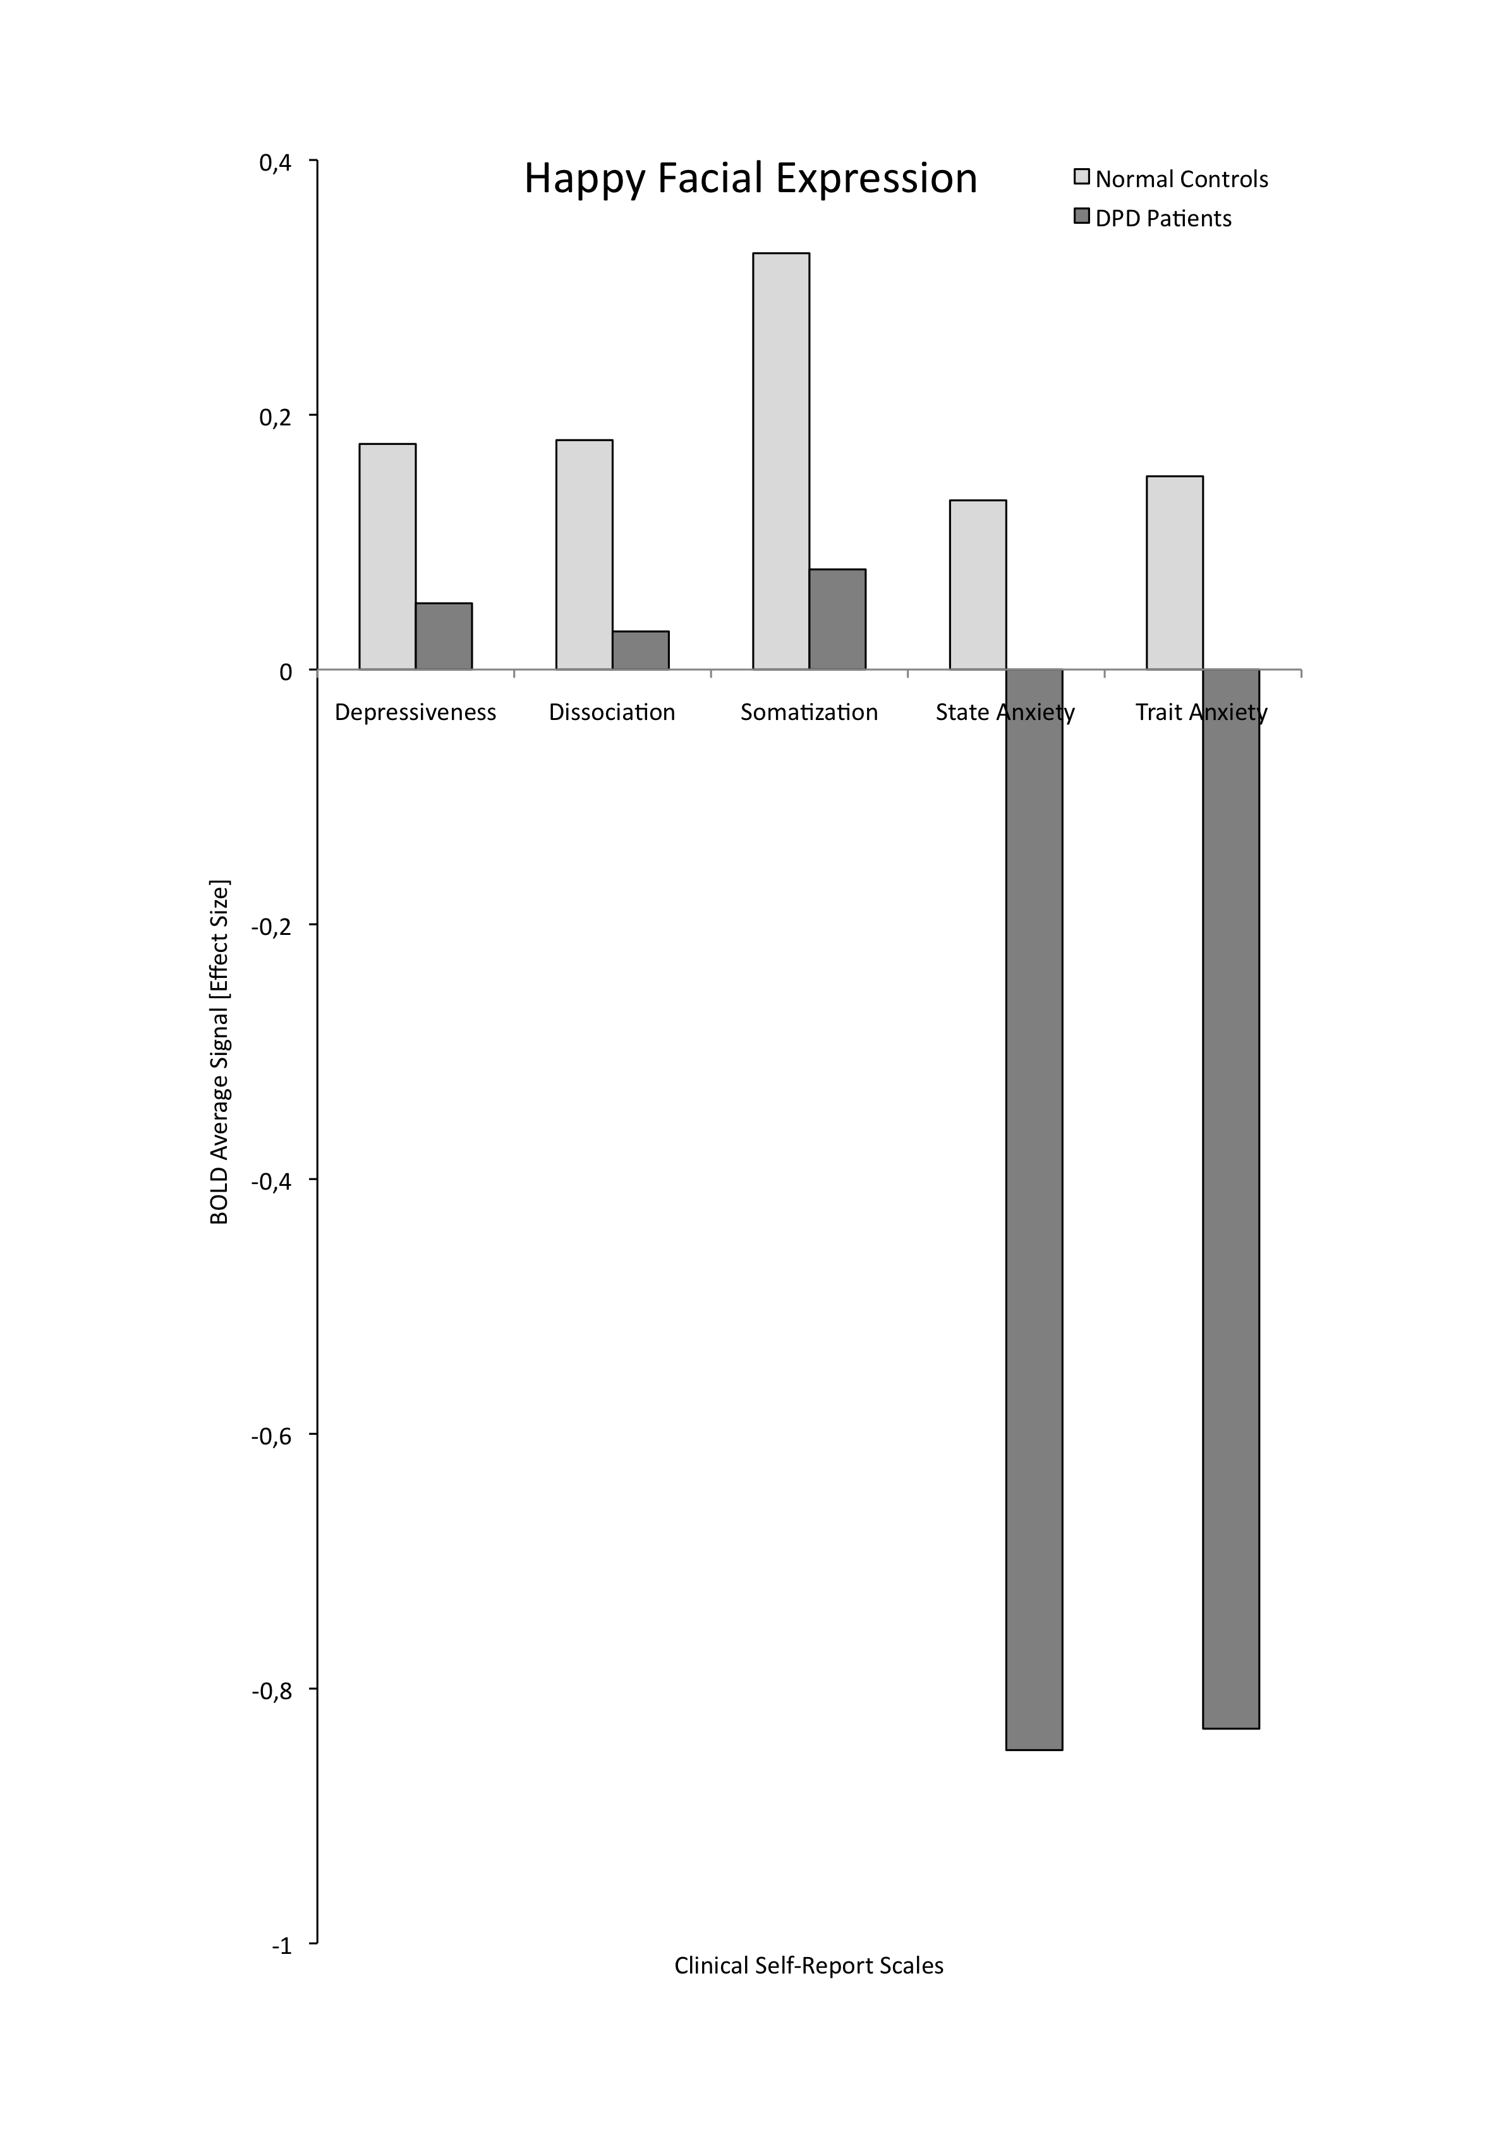

Supplementary Figure 2 BOLD signal levels for discriminative regions in sad condition
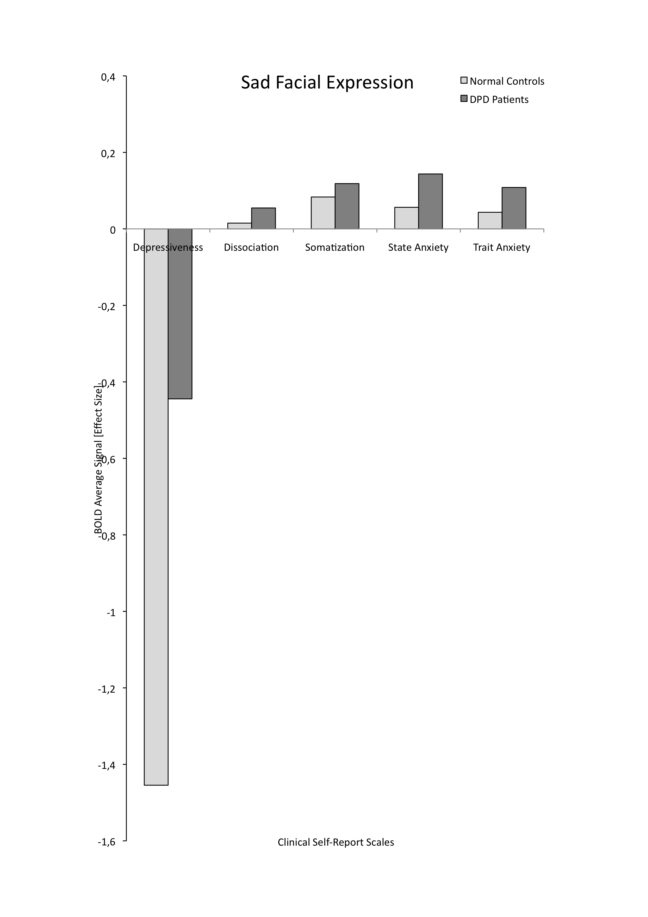

Supplementary References

1. Ekman P, Friesen WV (1976) Pictures of facial affect. Palo Alto, CA: Consulting Psychologists Press.
2. Ekman P, Friesen W (1978a) The facial action coding system. Palo Alto, CA: Consulting Psychologists Press.
3. Ekman P, Friesen WV, Ellsworth P (1982) What are the similarities and differences in facial behavior across cultures? In Emotions in the Human Face, 2 ed. [P Ekman, editor]. Cambridge, UK: Cambridge University Press.
4. Ekman P (1992a) Are there basic emotions? Psychological Review 99, 550-553.
5. Ekman P (1992b) An argument for basic emotions. Cognition and Emotion 6, 169-200.
6. Young AW, Perrett DI, Calder AJ et al. (2002) Facial expressions of emotion: stimuli and test (FEEST). Bury St. Edmunds, UK: Thames Valley Test Company.
7. Lange K, Williams LM, Young AW et al. (2003) Task instructions modulate neural responses to fearful facial expressions. Biological Psychiatry 53, 226-232.
8. Bullmore ET, Brammer MJ, Rabe-Hesketh S et al. (1999a) Methods for diagnosis and treatment of stimulus-correlated motion in generic brain activation studies using fMRI. Human Brain Mapping 7, 38-48.
9. Friman O, Borga M, Lundberg P et al. (2003) Adaptive analysis of fMRI data. NeuroImage 19, 837-845.
10. Bullmore ET, Long C, Suckling J et al. (2001) Color noise and computational inference in neurophysiological (fMRI) time series analysis: Resampling methods in time and wavelet domains. Human Brain Mapping 12, 61-78.
11. Breakspear M, Brammer MJ, Robinson PA (2003) Construction of multivariate surrogate sets from nonlinear data using the wavelet transform. Physica D: Nonlinear Phenomena 182, 1-22.
12. Breakspear M, Brammer MJ, Bullmore ET et al. (2004) Spatiotemporal wavelet resampling for functional neuroimaging data. Human Brain Mapping 23, 1-25.
13. Talairach J, Tournoux P (1988) Co-planar stereotaxic atlas of the human brain. Stuttgart, Germany: Thieme Medical Publishers.
14. Brammer MJ, Bullmore ET, Simmons A et al. (1997) Generic brain activation mapping in functional magnetic resonance imaging: A nonparametric approach. Magnetic Resonance Imaging 15, 763-770.

Supplementary References 317 words

