Translating CBT for Voices into a Program for Carers: A Pilot Study

Janet Maxwell¹, John Farhall^{1,2*}, Thomas Matyas¹
¹La Trobe University, Melbourne, Australia
²North Western Mental Health, Melbourne, Australia
* Correspondence should be addressed to Dr. John Farhall, School of Psychological Science, La Trobe University, VIC 3086, Australia email: j.farhall@latrobe.edu.au

Background: The treatment of persisting psychotic symptoms with cognitive behavioural therapy (CBTp) is now established as an evidence-based treatment, however its availability remains limited. We piloted a novel CBTp skills-based group training program for carers. The aim was to reduce service users’ auditory hallucinations severity through carers’ use of basic CBTp methods in their regular interactions. Method: Eight carer-service user dyads and 1 carer-carer-service user triad participated. Carers attended the 10-week (25-hour) program, and completed measures of subjective burden and expressed emotion (EE) over a 30-week period which included a baseline phase prior to the training and implementation phase. Service users completed weekly interviews assessing voice symptomatology. Analyses were conducted for each dyad using time-series methods. Results: The training program was rated highly. Improvements in symptoms and carer burden ranged from none to clinically significant across different dyads. Carer implementation of strategies was related to reduced symptoms in one dyad; reductions in EE were related to symptom improvements in two dyads. Conclusions: There may be benefits in training carers in behavioural and cognitive management of persisting hallucinations. Possible mechanisms for improvements in voice symptomatology include reduction in carers’ EE, and carer implementation of strategies taught.
Keywords: Cognitive Behavioural Therapy, Psychosis, Carers, Training, Auditory Hallucinations

Introduction
The treatment of persisting psychotic symptoms with cognitive behavioural therapy (CBTp) is now well established as an efficacious treatment (Wykes, Steel, Everitt & Tarrier, 2007; Zimmerman, Favrod, Trieu, & Pomini, 2005). There is also evidence that it is an acceptable intervention in routine practice settings and that techniques can be integrated into everyday practice (Farhall and Cotton, 2002). Effectiveness trials (e.g. Farhall, Freeman, Shawyer & Trauer, 2009; Morrison et al., 2004) have had mixed results but on balance suggest that some benefits of CBTp can be demonstrated in routine practice. Despite this, the availability of such treatment for individuals with psychosis remains restricted outside of the United Kingdom (Moran, 2003).
To increase the availability of psychosocial interventions including CBTp and family interventions, a number of studies have investigated dissemination through the training of community psychiatric nurses (CPNs). These studies provide evidence that CPNs can deliver psychological interventions, resulting in improvements in overall psychopathology (Lancashire, Haddock, Tarrier, & Baguley, 1997; Turkington, Kingdon, & Turner, 2002), and improvements in positive and negative symptoms of schizophrenia at 12 month follow up (Brooker et. al., 1994). Delivery of “family management” by CPNs has also been found to result in significant improvements in service users’ anxiety and depression, and improvements in family members’ psychopathology (Brooker et al., 1992).
The case study of delivery of informal cognitive therapy by a carer (George, Bandopadhay, & Cowan, 2005), which resulted in reduced delusional conviction in an individual with paranoid schizophrenia, raises the possibility that dissemination of CBTp may be possible through carers of those who have persisting symptoms. The involvement of carers as “co-therapists” has been found to be effective in the treatment of anxiety disorders (Mehta, 1990; Van Noppen, Steketee, McCorkle, & Pato, 1997), but is as yet unreported for CBTp. Families of individuals with schizophrenia are known to participate actively in the management and rehabilitation of their ill relative (Barrowclough & Tarrier, 1992; Kavanagh, 1992), and the existence of a well-established relationship along with consistent and regular contact places carers in a potentially strong position to assist their relative with psychosis.
Evidence based family interventions have historically been founded on a rationale of relapse prevention through reduction of levels of ‘expressed emotion’ (EE) in the family environment (Barbato & D' Avanzo, 2000), rather than on symptom reduction. These interventions promote better understanding of symptoms, and enhancement of communication, problem solving and coping (Macfarlane, 2003), however, they fall short of specifically training the family members in CBT. Nonetheless, there is growing evidence in the literature that family interventions can result in improvements in service user psychopathology, including both positive and negative symptoms (Chen, Li, & Li, 2002) although many studies fail to report on the clinical significance of such improvements (Chen, 2000; Li & Xu, 2003; Zhu et al., 2002).
A number of mechanisms of action of family interventions have been proposed including: that reductions in EE might result in lower levels of service user arousal/stress (Myin-Germeys & van Os, 2007); that family interventions might improve service user psychotic symptomatology as a result of relatives’ discussing alternative explanations for their psychotic experiences with a carer, leading to improved cognitive processes and greater insight (Garety, et al., 2001); and finally, that family interventions might alter carers’ attributions regarding their relatives illness from internal to external, resulting in lower levels of EE (Barrowclough, Johnston, & Tarrier, 1994; Brewin, MacCarthy, Duda, & Vaughn, 1991).
The aim of this study was to evaluate a course that aimed to skill carers of individuals who hear voices to better assist their ill relative to cope with, and possibly reduce, persisting voices. The skills were based on core components of CBTp and were directed at promoting adaptive change through carers’ daily interactions with their relative, rather than through formal therapy sessions and ‘therapeutic’ relationship. The literature summarized above suggests that such an approach may lead to improvements in service user voice symptomatology as a result of improved symptom management. A valuable by-product of such a course may be an improvement in carer-service user relationships resulting from more confident, informed, and helpful communication about persisting symptoms. The course also redresses, in a naturalistic way, some of the practical challenges to dissemination of clinician-delivered CBTp, such as difficulties with service user engagement and access to therapeutic services.
The study addressed the following research questions: Can the delivery of skills training in psychological management strategies for voices delivered to carers reduce the severity of service users’ voices? Furthermore (while not a target of intervention), does the delivery of such a training program result in changes in carer expressed emotion and subjective burden? And finally; if changes are observed in service user symptomatology, are these associated with carers’ use of psychological management strategies or altered carer expressed emotion?
Method
Approval to conduct this study was obtained from the La Trobe University, Faculty of Science Technology and Engineering, Human Ethics Committee and the Melbourne Health Mental Health Research and Ethics Committee.
Participants
Participants were recruited via advertisements in a carer support organisation (Arafemi) newsletter and website, advertisements through a regional public mental health service (North Western Mental Health, Melbourne), and word of mouth. Informed consent from both members of the carer-service user dyad was required for participation in the study.
Eligibility criteria for service users were: a DSM-IV diagnosis of schizophrenia or schizoaffective disorder by a treating psychiatrist or psychologist and the persistence of hallucinations for a minimum of 6 months whilst on stable medication. Service users with substance abuse as the primary problem, and those already receiving CBTp, were excluded from the study. Carers were family members of a service user who maintained frequent contact with their relative (5 or more contacts per week).
Nine carers aged between 34 and 65 years, and 8 voice-hearing relatives aged between 19 and 40 years participated in the study (8 carer-service user dyads and one carer-carer-service user triad). Three of the service users resided with their relative and 6 lived separately.

Measures

Descriptive Measures
Duration of the service user’s psychotic illness and number of previous hospitalizations were recorded prior to intervention. Medication use was recorded on a weekly basis from service user self-report, with any changes noted.
Primary Outcome Measures
Service users
The Auditory Hallucinations subscale of the Psychotic Symptom Rating Scale (PSYRATS; Haddock, McCarron, Tarrier, & Faragher, 1999) was used to measure specific dimensions of hallucinations. The auditory hallucinations sub-scale consists of 10 items that are rated on individual scales from 0 (eg. no voices) to 4 (eg. continuous voices), measuring frequency, duration, loudness, negative content, intensity of distress and degree of disruption to life.
Carers
The Family Questionnaire (FQ) was used to assess Expressed Emotion (Wiedemann et al., 2002). The FQ is a 20 item self-report questionnaire incorporating items such as “I regard my own needs as less important”. Items are scored on a 4 point Likert scale (never/very rarely, rarely, often, very often). The FQ consists of two subscales, “Critical Comments” and “Emotional Over-Involvement”.
The Involvement Evaluation Questionnaire (IEQ; van Wijngaarden et al., 2000) was used to elicit measures of care-giving consequences, more simply conceptualized as subjective burden. The IEQ consists of 31 items relating to “tension”, “supervision”, “worrying”, and “urging”. Items are scored on a 5 point Likert scale (never, sometimes, regularly, often, always).

Other Measures
The number and frequency of cognitive and behavioural strategies introduced by the course and implemented by carers was recorded by a self-report checklist that was completed on a daily basis during the 10 weeks of the program. This measure was only taken throughout the 10 weeks of the program due to the intensive nature of monitoring. The checklist was not introduced during the baseline phase due to the possibility that carer behaviour may be cued by the items on the checklist.
Carer satisfaction with the program was recorded in the final session of the program via a questionnaire developed by the first two authors. The questionnaire contained 6 items in which carers were asked to rate the program from 1 to 10 on ease/difficulty of understanding (with anchors 1, “very difficult” and 10, very easy”), ease/difficulty of implementing strategies, likelihood of continuing to use strategies, enjoyability, effectiveness of facilitators, and overall satisfaction.

Design and procedure
A within-subjects, multiple-baseline, repeated-measures design (see Figure 1) was selected for this study as dimensions of psychotic symptoms vary considerably between individuals, and the effect size of the intervention was difficult to estimate, making it uncertain whether sufficient power could be achieved in a pilot sample to detect group differences. The design has the advantage of reducing outcome variability evident in between-group studies, and thus increasing sensitivity and likelihood of detecting change (Kazdin, 2003). Furthermore, it allows for the assessment of individual factors in treatment efficacy.
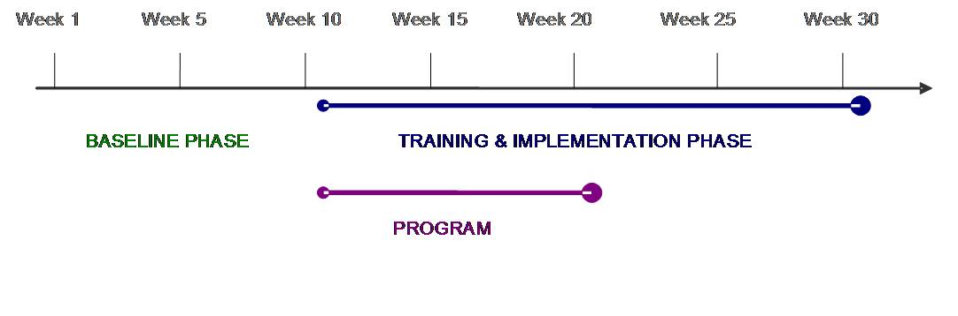
Figure 1. Study Design.

Service users continued receiving treatment as usual as delivered by their private or public service providers throughout the study period. Voice phenomenology measures were obtained from service users via brief interviews with the researcher weekly for the duration of the study and interviews were recorded on an MP3 voice recording device for the purpose of conducting a reliability check.
The program was delivered to carers in weeks 10-20 and consisted of 10, weekly, 2½ hour sessions. The program was jointly facilitated by the first two authors. Carers were required to attend at least 8 of the 10 sessions to maintain enrolment in the study. The training and implementation phase included the 10-week period following the program in which carers were encouraged to continue using strategies learned. The IEQ and FQ were completed by carers weekly for the duration of the study (30 weeks). Participation in the final 10 weeks of the study was optional, in recognition of the demands upon participants of such a long period of data collection.

Intervention

An outline of the program (known locally as CUPS – Carers Upskilling for Positive Symptoms) is presented in Table 1. A program manual (available on request) was developed for the study based upon evidence-based practices in the treatment of auditory hallucinations. For each session, the manual presents aims, weekly task sheets and worksheets; preparation and materials required; suggested facilitator reading for each session; and presentation slides and facilitator notes.

Table 1

Outline of the Program
Session | Topic/s
 | Introduction & Psychoeducation
 | Hallucinated Voices and Psychological Management Strategies
 | Introduction to Coping Strategies for Voices
 | Enhancing Your Relative’s Coping
 | Minimising Triggers and Facilitating Distancing
 | Beliefs About Voices – Introduction
 | Belief Modification – Analysis of Evidence
 | Having Helpful Conversations about Voices

Belief Modification – Reality Testing

Review of Program
 | Feedback and Planning Ahead

Each 2½ hour session started with a brief review of the topics covered in the previous session and an opportunity for carers to ask questions. The weekly task from the previous session was then reviewed, followed by problem solving around any difficulties encountered. The focus for the week was then presented, and upon conclusion of the session, a brief summary was provided, highlighting key points and outlining the homework task set for the coming week. Figure 2 shows a brief description of a session.
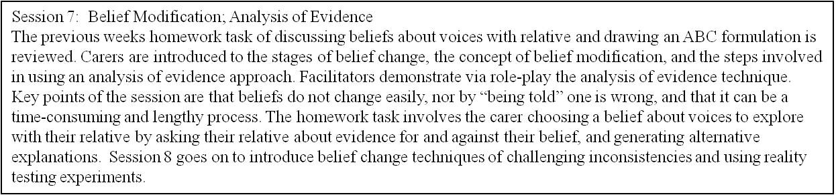
Figure 2. Description of one of the program sessions.

Analysis
SPSS 14 for Windows was used to undertake all statistical analyses. For primary outcome variables, sum-scores, and subscale scores were converted into a percentage of the maximum score for a particular measure for easier visual analysis and comparison between participants. The time-series data for each participant was studied in baseline and intervention phases, and models (with confidence intervals) fitted for each phase. To prevent violations of homoscedasticity, analysis of voice severity data excluded data points from weeks where no voices were heard. The majority of baselines fitted a simple linear model with no evidence of significant positive auto-correlation and as such, it was appropriate to conduct interrupted time-series analyses using ordinary least square measurement techniques to identify whether there was a departure in the training and implementation phase from the pre-existing model identified in the baseline phase. Due to the simplicity of the baseline models, it was possible to evaluate differences between baseline and training and implementation phases with simple pair-wise contrasts using the t-distribution
Data points that fell outside of 3 standard deviations from the mean of any model were excluded from analysis. Outcomes were measured by statistically, and clinically significant (defined as greater than 10% improvement), differences between baseline and intervention phases. Due to the small number of time-series data points, confidence intervals were calculated conservatively, using standard error values multiplied by critical values of the t-distribution (based on 0.05 level of significance on a two-tailed test). On the rare occasions in which the assumption of homogeneity of variance was violated, corrected values taking into account this variance were used.
Linear regressions were run to investigate the relationship between carer strategy use and voice severity. Statistical significance was set at a level of α < 0.05.

Results
Attrition
One service user withdrew from the study in week 5 of the baseline phase due to a severe relapse and subsequent hospitalisation, which raised doubts regarding her ability to provide continuing informed consent. All other participants completed the baseline and intervention phases, however, one service user and three carers opted out of the post-training data collection.
Demographics/Descriptive Information
All service users but one maintained stable medication regimes throughout the course of the study. Service User 1’s anti-psychotic medication dose was reduced to 400mg daily under the supervision of his psychiatrist in the training and implementation phase.
Table 2
Descriptive Information (Service Users)
Service User | Age (years) | Duration of psychotic illness (years) | No. of psychiatric hospitalisations | Medication (daily, unless stated otherwise)
SU 1 | 19 | 2 | 2 | 500mg clozapine (at baseline)
SU 2 | 29 | 6.5 | 2 | 17.5 mg olanzapine, 25mg sertraline
SU 3 | 38 | 10 | 2 | 1000mg lithium, 15mg olanzapine,  20 mg fluoxetine
SU 4 | 40 | 4 | 4 | 400mg clozapine, 60mg citalopram
SU 5 | 29 | 9 | 6 | 35mg risperidone injection (2/12),  900mg quetiapine PRN
SU 6 | 32 | 15 | 8 | 1500mg sodium valproate, 1200mg amisulpride, 150mg venlafaxine, 50mg risperidone injection (2/12)
SU 7 | 37 | 17 | >10 | 60mg propranolol, 2mg benztropine, 1600mg amisulpride, 1350mg lithium SR, 80mg fluoxetine

Inter-rater Reliability
A sample of the PSYRATS data was co-rated by a provisional psychologist experienced in PSYRATS assessment who was independent of the study. Three randomly selected PSYRATS interviews (one each from baseline, training, and intervention phases) for each service user were co-rated and regression analyses conducted to establish inter-rater reliability. The independent rater was blind to the phase of each interview. A very high inter-rater correlation was identified for PSYRATS total score (r =0.998, t = 55.89, p = 0.00). The other main outcome measures were self-report.
Acceptability of the Intervention
Carers’ feedback about the program indicated high levels of acceptability of the intervention (see Figure 3). Ratings of the ease of implementation of strategies ranged from 5-10/10, indicating some difficulty in this area, however no carers rated this as being ‘very difficult’. Qualitative feedback from a number of carers on the satisfaction questionnaire suggested that difficulty around implementation was related to cognitive strategies (e.g., discussing beliefs about voices) being more difficult to implement than behavioural strategies, finding time to use the strategies, and trying new approaches after having used others for a long period of time.
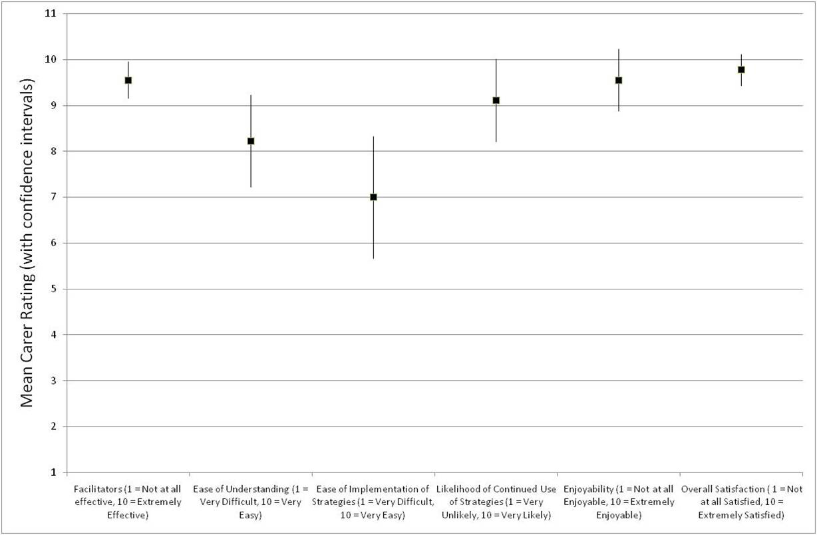

Figure 3. Mean carer ratings (with confidence intervals) on course acceptability items.
Carer Strategy Use
Carers reported their implementation of strategy use on a daily checklist. Behavioural strategies were as follows: Encouraging use of distraction, sub-vocalisation, competing auditory stimuli, self-instruction, activity; and, encouraging changes in level of social contact; minimizing stressors/triggers; and, altering the environment.
Cognitive strategies were: encouraging distancing from voices; identifying beliefs about voices with relative; exploring evidence for or against beliefs about voices; testing a belief by behavioural experiment; and, identifying alternative explanations. All carers reported using at least six of the eight behavioural strategies, and at least two of the five cognitive strategies at some time during the training and implementation phase. Weekly average number of occasions of behavioural and cognitive strategy implementation can be observed in Figures 4 and 5, respectively.
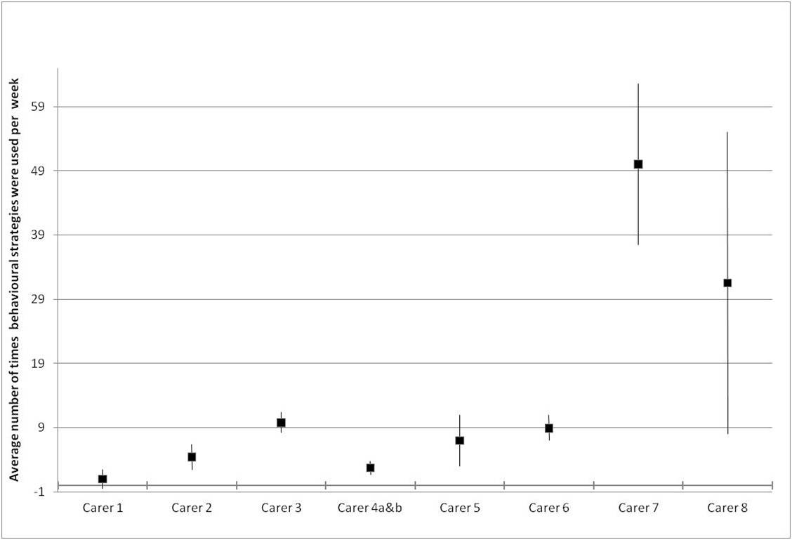
Figure 4. Carer mean weekly implementation of behavioural strategies (with confidence intervals).
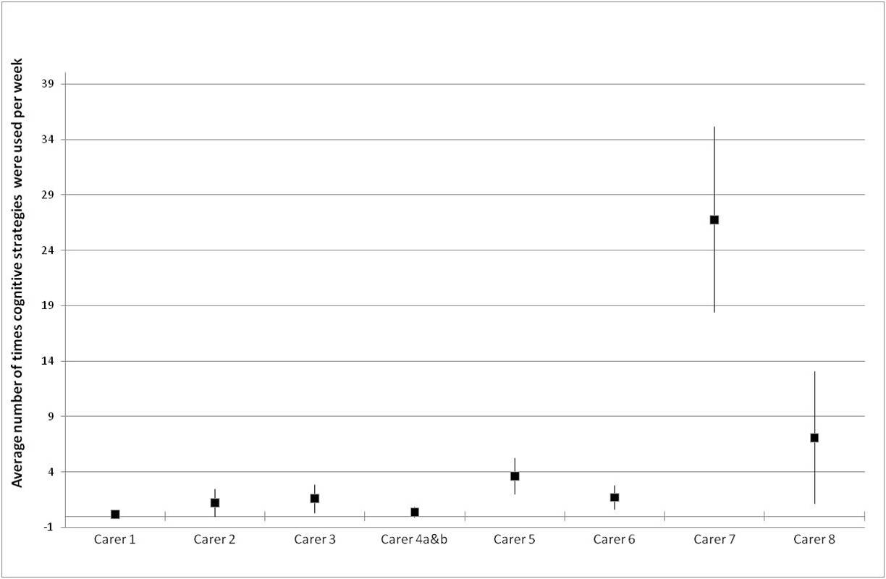
Figure 5. Carer mean weekly implementation of cognitive strategies (with confidence intervals).

The relationship between carers’ use of strategies taught in the course and the voice severity of the respective service users was examined via correlations. Negative correlations, indicating reduction in voice severity with greater use by carers of strategies, were identified for 5 out of 7 dyads, however, with the exception of one dyad, these relationships were not statistically significant. The only statistically significant relationship identified was a moderate negative correlation between service user voice severity and carer strategy use for Service User 6 (t =-3.54, p =0.01), a service user whose voice severity changed substantially. A moderate negative correlation approaching statistical significance was identified for Service User 2 (t =-2.03, p =0.08).

Service User Voice Severity

Service User 1’s voice severity data did not lend itself to time-series analysis. Although reporting current hallucinations at initial assessment, he reported hearing voices at only 3 of the 10 baseline time-points. Over the 20-week carer training and implementation period he reported just 3 further weeks in which he heard voices, indicating a further reduction of voice presence.

Voice severity time-series data were analysed for each of the other service users. Figure 6 provides an illustration, using the data from service user 7. A statistically and clinically significant difference between models in the baseline phase compared with the training and implementation phase was identified for this service user (t =4.217, p =0.000). Although greater variability is evident in voice severity in the training and implementation phase than in the baseline phase, the mean voice severity score is lower (67.5% in baseline, 48.78% training and implementation), and the long term stability point of the data is lower, showing an 18% mean reduction in the severity of voice severity for Service User 7.
The mean differences in voice severity (PSYRATS) between the baseline phase and the training and implementation phase for service users 2-7, based on individual time series analyses, are presented in Figure 7.
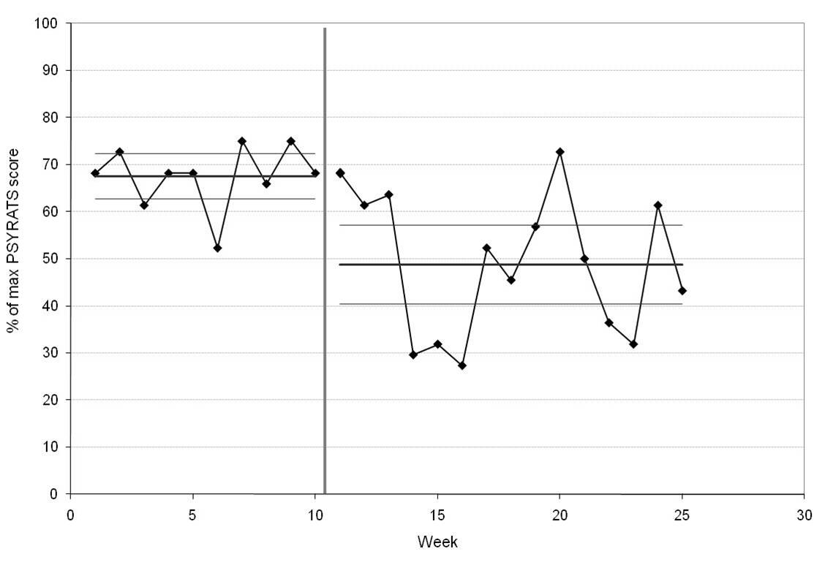
Figure 6. Voice severity time-series: Service User 7 (with phase means and confidence intervals).
Clinically significant improvements in voice severity were identified for Service User 7 (t =4.217, p =0.00), and Service User 6 (t =2.90, p =0.009). Service users 2, 3, 4 and 5 did not show clinically or statistically significant improvements in voice severity in the training and implementation phase.
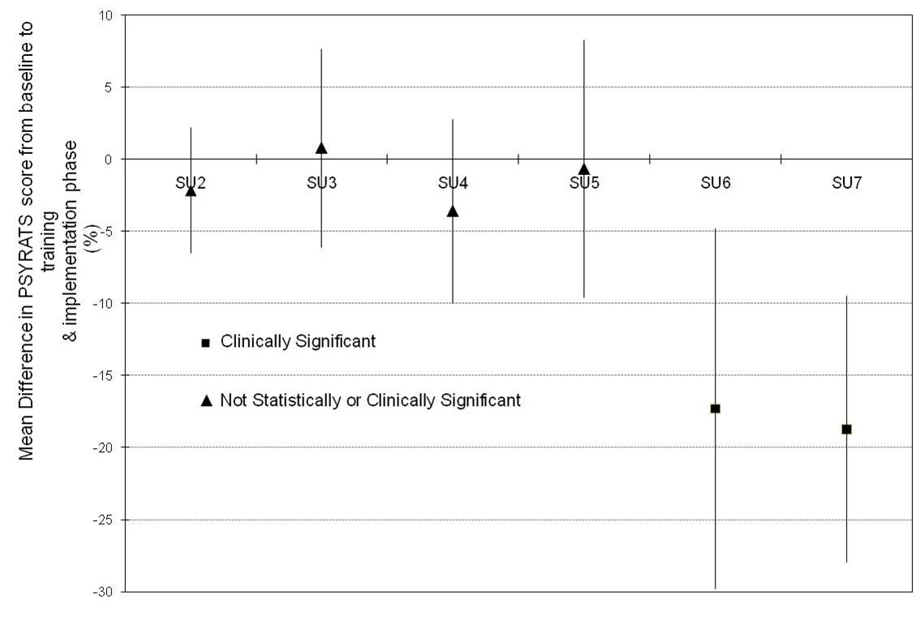
Figure 7. Service user (SU) voice severity: Mean differences from baseline to training and implementation phase (with confidence intervals)

Carer Expressed Emotion
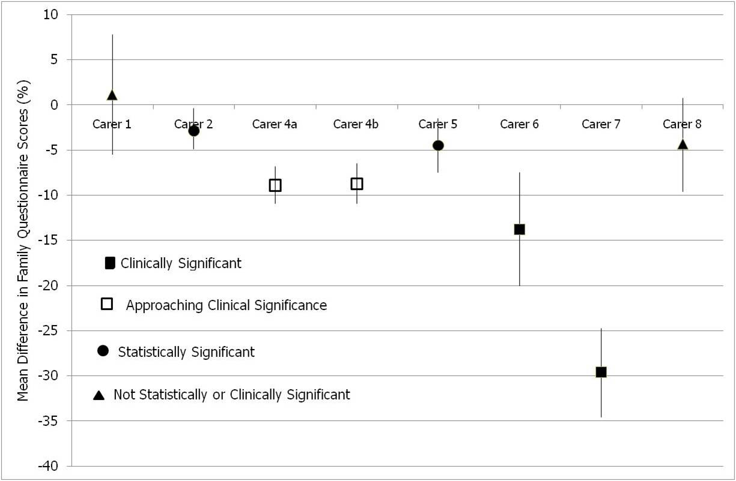
Figure 8. Carer expressed emotion: Mean differences from baseline to training and implementation phases (with confidence intervals).

Carer 7 and Carer 6 showed clinically significant reductions in expressed emotion in the training and implementation phase of the study (t =12.52, p =0.00; t =4.53, p =0.00, respectively) with Carer 4a and Carer 4b showing statistically significant reductions approaching a clinically significant level of change (t =9.11, p =0.00; t =8.29, p =0.00 respectively; see Figure 8). Carer 2 and Carer 5 showed a statistically, but not clinically, significant reduction in expressed emotion in the training and implementation phase of the study (t =2.43, p =0.02; t =3.11, p =0.00 respectively), with Carer 1 and Carer 8 showing no statistically significant change.
Expressed emotion scores for carer 3 reduced over several weeks from a high of 68% in week 1 of baseline, until fluctuating around 40% in weeks 7-10. Scores reduced a little more during the 10-week training period. Following the course, the ratings were generally higher, ranging widely from 30% to 75%. The significant positive auto correlation in the baseline period meant that further model fitting analysis was unlikely to yield useful information about an intervention effect, thus time series analysis was not carried out for this carer. Separate time series analyses were performed for each remaining carer using the Expressed Emotion measure.

Carer Burden
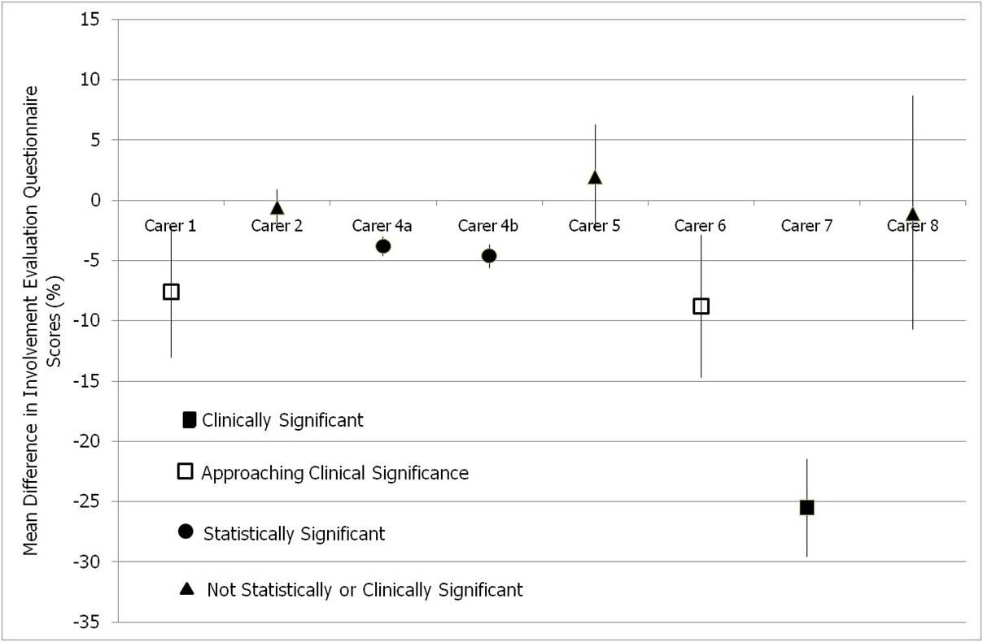
Figure 9. Carer subjective burden: Mean differences from baseline to training and implementation phase (with confidence intervals).
Five of the 8 carers showed a statistically significant reduction in burden between the baseline phase and the training and implementation phase (Figure 9). Once again, Carer 7 showed a clinically significant reduction in Subjective burden with a mean reduction of 25.6% in the training and implementation phase (t =12.94, p =0.00). Carers 4a and 4b and carers 1 and 6 all showed statistically significant reductions (t =10.22, p =0.00; t =10.11, p =0.00; t =3.07, p =0.005; t =2.90, p =0.008, respectively), but only the latter two approached clinical significance.

Discussion
The primary aim of this study was to evaluate the impact of a course that taught behavioural and cognitive intervention skills to carers to help them address problematic voice hearing in a relative. Although a small pilot program, the carer feedback and the time series data analyses provide useful information about feasibility of the intervention, outcome for the voice hearers and likely mechanisms of action.
Overall, the 10-week course was clearly acceptable to carers. The structured feedback revealed high levels of satisfaction with the CUPS training program, with carers reporting that they were able to understand the concepts and strategies introduced, and that they intended to continue using these following cessation of the program. Regarding the feasibility of carers learning and implementing naturalistic behavioural and cognitive intervention strategies, the strategy implementation records over the 10-week training period showed that all carers implemented at least nine of the 13 strategies learned. Their feedback about strategy implementation suggested that the behavioural and environmental strategies were easier to employ than cognitive techniques such as conversations designed to weaken evidence for a belief about voices. This is hardly surprising, as the nature of such an interaction is more complex than encouraging a voice-hearer to try a behavioural management strategy such as reducing triggers or increasing auditory stimulation. It also suggests that closer examination of the extent to which cognitive strategies are, or can be, successfully taught would be desirable in future research, A challenge in doing this is that established processes for assessing fidelity (Perepletchikova, Treat, & Kazdin, 2007) and CBT skills (Startup, Jackson, & Pearce, 2002) typically rely on recordings of direct interactions with the service user, thus may not feasible in a context where carers are the implementers of the intervention in informal home environments.
Our results suggest that voice severity for people with psychosis can be impacted by an intervention that works through carers, rather than directly with the service users. Statistically and clinically significant improvements in voice severity were evident for two of the six service users with time series data, and the frequency of hearing voices for a further service user halved in the intervention and follow-up period. Studies of individual and group CBT for psychosis suggest that at most, about 50% of participants will achieve clinically significant change (Gaudiano, 2005). It could be expected that carers without a foundation in therapy skills, and who had only 25 hours of training, would achieve a considerably lesser rate of clinically significant change. The proportion of participants with clinically significant improvement in our sample, if it were to be replicated in larger studies, is therefore most promising.

In addition to these benefits for some of the service users, a majority of carers experienced reduced subjective burden. Given that it has been well established that carers of individuals with a psychiatric illness experience substantial burden (Creer & Wing, 1974; Fadden, Bebbington, & Kuipers, 1987; Joyce et al., 2003) the implication of our study that an intervention based on encouraging realistic changes in carer interactions with service users can reduce Subjective burden, rather than add burden to already burdened carers, is notable. Reductions in burden have been rarely reported in the family intervention for psychosis literature (Barbato & D' Avanzo, 2000).
While the study demonstrated the feasibility of this novel approach, it did not address in depth the process by which beneficial outcomes for service users were achieved. The hypothesised route of change for service user symptomatology in the present study was via an increase in carers’ and service users’ use of psychological management strategies. The results provide some evidence for this route, with one statistically significant correlation identified between carer strategy use and significant reductions in service user voice symptomatology, and one further correlation approaching statistical significance. This is consistent with literature in the field of coping with hallucinated voices, which provides some evidence for the efficacy of selected behavioural coping strategies (Farhall et al., 2007). It is possible that the correlation analysis undertaken (relationship between weekly ratings of voice severity and extent of carer strategy use that week) may have been too simplistic by not allowing for any time lag between the point of time in which a carer suggests or encourages a strategy to the service user, and the service user’s actual application of that strategy. A more effective way of measuring this may have been to ask the service user to keep a checklist of strategies employed, to see whether use of new strategies, or improved use of them, is correlated with voice symptomatology.

As we did not collect coping strategy implementation data from service users, we cannot be sure how frequently (or if at all) the introduction of an intervention by a carer resulted in an application of the strategy by the service user. Previous research suggests that the breadth of the coping repertoire is related to outcome (Farhall et al., 2007), thus it is likely that the participants who showed improvements in voice severity were those who tried more new strategies than those who did not benefit as obviously. Future studies should include measures of both carer strategy use and service user strategy use to assess the dissemination and acceptability of the intervention at the service user level. It is also important to note that while some strategies required the service user’s active participation (e.g., humming, monitoring voice phenomenology), others were able to be used by the carer (e.g., altering levels of stimulation, encouraging activity), thus future studies should differentiate the impact of these categories of intervention.
An important alternative explanation for the reductions in service user voice symptomatology is via the mechanism of reduction in carers’ EE. Despite not being a direct target of the CUPS intervention, clinically significant improvements in EE were identified for two carers, and in each case their voice hearing relative showed clinically significant improvements in voice severity. This interpretation of the mechanism of change is strengthened by the observation that while only one of these dyads showed a significant negative correlation between carer strategy use and voice severity, both carers demonstrated reductions in EE, suggesting this as a shared factor in the service user improvements. It is also supported empirically by the strong evidence-base reporting an association between reduced EE and reductions in service user relapse (Pilling et al., 2002).
It is possible that reductions in EE may have occurred in the context of the carers’ improved knowledge and understanding about the nature and intensity of psychotic experiences and related service user behavior (topics addressed explicitly in the course), leading to a shift in illness attributions from internal to external (Barrowclough, et al.,1994; Brewin, et al., 1991). This may subsequently have led to a reduction in critical comments, reducing the service users’ stress and arousal, leading to reduced voice symptomatology (Myin-Germey & van Os, 2007). If supported by future studies, these results would strengthen the case for the importance of psycho-education in family interventions. Furthermore, they also raise a question regarding the effects of behavioural and cognitive strategies over and above psycho-education alone, a question that has been long-standing, but not frequently investigated (Tarrier, Barrowclough, Vaughn, & Bamrah, 1988). Specific measures of carer attributions would have provided useful information with regard to this possible mechanism of action.
Implications for Treatment
If improvement in carers’ expressed emotion is made via changes to illness attributions, as suggested, then it could be argued that this program may have little effect over and above a psycho-education program alone. While dismantling approaches assessing individual components of interventions in this field are difficult to undertake and would require enormous samples to detect effect sizes (Gaudiano, 2005), research designs using psycho-education as a comparison group would assist in evaluating the effectiveness of behavioural and cognitive components of interventions. Direct evidence for the role of more accurate illness attributions by carers as a pathway to improved EE and service user voice symptomatology might also suggest that intervention would be best targeted at carers who show higher levels of (or perhaps firmly held) internal attributions regarding their relatives illness.
Of particular note are the Subjective burden results of the study, which indicate that carers can be trained in principles and strategies of CBT for psychosis without resulting in increased burden (as measured by subjective burden), and can even reduce carer burden to a clinically significant degree.
Limitations
Recruitment of a small, self-selected sample limits the generalisability of the results; however the difficulty in recruiting consenting pairs of service users and carers, and the evaluation demands on participants precluded a larger scale pilot. Nonetheless, the study took an important and realistic first step in establishing a treatment effect when carers are trained to informally use behavioural and cognitive change interventions with voice hearers.
While the 30-week study period in the present study was challenging with regard to data collection on the part of both researcher and participants, the absence of further weeks to assess follow-up effects is a limitation.
The rationale of the study was that carers could assist and teach behavioural coping strategies to their ill relative, and hold conversations that may over time weaken unhelpful beliefs about voices. Although some attention was given to measurement of process, the primary measures related to outcome – a key recommendation for future studies is the inclusion of measures of behavioural coping strategies actually implemented by service users (rather than raised by their carer), and measures of change in relevant cognitions such as beliefs about voices.
Conclusions
The present study provides promising pilot results indicating that training family carers in basic principles and strategies of CBT for psychosis is possible, highly acceptable, and can result in clinically significant improvements in service user voice symptomatology, and reduction in carer burden.
Two possible mechanisms of action had some support. The hypothesised link between carer use of behavioural and cognitive strategies, and improvements in service user voice symptomatology was weakly supported, but in the context of some design limitations that may have reduced the likelihood of finding relationships. An alternative mechanism of change was also suggested by the data. Shifting illness attributions from internal to external may have led to a less critical and strained environment (low EE) resulting in reductions in service user stress and arousal and subsequent improvements seen in symptoms. Given the small numbers in the study, these interpretations are somewhat speculative, but plausible in the context of existing literature. Further investigation is required to more conclusively identify mechanisms of action, essential in establishing important (and possibly redundant) components of such an intervention.

References
Barbato, A., & D' Avanzo, B. (2000). Family interventions in schizophrenia and related disorders: A critical review of clinical trials. Acta Psychiatrica Scandinavica, 102(2), 81-97. doi:10.1034/j.1600-0447.2000.102002081.X
Barrowclough, C., & Tarrier, N. (1992). Innovations in the psychological management of schizophrenia: Assessment, treatment and services. In M. Birchwood & N. Tarrier (Eds.), Interventions with families (pp. 79-101). Oxford, England: John Wiley & Sons.
Barrowclough, C., Johnston, M., & Tarrier, N. (1994). Attributions, expressed emotion, and patient relapse - an attributional model of relatives response to schizophrenic illness. Behavior Therapy, 25(1), 67-88. doi:10.1016/S0005-7894(05)80146-7.
Brewin, C. R., McCarthy, B., Duda, K., & Vaughn, C. E. (1991). Attribution and expressed emotion in the relatives of patients with schizophrenia. Journal of Abnormal Psychology, 100(4), 546-554. doi:10.1037/0021-843X.100.4.546.
Brooker, C., Falloon, I., Butterworth, A., Goldberg, D., Graham-Hole, V., & Hillier, V. (1994). The outcome of training community psychiatric nurses to deliver psychosocial intervention. British Journal of Psychiatry, 165(2), 222-230. doi:10.1192/bjp.165.2.222.
Brooker, C., Tarrier, N., Barrowclough, C., Butterworth, A., & Goldberg, D. (1992). Training community psychiatric nurses for psychosocial intervention: Report of a pilot study. British Journal of Psychiatry, 160, 836-844. doi:10.1192/bjp.160.6.836.
Chen, J. (2000). Comparative study on family intervention on schizophrenics in rural community. Journal of Handan Medical College, 16(6), 435-436.
Chen, G., Li, B., & Li, C. (2002). Efficacy of individual family intervention for schizophrenia patients: three years followed up study. Chinese Journal of Behavioral Medical Science, 11(4), 395-396.
Creer, C., & Wing, J. K. (1974). Schizophrenia in the Home. Surbiton: National Schizophrenia Fellowship.
Fadden, G., Bebbington, P., & Kuipers, L. (1987). The burden of care: The impact of functional psychiatric illness on the patient's family. British Journal of Psychiatry, 150, 285-292. doi:10.1192/bjp.150.3.285.
Farhall, J.F. & Cotton, S. (2002). Implementing psychological treatment for symptoms of psychosis in an area mental health service: The response of patients, therapists and managers. Journal of Mental Health, 11(5), 511-522. doi:10.1080/09638230020023868.
Farhall, J., Freeman, N., Shawyer, F., & Trauer, T. (2009). An effectiveness trial of cognitive behaviour therapy in a representative sample of outpatients with psychosis. British Journal of Clinical Psychology, 48, 47-62.
Farhall, J., Greenwood, K., & Jackson, H. (2007). Coping with hallucinated voices in schizophrenia: a review of self-initiated strategies and therapeutic interventions. Clinical Psychology Review, 27, 476-493. doi:10.1016/j.cpr.2006.12.002.
Gaudiano, B. A. (2005). Cognitive behavior therapies for psychotic disorders: Current empirical status and future directions. Clinical Psychology: Science and Practice, 12(1), 33-50. doi:10.1093/clipsy/bpi004.
Gaudiano, B.A. (2006). Is Symptomatic Improvement in Clinical Trials of Cognitive-Behavioral Therapy for Psychosis Clinically Significant? Journal of Psychiatric Practice, 12(1), 11-23. doi:10.1097/00131746-200601000-00003.
Garety, P. A., Kuipers, E., Fowler, D., Freeman, D., & Bebbington, P. E. (2001). A cognitive model of the positive symptoms of psychosis. Psychological Medicine, 31(2), 189-195. doi:10.1017/S0033291701003312.
George, S., Bandopadhay, S., & Cowan, C. (2005). A case report of informal cognitive therapy of delusions by a carer: A novel treatment paradigm? European Psychiatry, 20(1), 80-81. doi:10.1016/j.eurpsy.2004.09.027.
Haddock, G., McCarron, J., Tarrier, N., & Faragher, E. B. (1999). Scales to measure dimensions of hallucinations and delusions: The psychotic symptom rating scales (PSYRATS). Psychological Medicine, 29(4), 879-889. doi:10.1017/S0033291799008661.
Joyce, J., Leese, M., Kuipers, E., Szmukler, G., Harris, T., & Staples, E. (2003). Evaluating a model of caregiving for people with psychosis. Social Psychiatry and Psychiatric Epidemiology, 38(4), 189-195. doi:10.1007/s00127-003-0618-3.
Kavanagh, D. J. (1992). Recent developments in expressed emotion and schizophrenia. British Journal of Psychiatry, 160, 601-620. doi:10.1192/bjp.160.5.601.
Kazdin, A. E. (2003). Methodological issues and strategies in clinical work. Washington, DC: American Psychological Association.
Lancashire, S., Haddock, G., Tarrier, N., & Baguley, I. (1997). Effects of training in psychosocial interventions for community psychiatric nurses in England. Psychiatric Services, 48(1), 39-41.
Li, F., & Xu, J. (2003). Comparative study on the effect of family intervention on schizophrenia patients in convalescence and their family members. Health Psychology Journal 7474(2), 129-130.
McFarlane, W . (2003). How do we know what is going on in family therapy, even when it works? Families, Systems, & Health, 21(1); 53-56. doi:10.1037/h0089501.
Mehta, M. (1990). A comparative study of family-based and patient-based behavioural management in obsessive-compulsive disorder. The British Journal of Psychiatry, 157, 133-135. doi:10.1192/bjp.157.1.133.
Moran, M. (2003). Psychosocial treatments rare for schizophrenia patients. Psychiatric News, 38, 12.
Morrison, A.P., French, P., Walford, L., Lewis, S.W., Kilcommons, A., Greene, J.., Parker, S., Bentall, R, P. (2004). Cognitive therapy for the prevention of psychosis in people at ultra-high risk. The British Journal of Psychiatry,185, 291-297. doi:10.1192/bjp.185.4.291.
Myin-Germeys, I., & van Os, J. (2007). Stress-reactivity in psychosis: Evidence for an affective pathway to psychosis. Clinical Psychology Review, 27(4), 409-424. doi:10.1016/j.cpr.2006.09.005
Perepletchikova, F., Treat, T. A., & Kazdin, A. E. (2007). Treatment Integrity in Psychotherapy Research: Analysis of the Studies and Examination of the Associated Factors. Journal of Consulting and Clinical Psychology, 75(6), 829-884. doi:10.1037/0022-006X.75.6.829.
Pilling, S., Bebbington, P., Kuipers, E., Garety, P., Geddes, J., Orbach, G., & Morgan, C. (2002). Psychological treatments in schizophrenia: I. Meta-analysis of family intervention and cognitive behaviour therapy. Psychological Medicine, 32(5), 763-782. doi:10.1017/S0033291702005895.
Startup, M., Jackson, M., & Pearce, E. (2002). Assessing Therapist Adherence to Cognitive-Behaviour Therapy for Psychosis. Behavioural and Cognitive Psychotherapy, 30, 329-339. doi:10.1017/S1352465802003077.
Tarrier, N., Barrowclough, C., Vaughn, C., & Bamrah, J. S. (1988). The community management of schizophrenia: A controlled trial of a behavioural intervention with families to reduce relapse. British Journal of Psychiatry, 153(532-542). doi:10.1192/bjp.153.4.532.
Turkington, D., Kingdon, D., & Turner, T. (2002). Effectiveness of a brief cognitive-behavioural therapy intervention in the treatment of schizophrenia. British Journal of Psychiatry, 180(6), 523-527. doi:10.1192/bjp.180.6.523.
Van Noppen, B., Steketee, G., McCorkle, B., Pato, M. (1997). Group and multifamily behavioral treatment for obsessive compulsive disorder: A pilot study. Journal of Anxiety Disorders, 11(4), 431-446. doi:10.1016/S0887-6185(97)00021-2.
van Wijngaarden, B., Schene, A. H., Koeter, M., Vazquez-Barquero, J. L., Knudsen, H. C., Lasalvia, A., McCrone, P., & Group, E. S. (2000). Caregiving in schizophrenia: Development, internal consistency and reliability of the Involvement Evaluation Questionnaire--European Version: EPSILON Study 4. British Journal of Psychiatry, 177(39), s21-s27. doi:10.1192/bjp.177.39.s21.
Wykes, T., Steel, C., Everitt, B., & Tarrier, N. (2007). Cognitive behaviour therapy for schizophrenia: Effect sizes, clinical models, and methodological rigor. Schizophrenia Bulletin, 114, 1-15.
Zhu, Y., Zhu, Q., & Sun, X. (2002). A controlled study of the effects of family education on patients with schizophrenia in rehabilitation. Health Psychology Journal, 10(3), 169-171.
Zimmerman, G., Favrod., J., Trieu, V.H., & Pomini, V. (2005). The effect of cognitive behavioral treatment on the positive symptoms of schizophrenia spectrum disorders; A meta-analysis. Schizophrenia Research, 77, 1-9. doi:10.1016/j.schres.2005.02.018.

