Left running head: L. Ellett

right running head: Mindfulness and paranoia

Mindfulness for Paranoid Beliefs: Evidence from Two Case Studies

Lyn Ellett
Royal Holloway, University of London, UK

Background: Emerging evidence suggests that mindfulness can be beneficial for people with distressing psychosis. This study examined the hypothesis that for people with persecutory delusions in the absence of voices, mindfulness training would lead to reductions in conviction, distress, preoccupation and impact of paranoid beliefs, as well as anxiety and depression. Method: Two case studies are presented. Participants completed measures of mindfulness, anxiety and depression at baseline, end of therapy and 1 month follow up, and bi-weekly ratings of their paranoid belief on the dimensions of conviction, preoccupation, distress and impact. Results: Ratings of conviction, distress, impact and preoccupation, and measures of anxiety and depression, reduced for both participants from baseline to end of intervention. Improvements in mindfulness of distressing thoughts and images occurred for both participants. These gains were maintained at 1 month follow up. Conclusions: Findings suggest that mindfulness training can impact on cognition and affect specifically associated with paranoid beliefs, and is potentially relevant to both Poor Me and Bad Me paranoia.

Keywords: Mindfulness; persecutory delusions; case report; distress; conviction

Introduction
There is an emerging evidence base showing the potential benefits of mindfulness for individuals with distressing psychosis. An initial uncontrolled study found significant pre-post improvement in clinical functioning amongst 10 patients with distressing psychosis following 6 sessions of group mindfulness; secondary analyses also indicated improvement in mindfulness skills (Chadwick, Newman-Taylor & Abba, 2005). In a randomised feasibility trial (Chadwick, Hughes, Russell, Russell & Dagnan, 2009) 22 patients with distressing voices and paranoid beliefs were randomly allocated to either group-based mindfulness therapy or waitlist control for this therapy, with clinical functioning the primary outcome. A medium effect size was reported from the group comparison, and secondary analyses combining both groups and comparing scores before and after mindfulness training revealed significant improvement in clinical functioning and mindfulness of distressing thoughts and images. In another study, participants with psychosis randomised to an 8-week mindfulness intervention showed significantly more improvements in mindfulness of distressing thoughts and images than those randomised to waitlist control (Langer, Cangas, Salcedo & Fuentes, 2012). To complement ongoing quantitative research, qualitative studies have also started to identify possible mechanisms of change in mindfulness for psychosis, which have included centering in awareness of psychosis, allowing voices, thoughts and images to come and go without reacting or struggle, and reclaiming power through acceptance of psychosis and the self (Abba, Chadwick & Stevenson, 2008).
Collectively, these studies attest to the benefits of mindfulness practice for distressing psychosis, and suggest potential change mechanisms. However, studies have yet to examine benefit and process of change of mindfulness for people with persecutory delusions in the absence of voices. The focus on persecutory delusions is important because (a) it can be particularly difficult working directly with persecutory beliefs in CBT, and mindfulness offers an opportunity to ease distress without focusing on belief content and (b) it might be argued that it is easier to grasp mindfulness principles and practice in relation to voices, which are clearly distinct from one’s own thoughts, compared with paranoid cognitions, which can more easily fuse with worry and rumination.. Also, research on mindfulness for psychosis has yet to assess change in depression and anxiety. The present study reports 2 single cases testing the hypothesis that mindfulness training would result in reductions in conviction, distress, preoccupation and impact of paranoid beliefs, reductions in anxiety and depression, and improvements in mindfulness of distressing thoughts and images.

Method
Participants
Both participants met DSM IV diagnostic criteria for Delusional Disorder, had current distressing paranoid beliefs, and were meditation naïve. Both lived independently, took antipsychotic medication and received standard care from UK mental health services. Participant A was a 34 year old man who believed that other people were out to get him because they knew his history. He believed that he deserved to be persecuted (Bad Me Paranoia: Trower & Chadwick, 1995) because he had done some bad things in the past (client declined to further elaborate). He avoided public transport and left his flat only to attend essential appointments and buy food, due to fear of being attacked by his persecutors. Participant B was a 49 year old man who believed that his neighbours were tormenting him by deliberately damaging his car and property. He believed his persecution was completely undeserved (Poor Me Paranoia: Trower & Chadwick, 1995), and the reason for it was because they knew about his mental health difficulties and judged him negatively as a result. Participant B spent time checking his car and property and engaging in angry rumination about his persecutors. Neither participant had a history of hearing voices.

Measures
Consistent with published mindfulness for psychosis research, participants completed ratings of persecutory belief dimensions, including conviction, distress, impact and preoccupation on an 11 point scale grounded at either end as 0 (not at all) to 10 (totally) Please see Appendix 1 for a copy of the belief ratings used. Ratings were made at the end of each session, and once at home midway between sessions (to check for session-effects and generalisation). To assess mindfulness, anxiety and depression, participants completed the Southampton Mindfulness Questionnaire (SMQ, Chadwick et al., 2008) and the Hospital Anxiety and Depression Scale at the start of baseline, end of intervention and at 1 month follow up.

Mindfulness intervention
Sessions were conducted by one clinical psychologist (LE) who had four years mindfulness experience, including a 5 day MBCT training in Oxford. The content of sessions followed Chadwick et al (2005; 2009), such that mindfulness practice combined focusing awareness in body and breathing with open, or ‘choiceless’ awareness. Guidance during practice was frequent, to minimise the likelihood of participants getting lost in paranoid rumination, and referred explicitly to psychotic experiences and reactions to them.
Sessions lasted an hour each week, and included review of practice over the previous week and two 10-minute guided mindfulness practices. Each practice was followed by approximately 15 minutes of discussion to facilitate reflective learning and metacognitive insights about the nature of experience (e.g. unpleasant psychotic sensations do not stay in awareness permanently) and how reactions to it (e.g. judgement, rumination) maintain distress. The baseline phase lasted for 3 sessions for both participants, who each received 6 individual intervention sessions. Participants were given audio recordings of the guided practice, and were encouraged to practise between sessions.

Results
Belief dimensions of conviction, distress, impact and preoccupation of paranoid beliefs were plotted over time (Figure 1). Whilst there was some variability in dimensions during the 3-week baseline phase for both participants, there was no evidence of systematic change. Following the mindfulness intervention, self-ratings for all four belief dimensions reduced for both participants, so too did anxiety and depression. These gains were maintained at 1-month follow-up (Participant A Anxiety: baseline 17, end of intervention 3, follow up 3; Depression: baseline 15, end of intervention 3, follow up 3. Participant B Anxiety: baseline 12, end of intervention 10, follow up 10; Depression: baseline 20, end of intervention 8, follow up 8). Improvements in mindfulness of distressing thoughts and images, measured using the SMQ, occurred for both participants (Participant A: baseline 21, end of intervention 75, follow up 77; Participant B: baseline 31; end of intervention 56; follow up 60).

Insert Figure 1 here

Participants also reported behaviour change which they attributed to mindfulness practice. Participant A reported that he had used public transport on several occasions and had visited the local shopping centre; Participant B reported spending less time checking his car and property, and less time engaged in rumination. Both reported behaviour change and general clinical improvement were independently validated by the participant’s psychiatrist and key worker. No adverse events or consequences were reported by participants or therapist.

Discussion
Findings from the two cases suggest that mindfulness training resulted in reductions in key dimensions of paranoid beliefs, namely conviction, distress, preoccupation and impact. Depression and anxiety also reduced for both participants, although anxiety reduction for Participant B was minimal compared with a marked reduction for Participant A. Replicating previous studies (e.g. Chadwick et al, 2009; Langer et al, 2012), improvements were found on the SMQ, though the design used cannot establish that improved mindfulness mediated change in paranoia.
The study contributes to the literature on mindfulness for distressing psychosis in a number of ways. First, it shows potential benefits of mindfulness training alone to persecutory beliefs in the absence of voices – in Chadwick et al (2009) all 19 participants who reported paranoid beliefs also heard voices. Second, reductions in anxiety and depression following mindfulness practice have been shown for the first time in those with distressing psychosis; replication in future large scale studies is clearly needed. Third, it casts light on the process of change, showing how for both participants, reduction in dimensions of persecutory beliefs was accompanied by improvement in depression and anxiety scores (i.e. there was no indication of post-psychotic depression). Finally, the study supports application of mindfulness interventions for both Poor Me and Bad Me paranoia (Trower & Chadwick, 1995).
There are a number of methodological limitations with the study. First, the reported changes in belief dimensions could be due to demand characteristics, or timing of measurement at the end of each session. Against this, ratings completed outside sessions were consistent with within-session ratings, with independent validation of change for both participants. Second, although both participants reported practising mindfulness between sessions, this was not formally measured. Finally, the follow-up period was short. However, the primary interest was in whether mindfulness can impact on persecutory beliefs; maintenance will depend largely on continued practice and wasn’t the main focus with a small sample size. In spite of these limitations, the case studies reported here add to the literature on the impact of mindfulness for people with distressing psychosis, suggesting that mindfulness training can yield changes in cognition and affect specifically associated with paranoid beliefs.

References
Abba, N., Chadwick, P.D.J., & Stevenson, C. (2008). Responding mindfully to distressing psychosis: A Grounded Theory Analysis. Psychotherapy Research, 18, 77-87.
Chadwick PDJ, Hember M, Symes J, Peters E, Kuipers, E & Dagnan, D. (2008). Responding mindfully to distressing thoughts and images: evaluation of the Southampton mindfulness questionnaire (SMQ). British Journal of Clinical Psychology, 47, 451-455.
Chadwick, P.D.J., Newman-Taylor, K. & Abba, N. (2005). Mindfulness groups for
people with distressing psychosis. Behavioural & Cognitive Psychotherapy,
33, 351-359.
Chadwick P.D.J., Hughes, S, Russell, I, Russell, D & Dagnan, D. (2009). Mindfulness groups for distressing psychosis: A replication and feasibility study. Behavioural & Cognitive Psychotherapy, 37, 403-413.
Langer, A.I., Cangas, A.J., Salcedo, E., & Fuentes, B. (2012). Applying mindfulness
therapy in a group of psychotic individuals: A controlled study. Behavioural and Cognitive Psychotherapy, 40(1), 105-11.
Trower, P., & Chadwick, P.D.J. (1995). Pathways to defense of the self: A theory of
two types of paranoia. Clinical Psychology: Science and Practice, 2(3), 263-
276.

Figure 1. Measures of dimensions of paranoid beliefs over time.

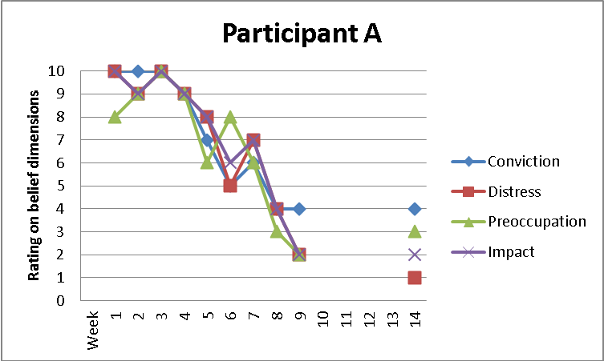

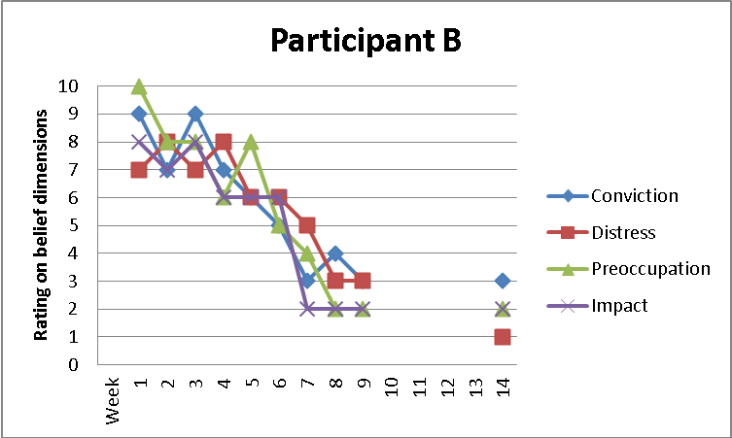

Appendix 1. Weekly and between session belief ratings.

Belief: …………………………………………………………

- How much do you believe this right now?

0 1 2 3 4 5 6 7 8 9 10
Not at Totally
all

- How distressed are you by this right now?

0 1 2 3 4 5 6 7 8 9 10
Not at Totally
all

- How much impact has this belief had over the past few days?

0 1 2 3 4 5 6 7 8 9 10
None at Extreme Impact
all

- How preoccupied have you been with this belief over the past few days?

0 1 2 3 4 5 6 7 8 9 10
Not at all Totally
Preoccupied preoccupied

