Cognitive Behavioural Therapy for Depression and Anxiety in a Carer for Two Family Members With Dementia: A Single Case Experimental Design Study.

Abstract

This case study aimed to evaluate the application of CBT to a client experiencing anxiety and depression whilst caring for two family members with dementia. The client received cognitive behaviour therapy (CBT) consisting of cognitive restructuring of unhelpful thoughts about dementia caregiving and increasing engagement in pleasurable activities. Although unhelpful thoughts did not completely disappear by the end of therapy, the client’s depression and anxiety scores improved significantly and she met her goal of being able to manage when caregiving activities go wrong during daily life. Implications for clinical practice when working with dementia family caregivers are discussed.

Keywords: Cognitive behavioural therapy, anxiety, depression, carer, dementia

**Cognitive Behavioural Therapy for Depression and Anxiety in a Carer for Two Family Members With Dementia: A Single Case Experimental Design Study.**

**Critical Overview of the Literature**

More than 800,000 people in the UK alone have dementia, two thirds of whom are cared for by around 670,000 informal caregivers, predominantly family members such as partners (Knapp et al., 2014). Providing care for family members with dementia can have positive effects, such as personal accomplishment and gratification, feelings of mutuality in a dyadic relationship, and a greater sense of family cohesion, personal growth and purpose in life (Doris, Cheng & Wang, 2018). Nonetheless, since dementia is a degenerative condition impacting someone’s daily functioning, the burden on carers increases over time. Research has sadly demonstrated that 40% of dementia family caregivers (DFCs) have symptoms of depression or anxiety (Livingston et al., 2014a). Daily life may be dominated by intense worries in multiple contexts about the uncertainty of what may happen in the future whilst caring for their family member, which may lead to feelings of being on edge, distressing thoughts, and reduced concentration. Caregivers may also experience low mood around their family member’s condition and life after diagnosis, which may involve a sense of loss, reduced participation in pleasurable activities, sleep disturbances, poor concentration, disturbed eating patterns, and sometimes suicidal ideation.

Due to an ageing population, DFCs increasingly tend to be older adults in the ‘sandwich generation’, who may care for parents as well as partners with dementia, on top of potential existing responsibilities for children and grandchildren. This poses unique challenges as these carers may struggle adapting to life transitions such as entering retirement, whilst facing a reversal in their roles due to new caring responsibilities for their parent and partner (Schumacher, 2010). Simultaneously, DFCs also face barriers to seeking help, such as feelings of guilt if they admit their role is a ‘burden’, and loneliness if they seek respite (Bruinsma et al., 2020; Gallego-Alberto et al., 2020).

Several models have been applied to depression and anxiety in these so-called ‘invisible second patients’ (Brodaty & Donkin, 2009). Cognitive behavioural models of depression and anxiety for older people underline the interactions between thoughts, feelings and behaviours which may result in psychological distress. For example, although dementia may be a critical incident triggering difficulty, carers may have early experiences across the developmental lifespan which lead them to have ‘dysfunctional beliefs’ about themselves, those around them and the world. This may lead carers to have certain cognitive biases and negative automatic thoughts about themselves as carers and others, such as professional staff (Jurgens et al., 2012). Carers may feel the need to give everything to their new caregiving role due to high expectations, which in turn can perpetuate low mood if these are not met. They may also understandably worry about potential feared consequences in the future as dementia progresses, coupled with concerns they will not have the resources to cope, leading them to be anxious (Losada et al., 2011).

Although early studies involving CBT for depression and anxiety in this population suggested that it was helpful (Pinquart & Sörenson, 2006), Laidlaw et al. (2004) suggested that early models of depression and anxiety did not consider key contextual factors for older people, such as cohort beliefs, role investments, intergenerational linkages, sociocultural context and health beliefs, all of which could impact how DFCs could think, feel and behave. More recently, Losada et al. (2011) devised a CBT program which tackled four components: firstly, cognitive restructuring of dysfunctional thoughts about dementia caregiving, secondly, assertive skills such as asking for help, thirdly, building relaxation strategies, and finally, increasing engagement in pleasurable activities. These topics are also similar in the ‘Strategies for Relatives’ (START) programme. Both of these programmes have been backed by randomised controlled trials demonstrating their effectiveness (Livingston et al., 2013; Losada et al. 2015).

Most recent systematic reviews suggest that cognitive behavioural approaches seem to provide the most beneficial effects for this population (Wiegelmann et al., 2021). CBT is recommended for dementia caregivers by the National Institute for Health and Care Excellence (NICE; NICE, 2012), and the research has consistently illustrated the main mechanisms of action in CBT for alleviating distress in DFCs are increasing pleasurable activities and altering maladaptive thought patterns (Losada et al., 2011).

However, some studies report the positive outcomes are small effects, limited to group CBT for caregiving depression (Hopkinson et al., 2019). Additionally, each family context may vary and thus carers may require individualised interventions. Most research has also focused on those who provide dementia care for solely one family member. The current study therefore aims to elucidate this mixed picture in the research, by evaluating the individual application of CBT to an older adult experiencing low mood and anxiety around caring for not just one, but two family members with dementia.

**Introduction to the Case**

Mrs P was a 68-year old lady in the ‘sandwich generation’ whose Mother had been living with dementia for many years. Although she was supported by the local Memory Service, she had not required specific psychological carer support. This changed, however, when Mrs P’s husband was diagnosed with mixed dementia in 2019. He denied his diagnosis, and the post-diagnostic support they received initially was restricted to telephone appointments with the Consultant Psychiatrist due to COVID-19. Mrs P’s husband rapidly deteriorated during the COVID-19 pandemic and she spoke to the allocated Senior Mental Health Practitioner from the Memory Service, expressing that she was struggling to cope with her caring role for her husband and her Mother who was also deteriorating in a local care home. Mrs P was referred for an initial consultation with a Trainee Clinical Psychologist (LF), during which she reported feeling low, anxious, guilty and overwhelmed by her new role caring for her husband and consented to confidential therapy due to her husband’s denial of his diagnosis.

**Assessment of Problem Situation**

Mrs P was born in the 1950s in Belgium. She grew up in a household which was dominated by her “critical” mother, who set high standards and expectations for Mrs P growing up. She moved to the UK when she was young, nonetheless, she had a successful career in the education industry, where she met her husband. Her mother received a diagnosis of dementia in the 2014, and Mrs P took most of the responsibility for her care. As her mother’s dementia progressed, her personality changed from being strict, to being more warm and caring. However, due to the lockdown restrictions, Mrs P could not have contact with her mum, which created a lot of anxiety for Mrs P that her mother would pass away before she got to interact with this new side to her mother.

Mrs P partly expected her mother’s diagnosis due to her age, however her husband’s was completely unexpected. The couple were adapting to the life transition of exiting work and entering retirement, and diagnosis caused relational difficulties at home. Her husband’s functioning rapidly deteriorated during lockdown, leading to a sense of being ‘pulled’ between her mother and her husband, who, until now, cared for her reciprocally. She struggled with commonly reported differences in caring for her partner versus her mother (Oldenkamp et al., 2016), given the intimacy the couple once had and the shared responsibilities they held for their children and grandchildren. At home, Mrs P supported her husband with daily activities, although whenever she assisted him, there was a pattern of being blamed for trying to ‘belittle’ him. This left her feeling on edge at home, and when things did not go to plan around her husband, she would criticise herself with thoughts of being ‘pathetic’ and ‘not good enough’. She felt lethargic, not motivated to get out of bed in the morning, and would worry about the day ahead. She felt little motivation to do things around the house, and as such, would procrastinate with household tasks, meaning the home environment became disorganised and Mrs P did not have the time to engage in hobbies she enjoyed, such as learning Spanish.

Although she stated she had always been ‘strong person’, she felt more physically and mentally unwell, started taking fluoxetine and sleeping tablets, and did not socialise with others to protect herself from having to talk about how she was feeling to other people, making her even more isolated in lockdown. Mrs P’s grandparent role was crucial to her, however if she went to go to pick up her grandchildren, her husband would forget where she is and panic, calling her to come back home if she had been out of the house for more than two hours.

**Cognitive-Behavioural Formulation**

Upon initial conversation based on the Laidlaw model of CBT for older adults, there were several age-related factors which impacted on Mrs P’s presentation. Therefore, formulation began with considering how Mrs P’s cohort beliefs about women taking care of the home may be impacting her difficulties. We also considered intergenerational factors, including the role reversal of having to look after her mother, and sociocultural factors such as the importance of the collective family unit in her family culture, which may have impacted on Mrs P’s presentation.

However, since Mrs P was quite distressed during the sessions, it became apparent that the Laidlaw model (Laidlaw et al., 2004) became complex for Mrs P to engage with. This is in line with Charlesworth and Reichelt’s (2004) guidance for formulating anxiety and depression in DFCs, who recommend simple case conceptualisations. Thus, a vicious flower was formed collaboratively with the client, which involved the key problems at the centre, and factors maintaining them surrounding them.

Recent experiences of low mood and anxiety were explored to identify triggers and maintenance factors involving thoughts, emotions, behaviours and physical sensations. Although Mrs P kept negative self-beliefs at bay via her successful career, the downward arrow technique identified that if she could not do something perfectly in her caring role after entering retirement, this would mean that she is ‘pathetic and not good enough as a carer’, leading her to feel extremely low and hopeless about the future. This was coupled with catastrophic worries about bad things happening in the future linked with dementia getting worse due to her husband’s dementia being different to her mother’s. She would even ask herself frequently: “What if I get dementia?”, and these catastrophic thoughts and uncertainties made her feel severely anxious.

Mrs P recognised that her critical early experiences at home growing up made her set high expectations of herself, which were linked to not feeling ’good enough’. However, it was her husband’s dementia leading to caring for two people that triggered her difficulties. Mrs P also said that she has always had ‘all or nothing’ perspectives on things, and due to the critical self-beliefs she had about herself, if her mother or husband did not receive ‘perfect’ care, she would ruminate and criticise herself, feeding the belief she is ‘not good enough’.

Due to her worries and hopelessness about the future, Mrs P felt low and was not motivated to do things at home, nor spend time on herself. She developed rigid beliefs about if she cared for herself, even when sick, this would mean she is a ‘bad carer’, leading to intense feelings of guilt. Yet, if she supported her husband, she was criticised, further confirming her harsh self-beliefs. At the same time, due to cultural family values about ‘status’ and high expectations, she would not seek outside help. Due to lockdown, she could not have much influence on her mother’s care in the care home, and spent even more time with her husband, which increased tensions, responsibilities, and made her more aware of when things went wrong. She procrastinated at home, which was positively reinforcing in the short-term, but in the long-term meant family affairs were not in order which caused more distress and confirmed negative beliefs about her caring abilities and the future. Mrs P recognised her husband and mother’s conditions may deteriorate due to their dementia, although she set a goal of being able to manage her thoughts and feelings when activities of everyday life did not go to plan with her husband, for example, whilst shopping.

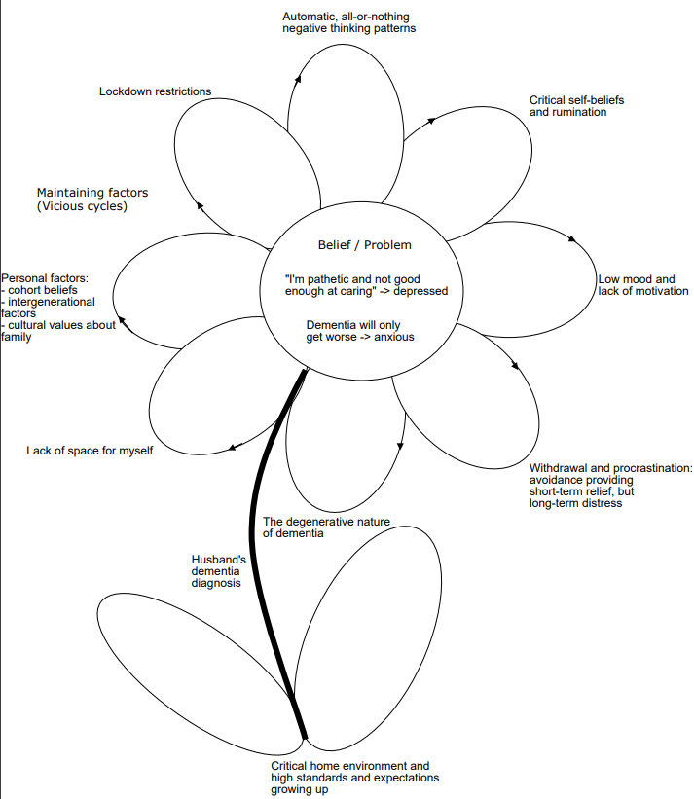**Figure** **1**

A vicious flower CBT formulation of Mrs P’s difficulties (Moorey, 2010).

# Method

## Design

A single-case experimental study with an AB design was adopted to evaluate the impact of an eight-session CBT intervention.

**Ethical Statement**

The authors have abided by the Ethical Principles of Psychologists and Code of Conduct as set out by the BABCP and BPS. The client described has seen the case report in full and has given informed consent for it to be published.

## Measures

### The Thoughts Questionnaire (TQ) for Family Caregivers of Dementia (Sullivan et al., 2016)

Due to the key role of Mrs P’s unhelpful thoughts about caring perpetuating her difficulties, this 25-item questionnaire was used. Items are rated from strongly agree to strongly disagree, and cover carers beliefs about themselves, others and the future. A higher score indicates greater unhelpful thoughts. It has been shown to strongly relate with depression and anxiety in this population, and has good validity and reliability (*α* = .84; Sullivan et al., 2016).

### The Patient Health Questionnaire (PHQ-9: Kroenke & Spitzer, 2002)

Due to Mrs P’s low mood, she completed the PHQ-9 at each session. The PHQ-9 is a reliable and validated self-report measure of depression routinely used in the memory service which requires patients to rate how often they have experienced nine symptoms of depression over the past two weeks on a 4-point scale ranging from not at all (0) to nearly every day (3), where higher scores indicates greater depression. The measure has 61% sensitivity and 94% specificity in adults.

### The Generalised Anxiety Disorder Assessment (GAD-7: Spitzer et al., 2006)

Due to Mrs P’s anxiety, she completed the GAD-7 at each session. The GAD-7 is a self-report measure of anxiety severity routinely used in the memory service which has good reliability and validity (Spitzer et al., 2006), which asks patients to rate how much seven symptoms of anxiety have ‘bothered them’ over the past two weeks using on a 4-point scale from not at all (0) to nearly every day (3). Higher scores indicate greater anxiety and using the threshold score of 10, the GAD-7 has a sensitivity of 89% and a specificity of 82% for GAD.

## Hypotheses

### Hypothesis One

It was firstly hypothesised that if Mrs P’s unhelpful thoughts could be modified, this would reduce anxiety and depression.

### Hypothesis Two

It was also hypothesised that increasing Mrs P’s engagement in pleasurable activities would make her feel less anxious and depressed.

## Intervention

Treatment consisted of a consultation and eight one-hour sessions delivered at an NHS Memory Service. The intervention was based on NICE guidelines and Losada et al.’s (2011) programme of CBT for dementia family caregivers and collaboratively adapted with Mrs P based on her family context and family members’ dementia. The measures and an assessment of risk were completed at every session, via the PHQ-9 and subsequent exploration by the therapist. A safety plan was created early on in treatment to help safely manage risk to self and from others whilst caregiving.

### Phase A: Assessment and Formulation

The first sessions were dedicated to gaining consent, building a rapport, validating Mrs P’s concerns, and normalising how understandably difficult that it is to care for family members with dementia, discussing that she was not alone in this. Next, Mrs P was socialised to the CBT model, and we started formulating her current challenging thoughts, feelings, and behaviours in a recent situation where caregiving had gone wrong, to understand what might be maintaining the problem. Socratic questioning enabled a process of guided discovery for the client to understand unhelpful thinking which may reinforce her negative beliefs about her caregiving, and how her behaviours such as procrastinating might be positively reinforced by a sense of relief, although may create vicious cycles which maintain her long-term low mood and anxiety. Home tasks helped the client to diarise times of the day when her thoughts were most challenging, understand triggers, as well as apply the formulation in daily life around her husband to empower the client to ensure the formulation was comprehensive and accurately reflected her experiences.

### Phase B: Intervention for Depression

The intervention phase started with the depressive symptomatology, which was a barrier to engaging in later components of treatment. The sessions were structured to last one hour, and involved collaborative agenda setting, the main points the of the session, followed by collaboratively setting between-session tasks, and lastly summarising and reviewing the session.

A thought record sheet facilitated Mrs P’s understanding of common situations where things may go wrong with her husband, such as him getting lost whilst shopping, or arguments around her husband having dementia whilst watching TV at home. We talked about these situations triggering thoughts that “things will never get better” and feelings of “powerlessness”. The therapist asked her: “What would be the worst thing that could happen?”, and she shifted her black or white thinking, by realising “Even if bad things happen, [she] cannot control everything and issues can be resolved retrospectively”. This alternative perspective reduced anxiety and low mood about these situations, helped her manage uncertainty, and Mrs P realised that because of her efforts, there are few occasions when things have gone wrong. Lastly, we discussed that it is possible to live well after diagnosis, and she said that she now has a ‘responsibility to take care of herself’.

Next, the most challenging beliefs about caring for family members for Mrs P were extracted from the TQ, and used to conduct a behavioural experiment into how other people would respond in a scenario where they were DFCs like Mrs P. All participants in the survey believed that you would have to take care of yourself before any family members, all people said they would accept outside help, and all participants said if you do not always get things right or if caregiving did not go to plan, this does not mean you are a ‘failure’. Mrs P described tackling her core belief about herself ‘not being a good enough carer’ in this way was a ‘turning point’. This opened up a discussion about how being a good or bad carer is not ‘all or nothing’ as Mrs P once thought, and that caregiving is on a continuum, as well as considering who actually may play a role when things do not go to plan, considering how to divide responsibility in these situations.

Mrs P was provided with psychoeducation around her husband’s mixed dementia, including how it might impact interactions at home, whilst also helping her to externalise the problem; she stated that dementia is unpredictable and when things go wrong, it might be ‘dementia’s fault’ (White, 1988).

Subsequently, Mrs P unfortunately suffered an abscess, although she explained that she used this as a behavioural experiment to test out feared consequences that something catastrophic would happen to her husband if she could not support him. This taught her the importance of the metaphor of not being able to give from an empty cup, and Mrs P practised some relaxation breathing scripts to introduce her to ways to care for herself. She also reflected on her weekly schedule, and collaborated with the therapist to find time to regain her life via new hobbies and interests. Mrs P attempted to shift her time to learn Spanish to the morning rather than at midnight, to remove a barrier to her sleep hygiene and also motivate her in the mornings, which helped interrupt ruminative thinking patterns and break obstructive cycles of avoidance during daily life.

Lastly, Mrs P and the therapist compared her scores on the measures at the beginning of therapy to her scores after therapy. A blueprint was created to plan for the future. Mrs P expected conversations about her husband not driving (considered in the risk management plan), and appointments to be difficult in the future. She produced the following messages to remind herself: “You’re not a bad person”, “You must take care of yourself”, and “Take back interest in yourself”.

# Results

Lane and Gast’s (2014) guidelines on visual analysis for A-B single case experimental design research were followed. The mean, median, and range of scores for each measure in both conditions were calculated. Relative and absolute level changes suggesting improvement were found in the scores across both conditions based on median and mean scores on each measure in both phases. Stable trends in improvement in scores were also observed across sessions. All scores in the intervention phase were lower compared to the baseline phase, suggesting no data overlap. Mrs P’s PHQ-9 scores reduced from 17 to five, and her GAD-7 scores reduced from 21 to three, suggesting reliable change (Clark & Oates, 2014).

**Table 1**

The mean, median, and range of scores on each measure during each condition.

|  |  |  |  |  |
| --- | --- | --- | --- | --- |
|  | Mean | Median | Range | Percent of scores on or within the stability envelope |
| *Baseline* |  |  |  |  |
| TQ | 53 | 53 | 12 | 100% (2/2) |
| PHQ-9 | 15.67 | 16 | 3 | 100% (3/3) |
| GAD-7 | 18.67 | 18 | 4 | 100% (3/3) |
| *Intervention* |  |  |  |  |
| TQ | 26 | 21 | 21 | 80% (4/5) |
| PHQ-9 | 7.8 | 10 | 8 | 80% (4/5) |
| GAD-7 | 9.2 | 8 | 12 | 100% (5/5) |

**Unhelpful Thoughts**

Figure two represents Mrs P’s scores for unhelpful thoughts about being a DFC across the therapy sessions. At baseline, Mrs P’s scores indicated a high level of unhelpful thoughts about caregiving. By the end of therapy, these thoughts had significantly diminished.

**Figure 2**

Mrs P’s scores for unhelpful thoughts about caregiving across the course of CBT.

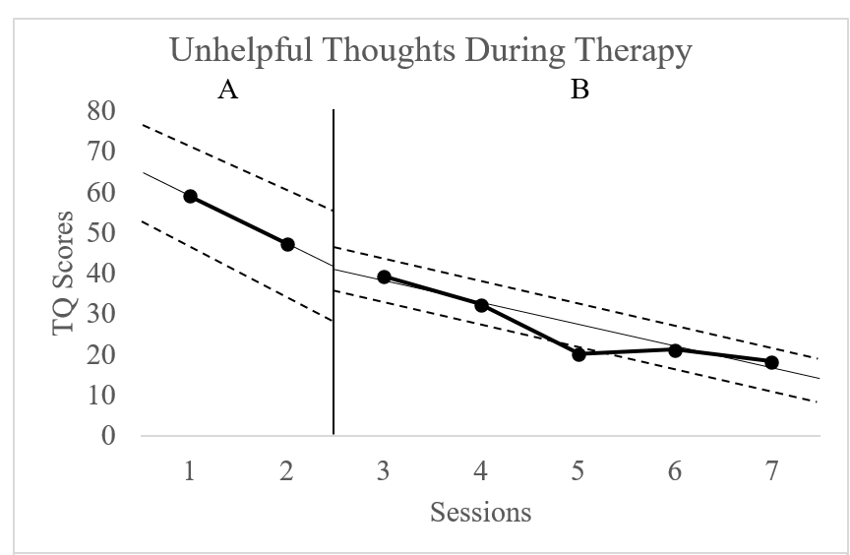

**Depression**

Figure 3 illustrates the clients’ levels of depression throughout therapeutic intervention. At baseline, Mrs P’s scores suggested moderately severe symptoms of depression. By the end of therapy, she scored five, which just meets the threshold for mild difficulties with depression.

**Figure 3**

Mrs P’s scores for depression during therapy.

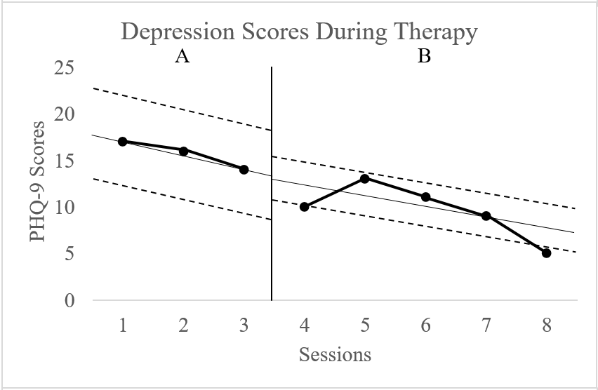

**Anxiety**

Mrs P’s anxiety scores are included in Figure 4. Before intervention, she scored within the severe range for symptoms of anxiety. At the end of therapy, she scored three, which is in the normal, non-clinical range.

**Figure 4**

Mrs P’s scores for anxiety during therapy.

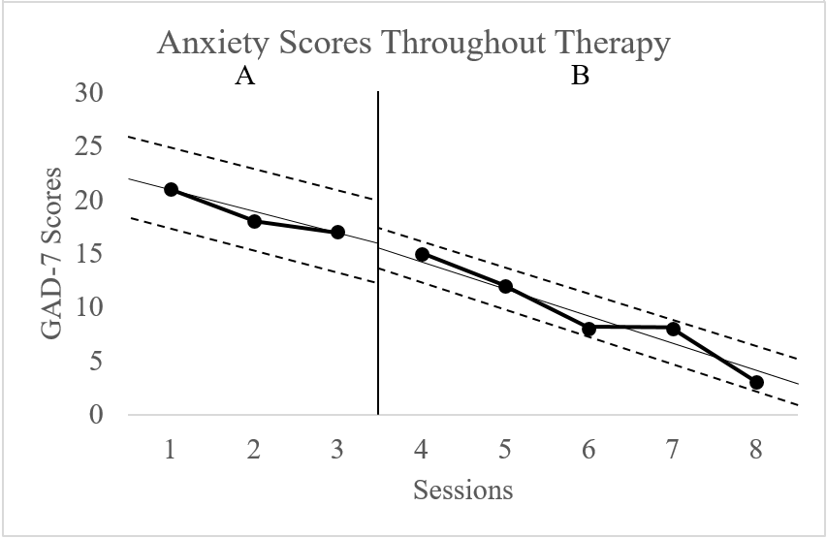

# Discussion

The aim of this paper was to evaluate the application of CBT to an older adult caring for two family members with dementia. The results suggest that unhelpful thoughts, anxiety and depression reduced significantly through the course of a time-limited CBT intervention. Additionally, Mrs P reported that over the sessions she met her goal, by becoming increasingly better at managing situations where things did not go to plan whilst caring for her husband, in particular by adopting alternative perspectives, such as “This is the dementia, not my husband” when there were disagreements at home, and “I cannot control everything” when her husband did unexpected things outside of the home.

In terms of the original theory-practice link, we hypothesised that unhelpful thoughts that some DFCs may have might lead them to believe they do not have the resources to cope, whilst also reducing the time that they spend on themselves to nurture their coping resources, leading to feelings of anxiety and depression. Losada et al. (2011), suggested this relationship between these unhelpful thoughts and carers’ mood and anxiety. Our findings support the hypotheses that modifying these cognitions and supporting carers to regain pleasurable and positively reinforcing activities in life may mitigate high levels of distress. In particular, in our study, unhelpful thoughts decreased in line with Mrs P’s anxiety and depression scores, which may support the association between them found in previous literature (Losada et al., 2011). Although scores did not reduce completely, this could be due to the understandable and inevitable challenges that carers of family members with dementia face reported in the qualitative research; life for the person with dementia and those around them does not get easier (Abreu et al., 2018).

## Limitations

A limitation of this study is that dementia impacts families in different ways, which limits the generalisability of the finding to other families. Pursuing the Laidlaw formulation in more detail could have accounted for some wider cohort beliefs which could have been representative of other carers’ experiences. Similarly, the current study did not involve any follow-up measures to measure the long-term impact of CBT for this client population. This makes it difficult to conclude whether the benefits suggested by the results lasted beyond the therapy sessions. Future research could investigate the long-term effects of CBT for this population, which have been eclipsed in the existing research. It could be that CBT has a protective effect for the carer’s journey through the therapy, which can sometimes be difficult to the fact that they observe the long-term impact of dementia on the person they care for.

Similarly, due to the fact that Mrs P’s husband did not accept his diagnosis, this was one barrier to the intervention. This restricted how much the client was able to engage in the in-between session tasks, which have been showed to be particularly effective in CBT for older adults (Kazantzis, Pachana & Secker, 2003), which could have impacted the results. This also meant that there were unique ethical considerations such as gaining consent from Mrs P and maintaining confidentiality whilst also carefully managing risk due to her husband still driving.

Moreover, there are some limitations of the single-case experimental design methodology applied to this case study. Firstly, there was limited opportunity to conduct multiple baseline assessments with this client, since she was with her husband all the time outside of the therapy sessions, and he denied his dementia diagnosis, and Mrs P did not want him to know she was in therapy. Since the baseline scores also varied, other factors could have contributed, and this may mean that the baseline scores on the TQ, PHQ-9 and GAD-7 were not a reliable representation of Mrs P’s wellbeing prior to the intervention phase. This makes it difficult to attribute the changes in scores after intervention to the CBT treatment. For example, during assessment, it could have been that addressing the unhelpful thought patterns and downward arrowing technique could have led to the PHQ-9 and GAD-7 scores initially worsening during the baseline measurements before improving, and the general normalising and therapeutic rapport building during assessment may have played a role in reducing the unhelpful thoughts on the TQ, which may have been difficult to receive from social support networks due to the COVID-19 lockdown and the time-consuming nature of caring for a family member with dementia. This may imply that the CBT intervention was not so helpful for reducing this client’s unhelpful thoughts, anxiety, and low mood.

# Conclusions

To conclude, this case study illustrates CBT may be a helpful intervention for DFCs, the active ingredients of which being modifying unhelpful thoughts about caring and supporting carers to reclaim enjoyable activities in daily life. However, it is worth noting that dementia can impact people in different ways, and each family system is different. In light of this study, which did not include follow-ups with Mrs P, future research is needed to investigate whether the encouraging findings of this study are generalisable to other dementia family caregivers, particularly in other families where different dementia profiles may be present.

References

Abreu, W., Rodrigues, T., Sequeira, C., Pires, R., & Sanhudo, A. (2018). The experience of psychological distress in family caregivers of people with dementia: A cross‐sectional study. *Perspectives in* *Psychiatric Care*, *54*(2), 317-323.

Brodaty, H., & Donkin, M. (2009). Family caregivers of people with dementia. *Dialogues in Clinical Neuroscience*, *11*(2), 217.

Bruinsma, J., Peetoom, K., Bakker, C., Boots, L., Verhey, F., & de Vugt, M. (2020). ‘They simply do not understand’: a focus group study exploring the lived experiences of family caregivers of people with frontotemporal dementia. *Aging & Mental Health*, 1-9.

Charlesworth, G. M., & Reichelt, F. K. (2004). Keeping conceptualizations simple: Examples with family carers of people with dementia. *Behavioural and Cognitive Psychotherapy*, *32*(4), 401-409.

Clark, D., & Oates, M. (2014, June). Improving Access to Psychological Therapies: Measuring Improvement and Recovery (Adult Services Version 2). National Health Service England.

Kroenke, K. & Spitzer, R.L. (2002). The PHQ-9: A new depression and diagnostic severity measure. *Psychiatric Annals*, *32*, 509-521.

Laidlaw, K., Thompson, L. W., & Gallagher-Thompson, D. (2004). Comprehensive

conceptualization of cognitive behaviour therapy for late life depression. *Behavioural*

*and Cognitive Psychotherapy*, *32*(4), 389-399.

Lane, J. D., & Gast, D. L. (2014). Visual analysis in single case experimental design studies:

Brief review and guidelines. *Neuropsychological Rehabilitation*, *24*(3-4), 445-463.

Losada, A., Márquez-González, M., Romero-Moreno, R., Mausbach, B. T., López, J., Fernández-

Fernández, V., & Nogales-González, C. (2015). Cognitive–behavioral therapy (CBT)

versus acceptance and commitment therapy (ACT) for dementia family caregivers with

significant depressive symptoms: Results of a randomized clinical trial. *Journal of*

*Consulting and Clinical Psychology*, *83*(4), 760.

Spitzer, R. L., Kroenke, K., Williams, J. B., & Löwe, B. (2006). A brief measure for assessing

generalized anxiety disorder: the GAD-7. *Archives of Internal Medicine*, *166*(10), 1092-

1097.

Sullivan, K. A., Beattie, E., Khawaja, N. G., Wilz, G., & Cunningham, L. (2016). The Thoughts

Questionnaire (TQ) for family caregivers of people with dementia. *Dementia*, *15(*6),

1474-1493.

Doris, S. F., Cheng, S. T., & Wang, J. (2018). Unravelling positive aspects of caregiving in

dementia: An integrative review of research literature. *International Journal of Nursing*

*Studies*, *79*, 1-26.

Gallego-Alberto, L., Losada, A., Cabrera, I., Romero-Moreno, R., Pérez-Miguel, A., Pedroso-

Chaparro, M. D. S., & Márquez-González, M. (2020). “I Feel Guilty”. Exploring Guilt-

Related Dynamics in Family Caregivers of People with Dementia. *Clinical Gerontologist*, 1-10.

Hopkinson, M. D., Reavell, J., Lane, D. A., & Mallikarjun, P. (2019). Cognitive behavioral

therapy for depression, anxiety, and stress in caregivers of dementia patients: A

systematic review and meta-analysis. *The Gerontologist*, *59*(4), e343-e362.

Jurgens, F. J., Clissett, P., Gladman, J. R., & Harwood, R. H. (2012). Why are family carers of

people with dementia dissatisfied with general hospital care? A qualitative study. *BMC*

*Geriatrics*, *12*(1), 1-10.

Kazantzis, N., Pachana, N. A., & Secker, D. L. (2003). Cognitive behavioral therapy for older

adults: Practical guidelines for the use of homework assignments. *Cognitive and*

*Behavioral Practice*, *10*(4), 324-332.

Kroenke, K. & Spitzer, R.L. (2002). The PHQ-9: A new depression and diagnostic severity measure. *Psychiatric Annals*, *32*, 509-521.

Laidlaw, K., Thompson, L. W., & Gallagher-Thompson, D. (2004). Comprehensive

conceptualization of cognitive behaviour therapy for late life depression. *Behavioural*

*and Cognitive Psychotherapy*, *32*(4), 389-399.

Livingston, G., Barber, J., Rapaport, P., Knapp, M., Griffin, M., King, D., ... & Cooper, C.

(2014). Long-term clinical and cost-effectiveness of psychological intervention for family

carers of people with dementia: a single-blind, randomised, controlled trial. *The Lancet*

*Psychiatry*, *1*(7), 539-548.

Livingston, G., Barber, J., Rapaport, P., Knapp, M., Griffin, M., King, D., ... & Cooper, C.

(2013). Clinical effectiveness of a manual based coping strategy programme (START,

STrAtegies for RelaTives) in promoting the mental health of carers of family members

with dementia: pragmatic randomised controlled trial. *BMJ*, *347*.

Losada, A., Márquez‐González, M., & Romero‐Moreno, R. (2011). Mechanisms of action of

a psychological intervention for dementia caregivers: effects of behavioral activation and

modification of dysfunctional thoughts. *International Journal of Geriatric Psychiatry*,

*26*(11), 1119-1127.

Losada, A., Márquez-González, M., Romero-Moreno, R., Mausbach, B. T., López, J., Fernández-

Fernández, V., & Nogales-González, C. (2015). Cognitive–behavioral therapy (CBT)

versus acceptance and commitment therapy (ACT) for dementia family caregivers with

significant depressive symptoms: Results of a randomized clinical trial. *Journal of*

*Consulting and Clinical psychology*, *83*(4), 760.

Moorey, S. (2010). The six cycles maintenance model: Growing a “vicious flower” for

depression. *Behavioural and Cognitive Psychotherapy*, *38*(2), 173-184.

Oldenkamp, M., Hagedoorn, M., Slaets, J., Stolk, R., Wittek, R., & Smidt, N. (2016). Subjective

burden among spousal and adult-child informal caregivers of older adults: results from a

longitudinal cohort study. *BMC Geriatrics*, *16*(1), 1-11.

Saunders, R., Buckman, J. E., Stott, J., Leibowitz, J., Aguirre, E., John, A., ... & Pilling, S.

(2021). Older adults respond better to psychological therapy than working-age adults:

evidence from a large sample of mental health service attendees. *Journal of Affective*

*Disorders*, *294*, 85-93.

Schumacher, L. A. (2010). The caregiver's journey: a phenomenological study of the lived

experience of leisure for caregivers in the sandwich generation who care for a parent with

dementia (Doctoral dissertation, The University of Iowa).

Spitzer, R. L., Kroenke, K., Williams, J. B., & Löwe, B. (2006). A brief measure for assessing

generalized anxiety disorder: the GAD-7. *Archives of Internal Medicine*, *166*(10), 1092-

1097.

White, M., & White, M. (1988). *The externalising of the problems and the re-authorising of lives*

*and relationships*. M. White Selected Papers. Adelaide: Dulwich Centre Publications.

Wiegelmann, H., Speller, S., Verhaert, L. M., Schirra-Weirich, L., & Wolf-Ostermann, K. (2021).

Psychosocial interventions to support the mental health of informal caregivers of persons

living with dementia–a systematic literature review. *BMC Geriatrics*, *21*(1), 1-17.