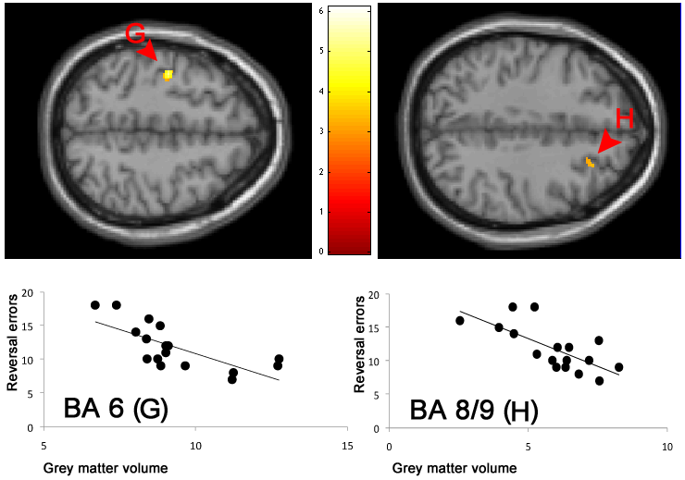

Figure S1

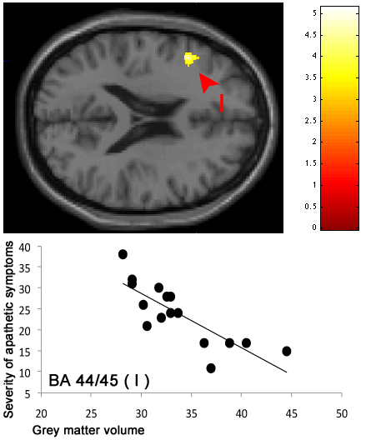

Figure S2

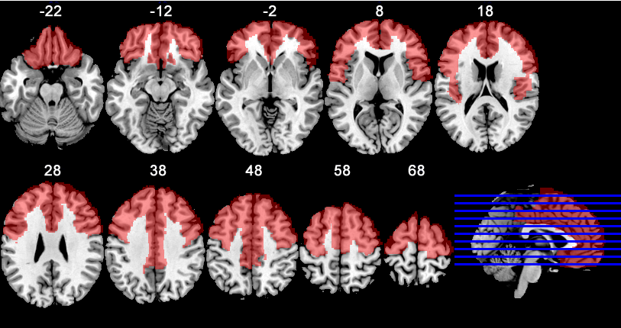
Figure S3

SOM Figures Legends
Figure S1 – Correlation between grey matter volume and the number of reversal errors in the behavioral-control test, superimposed on the canonical template provided in SPM. Normalized grey matter intensity in the left BA 6 (G) at -38 -12 48 and right BA 8/9 (H) at 30 17 48 are plotted against the number of reversal errors needed to reverse the first rule.
Figure S2 – Correlation between grey matter volume and the severity of apathetic symptoms as rated by caregivers in the apathy scale, superimposed on the canonical template provided in SPM. Normalized grey matter intensity in the left BA 44/45 at -46 23 24 (I) is plotted against apathy scale score.
Figure S3 – Frontal mask (in red) used in the VBM study, superimposed on axial slices of the template provided in MRIcro, with 10 mm of space between each slice. Numbers above each slice represent MNI z coordinates.

AAL Label names | Anatomical areas
Frontal Sup R | Superior frontal gyrus, Dorsolateral part
Frontal Sup L | Superior frontal gyrus, Dorsolateral part
Frontal Sup Orb L | Superior frontal gyrus, Orbital part
Frontal Sup Orb R | Superior frontal gyrus, Orbital part
Frontal Mid L | Middle frontal gyrus
Frontal Mid R | Middle frontal gyrus
Frontal Mid Orb L | Frontal Middle Orbital
Frontal Mid Orb R | Frontal Middle Orbital
Frontal Inf Oper L | Inferior frontal gyrus, Opercular part
Frontal Inf Oper R | Inferior frontal gyrus, Opercular part
Frontal Inf Tri L | Inferior frontal gyrus, Triangular part
Frontal Inf Tri R | Inferior frontal gyrus, Triangular part
Frontal Inf Orb L | Inferior frontal gyrus, Orbital part
Frontal Inf Orb R | Inferior frontal gyrus, Orbital part
Rolandic Oper L | Rolandic Operculum
Rolandic Oper R | Rolandic Operculum
Supp Motot Area L | Supplementary Motor Area
Supp Motor Area R | Supplementary Motor Area
Olfactory L | Olfactory cortex
Olfactory R | Olfactory cortex
Frontal Sup Medial L | Superior frontal gyrus, Medial part
Frontal Sup Medial R | Superior frontal gyrus, Medial part
Frontal Med Orb L | Middle frontal gyrus, Orbital part
Frontal Med Orb R | Middle frontal gyrus, Orbital part
Rectus L | Gyrus rectus
Rectus R | Gyrus rectus
Cingulum Ant L | Anterior cingulate and paracingulate gyri
Cingulum Ant R | Anterior cingulate and paracingulate gyri
Cingulum Mid L | Median cingulate and paracingulate gyri
Cingulum Mid R | Median cingulate and paracingulate gyri
Precentral L | Precentral gyrus
Precentral R | Precentral gyrus

Table S1 – Cerebral areas composing the mask (from WFU_Pickatlas), and their AAL labels. AAL=Automated Anatomical Labeling

