**Supplementary Appendix**

Contents

**eTable 1: Results of cognitive test score discretization in the Atherosclerosis Risk in Communities Neurocognitive Study (ARIC-NCS)** 3

**eTable2: Results of cognitive test score discretization in the Baltimore Longitudinal Study of Aging (BLSA)** 5

**eTable 3: Demographic Characteristics and Cognitive Test Scores in the Vision Samples** 7

**eTable 4: Demographic Characteristics and Cognitive Test Scores in the Hearing Samples** 8

**eTable 5: Cognitive test scores by sensory impairment status in the Atherosclerosis Risk in Communities Neurocognitive Study (ARIC-NCS)** 9

**eTable 6: Cognitive test scores by sensory impairment status in the Baltimore Longitudinal Study of Aging (BLSA)** 10

**eFigure 1: Item characteristic curves (ICCs) by hearing impairment in the Atherosclerosis Risk in Communities Neurocognitive Study (ARIC-NCS).** The plots show the relationship between latent cognitive functioning and the probability of answering an item correctly (or scoring high enough to be included in the next highest category of scores). The curves are shown for each item separately and stratified by hearing impairment status. Curves which are shifted right or left in the hearing impaired as compared to the non-impaired are either more difficult (shift right) or easier (shift left) in the hearing impaired. Curves that have a less steep slope in the hearing impaired as compared to the non-impaired indicate that the item has a weaker relationship with latent cognitive functioning in the hearing impaired as compared to the unimpaired. 11

**eFigure 2: Item characteristic curves (ICCs) by hearing impairment in the Baltimore Longitudinal Study of Aging (BLSA).** The plots show the relationship between latent cognitive functioning and the probability of answering an item correctly (or scoring high enough to be included in the next highest category of scores). The curves are shown for each item separately and stratified by hearing impairment status. Curves which are shifted right or left in the hearing impaired as compared to the non-impaired are either more difficult (shift right) or easier (shift left) in the hearing impaired. Curves that have a less steep slope in the hearing impaired as compared to the non-impaired indicate that the item has a weaker relationship with latent cognitive functioning in the hearing impaired as compared to the unimpaired. 13

**eFigure 3: Item characteristic curves (ICCs) by vision impairment in the Atherosclerosis Risk in Communities Neurocognitive Study (ARIC-NCS).** The plots show the relationship between latent cognitive functioning and the probability of answering an item correctly (or scoring high enough to be included in the next highest category of scores). The curves are shown for each item separately and stratified by vision impairment status. Curves which are shifted right or left in the vision impaired as compared to the non-impaired are either more difficult (shift right) or easier (shift left) in the vision impaired. Curves that have a less steep slope in the vision impaired as compared to the non-impaired indicate that the item has a weaker relationship with latent cognitive functioning in the vision impaired as compared to the unimpaired. 15

**eFigure 4: Item characteristic curves (ICCs) by vision impairment in the Baltimore Longitudinal Study of Aging (BLSA).** The plots show the relationship between latent cognitive functioning and the probability of answering an item correctly (or scoring high enough to be included in the next highest category of scores). The curves are shown for each item separately and stratified by vision impairment status. Curves which are shifted right or left in the vision impaired as compared to the non-impaired are either more difficult (shift right) or easier (shift left) in the vision impaired. Curves that have a less steep slope in the vision impaired as compared to the non-impaired indicate that the item has a weaker relationship with latent cognitive functioning in the vision impaired as compared to the unimpaired. 17

**eMethods 1: Additional methods for the estimation of differential item functioning using the alignment method** 19

**eMethods 2: Methods for the estimation of the confirmatory factor analysis for the comparison of cognition in ARIC-NCS and BLSA** 20

**eFigure 5: Distribution of Latent Cognitive Functioning in the Atherosclerosis Risk in Communities Neurocognitive Study (ARIC-NCS) and Baltimore Longitudinal Study of Aging (BLSA) Samples** 21

**Introduction to eTables 7 and 8** 22

**eTable 7: Parameter differences by hearing impairment status in the Atherosclerosis Risk in Communities Neurocognitive Study (ARIC-NCS) study in samples stratified by age, educational attainment, race, and sex** 23

**eTable 8: Parameter differences by vision impairment status in the Atherosclerosis Risk in Communities Neurocognitive Study (ARIC-NCS) study in samples stratified by age, educational attainment, race, and sex** 27

## **eTable 1: Results of cognitive test score discretization in the Atherosclerosis Risk in Communities Neurocognitive Study (ARIC-NCS)**

|  |  |  |
| --- | --- | --- |
| **Item** | **Discretized Value** | **Raw Values** |
| Digit Span Backwards | 1 | 0 to 3 |
| Digit Span Backwards | 2 | 4 to 4 |
| Digit Span Backwards | 3 | 5 to 5 |
| Digit Span Backwards | 4 | 6 to 6 |
| Digit Span Backwards | 5 | 7 to 8 |
| Digit Span Backwards | 6 | 9 to 12 |
| Trail-Making Test A | 1 | 70 to 240 |
| Trail-Making Test A | 2 | 49 to 69 |
| Trail-Making Test A | 3 | 37 to 48 |
| Trail-Making Test A | 4 | 30 to 36 |
| Trail-Making Test A | 5 | 16 to 29 |
| Digit Symbol Substitution Task | 1 | 0 to 24 |
| Digit Symbol Substitution Task | 2 | 25 to 32 |
| Digit Symbol Substitution Task | 3 | 33 to 40 |
| Digit Symbol Substitution Task | 4 | 41 to 48 |
| Digit Symbol Substitution Task | 5 | 49 to 72 |
| Trail-Making Test B | 1 | 183 to 240 |
| Trail-Making Test B | 2 | 124 to 182 |
| Trail-Making Test B | 3 | 94 to 123 |
| Trail-Making Test B | 4 | 76 to 93 |
| Trail-Making Test B | 5 | 63 to 75 |
| Trail-Making Test B | 6 | 29 to 62 |
| Delayed Word Recall | 1 | 0 to 3 |
| Delayed Word Recall | 2 | 4 to 4 |
| Delayed Word Recall | 3 | 5 to 5 |
| Delayed Word Recall | 4 | 6 to 6 |
| Delayed Word Recall | 5 | 7 to 10 |
| Logical Memory 1 | 1 | 0 to 13 |
| Logical Memory 1 | 2 | 14 to 19 |
| Logical Memory 1 | 3 | 20 to 24 |
| Logical Memory 1 | 4 | 25 to 30 |
| Logical Memory 1 | 5 | 31 to 44 |
| Logical Memory 2 | 1 | 0 to 8 |
| Logical Memory 2 | 2 | 9 to 13 |
| Logical Memory 2 | 3 | 14 to 19 |
| Logical Memory 2 | 4 | 20 to 24 |
| Logical Memory 2 | 5 | 25 to 30 |
| Logical Memory 2 | 6 | 31 to 44 |
| Incidental Memory | 1 | 0 to 3 |
| Incidental Memory | 2 | 4 to 5 |
| Incidental Memory | 3 | 6 to 6 |
| Incidental Memory | 4 | 7 to 7 |
| Incidental Memory | 5 | 8 to 9 |
| Phonemic Fluency (Sum of 3 Trials) | 1 | 1 to 15 |
| Phonemic Fluency (Sum of 3 Trials) | 2 | 16 to 25 |
| Phonemic Fluency (Sum of 3 Trials) | 3 | 26 to 35 |
| Phonemic Fluency (Sum of 3 Trials) | 4 | 36 to 45 |
| Phonemic Fluency (Sum of 3 Trials) | 5 | 46 to 81 |
| Categorical Fluency (Animals) | 1 | 1 to 8 |
| Categorical Fluency (Animals) | 2 | 9 to 11 |
| Categorical Fluency (Animals) | 3 | 12 to 14 |
| Categorical Fluency (Animals) | 4 | 15 to 17 |
| Categorical Fluency (Animals) | 5 | 18 to 20 |
| Categorical Fluency (Animals) | 6 | 21 to 35 |
| Boston Naming Test (30 Item) | 1 | 0 to 16 |
| Boston Naming Test (30 Item) | 2 | 17 to 21 |
| Boston Naming Test (30 Item) | 3 | 22 to 23 |
| Boston Naming Test (30 Item) | 4 | 24 to 26 |
| Boston Naming Test (30 Item) | 5 | 27 to 30 |

## **eTable2: Results of cognitive test score discretization in the Baltimore Longitudinal Study of Aging (BLSA)**

|  |  |  |
| --- | --- | --- |
| **Item** | **Discretized Value** | **Raw Values** |
| Digit Span Forwards | 1 | 0 to 5 |
| Digit Span Forwards | 2 | 6 to 6 |
| Digit Span Forwards | 3 | 7 to 7 |
| Digit Span Forwards | 4 | 8 to 8 |
| Digit Span Forwards | 5 | 9 to 9 |
| Digit Span Forwards | 6 | 10 to 10 |
| Digit Span Forwards | 7 | 11 to 14 |
| Digit Span Backwards | 1 | 0 to 5 |
| Digit Span Backwards | 2 | 6 to 6 |
| Digit Span Backwards | 3 | 7 to 7 |
| Digit Span Backwards | 4 | 8 to 9 |
| Digit Span Backwards | 5 | 10 to 10 |
| Digit Span Backwards | 6 | 11 to 14 |
| Trail-Making Test A | 1 | 47 to 300 |
| Trail-Making Test A | 2 | 36 to 46 |
| Trail-Making Test A | 3 | 29 to 35 |
| Trail-Making Test A | 4 | 24 to 28 |
| Trail-Making Test A | 5 | 21 to 23 |
| Trail-Making Test A | 6 | 10 to 20 |
| Trail-Making Test B | 1 | 136 to 300 |
| Trail-Making Test B | 2 | 99 to 135 |
| Trail-Making Test B | 3 | 79 to 97 |
| Trail-Making Test B | 4 | 65 to 78 |
| Trail-Making Test B | 5 | 55 to 64 |
| Trail-Making Test B | 6 | 48 to 54 |
| Trail-Making Test B | 7 | 24 to 47 |
| Card Rotations | 1 | 0 to 38 |
| Card Rotations | 2 | 39 to 63 |
| Card Rotations | 3 | 64 to 89 |
| Card Rotations | 4 | 90 to 114 |
| Card Rotations | 5 | 115 to 140 |
| Card Rotations | 6 | 141 to 198 |
| Similarities | 1 | 0 to 16 |
| Similarities | 2 | 17 to 18 |
| Similarities | 3 | 19 to 19 |
| Similarities | 4 | 20 to 21 |
| Similarities | 5 | 22 to 23 |
| Similarities | 6 | 24 to 27 |
| Clock 3:35 | 1 | 0 to 6 |
| Clock 3:35 | 2 | 7 to 7 |
| Clock 3:35 | 3 | 8 to 8 |
| Clock 3:35 | 4 | 9 to 9 |
| Clock 3:35 | 5 | 10 to 10 |
| Clock 11:10 | 1 | 0 to 7 |
| Clock 11:10 | 2 | 8 to 8 |
| Clock 11:10 | 3 | 9 to 9 |
| Clock 11:10 | 4 | 10 to 10 |
| Digit Symbol Substitution Task | 1 | 9 to 29 |
| Digit Symbol Substitution Task | 2 | 30 to 36 |
| Digit Symbol Substitution Task | 3 | 37 to 43 |
| Digit Symbol Substitution Task | 4 | 44 to 50 |
| Digit Symbol Substitution Task | 5 | 51 to 57 |
| Digit Symbol Substitution Task | 6 | 58 to 86 |
| Delayed Word Recall (CVLT) | 1 | 0 to 5 |
| Delayed Word Recall (CVLT) | 2 | 6 to 7 |
| Delayed Word Recall (CVLT) | 3 | 8 to 8 |
| Delayed Word Recall (CVLT) | 4 | 9 to 10 |
| Delayed Word Recall (CVLT) | 5 | 11 to 11 |
| Delayed Word Recall (CVLT) | 6 | 12 to 13 |
| Delayed Word Recall (CVLT) | 7 | 14 to 16 |
| Benton Visual Rention Task | 1 | 18 to 27 |
| Benton Visual Rention Task | 2 | 16 to 17 |
| Benton Visual Rention Task | 3 | 13 to 15 |
| Benton Visual Rention Task | 4 | 10 to 12 |
| Benton Visual Rention Task | 5 | 7 to 9 |
| Benton Visual Rention Task | 6 | 5 to 6 |
| Benton Visual Rention Task | 7 | 0 to 4 |
| Categorical Fluency (3 Categories) | 1 | 3.3 to 10 |
| Categorical Fluency (3 Categories) | 2 | 10.3 to 12.7 |
| Categorical Fluency (3 Categories) | 3 | 13 to 15.3 |
| Categorical Fluency (3 Categories) | 4 | 15.7 to 18 |
| Categorical Fluency (3 Categories) | 5 | 18.3 to 20.7 |
| Categorical Fluency (3 Categories) | 6 | 21 to 31.3 |
| Phonemic Fluency (Mean of 3 Trials) | 1 | 1 to 9.7 |
| Phonemic Fluency (Mean of 3 Trials) | 2 | 10 to 13 |
| Phonemic Fluency (Mean of 3 Trials) | 3 | 13.3 to 16.7 |
| Phonemic Fluency (Mean of 3 Trials) | 4 | 17 to 20 |
| Phonemic Fluency (Mean of 3 Trials) | 5 | 20.3 to 29 |
| Boston Naming Test (60 Item) | 1 | 18 to 44 |
| Boston Naming Test (60 Item) | 2 | 45 to 48 |
| Boston Naming Test (60 Item) | 3 | 49 to 52 |
| Boston Naming Test (60 Item) | 4 | 53 to 54 |
| Boston Naming Test (60 Item) | 5 | 55 to 56 |
| Boston Naming Test (60 Item) | 6 | 57 to 60 |

## **eTable 3: Demographic Characteristics and Cognitive Test Scores in the Vision Samples**

|  |  |  |
| --- | --- | --- |
|  | **ARIC-NCS** | **BLSA** |
| **Hearing Impairment - Impaired - N (%)** | 661 (65.6) | 340 (52.5) |
| **Vision Impairment - Impaired - N (%)** | 191 (18.2) | 176 (25.0) |
| **Age - Mean (SD)** | 79.1 (4.4) | 74.6 (9.0) |
| **Education: Less than HS - N (%)** | 181 (17.2) | 2 (0.3) |
| **Education: HS or equivalent - N (%)** | 424 (40.4) | 34 (4.8) |
| **Education: Beyond HS - N (%)** | 445 (42.4) | 666 (94.9) |
| **Race - Black - N (%)** | 491 (46.9) | 239 (34.0) |
| **Sex - Female - N(%)** | 664 (63.2) | 390 (55.6) |
| **Cognitive Items - Mean (SD)** |  |  |
| Benton Visual Retention Task† |  | 10.7 (5.5) |
| Boston Naming Test (30 Item)† | 24.3 (5.2) |  |
| Boston Naming Test (60 Item)† |  | 53.6 (6.6) |
| Card Rotations† |  | 83.1 (40.4) |
| Category Fluency (Animals)‡ | 15.3 (4.5) |  |
| Category Fluency (Mean of 3 Categories) ‡ |  | 15.3 (4.9) |
| Clock 11:10† |  | 8.9 (1.4) |
| Clock 3:35† |  | 8.5 (1.3) |
| Delayed Word Recall | 5.5 (1.7) |  |
| Delayed Word Recall (CVLT) ‡ |  | 10.2 (3.7) |
| Digit Span Backwards‡ | 5.2 (1.9) | 6.9 (2.2) |
| Digit Span Forwards‡ |  | 8.0 (2.3) |
| Digit Symbol Substitution Task† | 35.1 (11.3) | 40.4 (12.0) |
| Incidental Learning† | 6.0 (1.6) |  |
| Logical Memory Story 1‡ | 21.6 (6.8) |  |
| Logical Memory Story 2‡ | 17.3 (7.4) |  |
| Phonemic Fluency (Mean of 3 Trials)‡ |  | 14.6 (5.3) |
| Phonemic Fluency (Sum of 3 Trials)‡ | 31.2 (12.0) |  |
| Similarities‡ |  | 21.1 (3.6) |
| Trail-Making Test A† | 53.8 (28.4) | 36.0 (24.6) |
| Trail-Making Test B† | 139.6 (62.4) | 88.3 (46.6) |

Items whose assessments primarily relied solely on vision are indicated with †. Items whose assessments relied primarily solely on hearing are indicated with ‡. ARIC-NCS = Atherosclerosis Risk in Communities Neurocognitive Study, BLSA = Baltimore Longitudinal Study on Aging.

## **eTable 4: Demographic Characteristics and Cognitive Test Scores in the Hearing Samples**

|  |  |  |
| --- | --- | --- |
|  | **ARIC-NCS** | **BLSA** |
| **Hearing Impairment - Impaired - N (%)** | 2622 (73.0) | 351 (52.3) |
| **Vision Impairment - Impaired - N (%)** | 182 (18.1) | 159 (24.4) |
| **Age - Mean (SD)** | 79.8 (4.7) | 74.7 (8.9) |
| **Education: Less than HS - N (%)** | 429 (12.0) | 2 (0.3) |
| **Education: HS or equivalent - N (%)** | 1479 (41.3) | 34 (5.1) |
| **Education: Beyond HS - N (%)** | 1677 (46.8) | 634 (94.6) |
| **Race - Black - N (%)** | 837 (23.4) | 225 (33.5) |
| **Sex - Female - N(%)** | 2147 (59.8) | 373 (55.7) |
| **Cognitive Items - Mean (SD)** |  |  |
| Benton Visual Retention Task† |  | 10.8 (5.5) |
| Boston Naming Test (30 Item)† | 25.4 (4.7) |  |
| Boston Naming Test (60 Item)† |  | 53.6 (6.6) |
| Card Rotations† |  | 82.2 (40.4) |
| Category Fluency (Animals)‡ | 15.5 (5.0) |  |
| Category Fluency (Mean of 3 Categories) ‡ |  | 15.3 (4.9) |
| Clock 11:10† |  | 8.9 (1.4) |
| Clock 3:35† |  | 8.5 (1.3) |
| Delayed Word Recall | 5.2 (1.8) |  |
| Delayed Word Recall (CVLT) ‡ |  | 10.1 (3.7) |
| Digit Span Backwards‡ | 5.5 (1.9) | 6.8 (2.2) |
| Digit Span Forwards‡ |  | 7.9 (2.2) |
| Digit Symbol Substitution Task† | 36.9 (11.7) | 40.3 (11.9) |
| Incidental Learning† | 6.0 (1.7) |  |
| Logical Memory Story 1‡ | 22.0 (7.4) |  |
| Logical Memory Story 2‡ | 17.7 (8.1) |  |
| Phonemic Fluency (Mean of 3 Trials)‡ |  | 14.5 (5.3) |
| Phonemic Fluency (Sum of 3 Trials)‡ | 32.4 (12.3) |  |
| Similarities‡ |  | 21.1 (3.7) |
| Trail-Making Test A† | 51.3 (27.7) | 36.2 (24.9) |
| Trail-Making Test B† | 131.8 (59.4) | 88.5 (46.7) |

Items whose assessments primarily relied solely on vision are indicated with †. Items whose assessments relied primarily solely on hearing are indicated with ‡. ARIC-NCS = Atherosclerosis Risk in Communities Neurocognitive Study, BLSA = Baltimore Longitudinal Study on Aging.

## **eTable 5: Cognitive test scores by sensory impairment status in the Atherosclerosis Risk in Communities Neurocognitive Study (ARIC-NCS)**

|  |  |  |  |
| --- | --- | --- | --- |
| **Item**  **(Mean [SD])** | **No Sensory Impairment (N=949)** | **Hearing Impairment (N=2622)** | **Vision Impairment (N=191)** |
| Digit Span Backwards | 5.6 (2.0) | 5.4 (1.9) | 5.0 (2.1) |
| Trail-Making Test A | 50.4 (27.2) | 51.6 (27.7) | 62.6 (35.5) |
| Digit Symbol Substitution Task | 38.3 (12.0) | 36.4 (11.5) | 31.1 (11.0) |
| Trail-Making Test B | 128.4 (59.3) | 133.1 (59.3) | 153.4 (60.4) |
| Delayed Word Recall | 5.5 (1.7) | 5.1 (1.8) | 5.1 (1.7) |
| Logical Memory 1 | 22.6 (7.1) | 21.7 (7.4) | 20.7 (7.4) |
| Logical Memory 2 | 18.5 (7.9) | 17.5 (8.1) | 16.2 (8.1) |
| Incidental Memory | 6.2 (1.6) | 5.9 (1.7) | 5.6 (1.7) |
| Phonemic Fluency (Sum of 3 Trials) | 33.9 (12.5) | 31.9 (12.2) | 28.2 (11.3) |
| Categorical Fluency (Animals) | 16.1 (4.9) | 15.3 (5.0) | 14.7 (4.7) |
| Boston Naming Test (30 Item) | 25.3 (4.9) | 25.5 (4.6) | 23.6 (5.5) |

Individuals in the no sensory impairment category have neither hearing impairment nor vision impairment. Higher scores on Trail-Making Test A and B indicates lower performance.

## **eTable 6: Cognitive test scores by sensory impairment status in the Baltimore Longitudinal Study of Aging (BLSA)**

|  |  |  |  |
| --- | --- | --- | --- |
| **Item**  **(Mean [SD])** | **No Sensory Impairment (N=312)** | **Hearing Impairment (N=354)** | **Vision Impairment (N=180)** |
| Digit Span Forwards | 8.2 (2.3) | 7.8 (2.2) | 7.7 (2.3) |
| Digit Span Backwards | 7.1 (2.1) | 6.6 (2.3) | 6.5 (2.3) |
| Trail-Making Test A | 31.5 (18.4) | 39.6 (29.0) | 40.7 (25.7) |
| Trail-Making Test B | 78.1 (39.8) | 97.4 (50.8) | 103.1 (52.5) |
| Card Rotations | 89.7 (39.2) | 78.1 (41.0) | 71.6 (37.4) |
| Similarities | 21.4 (3.6) | 21.0 (3.8) | 20.4 (3.8) |
| Clock 3:35 | 8.7 (1.2) | 8.4 (1.4) | 8.3 (1.4) |
| Clock 11:10 | 9.0 (1.3) | 8.9 (1.4) | 8.7 (1.5) |
| Digit Symbol Substitution Task | 44.7 (11.7) | 36.5 (10.9) | 36.3 (10.9) |
| Delayed Word Recall (CVLT) | 11.1 (3.3) | 9.4 (3.8) | 9.0 (3.8) |
| Benton Visual Rention Task | 9.4 (5.2) | 11.7 (5.5) | 12.6 (5.5) |
| Categorical Fluency (3 Categories) | 16.5 (3.7) | 14.5 (5.6) | 14.4 (7.1) |
| Phonemic Fluency (Mean of 3 Trials) | 14.7 (4.4) | 14.4 (6.0) | 14.4 (7.3) |
| Boston Naming Test (60 Item) | 54.4 (5.8) | 53.4 (7.0) | 52.4 (7.8) |

Individuals in the no sensory impairment category have neither hearing impairment nor vision impairment. Higher scores on Trail-Making Test A and B indicates lower performance.

## **eFigure 1: Item characteristic curves (ICCs) by hearing impairment in the Atherosclerosis Risk in Communities Neurocognitive Study (ARIC-NCS).** The plots show the relationship between latent cognitive functioning and the probability of answering an item correctly (or scoring high enough to be included in the next highest category of scores). The curves are shown for each item separately and stratified by hearing impairment status. Curves which are shifted right or left in the hearing impaired as compared to the non-impaired are either more difficult (shift right) or easier (shift left) in the hearing impaired. Curves that have a less steep slope in the hearing impaired as compared to the non-impaired indicate that the item has a weaker relationship with latent cognitive functioning in the hearing impaired as compared to the unimpaired.

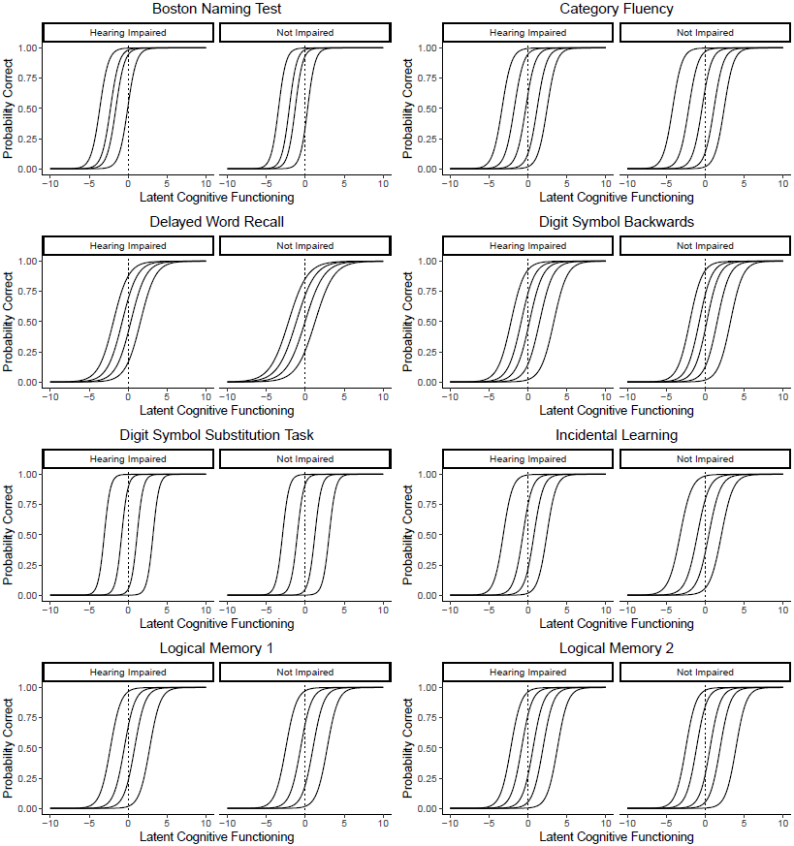

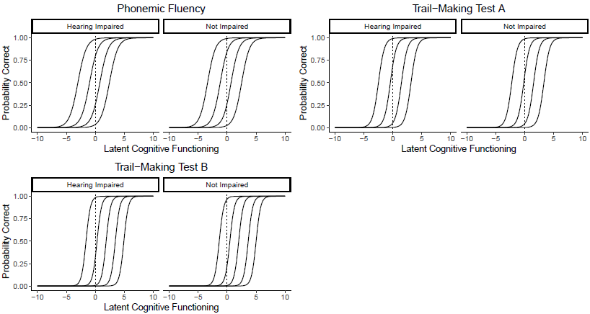

## **eFigure 2: Item characteristic curves (ICCs) by hearing impairment in the Baltimore Longitudinal Study of Aging (BLSA).** The plots show the relationship between latent cognitive functioning and the probability of answering an item correctly (or scoring high enough to be included in the next highest category of scores). The curves are shown for each item separately and stratified by hearing impairment status. Curves which are shifted right or left in the hearing impaired as compared to the non-impaired are either more difficult (shift right) or easier (shift left) in the hearing impaired. Curves that have a less steep slope in the hearing impaired as compared to the non-impaired indicate that the item has a weaker relationship with latent cognitive functioning in the hearing impaired as compared to the unimpaired.

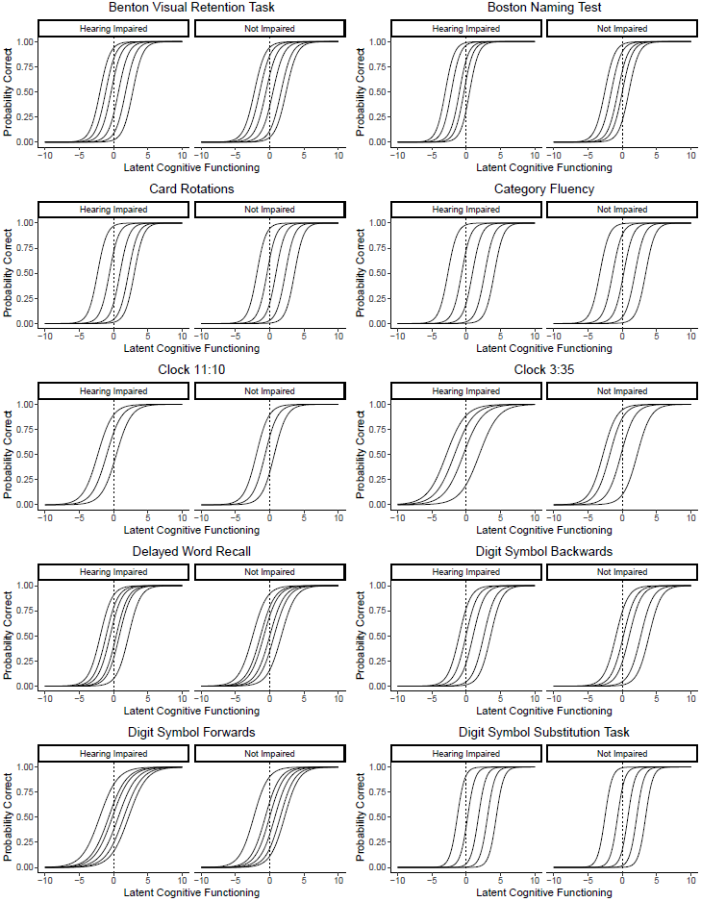

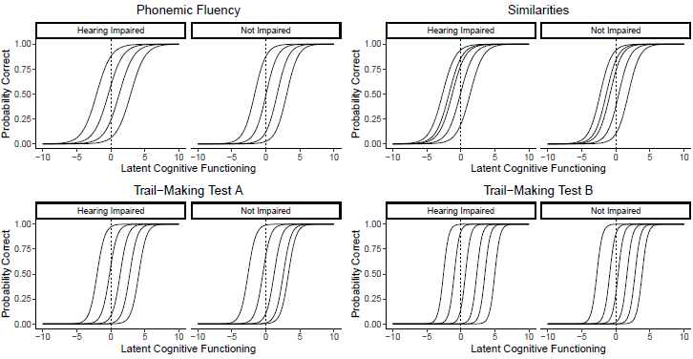

## **eFigure 3: Item characteristic curves (ICCs) by vision impairment in the Atherosclerosis Risk in Communities Neurocognitive Study (ARIC-NCS).** The plots show the relationship between latent cognitive functioning and the probability of answering an item correctly (or scoring high enough to be included in the next highest category of scores). The curves are shown for each item separately and stratified by vision impairment status. Curves which are shifted right or left in the vision impaired as compared to the non-impaired are either more difficult (shift right) or easier (shift left) in the vision impaired. Curves that have a less steep slope in the vision impaired as compared to the non-impaired indicate that the item has a weaker relationship with latent cognitive functioning in the vision impaired as compared to the unimpaired.

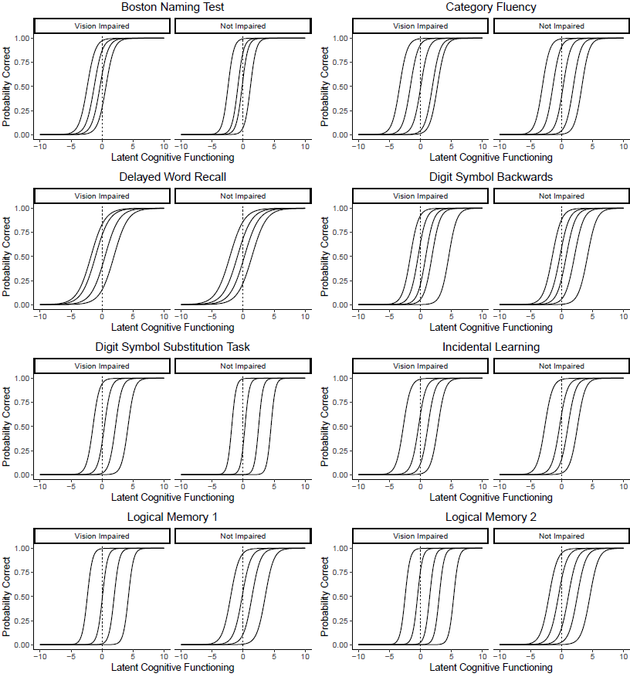

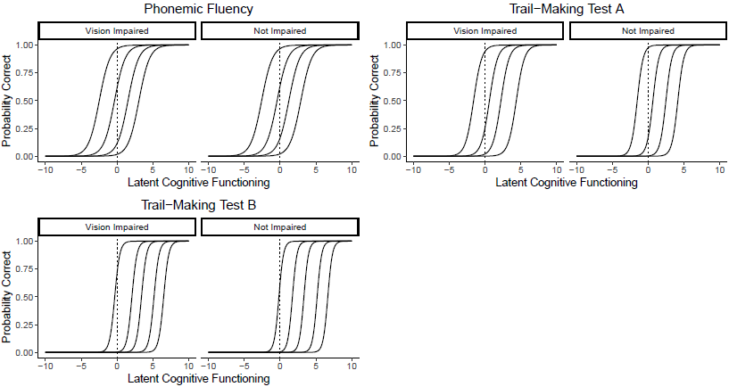

## **eFigure 4: Item characteristic curves (ICCs) by vision impairment in the Baltimore Longitudinal Study of Aging (BLSA).** The plots show the relationship between latent cognitive functioning and the probability of answering an item correctly (or scoring high enough to be included in the next highest category of scores). The curves are shown for each item separately and stratified by vision impairment status. Curves which are shifted right or left in the vision impaired as compared to the non-impaired are either more difficult (shift right) or easier (shift left) in the vision impaired. Curves that have a less steep slope in the vision impaired as compared to the non-impaired indicate that the item has a weaker relationship with latent cognitive functioning in the vision impaired as compared to the unimpaired.

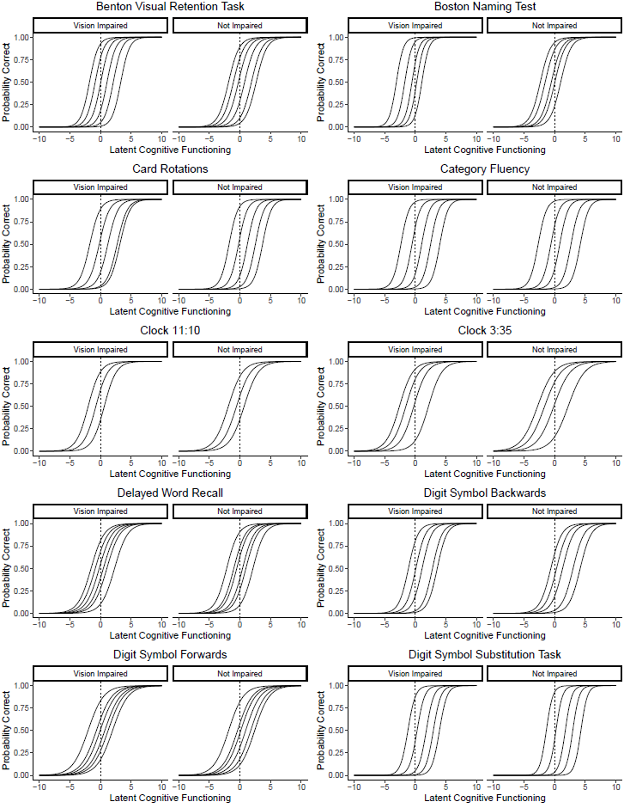

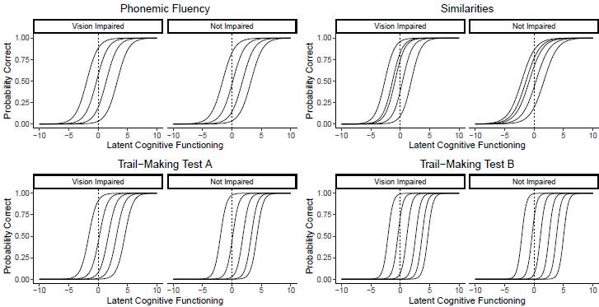

## **eMethods 1: Additional methods for the estimation of differential item functioning using the alignment method**

To test for DIF in cognitive testing by sensory impairment, we used the alignment method in Mplus software (version 8, Muthén & Muthén, Los Angeles CA) (Asparouhov & Muthén, 2014; Muthén & Asparouhov, 2014). Briefly, the optimization procedure for alignment analysis minimizes the number of parameters that are allowed to be different by sensory impairment status, compared to the fit of a configural model in which all parameters are fixed to be equal by impairment group. This procedure will identify solutions which favor a few parameters that show large DIF instead of a larger number of parameters showing moderate DIF. This method allows for testing of differences between groups on each parameter estimated in the model. We used this method to test for differential item function by vision impairment and by hearing impairment in both BLSA and ARIC-NCS batteries. The model was fit using a maximum likelihood estimator with robust standard errors. The graded response model, a generalized form of the two-parameter logistic model, was used to fit ordinal test items (Samejima, 1969).

## **eMethods 2: Methods for the estimation of the confirmatory factor analysis for the comparison of cognition in ARIC-NCS and BLSA**

To directly compare relative distributions of cognition between the BLSA and ARIC-NCS samples, we estimated a unidimensional confirmatory factor analysis model with both samples together using Mplus software (version 8, Muthén & Muthén, Los Angeles CA). The model was fit using a maximum likelihood estimator with robust standard errors. The graded response model, a generalized form of the two-parameter logistic model, was used to fit ordinal test items. The latent trait was constrained to have a mean of 0 and standard deviation of 1 for model identifiability. For this subanalysis, we included the Trail-Making test, parts A and B, the digit symbol substitution test and WAIS-R digit span backwards test, as these tests were administered uniformly between the cohorts. We included study, age and sex as predictors of cognition in the model.

## **eFigure 5: Distribution of Latent Cognitive Functioning in the Atherosclerosis Risk in Communities Neurocognitive Study (ARIC-NCS) and Baltimore Longitudinal Study of Aging (BLSA) Samples**

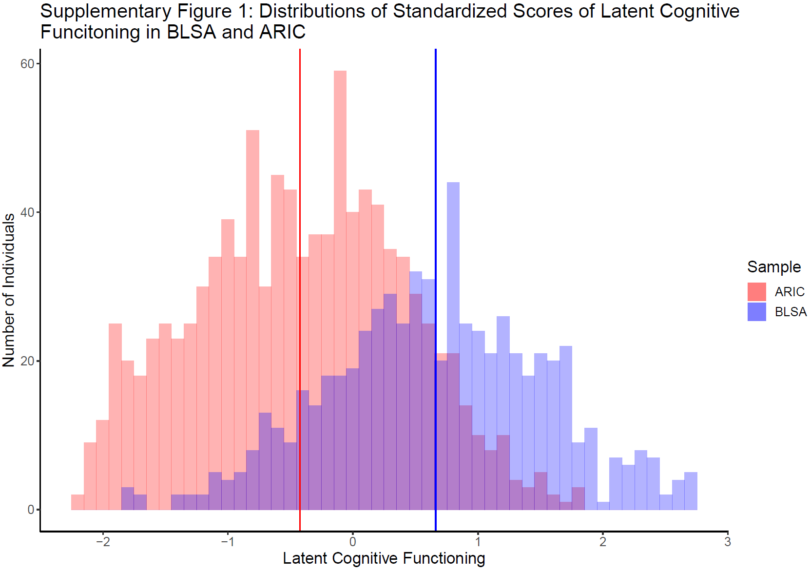

## **Introduction to eTables 7 and 8**

We conducted a number of different sensitivity analyses on subsets of the ARIC-NCS sample to test the effect of demographic factors on differential item functioning (DIF) findings. It is possible that demographic factors may influence test performance above and beyond their influence on latent cognitive ability, and therefore, we wanted to test the consistency of our findings in different demographic groups. We tested our findings among the following groups: those above 77 years old, below 77 years old, those with low educational attainment (high school or lower), high educational attainment, white race, black race, males and females. We further tried to quantify the level of consistency between our baseline and sensitivity analysis results. We defined a sensitivity analysis estimate as consistent with baseline for baseline estimates that were not statistically significant as a sensitivity analysis estimate that was also not statistically significant. We defined a sensitivity analysis estimate as consistent with baseline for baseline estimates that were statistically significant as a sensitivity analysis estimate in the same direction as the baseline estimate; we did not also require a significant result for consistency, as lower samples sizes affect power in stratified analyses. Given these definitions, we find that our baseline results reported in the paper were consistent in 94.3% of the above specified sensitivity analyses. Given the large number of tests conducted through these sensitivity analyses, even in the presence of some expected spurious results we believe that this level of consistency suggests the results are likely not confounded by demographic factors.

## **eTable 7: Parameter differences by hearing impairment status in the Atherosclerosis Risk in Communities Neurocognitive Study (ARIC-NCS) study in samples stratified by age, educational attainment, race, and sex**

|  |  |  |  |  |  |  |  |  |  |  |  |  |  |  |  |  |  |  |  |
| --- | --- | --- | --- | --- | --- | --- | --- | --- | --- | --- | --- | --- | --- | --- | --- | --- | --- | --- | --- |
| **Item** | **Parameter** | **Baseline** | | **Younger** | | **Older** | | **Low Education** | | **High Education** | | **Black** | | **White** | | **Male** | | **Female** | |
| Boston Naming Test | Discrimination | | -0.29 (0.15) | | -0.58 (0.28)* | | -0.22 (0.20) | | -0.07 (0.17) | | -0.65 (0.24)** | | 0.26 (0.34) | | -0.14 (0.20) | | -0.68 (0.34)* | | -0.12 (0.18) |
| Boston Naming Test | Threshold 1 | | -0.21 (0.20) | | 0.24 (0.34) | | -0.26 (0.25) | | -0.06 (0.30) | | -0.08 (0.22) | | -0.17 (0.37) | | 0.34 (0.23) | | -0.69 (0.38) | | -0.15 (0.23) |
| Boston Naming Test | Threshold 2 | | -0.21 (0.14) | | 0.05 (0.23) | | -0.24 (0.18) | | -0.29 (0.20) | | -0.36 (0.16)* | | 0.05 (0.25) | | 0.00 (0.14) | | -0.29 (0.29) | | -0.10 (0.15) |
| Boston Naming Test | Threshold 3 | | -0.28 (0.12)* | | -0.28 (0.17) | | -0.30 (0.16) | | -0.21 (0.17) | |  | | 0.03 (0.20) | |  | | -0.38 (0.24) | | -0.19 (0.14) |
| Boston Naming Test | Threshold 4 | | -0.36 (0.12)** | |  | | -0.35 (0.15)* | | -0.25 (0.15) | |  | | -0.19 (0.19) | |  | |  | | -0.18 (0.14) |
| Categorical Fluency | Discrimination | | 0.00 (0.09) | | -0.12 (0.16) | | -0.05 (0.12) | | -0.10 (0.14) | | 0.09 (0.14) | | -0.15 (0.22) | | -0.12 (0.14) | | 0.05 (0.16) | | -0.03 (0.12) |
| Categorical Fluency | Threshold 1 | | 0.85 (0.23)** | | 0.44 (0.32) | | 0.87 (0.28)** | | 0.74 (0.24)** | | 0.60 (0.29)* | | 0.29 (0.33) | | 0.29 (0.19) | | 0.12 (0.29) | | 0.75 (0.24)** |
| Categorical Fluency | Threshold 2 | | 0.34 (0.14)* | | -0.10 (0.17) | | 0.39 (0.17)* | | 0.24 (0.15) | | 0.19 (0.17) | | 0.11 (0.17) | | -0.06 (0.12) | | 0.17 (0.20) | | 0.19 (0.14) |
| Categorical Fluency | Threshold 3 | | 0.12 (0.10) | | -0.01 (0.12) | | 0.07 (0.12) | | 0.00 (0.13) | | 0.04 (0.13) | | -0.07 (0.17) | | -0.11 (0.14) | | 0.20 (0.17) | | -0.03 (0.11) |
| Categorical Fluency | Threshold 4 | | 0.05 (0.10) | | -0.03 (0.14) | | -0.01 (0.13) | | -0.21 (0.18) | | 0.11 (0.14) | | -0.17 (0.29) | | 0.10 (0.18) | | 0.01 (0.18) | | 0.04 (0.14) |
| Categorical Fluency | Threshold 5 | | 0.01 (0.13) | | -0.15 (0.16) | | 0.03 (0.17) | | 0.04 (0.22) | | 0.29 (0.18) | |  | |  | | 0.24 (0.24) | | 0.21 (0.18) |
| Delayed Word Recall | Discrimination | | 0.20 (0.08)* | | 0.04 (0.12) | | 0.24 (0.11)* | | 0.13 (0.12) | | 0.29 (0.14)* | | -0.11 (0.17) | | -0.08 (0.10) | | 0.17 (0.16) | | 0.17 (0.10) |
| Delayed Word Recall | Threshold 1 | | 0.26 (0.12)* | | -0.06 (0.22) | | 0.26 (0.15) | | 0.40 (0.17)* | | 0.09 (0.18) | | 0.35 (0.27) | | -0.27 (0.20) | | -0.26 (0.20) | | 0.35 (0.15)* |
| Delayed Word Recall | Threshold 2 | | 0.40 (0.09)** | | 0.27 (0.16) | | 0.33 (0.12)** | | 0.42 (0.14)** | | 0.37 (0.13)** | | 0.25 (0.21) | | -0.16 (0.16) | | 0.18 (0.17) | | 0.27 (0.12)* |
| Delayed Word Recall | Threshold 3 | | 0.38 (0.09)** | | 0.13 (0.15) | | 0.37 (0.11)** | | 0.39 (0.13)** | | 0.36 (0.12)** | | -0.04 (0.17) | | 0.02 (0.12) | | 0.29 (0.16) | | 0.17 (0.11) |
| Delayed Word Recall | Threshold 4 | | 0.33 (0.10)** | | 0.37 (0.21) | | 0.38 (0.14)** | | 0.34 (0.15)* | | 0.33 (0.14)* | | 0.16 (0.22) | | -0.14 (0.15) | | 0.29 (0.21) | | 0.13 (0.12) |
| Digit Symbol Backwards | Discrimination | | -0.08 (0.09) | | 0.31 (0.16) | | -0.43 (0.15)** | | 0.07 (0.13) | | -0.27 (0.14) | | -0.23 (0.26) | | 0.08 (0.12) | | -0.25 (0.21) | | -0.05 (0.11) |
| Digit Symbol Backwards | Threshold 1 | | -0.21 (0.13) | | -0.57 (0.21)** | | 0.10 (0.17) | | -0.27 (0.16) | | -0.19 (0.22) | | -0.27 (0.20) | | 0.01 (0.18) | | -0.47 (0.25) | | -0.15 (0.15) |
| Digit Symbol Backwards | Threshold 2 | | -0.11 (0.09) | | -0.20 (0.16) | | -0.08 (0.13) | | -0.09 (0.12) | | -0.13 (0.14) | | -0.27 (0.20) | | 0.08 (0.12) | | -0.14 (0.20) | | -0.14 (0.11) |
| Digit Symbol Backwards | Threshold 3 | | -0.01 (0.08) | | 0.07 (0.14) | | -0.11 (0.13) | | 0.04 (0.12) | | -0.04 (0.12) | | -0.25 (0.30) | | 0.05 (0.13) | | -0.21 (0.19) | | 0.02 (0.10) |
| Digit Symbol Backwards | Threshold 4 | | -0.05 (0.10) | | 0.25 (0.16) | | -0.34 (0.16)* | | -0.06 (0.16) | | -0.05 (0.13) | |  | | 0.15 (0.16) | | -0.26 (0.22) | | 0.04 (0.12) |
| Digit Symbol Backwards | Threshold 5 | | 0.07 (0.16) | | 0.54 (0.25)* | | -0.28 (0.25) | |  | | -0.15 (0.19) | |  | | 0.34 (0.19) | | 0.08 (0.30) | | 0.12 (0.20) |
| Digit Symbol Substitution Task | Discrimination | | 0.17 (0.19) | | 0.25 (0.25) | | 0.16 (0.22) | | 0.09 (0.31) | | 0.19 (0.22) | | 0.16 (0.43) | | 0.41 (0.31) | | -0.46 (0.48) | | 0.13 (0.25) |
| Digit Symbol Substitution Task | Threshold 1 | | -0.14 (0.19) | | -0.02 (0.31) | | -0.24 (0.24) | | -0.42 (0.44) | | -0.09 (0.35) | | -0.14 (0.25) | | 0.28 (0.25) | | -0.31 (0.38) | | -0.14 (0.22) |
| Digit Symbol Substitution Task | Threshold 2 | | 0.20 (0.13) | | 0.41 (0.22) | | 0.00 (0.16) | | -0.11 (0.26) | | -0.10 (0.19) | | 0.26 (0.24) | | 0.35 (0.14)** | | 0.02 (0.26) | | 0.00 (0.14) |
| Digit Symbol Substitution Task | Threshold 3 | | -0.07 (0.13) | | 0.05 (0.18) | | -0.21 (0.18) | | 0.31 (0.20) | | 0.15 (0.14) | | 0.17 (0.32) | | 0.35 (0.22) | | -0.44 (0.38) | | -0.34 (0.15)* |
| Digit Symbol Substitution Task | Threshold 4 | | 0.13 (0.19) | | 0.20 (0.27) | | 0.06 (0.27) | | -0.14 (0.22) | | 0.19 (0.20) | |  | |  | |  | | -0.04 (0.22) |
| Incidental Learning | Discrimination | | 0.35 (0.11)** | | 0.18 (0.17) | | 0.35 (0.15)* | | 0.24 (0.15) | | 0.28 (0.17) | | -0.10 (0.24) | | 0.26 (0.20) | | 0.34 (0.25) | | 0.13 (0.13) |
| Incidental Learning | Threshold 1 | | 0.04 (0.17) | | -0.13 (0.21) | | -0.05 (0.21) | | 0.11 (0.22) | | 0.18 (0.31) | | 0.00 (0.35) | | -0.55 (0.23)* | | -0.28 (0.34) | | 0.16 (0.21) |
| Incidental Learning | Threshold 2 | | 0.35 (0.10)** | | 0.42 (0.17)* | | 0.16 (0.13) | | 0.49 (0.15)** | | 0.10 (0.19) | | 0.36 (0.25) | | -0.05 (0.16) | | 0.12 (0.18) | | 0.35 (0.12)** |
| Incidental Learning | Threshold 3 | | 0.31 (0.10)** | | 0.44 (0.15)** | | 0.06 (0.14) | | 0.49 (0.15)** | | 0.16 (0.14) | | 0.05 (0.19) | | 0.18 (0.13) | | 0.10 (0.19) | | 0.25 (0.12)* |
| Incidental Learning | Threshold 4 | | 0.33 (0.14)* | | 0.26 (0.18) | | 0.24 (0.19) | | 0.38 (0.21) | | 0.05 (0.13) | | 0.00 (0.22) | | 0.03 (0.17) | | 0.16 (0.28) | | 0.25 (0.16) |
| Logical Memory 1 | Discrimination | | 0.03 (0.11) | | -0.44 (0.26) | | 0.10 (0.18) | | 0.00 (0.12) | | -0.08 (0.28) | | 0.10 (0.22) | | -0.55 (0.39) | | 0.13 (0.20) | | -0.02 (0.13) |
| Logical Memory 1 | Threshold 1 | | 0.23 (0.16) | | -0.09 (0.16) | | 0.17 (0.19) | | 0.59 (0.30)* | | 0.22 (0.20) | | -0.01 (0.31) | | -0.06 (0.16) | | 0.25 (0.38) | | 0.08 (0.23) |
| Logical Memory 1 | Threshold 2 | | 0.11 (0.10) | | -0.51 (0.15)** | | 0.22 (0.13) | | 0.36 (0.18) | | -0.05 (0.13) | | -0.12 (0.21) | | -0.39 (0.21) | | 0.12 (0.20) | | 0.26 (0.13)* |
| Logical Memory 1 | Threshold 3 | | -0.16 (0.10) | | -0.45 (0.24) | | 0.12 (0.13) | | 0.19 (0.14) | | -0.13 (0.18) | | -0.13 (0.31) | | -0.48 (0.35) | | 0.38 (0.16)* | | -0.11 (0.12) |
| Logical Memory 1 | Threshold 4 | | -0.04 (0.16) | |  | | 0.16 (0.19) | | -0.12 (0.14) | | -0.06 (0.29) | | -0.51 (0.53) | |  | | 0.08 (0.19) | | -0.10 (0.17) |
| Logical Memory 2 | Discrimination | | -0.02 (0.11) | | -0.51 (0.26) | | 0.18 (0.17) | | -0.02 (0.13) | | -0.20 (0.28) | | 0.02 (0.20) | | -0.64 (0.41) | | 0.01 (0.19) | | 0.02 (0.13) |
| Logical Memory 2 | Threshold 1 | | 0.28 (0.16) | | 0.25 (0.20) | | 0.14 (0.18) | | 0.33 (0.21) | | 0.12 (0.27) | | -0.05 (0.26) | | 0.09 (0.19) | | 0.11 (0.26) | | 0.09 (0.19) |
| Logical Memory 2 | Threshold 2 | | 0.29 (0.11)* | | 0.03 (0.14) | | 0.31 (0.14)* | | 0.41 (0.16)** | | 0.12 (0.17) | | -0.10 (0.20) | | -0.19 (0.16) | | 0.09 (0.17) | | 0.28 (0.13)* |
| Logical Memory 2 | Threshold 3 | | 0.03 (0.09) | | -0.36 (0.18) | | 0.03 (0.12) | | 0.16 (0.14) | | -0.09 (0.13) | | -0.12 (0.29) | | -0.50 (0.30) | | -0.08 (0.15) | | 0.05 (0.12) |
| Logical Memory 2 | Threshold 4 | | 0.00 (0.12) | |  | | 0.27 (0.17) | | -0.15 (0.17) | | -0.08 (0.19) | | -0.55 (0.43) | | -0.81 (0.47) | | 0.02 (0.20) | | -0.09 (0.16) |
| Logical Memory 2 | Threshold 5 | | -0.17 (0.22) | |  | | 0.01 (0.25) | | 0.03 (0.23) | | -0.34 (0.33) | |  | |  | |  | | -0.31 (0.24) |
| Phonemic Fluency | Discrimination | | -0.10 (0.10) | | 0.05 (0.14) | | -0.18 (0.14) | | -0.24 (0.15) | | 0.05 (0.12) | | -0.17 (0.30) | | -0.26 (0.19) | | -0.11 (0.20) | | -0.10 (0.13) |
| Phonemic Fluency | Threshold 1 | | 0.37 (0.17)* | | 0.35 (0.23) | | 0.36 (0.22) | | 0.38 (0.21) | | 0.28 (0.24) | | 0.04 (0.20) | | 0.33 (0.22) | | 0.22 (0.32) | | 0.14 (0.20) |
| Phonemic Fluency | Threshold 2 | | 0.19 (0.11) | | 0.31 (0.17) | | 0.18 (0.14) | | 0.16 (0.15) | | 0.27 (0.14)* | | 0.08 (0.18) | | -0.10 (0.12) | | 0.29 (0.23) | | 0.03 (0.12) |
| Phonemic Fluency | Threshold 3 | | 0.11 (0.10) | | 0.16 (0.15) | | 0.12 (0.13) | | 0.01 (0.13) | | 0.00 (0.12) | | 0.05 (0.27) | | -0.17 (0.16) | | 0.18 (0.18) | | -0.04 (0.11) |
| Phonemic Fluency | Threshold 4 | | -0.07 (0.13) | | 0.26 (0.21) | | -0.06 (0.17) | | -0.13 (0.17) | | 0.14 (0.17) | |  | | -0.42 (0.23) | | 0.14 (0.24) | | -0.21 (0.17) |
| Trail-Making Test A | Discrimination | | -0.06 (0.15) | | -0.07 (0.18) | | -0.15 (0.18) | | -0.13 (0.24) | | -0.03 (0.17) | | 0.16 (0.35) | | 0.25 (0.23) | | 0.03 (0.25) | | -0.25 (0.21) |
| Trail-Making Test A | Threshold 1 | | -0.26 (0.15) | | -0.28 (0.27) | | -0.30 (0.19) | | -0.28 (0.21) | | -0.25 (0.24) | | 0.14 (0.19) | | -0.16 (0.22) | | -0.94 (0.28)** | | 0.00 (0.17) |
| Trail-Making Test A | Threshold 2 | | -0.28 (0.11)** | | -0.43 (0.18)* | | -0.29 (0.15)* | | -0.39 (0.17)* | | -0.16 (0.14) | | 0.07 (0.24) | | -0.03 (0.12) | | -0.50 (0.21)* | | -0.26 (0.12)* |
| Trail-Making Test A | Threshold 3 | | -0.06 (0.12) | | -0.12 (0.17) | | -0.12 (0.18) | | -0.12 (0.20) | | 0.04 (0.15) | | -0.01 (0.35) | | 0.16 (0.16) | | -0.33 (0.27) | | -0.08 (0.15) |
| Trail-Making Test A | Threshold 4 | | -0.18 (0.18) | | -0.25 (0.23) | | -0.19 (0.26) | | -0.39 (0.31) | | 0.00 (0.22) | |  | | 0.35 (0.22) | | -0.58 (0.39) | | -0.19 (0.21) |
| Trail-Making Test B | Discrimination | | 0.06 (0.19) | | -0.08 (0.24) | | -0.03 (0.21) | | 0.08 (0.30) | | -0.15 (0.25) | | 0.46 (0.62) | | 0.44 (0.28) | | -0.09 (0.35) | | 0.14 (0.27) |
| Trail-Making Test B | Threshold 1 | | -0.24 (0.14) | | -0.45 (0.28) | | -0.22 (0.19) | | -0.01 (0.20) | | -0.45 (0.21)* | | 0.07 (0.40) | | -0.13 (0.18) | | -0.54 (0.28) | | -0.25 (0.17) |
| Trail-Making Test B | Threshold 2 | | -0.17 (0.12) | | -0.23 (0.21) | | -0.31 (0.20) | | 0.00 (0.21) | | -0.34 (0.16)* | | 0.58 (0.59) | | -0.02 (0.13) | | -0.18 (0.26) | | -0.19 (0.14) |
| Trail-Making Test B | Threshold 3 | | -0.12 (0.15) | | -0.23 (0.19) | | -0.18 (0.25) | | -0.14 (0.28) | | -0.17 (0.18) | | 0.51 (0.73) | | 0.14 (0.18) | | -0.36 (0.30) | | -0.02 (0.19) |
| Trail-Making Test B | Threshold 4 | | -0.19 (0.21) | | -0.19 (0.25) | | -0.34 (0.35) | | -0.27 (0.39) | | -0.22 (0.25) | |  | | 0.31 (0.26) | | -0.58 (0.46) | | -0.01 (0.26) |
| Trail-Making Test B | Threshold 5 | | -0.07 (0.28) | |  | |  | |  | |  | |  | |  | | -1.21 (0.69) | | 0.47 (0.35) |

Data show parameter differences (SE), parameter differences are the parameter value in the impaired group – the parameter value in the unimpaired group. Results in stratified samples that are similar to the baseline results provides evidence that other variables do not explain the observed biases by sensory impairment status. All stratified analyses were conducted in the ARIC-NCS sample due to the larger sample size. The younger group includes all individuals 77 and younger, while the older group includes all individuals over 77. High educational attainment includes all individuals with educational attainment higher than high school or equivalent, low educational attainment includes all individuals with educational attainment lower to or equivalent to a high school education. Missing cells indicate that there were not enough individuals in the stratified category to estimate every threshold in the baseline scenario including all data. Because of smaller sample sizes in the subgroup analyses, different thresholds may represent different cutoffs of the continuous traits for the various sensitivity analyses. **\* =** p < 0.05, ** = p < 0.01.

## **eTable 8: Parameter differences by vision impairment status in the Atherosclerosis Risk in Communities Neurocognitive Study (ARIC-NCS) study in samples stratified by age, educational attainment, race, and sex**

|  |  |  |  |  |  |  |  |  |  |  |  |
| --- | --- | --- | --- | --- | --- | --- | --- | --- | --- | --- | --- |
| **Item** | | **Parameter** | **Baseline** | **Younger** | **Older** | **Low education** | **High education** | **Black** | **White** | **Male** | **Female** |
| Boston Naming Test | Discrimination | | -0.62 (0.35) | -0.78 (0.79) | -0.41 (0.48) | 0.45 (0.67) | -0.97 (0.53) | -0.33 (0.51) | 0.06 (0.34) | -0.37 (0.68) | -1.01 (0.48)* |
| Boston Naming Test | Threshold 1 | | 0.05 (0.29) | 0.10 (0.46) | 0.19 (0.40) | -0.35 (0.47) | 0.16 (1.47) | 0.66 (0.51) | -0.16 (0.44) | -0.34 (0.54) | 0.15 (0.38) |
| Boston Naming Test | Threshold 2 | | -0.41 (0.24) | -0.17 (0.47) | -0.43 (0.30) | -0.07 (0.32) | -0.22 (1.43) | 0.02 (0.35) | 0.19 (0.34) | 0.05 (0.37) | -0.46 (0.33) |
| Boston Naming Test | Threshold 3 | | -0.17 (0.23) | -0.29 (0.48) | -0.24 (0.29) | 0.39 (0.30) |  | -0.16 (0.35) |  | -0.39 (0.33) | -0.27 (0.33) |
| Boston Naming Test | Threshold 4 | | -0.55 (0.24)* |  | -0.55 (0.29) | 0.26 (0.30) |  | -0.52 (0.37) |  |  | -0.74 (0.38)* |
| Categorical Fluency | Discrimination | | -0.05 (0.20) | 0.02 (0.33) | -0.06 (0.21) | -0.04 (0.20) | 0.31 (0.52) | 0.31 (0.39) | 0.27 (0.37) | 0.04 (0.29) | -0.04 (0.27) |
| Categorical Fluency | Threshold 1 | | -0.26 (0.40) | -0.31 (0.66) | -0.13 (0.44) | -0.32 (0.37) | -1.24 (1.26) | -1.29 (0.68) | 0.00 (0.35) | 0.25 (0.54) | -0.57 (0.46) |
| Categorical Fluency | Threshold 2 | | -0.22 (0.27) | -0.56 (0.47) | 0.02 (0.26) | -0.29 (0.27) | -1.19 (1.10) | -0.66 (0.36) | 0.13 (0.34) | -0.13 (0.39) | -0.19 (0.29) |
| Categorical Fluency | Threshold 3 | | -0.20 (0.22) | -0.80 (0.44) | -0.13 (0.25) | -0.27 (0.30) | -0.58 (1.04) | -0.54 (0.35) | -0.15 (0.37) | -0.11 (0.34) | -0.04 (0.32) |
| Categorical Fluency | Threshold 4 | | 0.03 (0.25) | -0.30 (0.46) | 0.20 (0.33) | -0.12 (0.33) | -0.32 (1.04) | 0.23 (0.58) | -0.50 (0.45) | 0.07 (0.34) | -0.23 (0.36) |
| Categorical Fluency | Threshold 5 | | -0.54 (0.31) | -0.34 (0.60) | -0.62 (0.38) | 0.45 (0.49) | -0.54 (1.07) |  |  | -0.60 (0.49) | -0.53 (0.46) |
| Delayed Word Recall | Discrimination | | 0.03 (0.15) | -0.35 (0.47) | 0.21 (0.23) | -0.29 (0.31) | -0.24 (0.42) | -0.02 (0.22) | -0.06 (0.32) | -0.08 (0.38) | -0.01 (0.19) |
| Delayed Word Recall | Threshold 1 | | 0.34 (0.24) | 0.69 (0.59) | 0.22 (0.27) | -0.33 (0.27) | 0.59 (0.65) | 0.08 (0.48) | 0.11 (0.52) | -0.40 (0.43) | 0.80 (0.31)** |
| Delayed Word Recall | Threshold 2 | | -0.14 (0.20) | 0.14 (0.44) | -0.23 (0.23) | 0.02 (0.21) | -0.17 (0.61) | 0.54 (0.35) | -0.14 (0.45) | -0.50 (0.33) | 0.14 (0.26) |
| Delayed Word Recall | Threshold 3 | | 0.27 (0.19) | 0.05 (0.31) | 0.38 (0.24) | -0.58 (0.24)* | -0.11 (0.62) | 0.31 (0.33) | -0.11 (0.31) | -0.10 (0.31) | 0.49 (0.26) |
| Delayed Word Recall | Threshold 4 | | 0.50 (0.24)* | -0.15 (0.41) | 0.78 (0.33)* | -0.73 (0.30)* | 0.30 (0.64) | 0.41 (0.38) | 0.27 (0.41) | 0.70 (0.53) | 0.46 (0.30) |
| Digit Symbol Backwards | Discrimination | | 0.19 (0.27) | 0.27 (0.51) | 0.31 (0.34) | -0.49 (0.49) | -0.03 (0.35) | 0.31 (0.44) | 0.21 (0.28) | 0.19 (0.50) | 0.16 (0.35) |
| Digit Symbol Backwards | Threshold 1 | | -0.13 (0.26) | -0.39 (0.57) | -0.03 (0.31) | 0.17 (0.30) | 0.24 (0.97) | 0.14 (0.36) | -0.12 (0.47) | 0.11 (0.37) | -0.21 (0.36) |
| Digit Symbol Backwards | Threshold 2 | | -0.11 (0.22) | 0.12 (0.38) | -0.15 (0.26) | -0.07 (0.28) | -0.20 (0.90) | -0.17 (0.35) | 0.07 (0.32) | 0.01 (0.29) | -0.14 (0.28) |
| Digit Symbol Backwards | Threshold 3 | | 0.10 (0.22) | 0.44 (0.34) | 0.05 (0.25) | -0.43 (0.30) | -0.16 (0.91) | -0.15 (0.50) | -0.23 (0.26) | -0.07 (0.31) | 0.26 (0.28) |
| Digit Symbol Backwards | Threshold 4 | | -0.22 (0.25) | -0.01 (0.40) | -0.19 (0.29) | -0.12 (0.38) | -0.56 (0.91) |  | -0.07 (0.33) | 0.11 (0.41) | -0.39 (0.29) |
| Digit Symbol Backwards | Threshold 5 | | 0.39 (0.54) | 0.62 (1.08) | 0.53 (0.66) |  | 0.21 (0.98) |  | 0.03 (0.45) | 24.11 (0.33)** | 0.00 (0.56) |
| Digit Symbol Substitution Task | Discrimination | | -0.93 (0.42)* | -0.73 (1.02) | -0.86 (0.55) | 0.98 (1.01) | -1.02 (0.92) | -0.77 (0.38)* | -0.29 (0.65) | -0.41 (1.63) | -0.93 (0.51) |
| Digit Symbol Substitution Task | Threshold 1 | | 0.38 (0.28) | 0.71 (0.55) | 0.50 (0.35) | -1.54 (0.59)** | 1.15 (1.86) | 0.79 (0.47) | 0.28 (0.56) | 0.33 (0.54) | 0.66 (0.37) |
| Digit Symbol Substitution Task | Threshold 2 | | 0.08 (0.25) | 0.25 (0.58) | 0.07 (0.28) | -0.49 (0.37) | 0.58 (1.78) | -0.18 (0.45) | 0.59 (0.56) | 0.32 (0.65) | 0.15 (0.36) |
| Digit Symbol Substitution Task | Threshold 3 | | -0.34 (0.34) | 0.40 (0.69) | -0.69 (0.47) | 0.25 (0.34) | 0.79 (1.80) | -0.33 (0.58) | 0.27 (0.76) | 0.07 (1.12) | -0.25 (0.42) |
| Digit Symbol Substitution Task | Threshold 4 | | -0.31 (0.52) | 0.71 (1.00) | -0.82 (0.72) | 0.81 (0.43) | 0.54 (1.80) |  |  |  | -0.28 (0.59) |
| Incidental Learning | Discrimination | | 0.10 (0.27) | 0.59 (0.78) | 0.09 (0.33) | -0.22 (0.54) | 0.40 (0.70) | -0.05 (0.31) | -0.52 (0.51) | 0.40 (0.88) | 0.10 (0.31) |
| Incidental Learning | Threshold 1 | | -0.06 (0.34) | 0.31 (0.48) | 0.06 (0.40) | -0.17 (0.42) | -0.36 (1.08) | 0.20 (0.62) | -0.57 (0.82) | -0.64 (0.73) | 0.09 (0.41) |
| Incidental Learning | Threshold 2 | | 0.01 (0.21) | 0.31 (0.44) | -0.05 (0.25) | -0.03 (0.21) | -0.31 (1.00) | 0.44 (0.45) | -0.20 (0.50) | -0.49 (0.44) | 0.29 (0.28) |
| Incidental Learning | Threshold 3 | | 0.17 (0.24) | 0.00 (0.43) | 0.33 (0.31) | 0.05 (0.22) | 0.13 (0.97) | 0.36 (0.38) | -0.56 (0.45) | 0.36 (0.51) | 0.17 (0.33) |
| Incidental Learning | Threshold 4 | | 0.25 (0.35) | 0.27 (0.62) | 0.43 (0.47) | 0.04 (0.35) | 0.67 (0.95) | 0.46 (0.45) | -0.88 (0.54) | 0.89 (0.79) | 0.18 (0.41) |
| Logical Memory 1 | Discrimination | | 0.93 (0.59) | 0.50 (0.85) | 1.75 (1.89) | -2.35 (1.36) | 0.21 (0.45) | 2.60 (1.19)* | 0.05 (0.56) | 0.39 (0.68) | 1.28 (0.76) |
| Logical Memory 1 | Threshold 1 | | -0.36 (0.40) | -0.78 (0.52) | -0.37 (0.80) | 1.48 (1.50) | -0.28 (1.11) | -1.59 (1.03) | -0.66 (0.51) | 0.50 (0.56) | -1.47 (0.80) |
| Logical Memory 1 | Threshold 2 | | 0.23 (0.27) | -0.16 (0.55) | 0.30 (0.36) | 0.80 (0.85) | -0.36 (0.96) | 0.05 (0.51) | -0.19 (0.39) | -0.12 (0.34) | 0.12 (0.39) |
| Logical Memory 1 | Threshold 3 | | 0.53 (0.44) | 1.18 (0.95) | 1.20 (1.17) | -0.82 (0.50) | -0.08 (0.58) | 1.40 (0.95) | -0.55 (0.59) | 0.17 (0.39) | 0.29 (0.43) |
| Logical Memory 1 | Threshold 4 | | 0.70 (0.73) |  | 1.31 (1.80) | -1.54 (1.13) | 0.19 (0.65) | 3.70 (1.74)* |  | 0.00 (0.55) | 0.70 (0.70) |
| Logical Memory 2 | Discrimination | | 1.05 (0.61) | 0.04 (0.65) | 1.90 (1.92) | -3.42 (2.52) | 0.00 (0.43) | 3.22 (1.47)* | 0.15 (0.63) | 0.59 (0.69) | 1.63 (0.91) |
| Logical Memory 2 | Threshold 1 | | -0.44 (0.43) | -0.42 (0.55) | -0.53 (0.94) | 1.47 (1.84) | -0.28 (1.43) | -0.86 (0.85) | -1.10 (0.78) | -0.35 (0.52) | -0.68 (0.69) |
| Logical Memory 2 | Threshold 2 | | 0.04 (0.26) | -0.24 (0.48) | 0.37 (0.38) | -0.18 (0.56) | -0.40 (1.16) | -0.01 (0.59) | -0.40 (0.43) | -0.19 (0.34) | -0.03 (0.41) |
| Logical Memory 2 | Threshold 3 | | 0.40 (0.38) | -0.30 (0.70) | 1.21 (1.06) | -2.01 (1.45) | -0.23 (0.90) | 2.36 (1.19)* | -0.11 (0.56) | -0.08 (0.45) | 1.02 (0.52) |
| Logical Memory 2 | Threshold 4 | | 0.50 (0.59) |  | 1.33 (1.76) | -2.96 (2.54) | -0.06 (0.60) | 3.45 (1.78) | -0.95 (0.72) | 0.11 (0.72) | 1.19 (0.81) |
| Logical Memory 2 | Threshold 5 | | 0.80 (0.88) |  | 1.55 (2.55) | -3.44 (3.56) | -0.13 (0.58) |  |  |  | 1.17 (1.04) |
| Phonemic Fluency | Discrimination | | 0.01 (0.17) | 0.01 (0.37) | 0.00 (0.15) | 0.13 (0.40) | 0.22 (0.45) | -0.01 (0.38) | -0.02 (0.27) | -0.11 (0.39) | 0.06 (0.24) |
| Phonemic Fluency | Threshold 1 | | 0.10 (0.30) | -0.33 (0.50) | 0.49 (0.34) | -0.26 (0.32) | 0.64 (0.85) | -0.02 (0.34) | 0.00 (0.29) | 0.73 (0.46) | -0.35 (0.43) |
| Phonemic Fluency | Threshold 2 | | 0.07 (0.20) | -0.12 (0.39) | 0.04 (0.24) | 0.05 (0.22) | 0.56 (0.82) | -0.47 (0.34) | 0.14 (0.30) | 0.44 (0.35) | -0.19 (0.28) |
| Phonemic Fluency | Threshold 3 | | 0.31 (0.23) | 0.47 (0.54) | 0.35 (0.25) | 0.22 (0.27) | 0.56 (0.88) | 0.46 (0.60) | 0.19 (0.41) | 0.56 (0.36) | 0.23 (0.30) |
| Phonemic Fluency | Threshold 4 | | 0.16 (0.31) | 0.37 (0.70) | 0.17 (0.35) | -0.51 (0.41) | 0.64 (0.88) |  | 0.48 (0.75) | 0.88 (0.66) | -0.09 (0.35) |
| Trail-Making Test A | Discrimination | | -0.64 (0.39) | -0.90 (0.70) | -0.66 (0.50) | 0.71 (0.82) | -0.30 (1.15) | 0.03 (0.37) | -0.34 (0.40) | -0.31 (1.07) | -0.77 (0.44) |
| Trail-Making Test A | Threshold 1 | | -0.08 (0.30) | -0.31 (0.75) | 0.14 (0.38) | -0.38 (0.36) | -0.45 (1.80) | -0.53 (0.41) | 0.94 (0.54) | 0.12 (0.61) | -0.18 (0.36) |
| Trail-Making Test A | Threshold 2 | | -0.06 (0.21) | 0.17 (0.52) | -0.16 (0.25) | 0.07 (0.29) | 0.38 (1.61) | 0.25 (0.51) | 0.55 (0.39) | -0.11 (0.40) | -0.03 (0.28) |
| Trail-Making Test A | Threshold 3 | | -0.26 (0.31) | -0.28 (0.54) | -0.30 (0.40) | 0.38 (0.41) | 0.16 (1.72) | 0.09 (0.55) | 0.67 (0.45) | 0.01 (0.60) | -0.41 (0.41) |
| Trail-Making Test A | Threshold 4 | | 0.21 (0.53) | 0.54 (0.94) | -0.06 (0.68) | 0.20 (0.72) | 1.13 (2.08) |  | 1.33 (0.86) | -0.31 (0.88) | 0.76 (0.84) |
| Trail-Making Test B | Discrimination | | -0.29 (0.53) | -0.07 (1.05) | -0.87 (0.69) | 0.59 (1.09) | -0.36 (1.20) | 0.01 (0.76) | 0.00 (0.43) | -0.03 (0.49) | -0.32 (0.70) |
| Trail-Making Test B | Threshold 1 | | -0.16 (0.28) | -0.84 (0.75) | -0.01 (0.32) | -0.23 (0.46) | -0.99 (2.07) | -0.67 (0.62) | 0.40 (0.48) | -0.57 (0.59) | 0.14 (0.40) |
| Trail-Making Test B | Threshold 2 | | 0.36 (0.34) | -0.01 (0.53) | 0.14 (0.59) | 0.29 (0.65) | 0.98 (2.20) | -0.20 (0.83) | 0.85 (0.47) | 0.09 (0.58) | 0.60 (0.51) |
| Trail-Making Test B | Threshold 3 | | 0.09 (0.42) | 0.44 (0.94) | -0.47 (0.72) | 0.50 (0.85) | 0.42 (2.27) | -0.22 (1.08) | 0.51 (0.55) | 0.24 (0.85) | 0.15 (0.59) |
| Trail-Making Test B | Threshold 4 | | -0.01 (0.62) | 0.46 (1.40) | -0.65 (1.06) | 0.60 (1.11) | 0.48 (2.53) |  | 0.14 (0.73) | -0.11 (1.23) | 0.28 (0.90) |
| Trail-Making Test B | Threshold 5 | | -0.15 (0.76) |  |  |  |  |  |  | 23.60 (0.71)** | -0.57 (0.93) |

Data show parameter differences (SE), parameter differences are the parameter value in the impaired group – the parameter value in the unimpaired group. Results in stratified samples that are similar to the baseline results provides evidence that other variables do not explain the observed biases by sensory impairment status. All stratified analyses were conducted in the ARIC-NCS sample due to the larger sample size. The younger group includes all individuals 77 and younger, while the older group includes all individuals over 77. High educational attainment includes all individuals with educational attainment higher than high school or equivalent, low educational attainment includes all individuals with educational attainment lower to or equivalent to a high school education. Missing cells indicate that there were not enough individuals in the stratified category to estimate every threshold in the baseline scenario including all data. Because of smaller sample sizes in the subgroup analyses, different thresholds may represent different cutoffs of the continuous traits for the various sensitivity analyses. **\* =** p < 0.05, ** = p < 0.01.