Supplemental Table 1

Mean and Median Times to Complete with No Trim and 5% Trimmed data.

|  |  |  |  |  |  |  |
| --- | --- | --- | --- | --- | --- | --- |
| Summary Stats (Min) | No Trim | | | 5 Percent Trim | | |
| N_Admin | Mean | Median | SD | mean | median | SD |
| 1 | 5.3 | 5.3 | NA | 5.3 | 5.3 | 0 |
| 2 | NA | NA | NA | NA | NA | NA |
| 3 | 0.5 | 0.5 | NA | 0.5 | 0.5 | 0 |
| 4 | 3.3 | 2.8 | 4.4 | 3.3 | 2.8 | 1.8 |
| 5 | 3.3 | 3.3 | 2.1 | 3.1 | 3.3 | 1.6 |
| 6 | 3.4 | 3.3 | 2.1 | 3.1 | 3.3 | 1.2 |
| 7 | 2.9 | 2.9 | 1.8 | 2.8 | 2.9 | 1.3 |
| 8 | 3.6 | 3.1 | 2.1 | 3.5 | 3.1 | 1.7 |
| 9 | 3.6 | 3.3 | 2.5 | 3.4 | 3.3 | 2.0 |
| 10 | ---- | 4.0 | ----- | 4.3 | 4.0 | 1.8 |
| 11 | 4.9 | 3.9 | 5.1 | 4.2 | 3.9 | 1.8 |
| 12 | 4.8 | 4.6 | 3.4 | 4.5 | 4.6 | 2.1 |
| 13 | 5.4 | 4.9 | 4.2 | 4.9 | 4.9 | 2.3 |
| 14 | 6.6 | 5.2 | 7.1 | 5.6 | 5.2 | 2.6 |
| 15 | 5.6 | 5.5 | 3.7 | 5.3 | 5.5 | 2.8 |
| 16 | 6.3 | 6.1 | 2.9 | 6.3 | 6.1 | 2.6 |
| 17 | 7.5 | 6.6 | 6.1 | 6.8 | 6.6 | 3.2 |
| 18 | 7.5 | 6.9 | 3.8 | 7.2 | 6.9 | 2.7 |
| 19 | 7.1 | 6.9 | 3.9 | 7.0 | 6.9 | 3.4 |
| 20 | 8.7 | 8.5 | 5.0 | 8.4 | 8.5 | 3.4 |
| 21 | 11.0 | 8.1 | 14.4 | 9.0 | 8.0 | 3.4 |
| 22 | 15.2 | 8.7 | 93.6 | 8.8 | 8.7 | 3.9 |
| 23 | 19.2 | 10.1 | 214.0 | 10.6 | 10.1 | 4.6 |
| 24 | 5.5 | 3.8 | 4.9 | 5.5 | 3.8 | 3.0 |
| 25 | 11.7 | 12.4 | 3.2 | 11.7 | 12.4 | 2.1 |
| 26 | 9.0 | 8.0 | 5.1 | 9.0 | 8.0 | 4.0 |

Supplemental Table 2

Frequency Distribution of Number of Items Administered in CAT

Standard Error <= .40 Condition.

|  |  |  |
| --- | --- | --- |
| Number of Items Administered | N | Percent Receiving Number of Items |
| 3 | 249 | 0.11 |
| 4 | 1182 | 0.54 |
| 5 | 104 | 0.05 |
| 6 | 136 | 0.06 |
| 7 | 85 | 0.04 |
| 8 | 85 | 0.04 |
| 9 | 9 | 0.00 |
| 10 | 8 | 0.00 |
| 11 | 44 | 0.02 |
| 12 | 1 | 0.00 |
| 13 | 1 | 0.00 |
| 21 | 283 | 0.13 |

Supplemental Figure 1

Frequency Distribution of the Number of Items Administered in Original Testing.

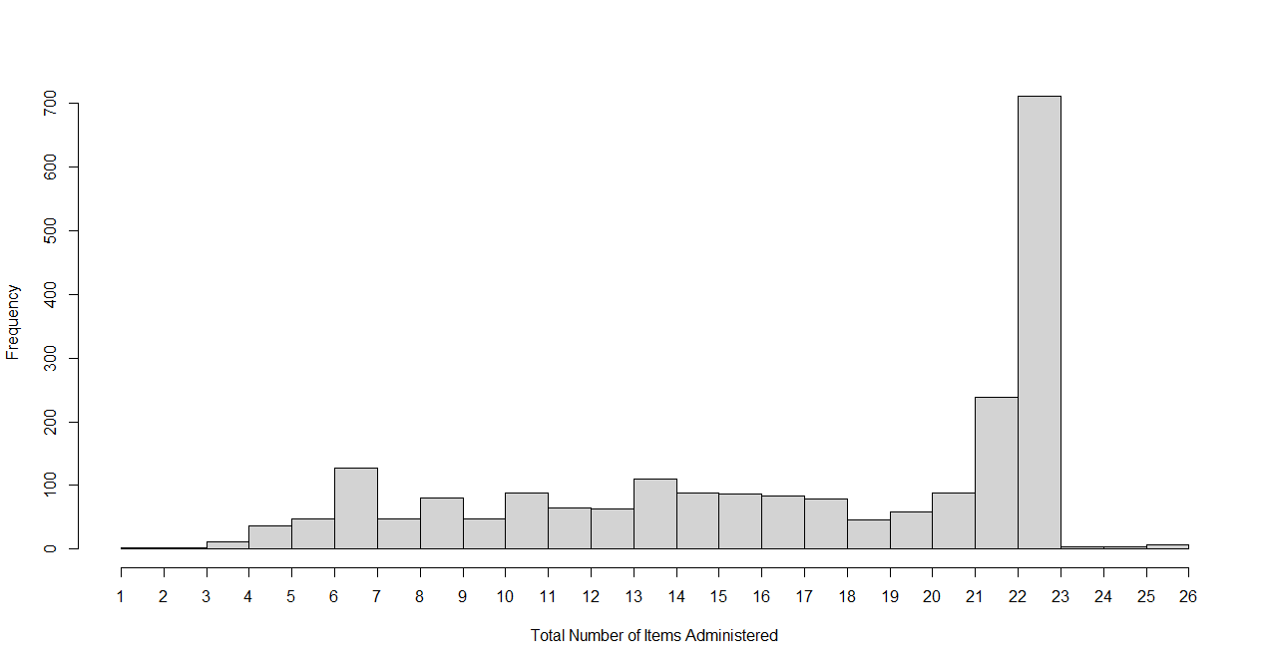

Supplemental Figure 2

Time to Complete in Minutes versus Number of Items Administered.

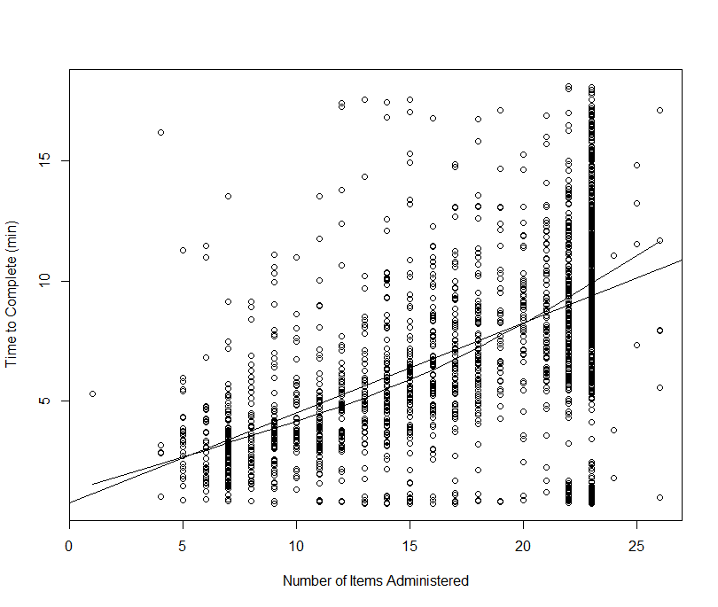

Supplemental Figure 3

Computerized Adaptive Test (3-item) Estimated Matrix Reasoning Trait Levels Versus Full Scale Estimated Trait Level.

Supplemental Figure 4

Computerized Adaptive Test (6-item) Estimated Matrix Reasoning Trait Levels Versus Full Scale Estimated Trait Level.

Supplemental Figure 5

Computerized Adaptive Test (12-item) Estimated Matrix Reasoning Trait Levels Versus Full Scale Estimated Trait Level.

Supplemental Figure 6

Trait Level Estimates for CAT versus the Number of Items Administered in SE <= .40

Condition.

