A Ricardian analysis of Mexican farms∗

Robert Mendelsohn, School of Forestry and Environmental Studies, Yale University, 195 Prospect Street, New Haven CT 06511, USA. Phone:1-203-432-5128,
Email: robert.mendelsohn@yale.edu

Jesus Arellano-Gonzalez, Vicente Guerrero No. 13, San Gabriel Las Palmas, Amacuzac, Morelos, C.P. 62642, Mexico. Email: jagonzalez@colmex.mx

Peter Christensen, School of Forestry and Environmental Studies, Yale University, 195 Prospect Street, New Haven CT 06511, USA. Email: peter.christensen@yale.edu

Appendix 2: Color Maps of Climate Change Impacts

Figure 1: Map of change in Mexican farmland value for PCM Scenario

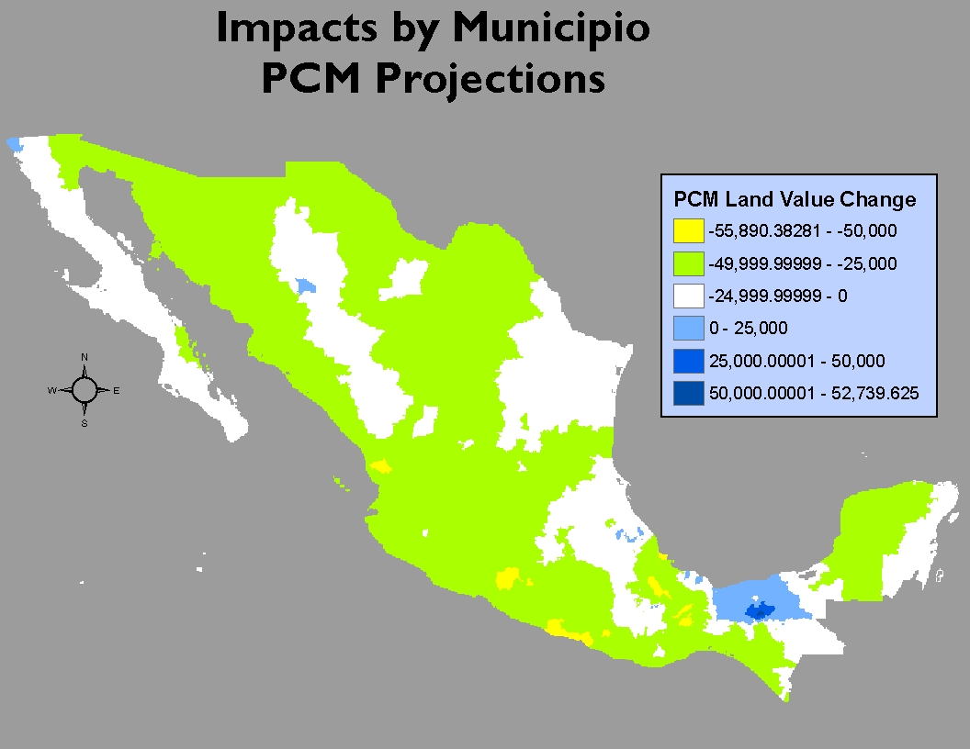
Figure 2: Map of change in Mexican farmland value for MIMR Scenario

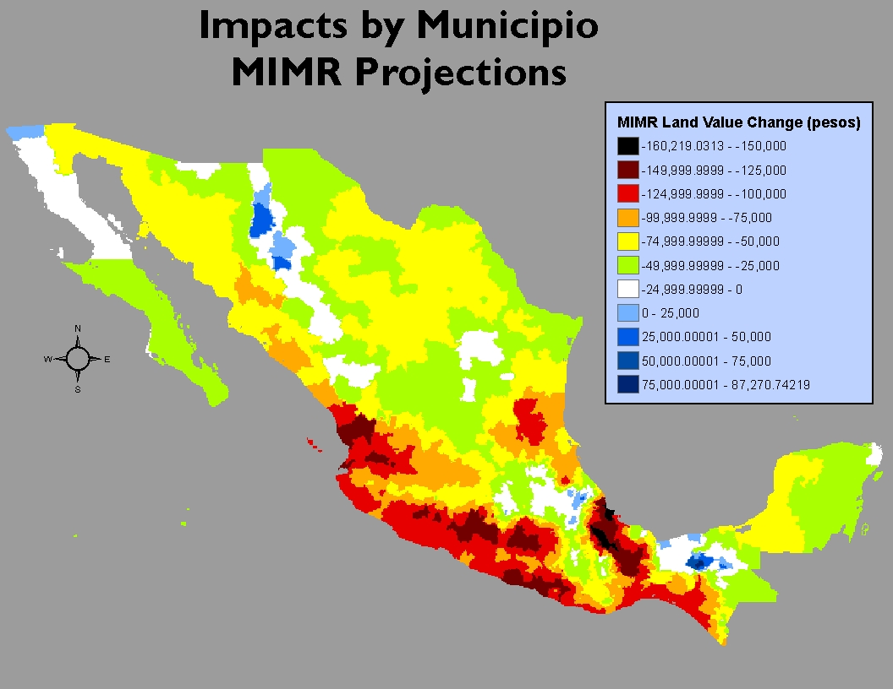
Figure 3: Map of change in Mexican farmland value for HADCM3 Scenario

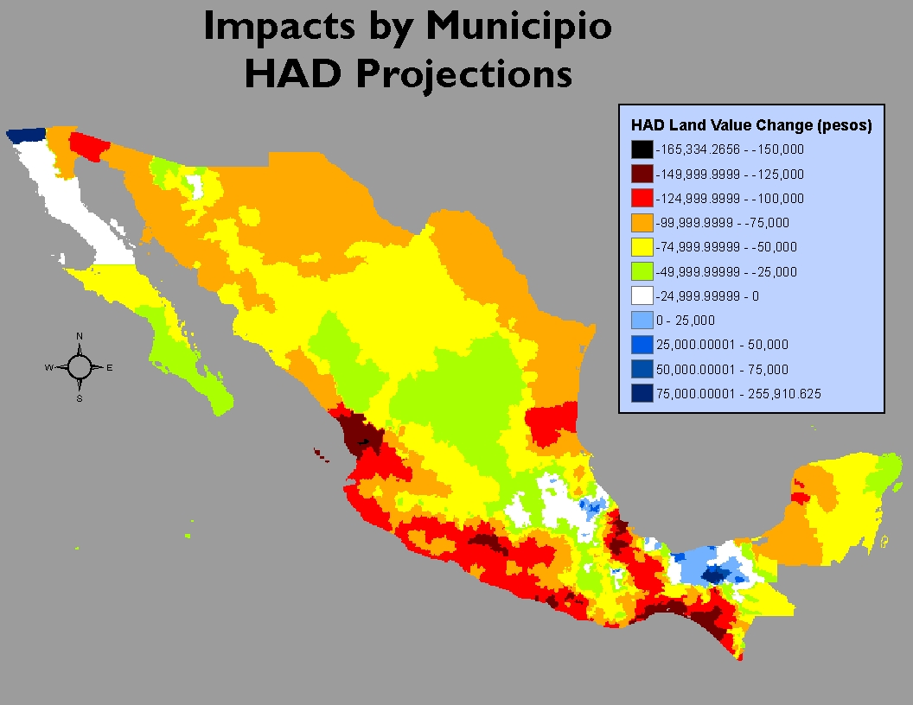

 Acknowledgement: this research was funded by the World Bank but all views are the authors alone. We thank the Yale Fox International Fellowship Program for supporting Jesus Arellano-Gonzalez. We also thank John Nash and Ariel Dinar for their comments.

