Supplementary Table 1. Hemoglobin and anemia status by 7 - day intake frequency of 7 food groups at early pregnancy in rural Bangladesh¹
Food group | N (%) | Anemia²  N (%) | Hemoglobin, g/L  Mean (SD)
Meat
< 3 times | 252 (88.4) | 51 (20.2) | 118.98 (14.17)
≥ 3 times | 33 (11.6) | 4 (12.1) | 122.18 (14.54)
Fish
< 3 times | 127 (44.6) | 23 (18.1) | 120.33 (14.42)
≥ 3 times | 158 (55.4) | 32 (20.3) | 118.57 (14.06)
Egg³
< 3 times | 229 (81.2) | 45 (19.7) | 119.72 (14.27)
≥ 3 times | 53 (18.8) | 9 (17.0) | 117.34 (13.79)
Dairy
< 3 times | 195 (68.4) | 38 (19.5) | 119.59 (14.01)
≥ 3 times | 90 (31.6) | 17 (18.9) | 118.83 (14.72)
Dark green leafy vegetables³
< 3 times | 220 (77.7) | 47 (21.4) | 118.95 (14.86)
≥ 3 times | 63 (22.3) | 7 (11.1) | 120.67 (11.58)
Other vegetables
< 3 times | 213 (74.7) | 45 (21.1) | 118.70 (13.90)
≥ 3 times | 72 (25.3) | 10 (13.9) | 121.28 (15.08)
Fruits
< 3 times | 181 (63.5) | 32 (17.7) | 119.72 (13.25)
≥ 3 times | 104 (36.5) | 23 (22.1) | 118.71 (15.82)
¹ No significant difference (all p > 0.05) in prevalence of anemia or hemoglobin concentration by intake frequency for any food group.
² Anemia was defined by hemoglobin as: mild, <110 g/L and <105 g/L for < or ≥12 GA wk, respectively (20).
³ Missing value for egg consumption (n=2) and dark-green leafy vegetable consumption (n=2). Percentage calculation based on those with data.
Supplementary Figure 1. Pair-wise scatterplots and correlations between biochemical indicators of micronutrient status among women in early pregnancy in rural Bangladesh (n 285)
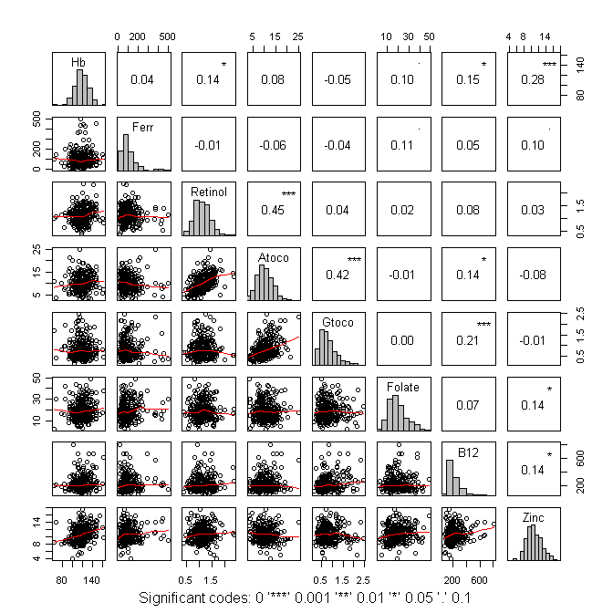
*P < 0.05, **P < 0.01, ***P < 0.001.

