Supplementary material – Leaflet used in WBC intervention
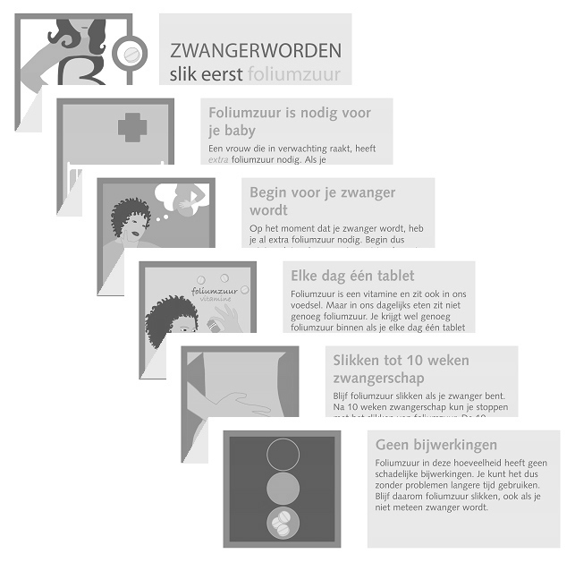
TRANSLATED TEXTS
BECOMING PREGNANT Take folic acid first
Folic acid is needed for your baby
A woman who becomes pregnant, needs extra folic acid. If you take folic acid, you have less chance on having a baby with open back or skull.
Start before you are pregnant
You need extra folic acid already at the moment that you become pregnant. So take 1 tablet of folic acid each day at least 4 weeks before you start to try and get pregnant.
One tablet each day
Folic acid is a vitamin that is also in our daily food. But there is not enough folic acid in our daily food. You get however enough if you take one tablet of folic acid each day. You can buy folic acid in the drugstore or pharmacy (from € 3,- per 90 tablets).
Take until 10 weeks of pregnancy
Keep taking folic acid once you are pregnant. After 10 weeks of pregnancy you can stop taking folic acid. You should count the 10 weeks from the first day of your last period.
No side-effects
Folic acid in the dosage you need has no side-effect. You can use it for a longer period without any problems. So keep taking folic acid, even if you do not become pregnant immediately.

