Supplementary material

A B
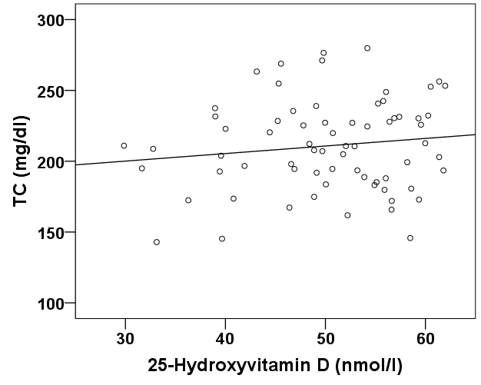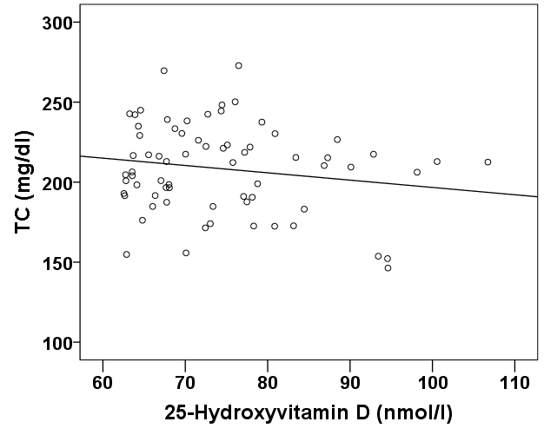
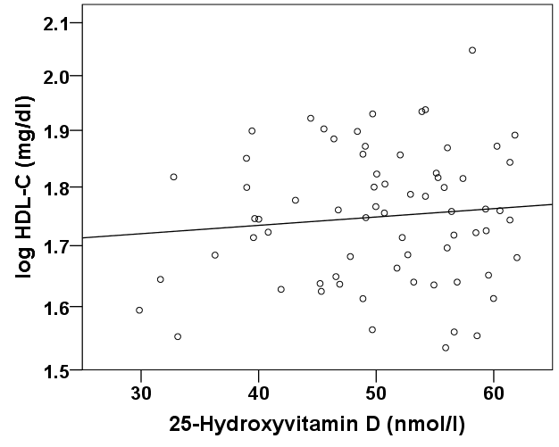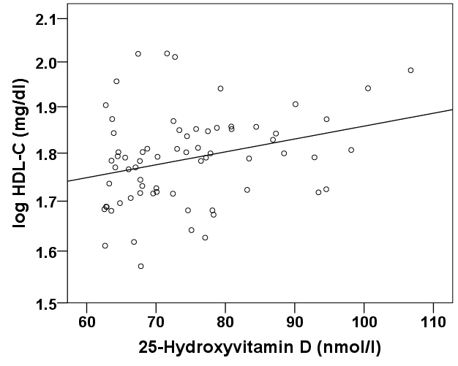
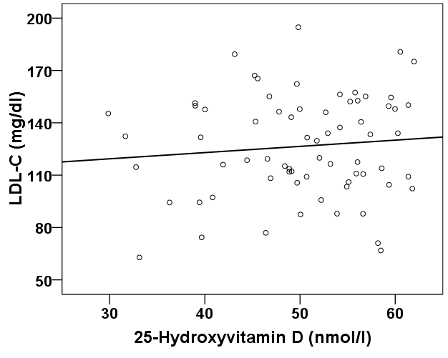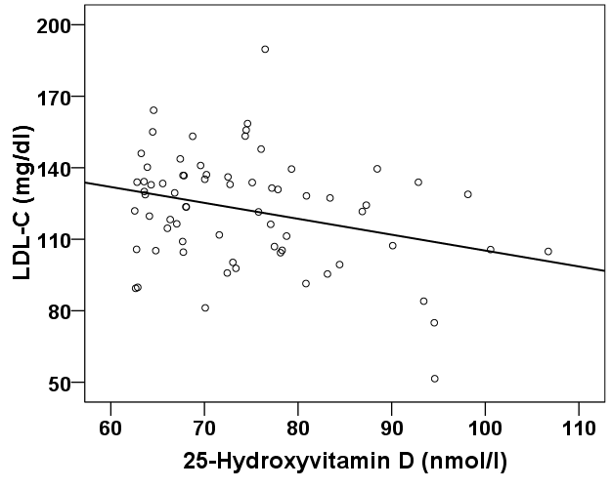
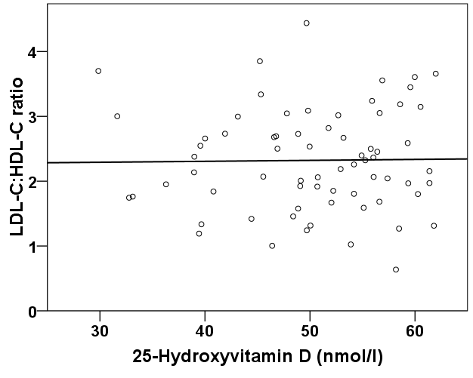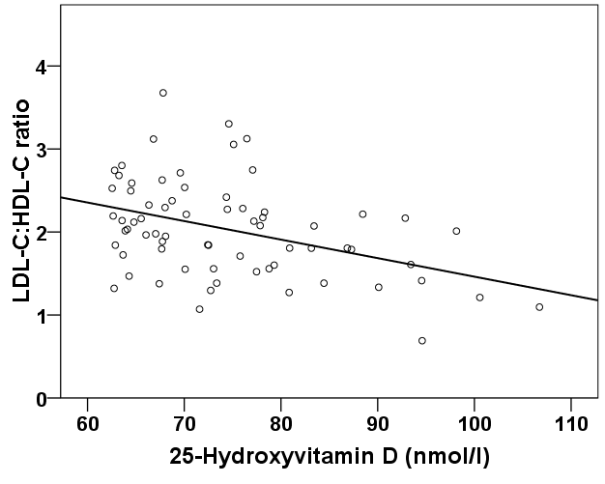
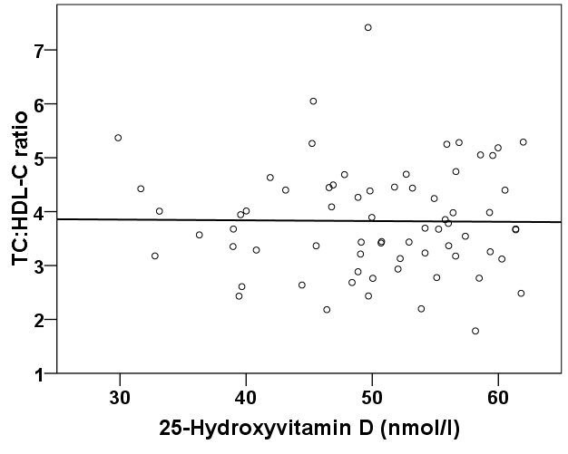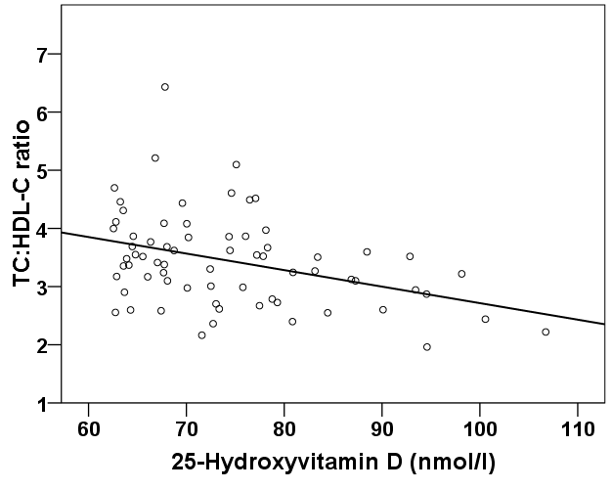
Supplemental Fig. 1 Associations of 25-hydroxyvitamin D₃ with serum lipids as a function of the vitamin D status in women. The left diagrams (column A) represent the associations between serum 25-hydroxyvitamin D₃ and serum lipids in the 69 female subjects with a vitamin D status <62⋅3 nmol/l and the right diagrams (column B) represent the associations in the 69 female subjects with a vitamin D status ≥62⋅3 nmol/l. The following P values and the standardised coefficients beta (β) were calculated by univariate regression analyses. The associations of serum 25-hydroxyvitamin D₃ with total cholesterol (TC) (β = 0⋅133; P = 0⋅274), log HDL-C (β = 0⋅102; P = 0⋅403), LDL-C (β = 0⋅098; P = 0⋅423), LDL-C:HDL-C (β = 0⋅015; P = 0⋅902) and TC:HDL-C (β = −0⋅011; P = 0⋅930) were not significant in women with a vitamin D status <62⋅3 nmol/l, whereas in women with a vitamin D status ≥62⋅3 nmol/l, serum 25-hydroxyvitamin D₃ was associated with TC by trend (β = ‒0⋅173; P = 0⋅154) and showed significant associations with log HDL-C (β = 0⋅292; P = 0⋅015), LDL-C (β = −0⋅303; P = 0⋅011), LDL-C:HDL-C (β = −0⋅408; P = 0⋅001) and TC:HDL-C (β = −0⋅377; P = 0⋅001).

