Supplementary material
Evaluating the internal validity of the HFIAS

- Introduction
In the main article, we focused on the cross-sectional and inter-temporal validity of the HFIAS. In other words, we examined whether the HFIAS is correlated with other proxies of food security such as energy intake and the socio-economic status of a household. We did not evaluate the internal validityof the HFIAS, sometimes also referred to as structural validity, and only reported Cronbach’s alpha. Internal validity requires that the different questions of a food security indicator measure a same underlying construct. Previous studies already validated the internal validity of the HFIAS ^{(1; 2; 3)}.
Internal validity is, however, an essential aspect of every food security indicator⁽⁴⁾. Moreover, a lack of internal validity is a potential explanation for the lack of inter-temporal validity of the HFIAS. If the nine questions of the HFIAS were unstable or if a different construct was measured in 2007 than 2012 this may cause a lack of inter-temporal validity. For instance, if a question was interpreted differently in 2007 than 2012 by respondents or enumerators, this could bias the inter-temporal interpretation of the results. In this respect, it should already be noted that the decrease in average HFIAS score from 2007 to 2012 (Table 2, main paper) is not driven by one question, but is the result of a general decrease in the perception of food insecurity.
In this supplement to the paper, we demonstrate the internal validity of the HFIAS using two different approaches, principal component analysis (PCA) and Rasch models.

- Evaluating internal validity of the HFIAS
  - Principal component analysis
We performed principal component analysis on the nine questions of the HFIAS for both 2007 and 2012 and rotated the components (VARIMAX procedure) to facilitate interpretation. For both periods two components had an eigenvalue exceeding 1 and explained together 76% and 86% of the total variance in 2007 and 2012, respectively. The same components were distinguished in 2007 and 2012 and the loadings were remarkably similar (Supplemental Table 1). The first component can be regarded as food quality as it loaded positively on the first five questions of the HFIAS, while the second component can be regarded as food intake, as it loaded positively on the final three questions of the HFIAS that are related to insufficient food availability. Question 6 (Did you or any other household member have to eat fewer meals in a day?) loaded positively on both components. These components are similar to those found in a previous study in Tanzania ⁽¹⁾ that used exactly the same method. These findings confirm that the HFIAS is internally valid and measures well-defined concepts.

Supplemental Table 1: Results of principal component analysis, by round of data collection (n=314)
HFIAS Question | Comp1 | Comp2 | % of variance explained
2007
1 | 0.382 | 0.071 | 0.761
2 | 0.467 | -0.094 | 0.801
3 | 0.447 | -0.045 | 0.798
4 | 0.443 | -0.058 | 0,765
5 | 0.361 | 0.112 | 0,764
6 | 0.285 | 0.200 | 0.683
7 | -0.043 | 0.602 | 0.792
8 | -0.098 | 0.632 | 0.770
9 | 0.129 | 0.409 | 0.692
% of variance explained | 48.7 | 27.2
2012
1 | 0.388 | 0.036 | 0.816
2 | 0.446 | -0.067 | 0.876
3 | 0.447 | -0.056 | 0.897
4 | 0.420 | -0.020 | 0.844
5 | 0.390 | 0.029 | 0.810
6 | 0.345 | 0.106 | 0.782
7 | 0.060 | 0.508 | 0.816
8 | -0.025 | 0.605 | 0.881
9 | -0.022 | 0.595 | 0.859
% of variance explained | 55.6 | 28.7

  - Rasch models
We performed a basic polytomous Rasch analysis using the Stata package ‘gllamm’ ^{(5; 6)}. Rasch models allow objective, non-sample-specific item (i.e. the nine questions of the HFIAS) parameter estimates, such that the estimates are not influenced by the level of food insecurity of the sample, which allows evaluating the stability of the items ^{(7; 8)}.This method has already been used to validate the HFIAS ⁽³⁾ and to validate other indicators of food insecurity such as the Household Food Security Survey Module (HFSSM) ⁽⁴⁾, closely related to the HFIAS. We limited our investigation to examining whether there is a monotonic trend in increasing item and sub-item severity in both periods. In other words, we studied whether more food insecure households were more likely to report more severe events related to food insecurity (item severity) and whether these households experienced these shocks more often than less food insecure households (sub-item severity). In addition, we compared the estimates of item difficulty between the two periods to evaluate the stability of the items. Important issues such as differential item functioning or goodness of fit statistics (infit/outfit statistics) were not considered.
Supplemental Table 2 shows the results for both periods of the estimations with polytomous Rasch models, more specifically the Partial Credit Model. To facilitate interpretation, the estimates were used to predict the probability of reporting ‘never’ and ‘often’ on the nine questions of the HFIAS as a function of the latent trait, i.e. food insecurity (Supplemental Figure 1 for 2007 and Supplemental Figure 2 for 2012). Comparing these curves between 2007 and 2012 allows us to evaluate whether the difficulty, and thus the stability, of the items is similar in both periods. Supplemental Figure 3 shows the probability of answering ‘never’, ‘rarely’, ‘sometimes’ and ‘often’ for all 9 items as a function of the latent trait for 2007 (results for 2012 were similar and are available upon request). This allows us to evaluate the consistency of sub-item severity.
We first discuss sub-item severity (Supplemental Figure 3). We examined whether reporting ‘often’ is more likely than ‘sometimes’, ‘sometimes’ more likely than ‘rarely’ and ‘rarely’ more likely than ‘never’ with increasing levels of food insecurity. Mathematically, this implies that the sub-item difficulty increases with each step. For instance, item 2 in 2007 fulfils this condition (table 3): the probability of reporting ‘never’ equals the probability of reporting ‘rarely’ at -2.6 logs, the probability of reporting ‘rarely’ equals the probability of reporting ‘sometimes’ at -1.2 logs and the probability of reporting ‘sometimes’ equals the probability of reporting ‘never’ at 0.15 logs. Hence, a more food insecure household faced more regularly a shock related to being ‘unable to eat the kinds of food it preferred (question 2)’. In both periods, there were only a few sub-items that did not follow a monotonic trend of increasing severity (underlined in Supplemental Table 2). Moreover, in those cases the estimated sub-item difficulty did not differ significantly from the general trend as can be seen in Supplemental Figure 3. In sum, sub-item difficulty seems to be consistent with expectations in both periods.
We now turn to discussing item difficulty. In theory, the questions of the HFIAS are ordered by increasing difficulty/severity, that is, a household that reports having spent a whole day and night without eating (question 9), should also have experienced all other, less severe, events related to food insecurity (question 1 to 8). It seems that the difficulty of the questions as estimated with a Rasch model does not correspond with a priori expectations (see Supplemental Figures 1 and 2). First, question 1 (did you worry that your household would not have enough food), which is supposed to be the easiest question, turned out to be more difficult than questions 2, 3, 4 and 5 and as difficult as question 6 in both periods. Second, in 2007 question 9 turned out to be less difficult than question 7 and 8, clearly contradicting expectations, while in 2012 question 9 was more difficult than question 7 and 8. We cannot explain the different interpretation of question 9 in 2007. The order of the other questions was similar in 2007 and 2012.
Hence, we have to wonder whether the fact that households perceived question 9 to be less difficult in 2007 than 2012 explains the lack of inter-temporal validity. It is indeed true that the decrease in average HFIAS from 13.9 in 2007 to 10.8 in 2012 is partially caused by the decrease in the score on question 9 from 1.20 in 2007 to 0.55 in 2012 (see Table 2, main article). However, even if question 9 was excluded from the HFIAS, overall HFIAS score would still decrease with 1.45 points from 2007 to 2012, while food production decreased during the same time interval. This confirms that HFIAS may not be inter-temporally valid. Nevertheless, instability of the items may contribute to the lack of inter-temporal validity.

Supplemental Table 2: Estimation results of a polytomous Rasch model (Partial Credit Model) in 2007 and 2012
 |  | 2007 |  |  |  | 2012
Item | Sub-item | Coefficient | 95% CI interval |  |  | Coefficient | 95% CI interval
Item 1 | Step 2 | -0.88 | -1.38 | -0.37 |  | -1.03 | -1.64 | -0.41
 | Step 3 | -0.86 | -1.31 | -0.41 |  | 0.49 | -0.076 | 1.05
 | Step 4 | 1.52 | 1.10 | 1.95 |  | 3.13 | 2.51 | 3.76
Item 2 | Step 2 | -2.61 | -3.22 | -1.99 |  | -1.73 | -2.39 | -1.07
 | Step 3 | -1.22 | -1.69 | -0.75 |  | -0.043 | -0.62 | 0.54
 | Step 4 | 0.15 | -0.24 | 0.55 |  | 1.94 | 1.37 | 2.52
Item 3 | Step 2 | -2.51 | -3.14 | -1.88 |  | -1.93 | -2.60 | -1.25
 | Step 3 | -1.47 | -1.97 | -0.98 |  | -0.089 | -0.68 | 0.50
 | Step 4 | -0.052 | -0.45 | 0.34 |  | 1.33 | 0.76 | 1.89
Item 4 | Step 2 | -2.88 | -3.43 | -2.18 |  | -1.96 | -2.63 | -1.29
 | Step 3 | -1.23 | -1.70 | -0.77 |  | 0.021 | -0.56 | 0.60
 | Step 4 | 0.18 | -0.21 | 0.58 |  | 1.65 | 1.08 | 2.22
Item 5 | Step 2 | -1.34 | -1.89 | -0.80 |  | -1.22 | -1.86 | -0.58
 | Step 3 | -1.09 | -1.57 | -0.62 |  | 0.039 | -0.54 | 0.62
 | Step 4 | 0.55 | 0.15 | 0.95 |  | 2.15 | 1.57 | 2.73
Item 6 | Step 2 | -0.82 | -1.34 | -0.29 |  | -0.026 | -0.65 | 0.60
 | Step 3 | -1.02 | -1.50 | -0.54 |  | -0.037 | -0.64 | 0.56
 | Step 4 | 0.80 | 0.39 | 1.20 |  | 2.78 | 2.18 | 3.38
Item 7 | Step 2 | 1.04 | 0.62 | 1.47 |  | 2.48 | 1.85 | 3.11
 | Step 3 | 1.11 | 0.62 | 1.60 |  | 1.33 | 0.64 | 2.01
 | Step 4 | 2.49 | 1.91 | 3.06 |  | 3.40 | 2.69 | 4.10
Item 8 | Step 2 | 2.01 | 1.57 | 2.46 |  | 2.95 | 2.33 | 3.58
 | Step 3 | 1.63 | 1.07 | 2.18 |  | 2.00 | 1.29 | 2.70
 | Step 4 | 4.45 | 3.56 | 5.34 |  | 4.95 | 4.07 | 5.83
Item 9 | Step 2 | 0.28 | -0.16 | 0.72 |  | 2.95 | 2.32 | 3.57
 | Step 3 | 0.26 | -0.20 | 0.72 |  | 2.07 | 1.36 | 2.78
 | Step 4 | 1.73 | 1.26 | 2.20 |  | 4.38 | 3.55 | 5.21
Underlined values violate the monotonic trend in sub-item severity
Estimates should be interpreted as the threshold at which a person is equally likely to be classified in adjacent categories (also see Supplemental Figure 3)
Supplemental Figure 1: Probability of reporting never/often on all nine questions (items) of the HFIAS in 2007 as function of the latent trait
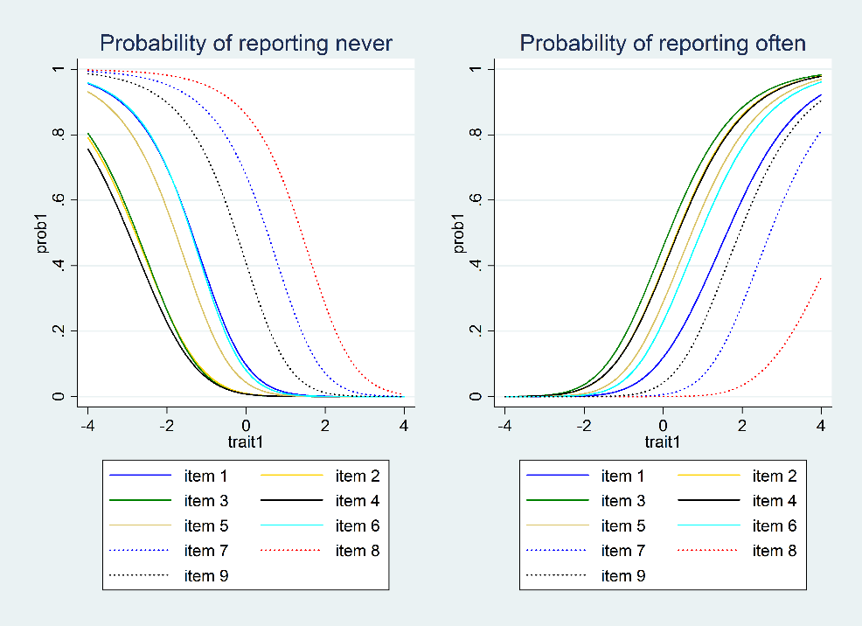

Supplemental Figure 2: Probability of reporting never/often on all nine questions (items) of the HFIAS in 2012 as function of the latent trait 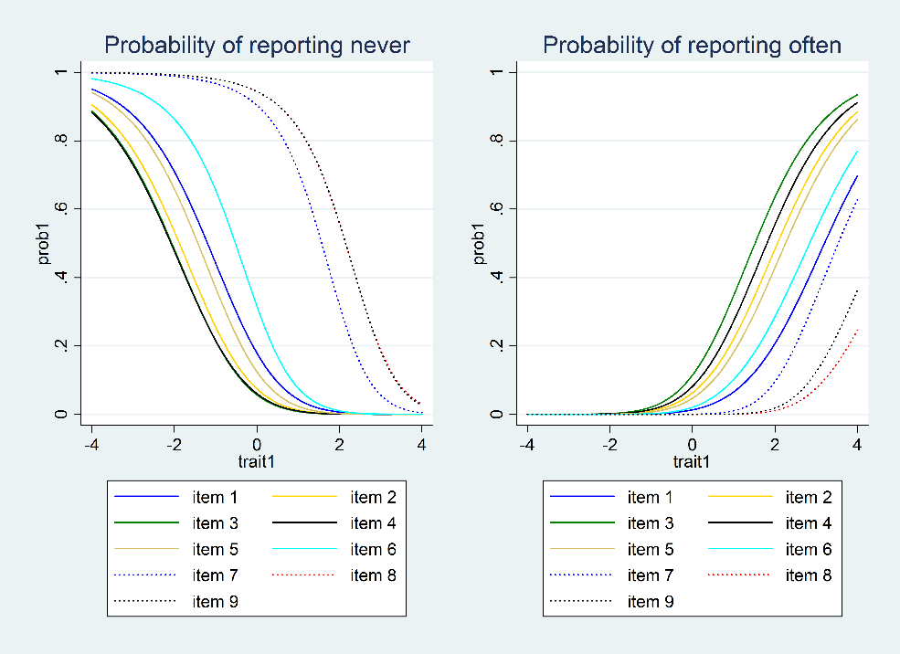

Supplemental Figure 3: Evaluating sub-item severity in 2007
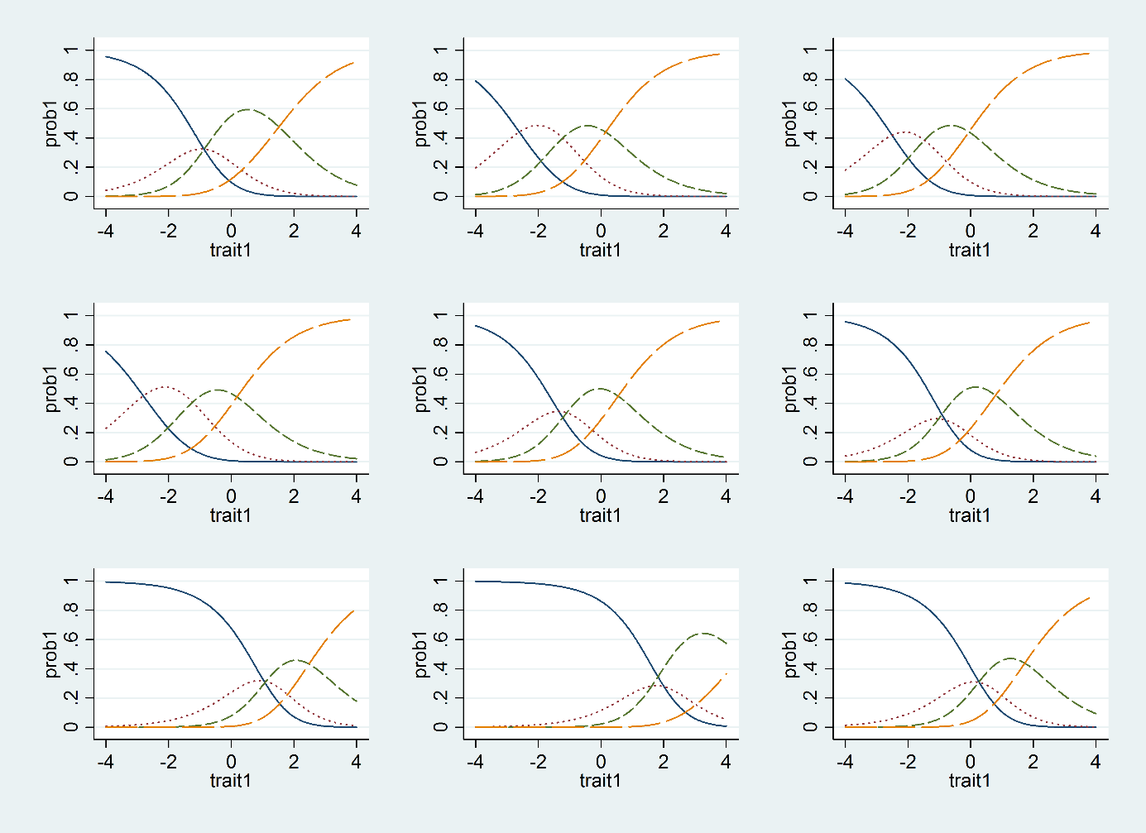
Blue, red, green and yellow curve indicate probability of reporting ‘never’, ‘rarely’, ‘sometimes‘ and ‘often’, respectively.

- Conclusion
This supplemental material studies the internal validity of the HFIAS. We first showed with principal component analysis that a similar, two-dimensional construct is measured in 2007 and 2012. This shows that HFIAS measures food insecurity. Using Rasch models, we then showed that all the items and sub-items correlated with the latent trait, i.e. food insecurity. However, respondents interpreted question 9 differently in 2007 than 2012. This suggests that this item was unstable and requires further research. We are nevertheless fairly confident that the instability of question 9 can only partially explain the lack of inter-temporal validity.

- References
1. Knueppel D, Demment M, Kaiser L (2010) Validation of the Household Food Insecurity Access Scale in rural Tanzania. Public Health Nutr13, 360-367.
2. Maes KC, Hadley C, Tesfaye F et al. (2009) Food insecurity among volunteer AIDS caregivers in Addis Ababa, Ethiopia was highly prevalent but buffered from the 2008 food crisis. J Nutr. 139, 1758-1764.
3. Deitchler M, Ballard T, Swindale A et al. (2010) Validation of a measure of household hunger for cross-cultural use. Food and Nutrition Technical Assistance Project II (FANTA II). Washington, D.C.: US Agency for International Development.
4. Marques ES, Reichenheim ME, de Moraes CL et al. (2014) Household food insecurity: a systematic review of the measuring instruments used in epidemiological studies. Public Health Nutr, 1-16.
5. Rabe-Hesketh S, Skrondal A, Pickles A (2004) GLLAMM manual.
6. Zheng X, Rabe-Hesketh S (2007) Estimating parameters of dichotomous and ordinal item response models with gllamm. Stata Journal 7, 313-333.
7. Casillas A, Schulz EM, Robbins SB et al. (2006) Exploring the Meaning of Motivation Across Cultures: IRT Analyses of the Goal Instability Scale. Journal of Career Assessment14, 472-489.
8. Salzberger T, Sinkovics RR, Schlegelmilch BB (1999) Data Equivalence in Cross-Cultural Research: A Comparison of Classical Test Theory and Latent Trait Theory Based Approaches. Australasian Marketing Journal (AMJ)7, 23-38.

We thank an anonymous reviewer for pointing this out.
It should be noted that the estimates of the Rasch models for 2007 and 2012 (Supplemental Table 2) cannot be directly compared because they have not been standardized. The estimates should only be similar up to a linear transformation, but the order of the items should be the same in 2007 and 2012.

