Supplementary material:
Fig. S1. Flow diagram for study selection
Fig. S2. Dose-response relation between processed meat intake and risk of all-cause mortality. CI, confidence interval; RR, relative risk.
Fig. S3. Dose-response relation between processed meat intake and risk of CVD mortality. CI, confidence interval; CVD, cardiovascular disease; RR, relative risk.
Fig. S4. Dose-response relation between processed meat intake and risk of cancer mortality. CI, confidence interval; RR, relative risk.
Fig. S5. Risk of all-cause, cardiovascular, and cancer mortality associated with servings per day of unprocessed red meat in the US populations. Weights are from random effects analysis. CI, confidence interval; F, female; M, male; RR, relative risk.

5536 Studies identified through literature search
5441 Studies excluded on the basis of titles and abstracts
2618 Redundant articles
2823 Irrelevant publications
95 Potentially relevant studies for evaluation
75 Excluded
11 Ecological or cross-sectional studies
8 Reviews or meta-analyses
5 Commentaries or editors
38 Animals studies or assessing diet patterns
13 Meat and processed meat intake not reported
23 Relevant outcomes not reported
20 Relevant studies eligible
11 Papers excluded from remaining studies
7 Insufficient data or unclear definition of meat
1 The same cohort as other studies
3 Studies comparing meat consumers with vegetarians
9 Studies included in meta-analysis with 17 independent cohorts
Fig. S1.

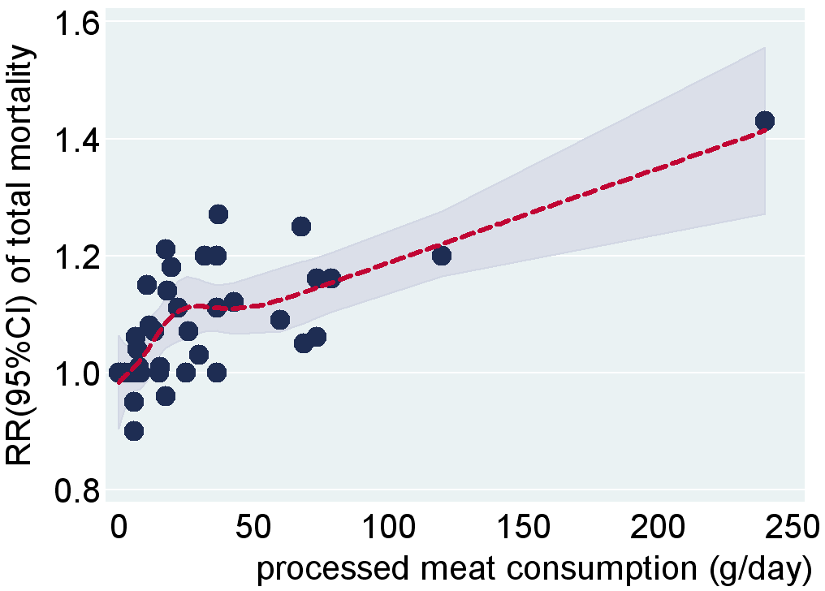
Fig. S2.

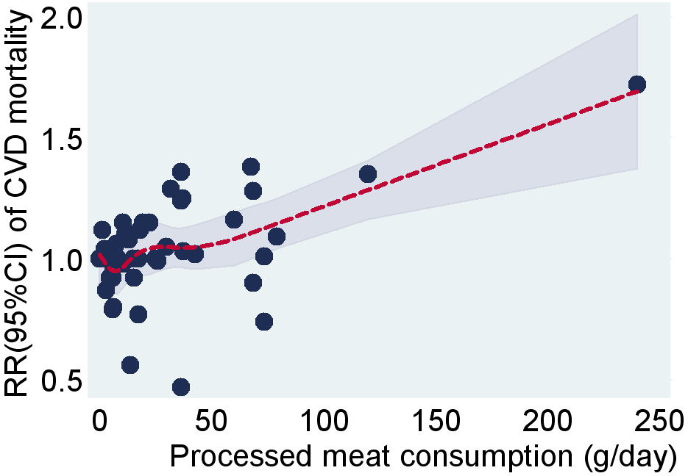
Fig. S3.

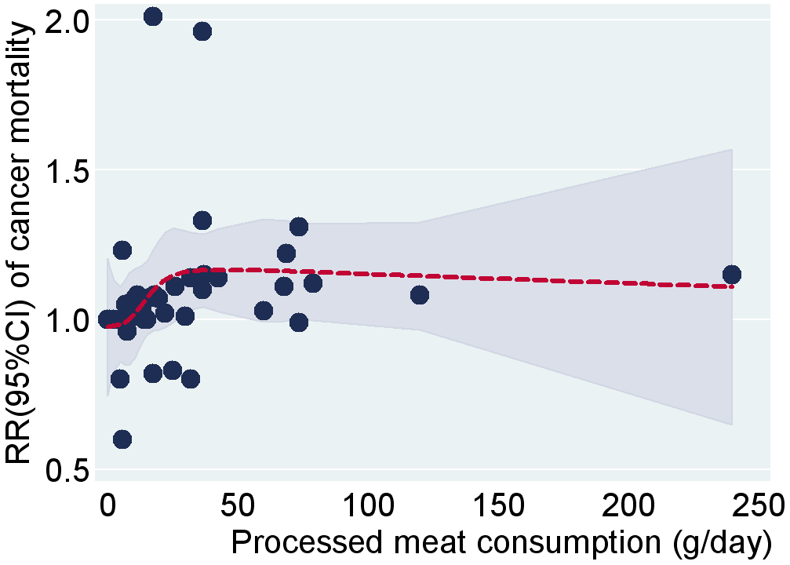
Fig. S4.

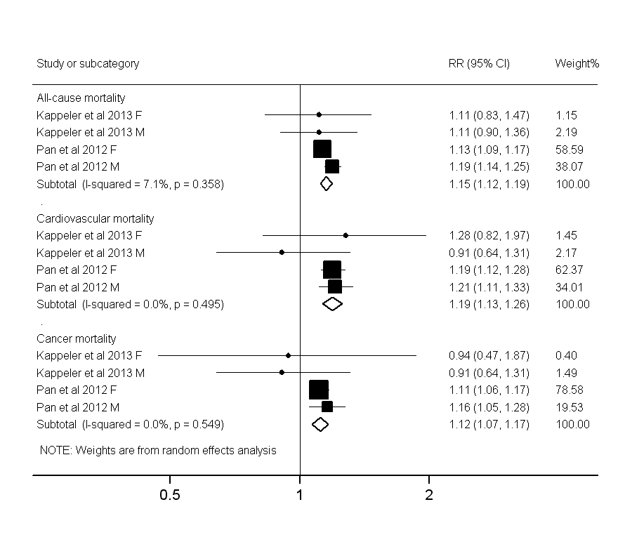
Fig. S5.

