Supplemental Table 1. Changes in the SCG FFQ since previous validation study conducted
Since the previously validated SCG FFQ (version 6.31), numerous food items have been added to the FFQ including soy milk, hummus, pesto, reduced fat crisps, noodles, mixed vegetable dishes, olives, fresh fruit salad, tinned fish (salmon, sardines, pilchards and rollmop herrings), tap water, mineral water, alcoholic cider, hot chocolate and malted milk drinks. Some food items (e.g. savoury pancakes) have been removed from the FFQ, as has information on special diets or dietary restrictions (e.g. exclusion of specific foods). Other food items have been separated into more than one category (e.g. ‘wine’ has been disaggregated into red and white varieties, and ice-cream separated into wrapped and other categories).
Food items removed from the FFQ since version 6.31 | Food items added to the FFQ in the revised version 6.6
Tinned sardines | Soy milk
Savoury pancakes | Hummus
Wine | Pesto
Ice cream | Reduced fat crisps
Have you excluded any of the following foods from your diet in the last 2-3 months…? | Noodles
Have you been on a weight-reducing diet in the last 2-3 months? | Mixed vegetable dishes
Have you been on a special diet in the last 2-3 months? | Olives
 | Fresh fruit salad
 | Tinned salmon
 | Sardines, pilchards or rollmop herrings
 | Tap water
 | Mineral water
 | Cider (alcoholic)
 | Hot chocolate
 | Malted milk drinks
 | Red wine
 | White wine
 | Wrapped ice creams

Supplemental Table 2. Median crude daily energy and nutrient intakes in 96 men and women, and relative differences between the FFQ and food diary
Nutrient | Women (n=56) |  |  | Men (n=40)
Nutrient | SCG FFQ | Food diary | Relative difference (%) | SCG FFQ | Food diary | Relative difference (%)
Nutrient | Median (P₂₅-P₇₅) | Median (P₂₅-P₇₅) | Median (P₂₅-P₇₅) | Median (P₂₅-P₇₅) | Median (P₂₅-P₇₅) | Median (P₂₅-P₇₅)
Energy (kJ) | 8744.0 (7406.8, 10372.3) | 6065.5 (5122.8, 7416.8) | 45.2 (20.2, 74.7) | 10464 (8901.8, 12912.0) | 7360.5 (6679.8, 9174.3) | 38.2 (5.2, 64.3)
Fat (g) | 77.2 (62.8, 96.1) | 54.4 (45.3, 71.0) | 34.0 (11.6, 84.9) | 95.4 (71.4, 118.9) | 67.9 (53.4, 86.6) | 36.1 (-4.0, 103.3)
% energy from fat | 33.0 (31.2, 35.9) | 33.3 (29.6, 38.5) | -2.86 (-12.1, 12.4) | 32.5 (30.3, 37.5) | 34.0 (29.0, 37.7) | 2.1 (-10.4, 15.0)
SFA (g) | 31.2 (25.9, 39.2) | 19.7 (13.2, 25.2) | 60.4 (18.4, 99.1) | 37.3 (28.8, 50.1) | 25.4 (20.4, 32.6) | 52.1 (7.2, 110.2)
% energy from SFA | 13.3 (11.8, 14.3) | 11.5 (9.8, 13.7) | 14.6 (-3.8, 27.7 | 13.0 (11.4, 14.8) | 12.0 (10.0, 15.2) | 8.5 (-8.1, 26.5)
PUFA (g) | 12.7 (10.0, 16.2) | 9.2 (6.8, 13.1) | 42.6 (-0.5, 82.9) | 15.1 (12.6, 19.9) | 9.8 (7.4, 13.4) | 63.7 (3.8, 112.1)
MUFA (g) | 26.8 (21.2, 34.0) | 17.7 (13.9, 24.2) | 48.2 (9.1, 81.6) | 33.0 (25.4, 39.6) | 23.8 (18.1, 30.9) | 45.9 (5.7, 103.6)
Protein (g) | 85.9 (70.6, 109.1) | 60.1 (50.0, 72.2) | 43.4 (22.1, 86.8) | 104.4 (78.3, 126.3) | 73.7 (60.9, 83.4) | 38.8 (4.6, 78.8)
% energy from protein | 17.2 (15.8, 19.0) | 16.8 (15.0, 18.6) | 1.3 (-4.9, 11.4) | 16.2 (14.9, 18.1) | 15.6 (14.4, 18.5) | 9.5 (-6.6, 17.1)
CHO (g) | 241.8 (214.0, 312.1) | 172.0 (143.8, 205.9) | 51.8 (19.6, 84.7) | 312.7 (235.2, 376.6) | 214.8 (187.5, 261.1) | 36.6 (2.6, 66.4)
% energy from CHO | 46.1 (42.7, 50.0) | 45.1 (40.9, 51.2) | 0.6 (-5.6, 10.8) | 45.0 (41.8, 50.0) | 45.3 (40.7, 52.3) | -3.6 (-10.6, 5.7)
Starch (g) | 129.0 (106.0, 152.0) | 89.5 (73.7, 104.9) | 47.9 (20.3, 79.6) | 154.0 (128.0, 191.3) | 118.1 (103.7, 145.4) | 31.2 (0.5, 68.4)
Total sugars (g) | 117.1 (96.4, 139.3) | 77.3 (62.1, 99.6) | 49.0 (25.4, 85.3) | 137.3 (96.9, 172.7) | 88.8 (66.0, 115.5) | 47.4 (16.6, 64.3)
NSP (g) | 19.1 (15.6, 23.7) | 15.0 (12.1, 18.6) | 33.9 (7.6, 65.8) | 19.5 (15.6, 27.2) | 15.9 (13.4, 21.6) | 25.2 (-7.9, 54.3)
Alcohol (g) | 7.3 (2.4, 18.6) | 4.2 (0.0, 13.2) | 26.6 (-8.7, 147.6) | 13.7 (5.2, 21.2) | 9.7 (0.0, 17.1) | 14.6 (-6.9, 134.7)
Retinol (µg) | 363.5 (259.8, 559.8) | 224.5 (160.8, 314.3) | 73.8 (23.5, 139.5) | 412.5 (318.0, 570.0) | 302.5 (202.5, 405.8) | 55.2 (2.6, 143.3)
β-carotene (µg) | 4462.5 (2697.3, 6191.8) | 2334.5 (1240.0, 3254.5) | 112.2 (36.8, 256.5) | 3569.0 (2409.3, 5924.5) | 1891.0 (1267.8, 3102.3) | 116.9 (28.4, 206.3)
Vit D (µg) | 3.2 (1.9, 5.2) | 1.6 (1.1, 2.3) | 104.3 (25.2, 217.3) | 4.3 (2.4, 6.4) | 1.8 (1.3, 2.6) | 132.0 (60.8, 206.3)
Vit E (mg) | 10.5 (8.1, 13.8) | 6.2 (4.9, 8.3) | 61.0 (26.7, 131.2) | 11.6 (9.5, 14.5) | 6.2 (5.0, 9.5) | 70.7 (33.2, 121.7)
Thiamin (mg) | 1.7 (1.4, 2.3) | 1.2 (1.0, 1.3) | 45.3 (26.8, 96.9) | 2.0 (1.6, 2.5) | 1.4 (1.2, 1.6) | 44.3 (17.1, 85.0)
Riboflavin (mg) | 2.1 (1.6, 2.6) | 1.4 (1.1, 1.7) | 52.4 (28.2, 90.3) | 2.3 (1.8, 3.0) | 1.6 (1.2, 2.0) | 49.5 (29.0, 103.3)
Vit B₆(mg) | 2.4 (2.0, 2.9) | 1.5 (1.2, 1.8) | 63.6 (26.6, 101.1) | 2.8 (2.2, 3.4) | 1.8 (1.4, 2.1) | 61.0 (18.2, 101.3)
Vit B₁₂(µg) | 6.1 (4.0, 8.6) | 3.3 (2.4, 4.1) | 92.8 (33.6, 160.6) | 7.0 (4.9, 10.4) | 3.9 (2.9, 5.3) | 81.8 (12.6, 211.7)
Vit C (mg) | 136.0 (101.3, 196.8) | 79.0 (52.0, 102.0) | 73.5 (28.6, 167.8) | 120.0 (78.3, 153.0) | 66.5 (41.5, 103.8) | 67.4 (8.9, 142.9)
Folate (µg) | 303.5 (246.0, 378.5) | 195.0 (147.0, 218.8) | 64.1 (33.1, 125.2) | 326.0 (280.3, 412.3) | 232.5 (183.3, 272.3) | 53.6 (21.2, 95.8)
Niacin Equivalents (mg) | 37.3 (31.6, 49.1) | 27.4 (21.9, 31.0) | 50.4 (22.5, 81.2) | 46.6 (39.7, 54.9) | 32.5 (28.2, 38.3) | 39.9 (3.3, 92.0)
Iron (mg) | 13.7 (11.2, 17.6) | 9.3 (7.4, 10.5) | 55.2 (27.5, 84.5) | 15.0 (13.2, 20.3) | 10.4 (8.9, 12.7) | 44.1 (12.0, 83.3)
Calcium (mg) | 1155.0 (917.0, 1410.3) | 745.0 (582.0, 899.8) | 56.0 (31.3, 94.7) | 1302.0 (1010.5, 1684.0) | 787.0 (675.0, 1002.8) | 56.8 (33.6, 100.9)
Magnesium (mg) | 342.5 (277.0, 436.8) | 233.5 (192.0, 280.3) | 50.5 (21.7, 80.0) | 398.5 (341.5, 502.0) | 266.5 (233.5, 329.0) | 44.1 (12.3, 81.1)
Potassium (mg) | 3794.5 (3246.0, 4698.5) | 2603.0 (2271.8, 3069.5) | 52.8 (20.4, 85.0) | 4109.0 (3355.8, 5432.5) | 2888.5 (2378.5, 3304.0) | 38.9 (17.1, 79.7)
Zinc (mg) | 10.9 (8.8, 14.3) | 7.2 (5.8, 8.5) | 47.8 (31.0, 88.2) | 13.0 (10.6, 15.7) | 8.8 (7.3, 9.8) | 44.4 (11.4, 105.6)
SFA, saturated fatty acids; PUFA, polyunsaturated fatty acids; MUFA, monounsaturated fatty acids; NSP, non-starch polysaccharides; CHO, carbohydrates. Relative Difference: ((FFQ - food diary)/food diary) x 100.
Supplemental Table 3. Spearman r_{s} correlation coefficients, percentages of subjects classified into the same and opposite third of intake, and weighted kappa (K_{w}) in 96 adults living in Scotland using energy-adjusted nutrient intakes (analysis separated by sex).
Nutrient | Women (n=56) |  |  |  |  |  | Men (n=40)
Nutrient | Spearman Correlation |  |  | Percentage classified in |  | K_{w} | Spearman Correlation |  |  | Percentage classified in |  | K_{w}
Nutrient | r_{s} | 95% CI | p | Same third | Opposite third | K_{w} | r_{s} | 95% CI | p | Same third | Opposite third | K_{w}
Energy (kJ) | 0.29 | 0.03, 0.51 | 0.031 | 42.9 | 14.3 | 0.19 | 0.16 | -0.16, 0.45 | 0.333 | 37.5 | 17.5 | 0.09
Fat (g) | 0.41 | 0.17, 0.61 | 0.002 | 57.1 | 14.3 | 0.35 | 0.58 | 0.33, 0.75 | <0.001 | 40.0 | 5.0 | 0.26
% E from Fat | 0.52 | 0.30, 0.69 | <0.001 | 57.1 | 7.1 | 0.43 | 0.54 | 0.27, 0.73 | <0.001 | 47.5 | 7.5 | 0.32
SFA (g) | 0.54 | 0.32, 0.70 | <0.001 | 51.8 | 5.4 | 0.39 | 0.52 | 0.25, 0.72 | 0.001 | 60.0 | 10.0 | 0.43
% E from SFA | 0.56 | 0.35, 0.72 | <0.001 | 44.6 | 8.9 | 0.27 | 0.54 | 0.27, 0.73 | <0.001 | 50.0 | 5.0 | 0.37
PUFA (g) | 0.07 | -0.19, 0.33 | 0.597 | 33.9 | 19.6 | 0.03 | 0.56 | 0.31, 0.74 | <0.001 | 57.5 | 7.5 | 0.43
MUFA (g) | 0.33 | 0.08, 0.55 | 0.012 | 41.1 | 12.5 | 0.19 | 0.52 | 0.24, 0.71 | 0.001 | 55.0 | 5.0 | 0.43
Protein (g) | 0.52 | 0.30, 0.69 | <0.001 | 51.8 | 12.5 | 0.31 | 0.41 | 0.12, 0.64 | 0.008 | 35.0 | 10.0 | 0.15
% E from Protein | 0.52 | 0.30, 0.69 | <0.001 | 55.4 | 8.9 | 0.39 | 0.55 | 0.29, 0.74 | <0.001 | 50.0 | 10.0 | 0.32
CHO (g) | 0.65 | 0.47, 0.78 | <0.001 | 51.8 | 1.8 | 0.43 | 0.73 | 0.54, 0.85 | <0.001 | 60.0 | 5.0 | 0.49
% E from CHO | 0.74 | 0.59, 0.84 | <0.001 | 66.1 | 1.8 | 0.60 | 0.66 | 0.44, 0.81 | <0.001 | 65.0 | 5.0 | 0.54
Sugars (g) | 0.64 | 0.45, 0.77 | <0.001 | 48.2 | 5.4 | 0.35 | 0.62 | 0.39, 0.78 | <0.001 | 60.0 | 5.0 | 0.49
Starch (g) | 0.58 | 0.37, 0.73 | <0.001 | 60.7 | 0 | 0.56 | 0.56 | 0.30, 0.74 | <0.001 | 47.5 | 7.5 | 0.32
NSP (g) | 0.60 | 0.40, 0.74 | <0.001 | 62.5 | 5.4 | 0.52 | 0.64 | 0.42, 0.80 | <0.001 | 62.5 | 7.5 | 0.49
Alcohol (g) | 0.73 | 0.57, 0.83 | <0.001 | 64.3 | 3.6 | 0.56 | 0.52 | 0.24, 0.71 | 0.001 | 60.0 | 10.0 | 0.43
Retinol (µg) | 0.11 | -0.16, 0.36 | 0.421 | 44.6 | 19.6 | 0.15 | 0.30 | -0.02, 0.56 | 0.062 | 55.0 | 10.0 | 0.37
β-carotene (µg) | 0.42 | 0.18, 0.61 | 0.001 | 46.4 | 10.7 | 0.27 | 0.50 | 0.22, 0.70 | 0.001 | 50.0 | 10.0 | 0.32
Vit D (µg) | 0.23 | -0.03, 0.47 | 0.082 | 41.1 | 16.1 | 0.15 | 0.34 | 0.04, 0.59 | 0.030 | 42.5 | 7.5 | 0.26
Vit E (mg) | 0.24 | -0.03, 0.47 | 0.081 | 42.9 | 10.7 | 0.23 | 0.43 | 0.14, 0.66 | 0.005 | 55.0 | 10.0 | 0.37
Thiamin (mg) | 0.47 | 0.23, 0.65 | <0.001 | 60.7 | 17.9 | 0.35 | 0.03 | -0.28, 0.34 | 0.833 | 37.5 | 22.5 | 0.03
Riboflavin (mg) | 0.67 | 0.50, 0.79 | <0.001 | 50.0 | 3.6 | 0.39 | 0.56 | 0.30, 0.74 | <0.001 | 47.5 | 7.5 | 0.32
Vit B₆ (mg) | 0.53 | 0.32, 0.70 | <0.001 | 50.0 | 10.7 | 0.31 | 0.73 | 0.54, 0.85 | <0.001 | 70.0 | 5.0 | 0.60
Vit B₁₂ (µg) | 0.49 | 0.26, 0.67 | <0.001 | 53.6 | 7.1 | 0.39 | 0.41 | 0.12, 0.64 | 0.008 | 32.5 | 2.5 | 0.20
Vit C (mg) | 0.48 | 0.25, 0.66 | <0.001 | 46.4 | 7.1 | 0.31 | 0.70 | 0.50, 0.83 | <0.001 | 45.0 | 0 | 0.37
Folate (µg) | 0.51 | 0.29, 0.68 | <0.001 | 57.1 | 10.7 | 0.39 | 0.50 | 0.23, 0.70 | 0.001 | 52.5 | 12.5 | 0.32
Niacin Equivalents (mg) | 0.62 | 0.43, 0.76 | <0.001 | 58.9 | 8.9 | 0.43 | 0.38 | 0.08, 0.62 | 0.015 | 27.5 | 7.5 | 0.09
Iron (mg) | 0.45 | 0.21, 0.64 | <0.001 | 44.6 | 8.9 | 0.27 | 0.43 | 0.14, 0.65 | 0.006 | 40.0 | 10.0 | 0.20
Calcium (mg) | 0.39 | 0.14, 0.59 | 0.003 | 46.4 | 14.3 | 0.23 | 0.30 | -0.02, 0.56 | 0.064 | 42.5 | 12.5 | 0.20
Magnesium (mg) | 0.69 | 0.52, 0.80 | <0.001 | 57.1 | 3.6 | 0.48 | 0.72 | 0.52, 0.84 | <0.001 | 60.0 | 5.0 | 0.49
Potassium (mg) | 0.62 | 0.43, 0.76 | <0.001 | 55.4 | 5.4 | 0.43 | 0.61 | 0.36, 0.77 | <0.001 | 55.0 | 5.0 | 0.43
Zinc (mg) | 0.54 | 0.33, 0.71 | <0.001 | 44.6 | 5.4 | 0.31 | 0.35 | 0.04, 0.59 | 0.029 | 37.5 | 12.5 | 0.15
SFA – Saturated fatty acids; PUFA – Polyunsaturated fatty acids; MUFA – monounsaturated fatty acids; NSP – non-starch polysaccharides; CHO – Carbohydrates. Values of weighted kappa greater than 0.60 indicate good agreement, between 0.41–0.60 moderate agreement, 0.21–0.40 fair agreement, and less than or equal to 0.20 poor agreement .
Suppemental Table 4. Bland Altman calculations of mean difference between the FFQ and diary and limits of agreement for energy, percent-energy from macronutrients and energy-adjusted nutrient intakes (analysis separated by sex).
Nutrient | Women (n=56) |  |  |  | Men (n=40)
Nutrient | Mean difference between FFQ and diary | SD | 95% limits of agreement |  | Mean difference between FFQ and diary | SD | 95% limits of agreement
Nutrient | Mean difference between FFQ and diary | SD | Upper limit | Lower limit | Mean difference between FFQ and diary | SD | Upper limit | Lower limit
Energy (kJ) | 2975.6 | 2697.2 | 8262.1 | -2310.9 | 3045.6 | 3437.4 | 9782.9 | -3691.7
Fat (g) | 25.0 | 10.2 | 45.0 | 5.0 | 30.1 | 12.1 | 53.8 | 6.4
% energy from fat | -0.54 | 5.2 | 9.65 | -10.73 | 0.54 | 5.3 | 10.93 | -9.85
SFA (g) | 12.0 | 5.9 | 23.6 | 0.4 | 13.7 | 8.3 | 30.0 | -2.6
% energy from SFA | 1.2 | 2.5 | 6.1 | -3.7 | 1.0 | 2.9 | 6.7 | -4.7
PUFA (g) | 3.4 | 4.2 | 11.6 | -4.8 | 5.9 | 4.2 | 14.1 | -2.3
MUFA (g) | 9.0 | 4.7 | 18.2 | -0.2 | 10.7 | 5.3 | 21.1 | 0.3
Protein (g) | 35.7 | 10.6 | 56.5 | 14.9 | 28.3 | 20.9 | 69.3 | -12.7
% energy from protein | 0.23 | 2.5 | 5.13 | -4.67 | 0.24 | 3.2 | 6.51 | -6.03
CHO (g) | 90.3 | 24.5 | 138.3 | 42.3 | 77.5 | 31.5 | 139.2 | 15.8
% energy from CHO | 0.5 | 4.9 | 10.1 | -9.1 | -1.0 | 5.3 | 9.4 | -11.4
Starch (g) | 53.1 | 20.0 | 92.3 | 13.9 | 33.1 | 32.7 | 97.2 | -31.0
Total sugars (g) | 38.7 | 20.3 | 78.5 | -1.1 | 44.0 | 29.7 | 102.2 | -14.2
NSP (g) | 6.9 | 5.8 | 18.3 | -4.5 | 2.9 | 5.6 | 13.9 | -8.1
Alcohol (g) | -0.4 | 7.5 | 14.3 | -15.1 | 7.7 | 12.7 | 32.6 | -17.2
Retinol (µg) | 201.9 | 484.7 | 1151.9 | -748.1 | 126.7 | 410.4 | 931.1 | -677.7
β-carotene (µg) | 3344.0 | 3582.9 | 10366.5 | -3678.5 | 2163.8 | 3222.3 | 8479.5 | -4151.9
Vit D (µg) | 2.4 | 2.8 | 7.9 | -3.1 | 2.9 | 2.9 | 8.6 | -2.8
Vit E (mg) | 4.7 | 3.1 | 10.8 | -1.4 | 4.5 | 3.8 | 11.9 | -2.9
Thiamin (mg) | 0.8 | 0.3 | 1.4 | 0.2 | 0.49 | 0.7 | 1.9 | -0.9
Riboflavin (mg) | 0.81 | 0.4 | 1.59 | 0.03 | 0.99 | 0.6 | 2.2 | -0.2
Vit B₆ (mg) | 1.0 | 0.4 | 1.8 | 0.2 | 1.0 | 0.6 | 2.2 | -0.2
Vit B₁₂ (µg) | 3.7 | 3.2 | 10.0 | -2.6 | 4.0 | 3.2 | 10.3 | -2.3
Vit C (mg) | 79.7 | 67.9 | 212.8 | -53.4 | 40.4 | 61.4 | 160.7 | -79.9
Folate (µg) | 151.2 | 77.7 | 303.5 | -1.1 | 117.9 | 94.1 | 302.3 | -66.5
Niacin equivalents (mg) | 15.5 | 5.0 | 25.3 | 5.7 | 12.9 | 9.2 | 30.9 | -5.1
Iron (mg) | 6.1 | 2.5 | 11.0 | 1.2 | 4.9 | 2.7 | 10.2 | -0.4
Calcium (mg) | 465.2 | 233.5 | 922.9 | 7.5 | 560.0 | 408.9 | 1361.4 | -241.4
Magnesium (mg) | 127.4 | 43.4 | 212.5 | 42.3 | 139.0 | 64.2 | 264.8 | 13.2
Potassium (mg) | 1485.8 | 549.9 | 2563.6 | 408.0 | 1428.2 | 689.9 | 2780.4 | 76.0
Zinc (mg) | 4.6 | 1.5 | 7.5 | 1.7 | 4.8 | 2.8 | 10.3 | -0.7

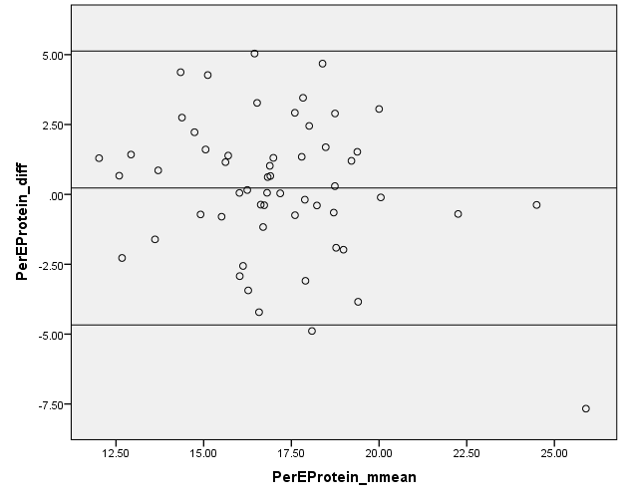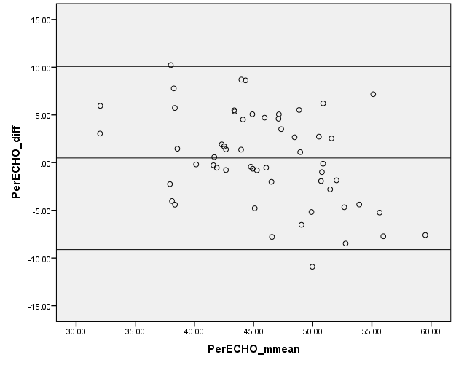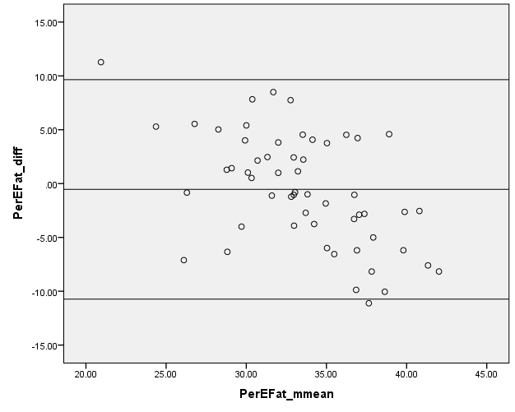
Supplemental Fig. 1. Bland Altman plots to assess relative agreement for percentage energy from protein, carbohydrates and fat between the SCG FFQ and food diary for women (n=56).

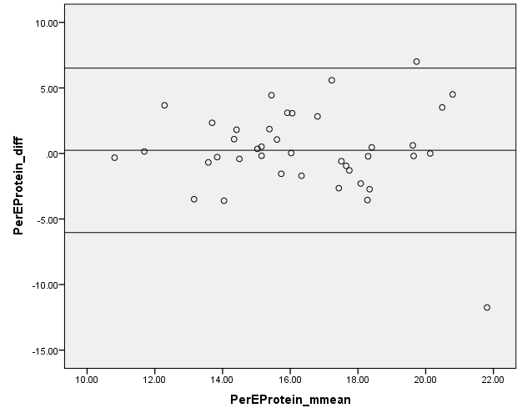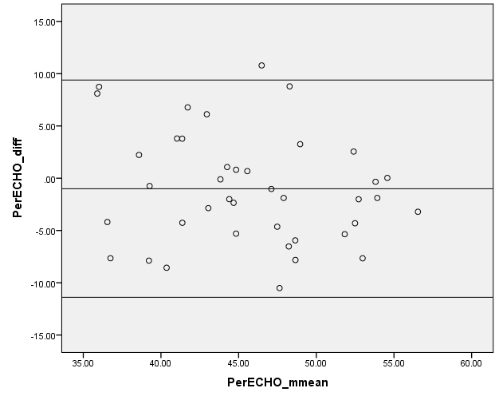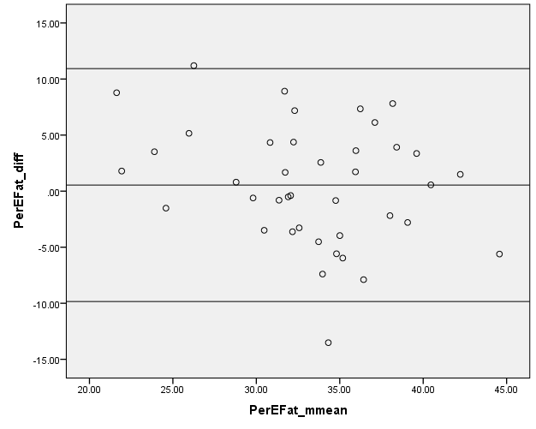
Supplemental Fig. 2. Bland Altman plots to assess relative agreement for percentage energy from protein, carbohydrates and fat between the SCG FFQ and food diary for men (n=40).
Supplemental Table 5. Spearman r_{s} correlation coefficients, percentages of subjects classified into the same and opposite third of intake, and weighted kappa (K_{w}) in 81 adults (40 women and 41 men) using energy and energy-adjusted nutrient intakes from the previous validation study .
Nutrient | Women (n=40) |  |  |  |  |  | Men (n=41)
Nutrient | Spearman Correlation |  |  | Percentage classified in |  | K_{w} | Spearman Correlation |  |  | Percentage classified in |  | K_{w}
Nutrient | r_{s} | 95% CI | p | Same third | Opposite third | K_{w} | r_{s} | 95% CI | p | Same third | Opposite third | K_{w}
Energy (kJ) | 0.39 | 0.09, 0.62 | <0.05 | 58 | 13 | 0.37 | 0.24 | -0.01, 0.51 | >0.05 | 34 | 12 | 0.12
Fat (g) | 0.64 | 0.41, 0.79 | <0.001 | 53 | 8 | 0.37 | 0.42 | 0.13, 0.65 | <0.01 | 44 | 15 | 0.21
SFA (g) | 0.71 | 0.51, 0.84 | <0.001 | 65 | 5 | 0.54 | 0.59 | 0.34, 0.76 | <0.001 | 51 | 5 | 0.38
PUFA (g) | 0.58 | 0.32, 0.75 | <0.001 | 55 | 5 | 0.43 | -0.07 | -0.24, 0.37 | >0.05 | 22 | 22 | -0.14
MUFA (g) | 0.66 | 0.44, 0.81 | <0.001 | 43 | 8 | 0.26 | 0.36 | 0.01, 0.60 | <0.05 | 37 | 10 | 0.16
Protein (g) | 0.43 | 0.14, 0.65 | <0.01 | 50 | 5 | 0.37 | 0.25 | -0.01, 0.52 | >0.05 | 34 | 15 | 0.08
Sugars (g) | 0.72 | 0.52, 0.84 | <0.001 | 63 | 3 | 0.54 | 0.17 | -0.15, 0.45 | >0.05 | 37 | 20 | 0.08
Starch (g) | 0.52 | 0.24, 0.71 | <0.001 | 45 | 5 | 0.32 | 0.45 | 0.16, 0.66 | <0.01 | 46 | 10 | 0.29
NSP (g) | 0.76 | 0.59, 0.87 | <0.001 | 60 | 0 | 0.54 | 0.65 | 0.43, 0.80 | <0.001 | 54 | 5 | 0.43
Alcohol (g) | 0.79 | 0.63, 0.88 | <0.001 | 60 | 0 | 0.54 | 0.72 | 0.53, 0.84 | <0.001 | 61 | 2 | 0.53
Retinol (µg) | 0.34 | 0.03, 0.59 | <0.05 | 45 | 15 | 0.20 | -0.13 | -0.36, 0.25 | >0.05 | 29 | 22 | -0.03
β-carotene (µg) | 0.44 | 0.14, 0.66 | <0.01 | 40 | 10 | 0.20 | 0.11 | -0.21, 0.40 | >0.05 | 44 | 22 | 0.12
Vit D (µg) | 0.37 | 0.06, 0.61 | <0.05 | 48 | 13 | 0.26 | 0.38 | 0.07, 0.61 | <0.05 | 42 | 10 | 0.23
Vit E (mg) | 0.52 | 0.24, 0.71 | <0.001 | 60 | 5 | 0.49 | 0.23 | -0.08, 0.50 | >0.05 | 39 | 15 | 0.15
Thiamin (mg) | -0.04 | -0.28, 0.35 | >0.05 | 35 | 30 | -0.08 | 0.37 | 0.07, 0.61 | <0.05 | 46 | 17 | 0.19
Riboflavin (mg) | 0.69 | 0.48, 0.82 | <0.001 | 65 | 5 | 0.54 | 0.69 | 0.49, 0.83 | <0.001 | 51 | 2 | 0.41
Vit B₆ (mg) | 0.48 | 0.20, 0.69 | <0.01 | 43 | 8 | 0.26 | 0.33 | 0.03, 0.58 | <0.05 | 51 | 12 | 0.32
Vit B₁₂ (µg) | 0.31 | -0.01, 0.56 | >0.05 | 43 | 13 | 0.20 | 0.25 | -0.07, 0.52 | >0.05 | 51 | 20 | 0.23
Vit C (mg) | 0.59 | 0.34, 0.76 | <0.001 | 60 | 10 | 0.43 | 0.48 | 0.20, 0.68 | <0.01 | 37 | 12 | 0.15
Folate (µg) | 0.73 | 0.53, 0.85 | <0.001 | 68 | 3 | 0.60 | 0.55 | 0.30, 0.74 | <0.001 | 46 | 10 | 0.29
Niacin Equivalents (mg) | 0.43 | 0.13, 0.65 | <0.01 | 50 | 5 | 0.37 | 0.37 | 0.06, 0.60 | <0.05 | 54 | 15 | 0.30
Iron (mg) | 0.54 | 0.27, 0.73 | <0.001 | 58 | 8 | 0.43 | 0.60 | 0.36, 0.77 | <0.001 | 56 | 7 | 0.43
Calcium (mg) | 0.75 | 0.57, 0.86 | <0.001 | 70 | 5 | 0.60 | 0.49 | 0.21, 0.69 | <0.001 | 54 | 7 | 0.39
Magnesium (mg) | 0.71 | 0.52, 0.84 | <0.001 | 78 | 8 | 0.66 | 0.66 | 0.45, 0.81 | <0.001 | 54 | 2 | 0.45
Potassium (mg) | 0.67 | 0.46, 0.81 | <0.001 | 53 | 3 | 0.49 | 0.52 | 0.26, 0.71 | <0.001 | 54 | 5 | 0.43
Zinc (mg) | 0.57 | 0.31, 0.75 | <0.001 | 55 | 5 | 0.43 | 0.54 | 0.27, 0.72 | <0.001 | 39 | 7 | 0.23
Note: Bland Altman analyses were not conducted in the previous validation study of the SCG FFQ.

