Online Supplementary Material
Supplemental Fig. 1: Amounts of selected food groups in the optimized diets and penalty score as a function of pReCiPe, the indicator for overall environmental impact. Ages 9–13, 14–18, 19–30, 31-50 and 51-69.
Males 9-13
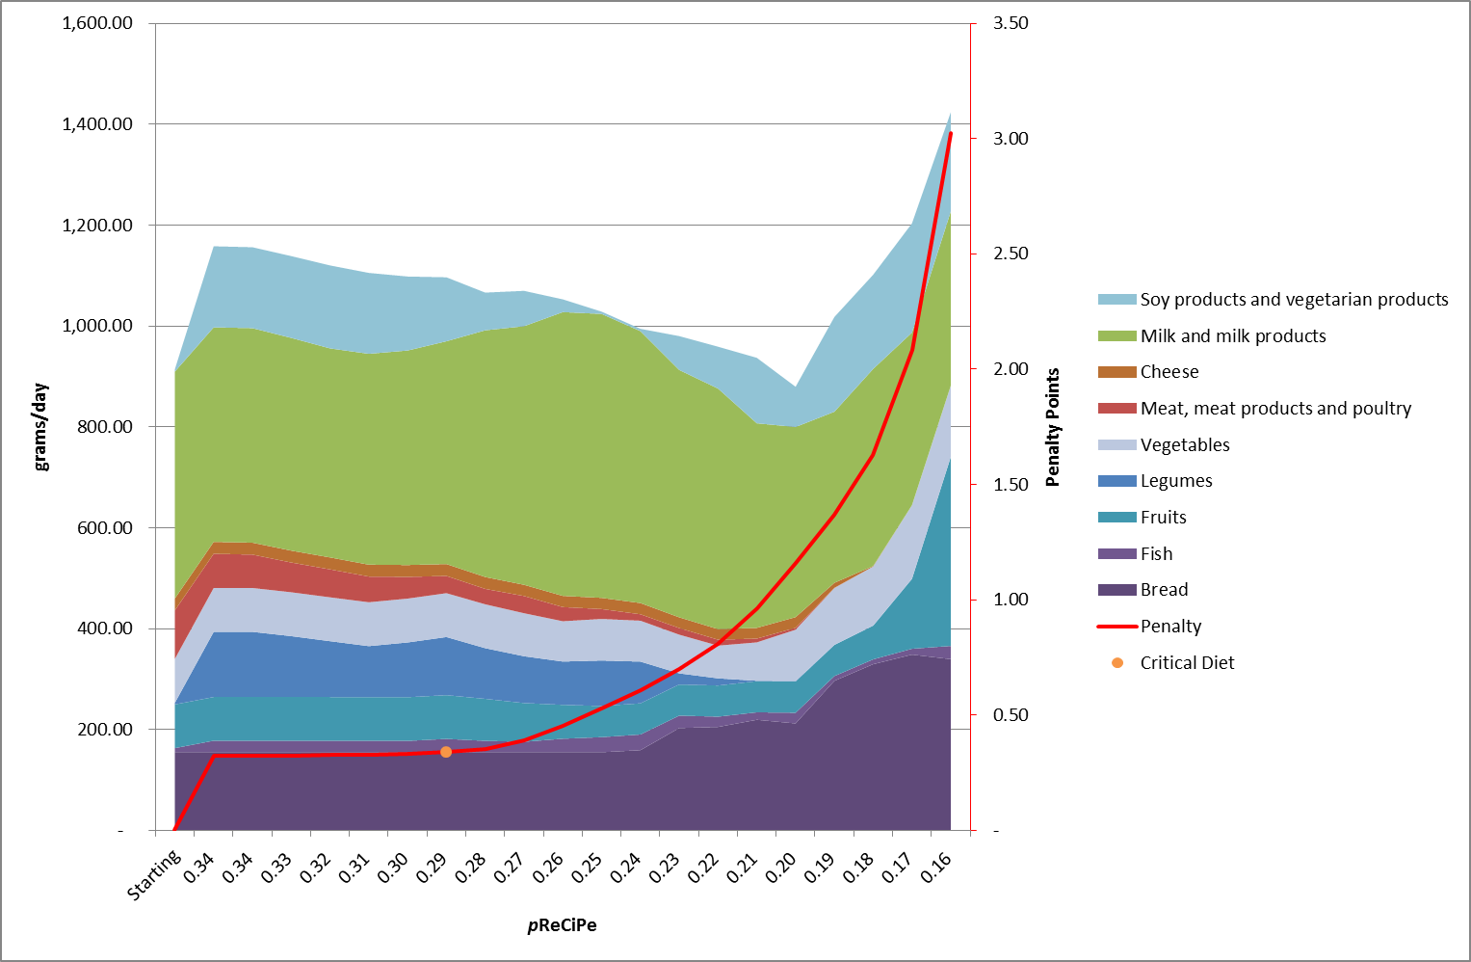
Females 9-13
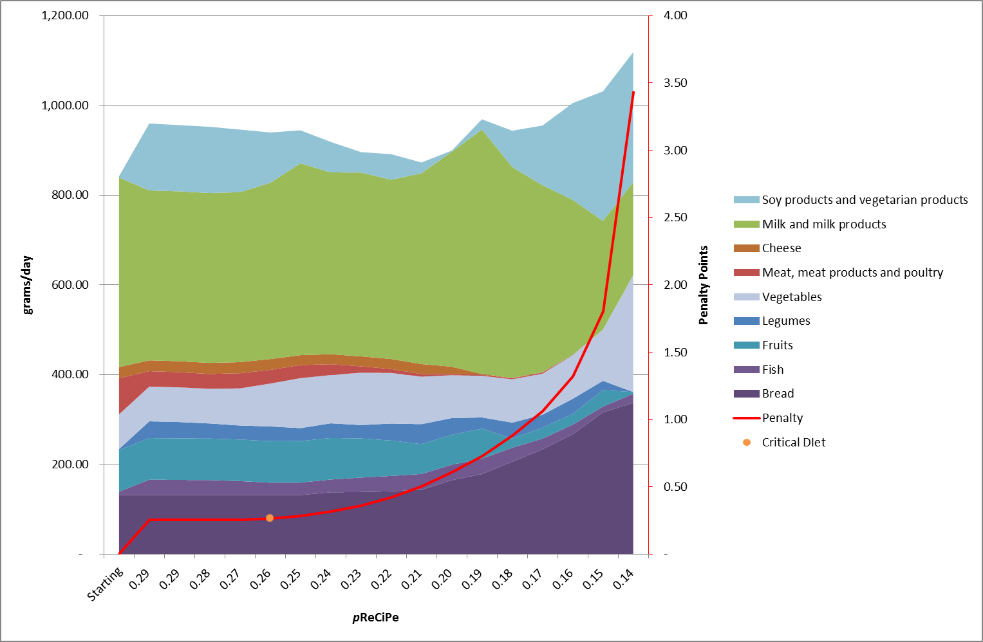
Males 14-18
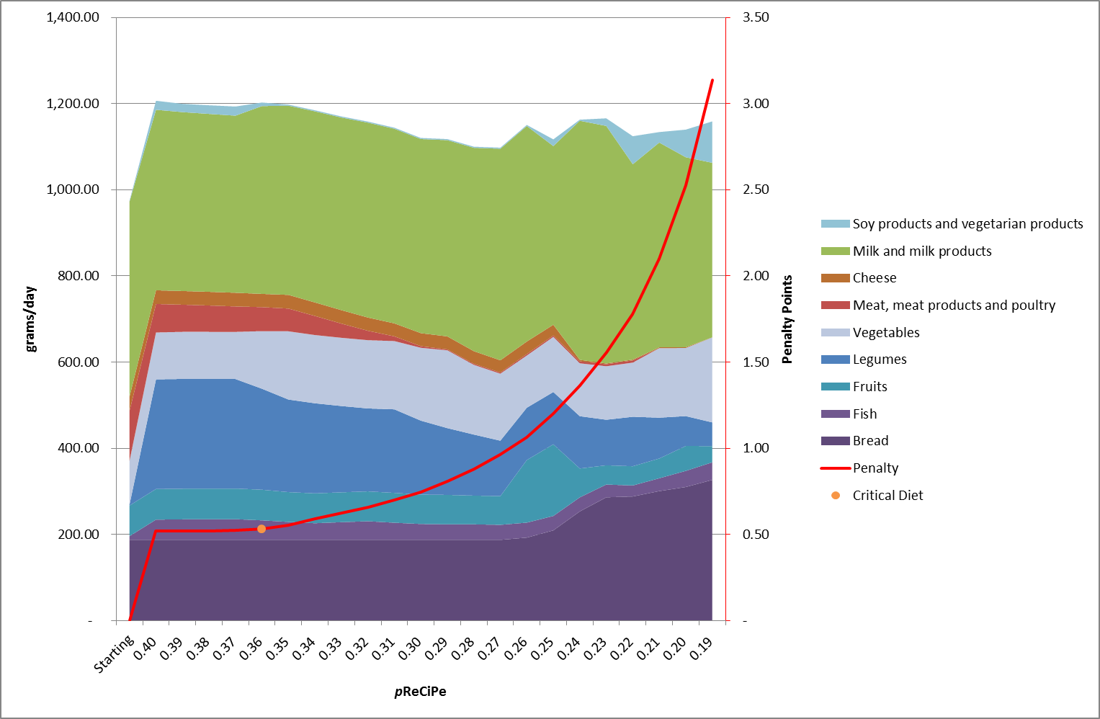
Females 14-18
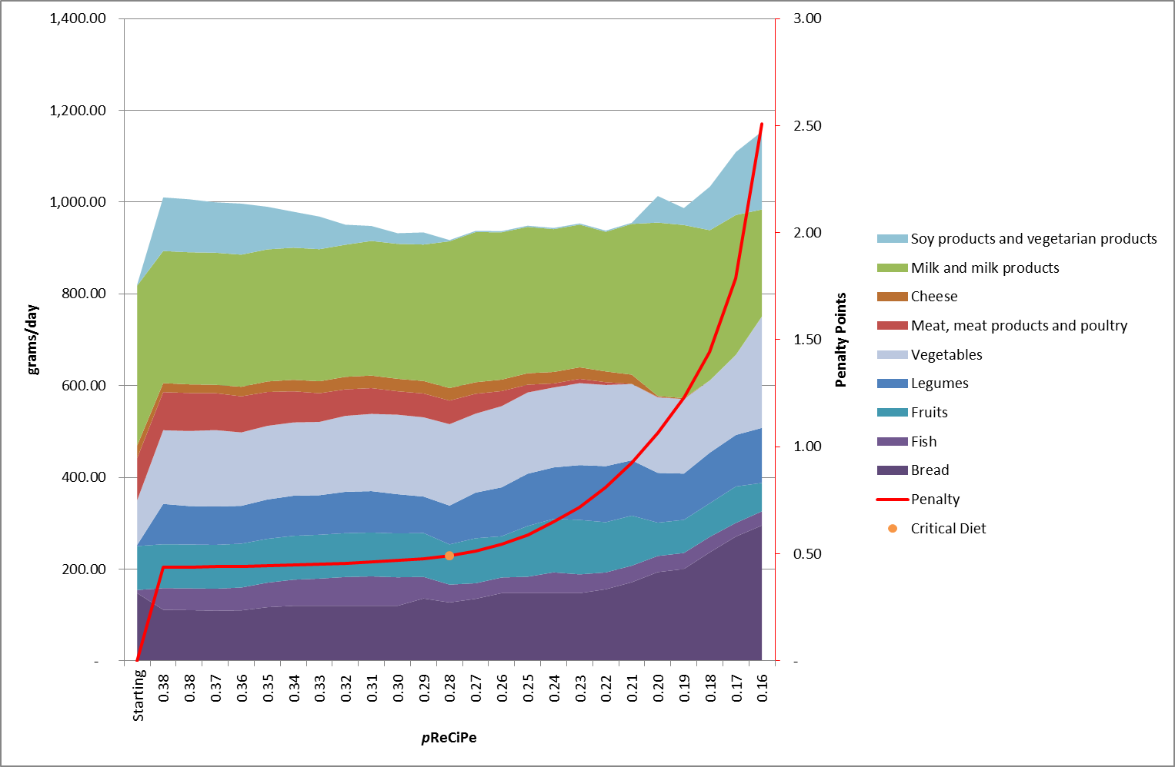
Males 19-30
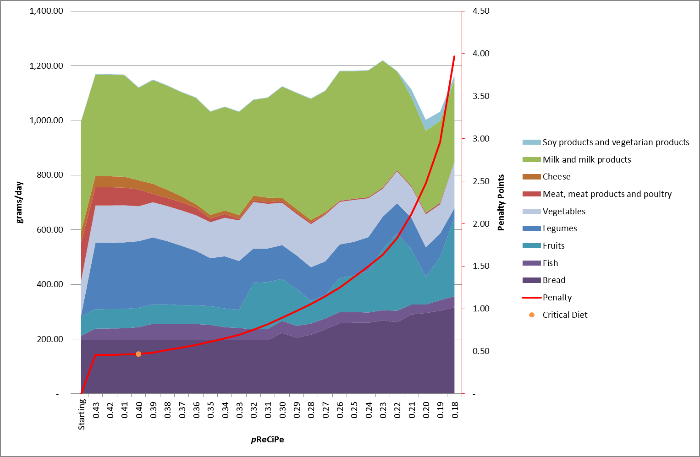
Females 19-30
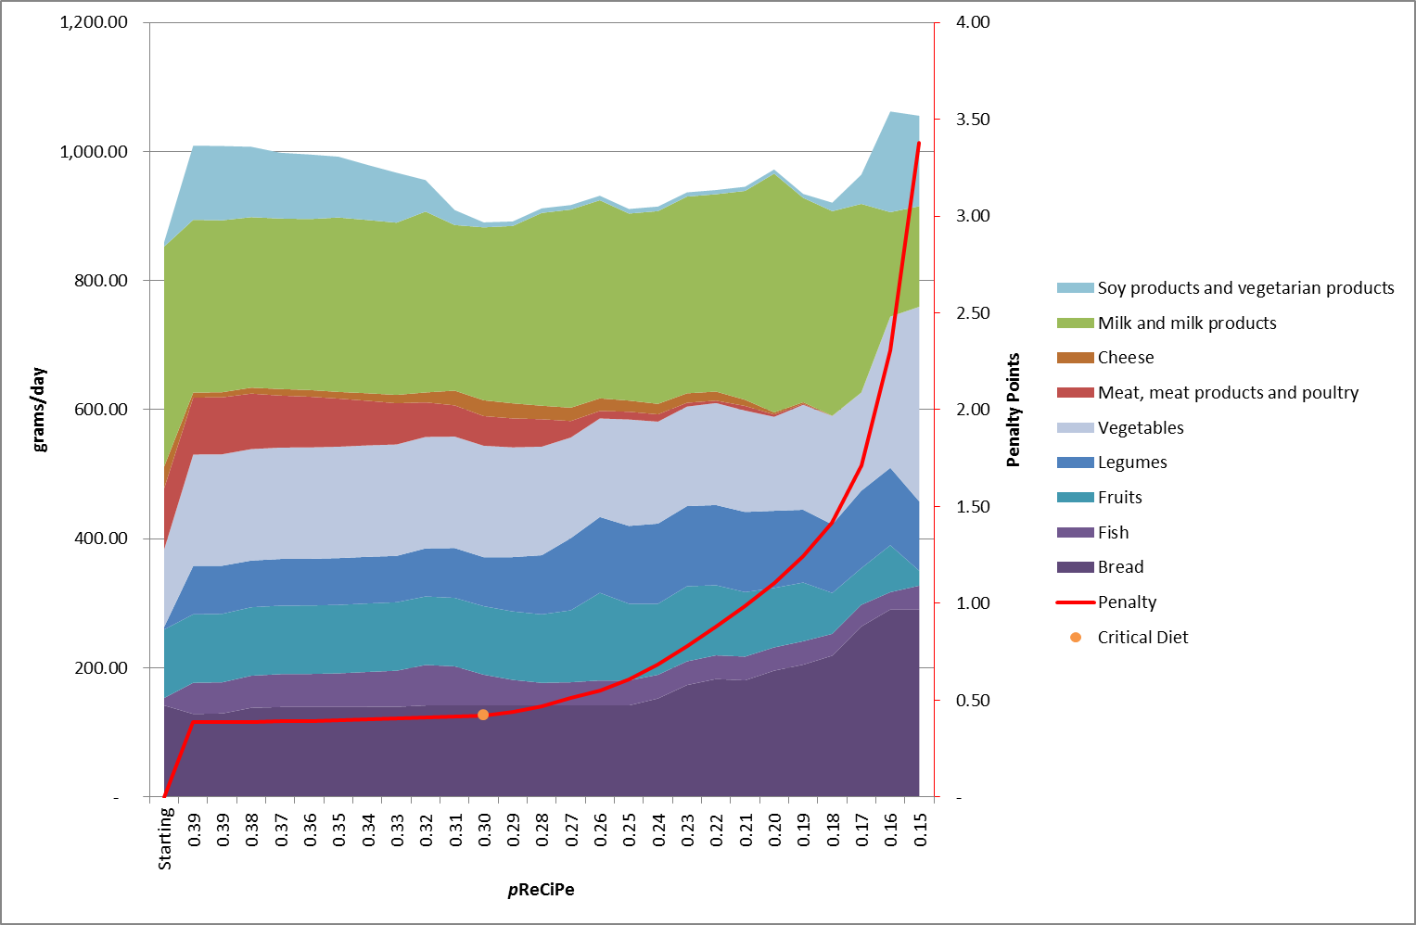
Females 31-50
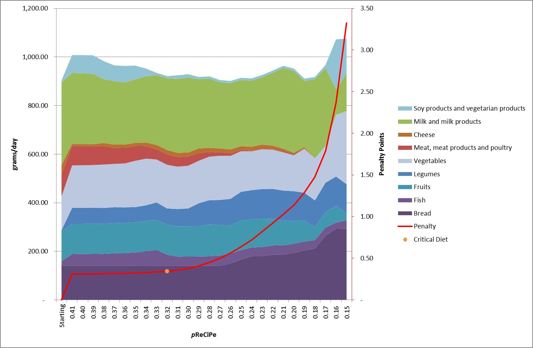

Males 51-69
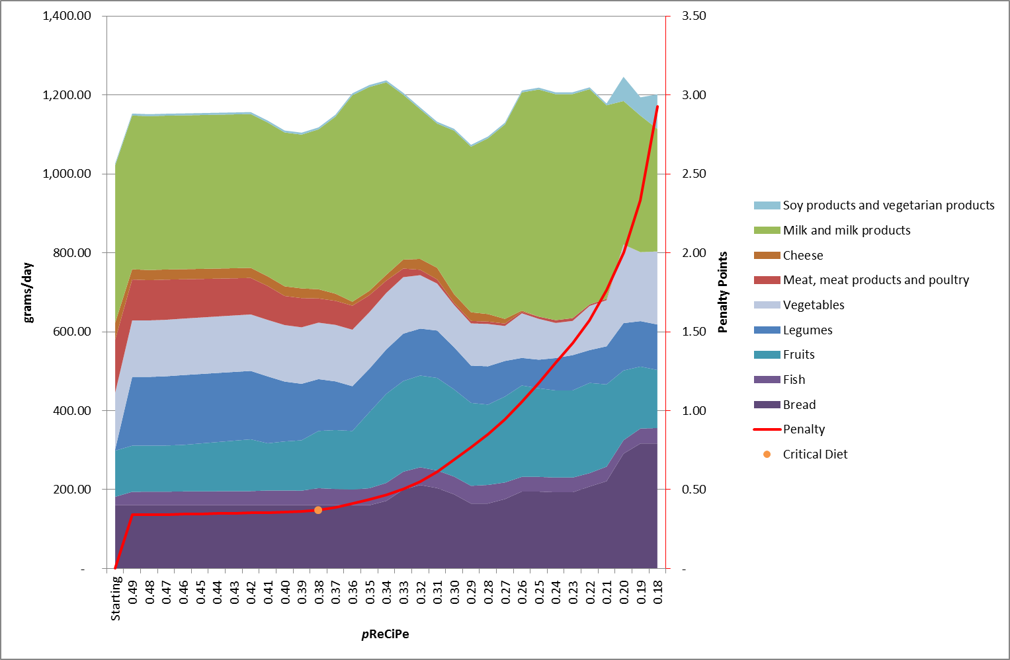
Females 51-69
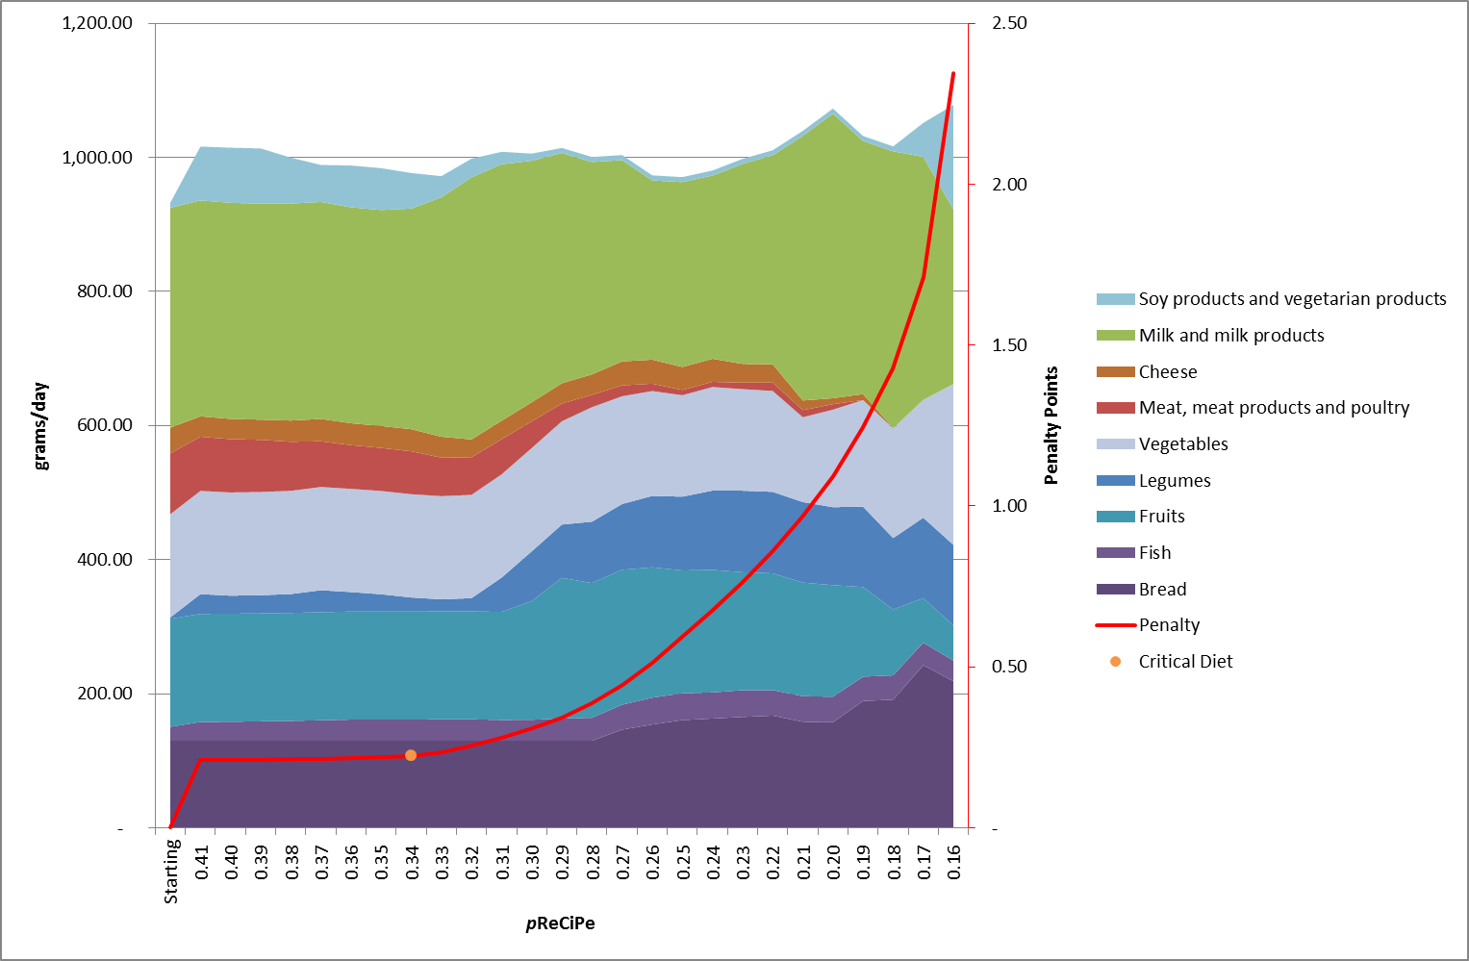
Supplemental Table 2: Differences in nutrient composition between Current Diets (scaled on energy intake DNFCS) and averages observed in the Dutch National Food Consumption Survey (DNFCS) in relation to nutrient requirements. Relevant mismatches are underlined.

