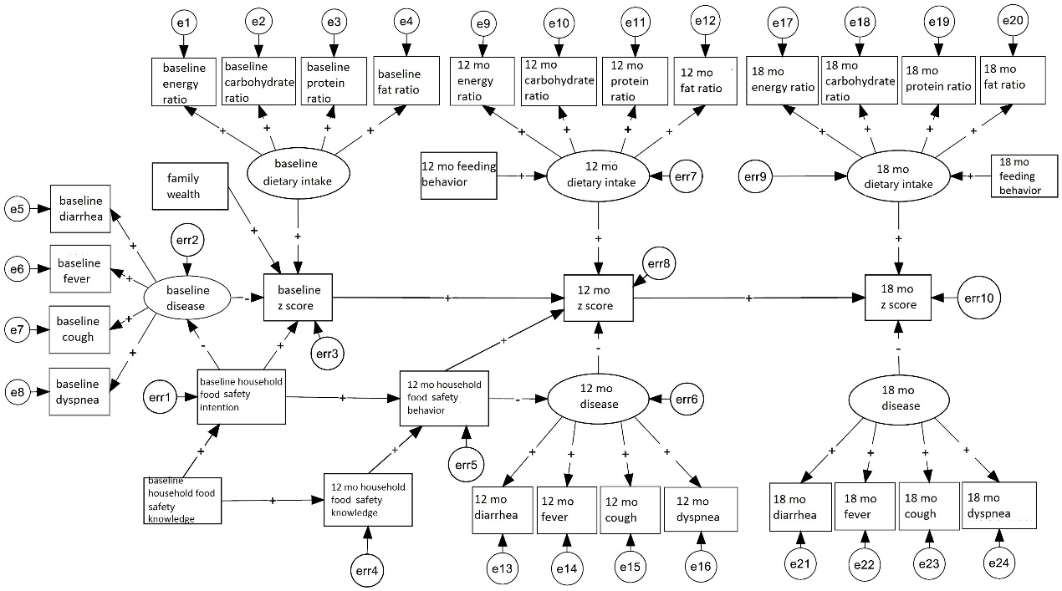

**Fig. S1**. Hypothetical structural equation model of paths of infant’s growth and development

Note: leave out related paths of exogenous variables

Table S1. The assignments of points of study variables

|  |  |  |
| --- | --- | --- |
| Variable | Containing Parts | Assignments of Points |
| Family Wealth | Father/Mother Education | “Primary school 1-3 grade”=1 point;  “Primary school 4-6 grade”=2 points;  “Middle school”=3 points;  “High school/ Vocational school”=4 points;  “Junior college and above”=5 points. |
| Household Belongs | Fridge, television, satellite, VCD/DCD, radio, telephone, each for 1 point. |
| Knowledge on Household Food Safety | Complementary Food Separately | Correct: +2 points; wrong: -1 point. |
| Washing Hands before Meal | Correct: +2 points; wrong: -1 point. |
| Baseline Intention on Household Food Safety | Complementary Food Separately | “Never”=1 point;  “Sometimes”=2 points;  “Always”=3 points. |
|  | Washing Hands before Meal | “Neither adults and children do”=1 point;  “Only adults or only children do”=2 points;  “Both adults and children do”=3 points. |
| Behaviors on Household Food Safety | Complementary Food Separately | “Never”=1 point;  “Sometimes”=2 points;  “Always”=3 points. |
| Washing Hands before Meal | “Neither adults and children do”=1 point;  “Only adults or only children do”=2 points;  “Both adults and children do”=3 points. |
| Feeding Behaviors | Current Breast Feeding | “Yes”=2 points; “No”=1 point. |
| Frequencies of Complementary Feeding during last 24 hours | Points equal to total numbers of complementary feeding during last 24 hours. |
| Growth and Development | Weight for Age | Z scores of weight for age. |
|  | Length for Age | Z scores of length for age. |
|  | Weight for Length | Z scores of weight for length. |

Table S2. The parameters representing validity and reliability of measurement model

|  |  |  |  |  |
| --- | --- | --- | --- | --- |
| Latent Variable | | Standardized Factor Loading | AVE | CR |
| Baseline Dietary Intake | Energy Ratio | 0.841 | 0.858 | 0.946 |
| Carbohydrates Ratio | 0.995 |
| Protein Ratio | 0.936 |
| 12 months  Dietary Intake | Energy Ratio | 0.983 | 0.841 | 0.940 |
| Carbohydrates Ratio | 0.912 |
| Protein Ratio | 0.851 |
| 12 months Disease | Diarrhea | 0.471 | 0.312 | 0.573 |
| Fever | 0.602 |
| Cough | 0.592 |
| 18 months  Dietary Intake | Energy Ratio | 0.978 | 0.762 | 0.905 |
| Carbohydrates Ratio | 0.822 |
| Protein Ratio | 0.808 |
| 18 months  Disease | Diarrhea | 0.321 | 0.288 | 0.528 |
| Fever | 0.540 |
| Cough | 0.684 |

Table S3. AVE and inter-correlation between Latent variables

|  |  |  |  |  |  |
| --- | --- | --- | --- | --- | --- |
| Latent Variable | Baseline Nutrition Intake | 12 months  Nutrition Intake | 12 months  Disease | 18 months  Nutrition Intake | 18 months  Disease |
| Baseline  Nutrition Intake | 0.858（AVE） | 0.012（r2） | 0.000（r2） | 0.001（r2） | 0.004（r2） |
| 12 months  Nutrition Intake | 0.109 | 0.841（AVE） | 0.000（r2） | 0.012（r2） | 0.012（r2） |
| 12 months  Disease | -0.015 | -0.014 | 0.312（AVE） | 0.020（r2） | 0.108（r2） |
| 18 months  Nutrition Intake | -0.031 | 0.109 | -0.141 | 0.762（AVE） | 0.060（r2） |
| 18 months  Disease | 0.060 | -0.110 | 0.328 | -0.243 | 0.288（AVE） |

Note: AVE at diagonal line, r at triangle below, r2 at triangle above