# Supplementary material to the manuscript: *Dietary habits, metabolic health, and vitamin D status in Greenlandic children*

**Supplementary material 1. Greenland: places of investigation**

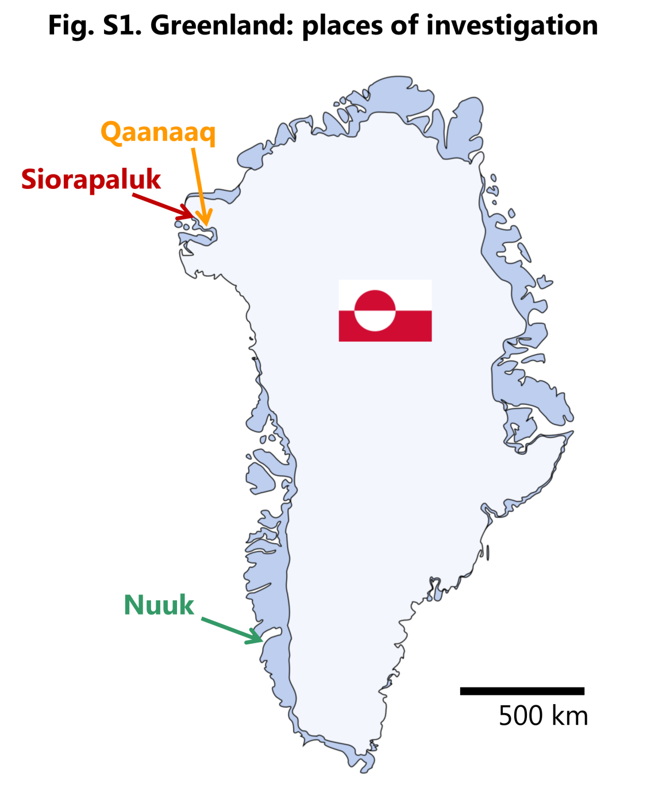

|  |  |  |  |  |
| --- | --- | --- | --- | --- |
| **Supplementary material 2. Individual food types from the questionnaire and formed categories** | | | | |
|  |  |  |  |  |
| **MMF** |  | **MEg** |  | **VegFr** |
| **Marine mammals and fish** |  | **Meat and eggs** |  | **Non-starchy vegetables and fruits** |
| **Traditional** |  | **Traditional** |  | **Traditional** |
| Seal meat |  | Reindeer, muskox |  | Berries |
| Beluga and narwhal |  | Reindeer entrails |  | **Imported** |
| Other whales, e.g. fin whales, minke |  | Razorbill |  | Apples, pears, bananas |
| Walrus |  | Common eider |  | Oranges, grapefruit |
| Seal entrails |  | Other wild birds |  | Other fresh fruits |
| Muktuk |  | Eggs from wild birds |  | Canned fruit |
| Cod |  | Dried reindeer meat |  | Mixed vegetables, frozen vegetable soup |
| Halibut |  | **Imported** |  | Carrots |
| Capelin |  | Lard (frozen, salted) |  | Cabbage e.g. white or red cabbage, cauliflower, broccoli |
| Trout, salmon |  | Beef |  | Tomatoes |
| Other fish |  | Pork e.g. chops, roast |  | Other vegetables |
| Clams, shrimp, crab |  | Lam |  |  |
| Dried seal and whale meat |  | Poultry (chicken, turkey, duck) |  |  |
| Dried fish e.g. capelin, Greenland cod |  | Meatball, sausages |  |  |
| **Imported** |  | Cold meats, meat spreads, liver paté |  |  |
| Fish spreads, herring, canned fish |  | Eggs |  |  |
|  |  |  |  |  |
|  |  |  |  |  |
| **DaP** |  | **JunkF** |  | **CCarb** |
| **Dairy products** |  | **Junk food and sweet drinks** |  | **Complex carbohydrates** |
| Whole milk |  | Pizza, burger |  | Potatoes |
| Light milk, skimmed milk |  | French fries |  | White bread |
| Yoghurt, fermented milk |  | Chips |  | Wholemeal bread |
| Cheese |  | Ice cream |  | Rye bread |
|  |  | Candy e.g. chocolate, bars, jelly, liquorice, sweets |  | Cornflakes, breakfast cereals and other cereals |
|  |  | Jam, marmalade, honey |  | Oat meal, porridge |
|  |  | Soda, cola, syrup |  | Spaghetti, pasta |
|  |  | Soda, cola (light) |  | Rice |
|  |  | Fruit juice |  | Beans, peas, chickpeas and similar |
|  |  | Sweet coffee |  | Cake, pastry, biscuits |

|  |  |  |  |  |  |  |  |  |  |  |  |  |  |  |  |  |  |  |  |
| --- | --- | --- | --- | --- | --- | --- | --- | --- | --- | --- | --- | --- | --- | --- | --- | --- | --- | --- | --- |
| **Supplementary material 3. Gender-specific characteristics of the children. Data are expressed as mean ± SD.** | | | | | | | | | | | | | | | | | | | |
|  | **Boys** | | | | | | | | |  | **Girls** | | | | | | | | | |
|  | **Siorapaluk** | | | **Qaanaaq** | | | **Nuuk** | | |  | **Siorapaluk** | | | **Qaanaaq** | | | **Nuuk** | | | |
| ***N*** | *13* | | | *31* | | | *53* | | |  | *2* | | | *39* | | | *39* | | | |
| **Leptin (ng/L)** | 2163 | ± | 1541 | 2814 | ± | 2202 | 3775 | ± | 4724 |  | 2405 | ± | 460 | 7012 | ± | 5623 | 8283 | ± | 9472 | |
| ***N*** | *13* | | | *31* | | | *53* | | |  | *2* | | | *38* | | | *39* | | | |
| **Adiponectin (µg/L)** | 20924 | ± | 6934 | 23558 | ± | 11966 | 20050 | ± | 12139 |  | 38265 | ± | 8648 | 33208 | ± | 16070 | 23143 | ± | 13544 | |
| ***N*** | *9* | | | *25* | | | *53* | | |  | *2* | | | *34* | | | *38* | | | |
| **Body fat (%)** | 50·5 | ± | 5·5 | 47·6 | ± | 6·3 | 47·9 | ± | 7·0 |  | 40·3 | ± | 0·0 | 42·9 | ± | 5·7 | 40·0 | ± | 6·1 | |
| ***N*** | *13* | | | *30* | | | *53* | | |  | *2* | | | *39* | | | *39* | | | |
| **VO2max (mL/kg/min)** | 19·8 | ± | 3·8 | 17·5 | ± | 4·3 | 19·5 | ± | 5·4 |  | 21·5 | ± | 1·0 | 22·2 | ± | 4·0 | 24·3 | ± | 4·8 | |

Please note that the raw data used in this table are already included in two previously published articles (1,2) that presented the primary endpoints of the original study. Given that the children selected in the present study are those for which we could gather quality dietary data, they represent only part of the initial cohort. Furthermore, children living in Siorapaluk and Qaanaaq were pooled in the previous publications as their characteristics seemed similar. In the current study targeting dietary habits, children living in Siorapaluk and Qaanaak were not pooled as their diet is in fact very different.

Supplementary material 4. Exact values presented in “Fig. 1 Dietary habits of the Inuit children”

The frequencies of consumption are expressed in times per month (maximum 1 time per day for each food type), and are a sum of 64 individual food types divided in 6 food categories (see details in Supplementary material 2).

|  |  |  |  |  |  |  |  |  |
| --- | --- | --- | --- | --- | --- | --- | --- | --- |
|  | **Siorapaluk**  **N=15** | |  | **Qaanaaq**  **N=70** | |  | **Nuuk**  **N=92** | |
|  | mean | SD |  | mean | SD |  | mean | SD |
| **Marine mammals and fish** , MMF  (15 food types) | 73.4 | 14.1 |  | 37.0 | 25.0 |  | 23.7 | 24.6 |
| **Meat and eggs**, Meg  (15 food types) | 85.5 | 28.2 |  | 54.2 | 21.3 |  | 55.6 | 26.1 |
| **Non-starchy vegetables and fruits**, VegFr  (10 food types) | 63.1 | 30.0 |  | 45.4 | 30.0 |  | 67.9 | 44.7 |
| **Complex carbohydrates**, CCarb  (10 food types) | 93.9 | 36.4 |  | 119.1 | 35.0 |  | 114.8 | 43.1 |
| **Dairy products**, DaP  (4 food types) | 56.6 | 19.3 |  | 41.8 | 17.7 |  | 43.2 | 23.9 |
| **Junk food and sweet drinks**, JunkF  (10 food types) | 82.0 | 26.2 |  | 95.8 | 31.6 |  | 74.6 | 37.6 |

**Supplementary material 5A and 5B. Focus on the marine mammal and fish (MMF) category.**

**Methods**

To assess the consumption of MMF in more details, the 15 food types of this category were analysed individually for each location. The five most frequently consumed food types in each location were searched in three food databases (3–5) according to reports on the species mostly consumed in Greenland when not specified in the FFQ (6). The composition of narwhal meat could not be found in the databases so only the composition of beluga is presented for this food type. The composition of dried capelin and Greenland cod could not be found in the databases and was replaced by dried cod. We focused on the composition in vitamin D, polyunsaturated fatty acids (PUFA, ≥C14), monounsaturated fatty acids (MUFA, ≥C14), and saturated fatty acids (SFA, mainly ≥C14). Omega-3 FA and Omega-6 FA are ≥C18.

|  |  |  |  |  |  |  |  |  |
| --- | --- | --- | --- | --- | --- | --- | --- | --- |
| **Supplementary material 5A. Detailed frequencies of consumption of MMF food types in each location (in times/month and expressed as mean ± SD unless otherwise specified). The 5 most frequently eaten food types for each location are presented in *italic* in the upper part of the table.** | | | | | | | | |
|  | | **Siorapaluk**  **N=15** | |  | **Qaanaaq**  **N=70** | |  | **Nuuk**  **N=92** | |
|  | | *mean* | *SD* |  | *mean* | *SD* |  | *mean* | *SD* |
| ***Cod*** | | *0·1* | *0·3* |  | *0·7* | *1·7* |  | *2·0* | *2·7* |
| ***Dried fish (Capelin, Greenland cod)*** | | *3·7* | *5·2* |  | *2·2* | *3·7* |  | *2·7* | *5·5* |
| ***Fish spreads, herring, canned fish*** | | *9·0* | *12·2* |  | *4·8* | *8·2* |  | *4·0* | *7·1* |
| ***Seal entrails*** | | *7·5* | *12·8* |  | *1·8* | *6·1* |  | *0·5* | *1·8* |
| ***Muktuk*** | | *12·2* | *12·3* |  | *6·5* | *8·6* |  | *1·9* | *4·2* |
| ***Seal meat*** | | *13·7* | *10·1* |  | *4·6* | *6·4* |  | *2·1* | *4·0* |
| ***Halibut*** | | *3·5* | *5·6* |  | *3·1* | *3·8* |  | *1·0* | *2·4* |
| ***Beluga and narwhal*** | | *10·6* | *12·8* |  | *4·3* | *7·2* |  | *0·4* | *1·0* |
| **Other whales, e.g. fin whales, Minke** | | 0·0 | 0·0 |  | 0·1 | 0·4 |  | 1·5 | 3·3 |
| **Walrus** | | 3·6 | 6·5 |  | 1·0 | 3·5 |  | 0·0 | 0·1 |
| **Capelin** | | 0·1 | 0·1 |  | 1·5 | 3·4 |  | 1·2 | 3·7 |
| **Trout, Salmon** | | 1·7 | 3·7 |  | 1·9 | 2·8 |  | 1·9 | 3·7 |
| **Other fish** | | 0·0 | 0·0 |  | 0·1 | 0·3 |  | 1·0 | 2·0 |
| **Clams, Shrimp, Crab** | | 3·9 | 2·6 |  | 1·5 | 2·9 |  | 1·5 | 2·5 |
| **Dried seal and whale meat** | | 3·8 | 6·9 |  | 2·8 | 4·4 |  | 1·9 | 4·9 |
| **Total marine mammals** | | **51·5** | **18·0** |  | **21·1** | **20·8** |  | **8·4** | **13·4** |
| **Total fish (excluding clams, shrimp, crab)** | | **18·0** | **14·5** |  | **14·3** | **13·3** |  | **13·8** | **13·7** |
| **Total marine mammals**   * **median** | | 57·2 | |  | 15·3 | |  | 4·3 | |
| * ***interquartile range*** | | *33·1* | |  | *26·2* | |  | *4·7* | |
| **Total fish (excluding clams, shrimp, crab)**   * **median** | | 13·3 | |  | 9·3 | |  | 9·3 | |
| * ***interquartile range*** | | *30·8* | |  | *18·6* | |  | *17·4* | |
| **Total MMF category**   * **median** | | 76·9 | |  | 39·4 | |  | 15·9 | |
| * ***interquartile range*** | | *8·1* | |  | *37·1* | |  | *20·8* | |

|  |  |  |  |  |  |  |  |
| --- | --- | --- | --- | --- | --- | --- | --- |
| **Supplementary material 5B. Detailed food compositions exported from food databases for the 5 most frequently eaten food types for each location in the MMF category. Values are given for 100 g of edible portion.** | | | | | | | |
| **Food type as in the FFQ** | **Individual foods found in databases** | **PUFA (g)** | **Omega-3 FA (g)** | **Omega-6 FA (g)** | **MUFA (g)** | **SFA (g)** | **Vitamin D (µg)** |
| **Cod** | Fish, cod (scrod), Atlantic, raw | 0·2 | 0·2 | 0·0 | 0·1 | 0·1 | 0·5 |
|  | Fish, cod (scrod), Atlantic, baked or broiled | 0·3 | 0·2 | 0·0 | 0·1 | 0·2 | 1·2 |
|  | Fish, cod (scrod), Atlantic, smoked | - | - | - | - | - | 0·6 |
| **Dried fish (Capelin, Greenland cod)** | Fish, cod (scrod), Atlantic, dried and salted | 0·8 | 0·5 | 0·1 | 0·3 | 0·5 | 4·0 |
| **Seal entrails** | Game meat, native, bearded seal, intestine, raw | 0·2 | 0·1 | 0·1 | 0·1 | 0·2 | - |
|  | Game meat, native, bearded seal, intestine, boiled | 0·5 | 0·4 | 0·1 | 0·3 | 0·3 | - |
|  | Game meat, native, ringed seal, liver, raw | 0·6 | 0·4 | 0·2 | 0·7 | 0·7 | 10·7 |
|  | Game meat, native, ringed seal, brain, raw | 0·8 | 0·5 | 0·1 | 0·9 | 1·4 | 1·5 |
| **Fish spreads, herring, canned fish** | Fish, cod, Atlantic, canned, solids and liquid | 0·3 | 0·2 | 0·0 | 0·1 | 0·2 | 1·2 |
| Fish, tuna, light, canned in water, drained, unsalted | 0·3 | 0·3 | 0·0 | 0·2 | 0·2 | 1·2 |
|  | Herring, Baltic Sea, unspecified, raw1 | 1·2 | 1·1 | 0·1 | 2·1 | 1·3 | 12·5 |
|  | Fish, herring, Atlantic, pickled | 1·7 | 1·5 | 0·2 | 11·9 | 2·4 | 6·7 |
|  | Fish, tuna, white, canned with oil, drained, salted | 3·0 | 0·4 | 2·5 | 3·3 | 1·3 | 2·0 |
|  | Cod, liver, canned*,1 | 13·4 | 11·6 | 1·7 | 26·0 | 11·8 | 100·0 |
| **Muktuk** | Game meat, native, beluga, muktuk, boiled | 1·5 | 1·2 | 0·1 | 9·9 | 2·8 | - |
|  | Game meat, native, narwhal, blubber, raw | 4·3 | 0·0 | 0·0 | 36·9 | 6·6 | 10·0 |
|  | Whale, bowhead, skin and subcutaneous fat (muktuk)2 | 8·0 | 0·5 | 0·0 | 28·1 | 6·6 | - |
|  | Game meat, native, walrus, blubber, boiled | 10·0 | 8·4 | 0·7 | 28·1 | 5·9 | 0·0 |
|  | Game meat, native, walrus, blubber, aged | 10·3 | 8·8 | 0·6 | 23·4 | 6·0 | 0·0 |
|  | Game meat, native, walrus, blubber, raw | 10·9 | 9·4 | 0·7 | 24·6 | 6·5 | 0·0 |
|  | Game meat, native, ringed seal, blubber, raw | 15·7 | 14·5 | 0·2 | 38·0 | 6·2 | 1·6 |
| **Seal meat** | Seal meat, loin, raw1 | - | - | - | - | - | 3·5 |
|  | Game meat, native, bearded seal meat, raw | 0·1 | 0·1 | 0·0 | 0·4 | 0·1 | - |
|  | Game meat, seal, harp, raw | 0·2 | 0·0 | 0·0 | 0·8 | 0·2 | - |
|  | Game meat, native, ringed seal, meat, raw | 0·2 | 0·2 | 0·0 | 0·6 | 0·3 | 0·0 |
|  | Game meat, native, ringed seal, meat, boiled | 0·4 | 0·3 | 0·1 | 0·8 | 0·5 | - |
|  | Game meat, native, bearded seal meat, boiled | 0·4 | 0·2 | 0·1 | 2·1 | 1·0 | 1·8 |
| **Halibut** | Halibut, Greenland, gravad1 | 1·1 | 0·4 | 0·1 | 9·2 | 2·2 | 5·0 |
|  | Halibut, Greenland, smoked1 | 1·2 | 0·2 | 0·2 | 8·8 | 2·8 | 5·0 |
|  | Fish, halibut, Greenland (turbot), baked or broiled | 1·8 | 1·3 | 0·2 | 10·7 | 3·1 | 35·1 |
| **Beluga and narwhal** | Whale, beluga, meat, raw | 0·0 | 0·0 | 0·0 | 0·3 | 0·1 | 3·5 |

PUFA: polyunsaturated fatty acids, MUFA: monounsaturated fatty acids, SFA: saturated fatty acids, FA: fatty acids.

All data come from the Canadian Nutrient File, Canadian Health, 2015, available at <https://food-nutrition.canada.ca/cnf-fce/index-eng.jsp>, except these foods:

1 National Food Institute, Danish Technical University. (2017). Fooddata, release 2, available at <http://frida.fooddata.dk/?lang=en>

2 US Department of Agriculture, Agricultural Research Service, Nutrient Data Laboratory. (2017). USDA National Nutrient Database for Standard Reference, Release 28, available at <https://ndb.nal.usda.gov/ndb/search/list>

**References to Supplementary material**

1. Munch-Andersen T, Sorensen K, Aachmann-Andersen N-J, et al. (2013) Ethnic differences in leptin and adiponectin levels between Greenlandic Inuit and Danish children. *Int. J. Circumpolar Health* **72**, 21458.

2. Munch-Andersen T, Sorensen K, Andersen LB, et al. (2013) Adverse metabolic risk profiles in Greenlandic Inuit children compared to Danish children. *Obes. Silver Spring Md* **21**, 1226–1231.

3. Canada H (2015) Canadian Nutrient File. https://food-nutrition.canada.ca/cnf-fce/index-eng.jsp (accessed June 2017).

4. US Department of Agriculture, Agricultural Research Service, Nutrient Data Laboratory USDA National Nutrient Database for Standard Reference, Release 28. https://ndb.nal.usda.gov/ndb/search/list (accessed June 2017).

5. National Food Institute, Danish Technical University Fooddata, release 2. http://frida.fooddata.dk/?lang=en (accessed June 2017).

6. Eva Garde (2013) *Seals in Greenland: An important component of culture and economy. The Last Ice Area Project*. WWF Verdensnaturfonden.