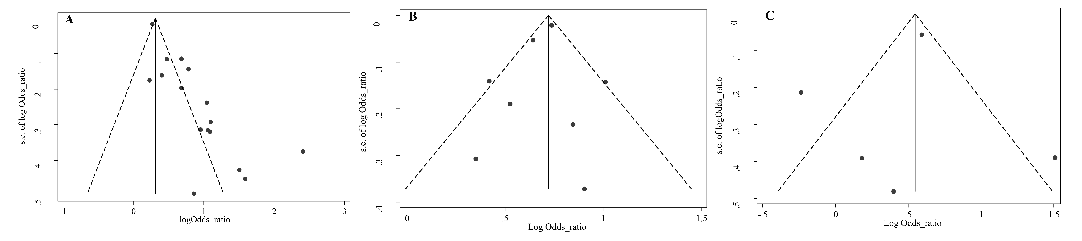
Supplementary figure 1. Funnel plot for evaluation publication bias among included in the meta-analysis of the association of food insecurity with, A: depression, B: stress, and C: anxiety risk

