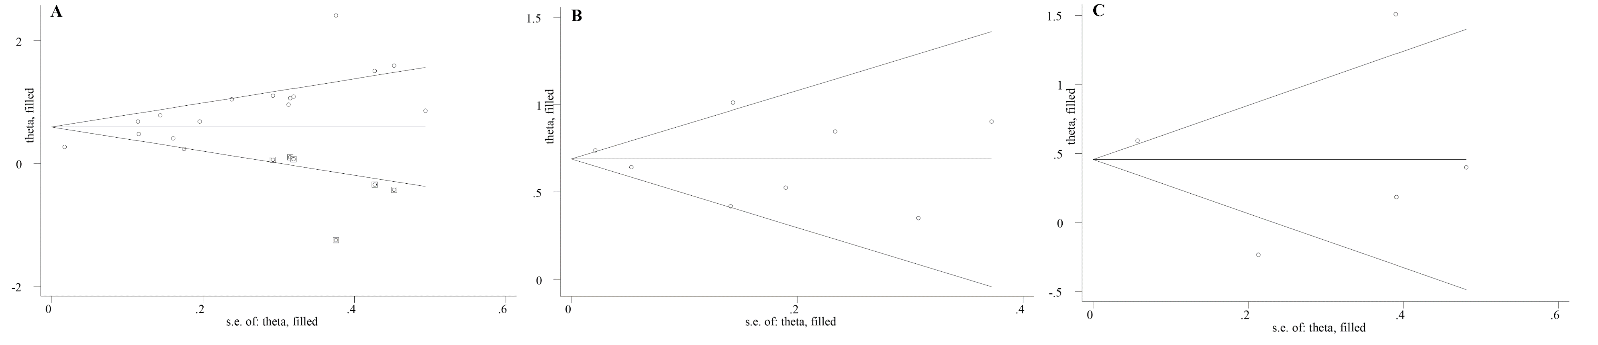
Supplementary figure 2. Filled funnel plot showing filled studies among included in the meta-analysis of the association of food insecurity with, A: depression, B: stress, and C: anxiety risk

