SUPPLEMENTARY MATERIAL
Table 1: Demographic and socioeconomic characteristics and body mass index according to participation in current analysis.
 | N (%) | N (%)
 | N (%) | Not participated  954 (32•3) | Participated  2000 (67•7) | P valueª
Age (years) (n=2954)  12•5-13•99  14-14•99  15-15•99  16-17•49 | 947 (32•1)  754 (25•5)  690 (23•4)  563 (19•1) | 345 (36•2)  237 (24•8)  203 (21•3)  169 (17•7) | 602 (30•1)  517 (25•8)  487 (24•4)  394 (19•7) | 0•009*
Sex (n=2954)  Male  Female | 1383 (46•8)  1571 (53•2) | 445 (46•6)  509 (53•4) | 938 (46•9)  1062 (53•1) | 0•897
FAS (n=2787)  Low  High | 1250 (44•9)  1537 (55•1) | 416 (46•7)  475 (53•3) | 834 (44•0)  1062 (56•0) | 0•181
Maternal education (n=2803)  Primary  Lower secondary  Higher secondary  University degree | 213 (7•6)  698 (24•9)  911 (32•5)  981 (35•0) | 74 (8•3)  232 (26•0)  270 (30•3)  316 (35•4) | 139 (7•3)  466 (24•4)  641 (33•5)  665 (34•8) | 0•313
Center (n=2954) |  |  |  | <0•001*
Athens | 290 (9•8) | 82 (8•6) | 208 (10•4)
Dortmund | 334 (11•3) | 102 (10•7) | 232 (11•6)
Gent  Heraklion | 285 (9•6)  254 (8•6) | 94 (9•9)  81 (8•5) | 191 (9•6)  173 (8•6)
Lille | 282 (9•5) | 92 (9•6) | 190 (9•5)
Pécs | 240 (8•1) | 78 (8•2) | 162 (8•1)
Rome | 287 (9•7) | 69 (7•2) | 218 (10•9)
Stockholm | 307 (10•4) | 105 (11•0) | 202 (10•1)
Vienna | 394 (13•3) | 94 (9•9) | 300 (15•0)
Zaragoza | 281 (9•5) | 157 (16•5) | 124 (6•2)
BMI (n=2954)  Thinness  Normal  Overweight  Obesity | 187 (6•3)  2083 (70•5)  518 (17•5)  166 (5•6) | 71 (7•4)  663 (69•5)  163 (17•1)  57 (6•0) | 116 (5•8)  1420 (71•0)  355 (17•8)  109 (5•4) | 0•339
FAS, Family Affluent Scale. BMI, Body Mass Index. ª Likelihood Ratio. *P value < 0•05.

Table 2: Total number of categories for nineteen items, generalized graded unfolding model item parameters estimates, outfit and infit for each item from Food Choices and Preferences questionnaire in Healthy Lifestyle in Europe by Nutrition in Adolescent study (n = 2000).
Item | N_{cat} | α_{i}  (SE) | δ_{i}  (SE) | τ_{i2} | τ_{i3} | τ_{i4} | τ_{i5} | Outfit | Infit
How healthy you perceived …
Chocolate milk | 4ª | 1•11 (0•07) | -0•11 (0•03) | -•2•39 | -1•16 | -0•53 | - | 1•12 | 1•09
Cheese products (e•g• cheddar, brie, cheese strings) | 4ª | 1•16 (0•07) | -0•01 (0•03) | -2•49 | -1•66 | -1•31 | - | 1•35 | 1•25
Sandwiches, toasties and pannini | 4ª | 1•11 (0•07) | -0•01 (0•03) | -2•22 | -1•26 | -0•18 | - | 1•14 | 1•11
Cereal bars | 4ª | 1•16 (0•08) | 0•03 (0•03) | -2•52 | -2•09 | -1•25 | - | 1•30 | 1•21
Yoghurt and yoghurt products | 5^{b} | 1•21 (0•07) | 0•05 (0•03) | -2•91 | -2•41 | -1•64 | -0•28 | 1•20 | 1•16
Juices | 5^{b} | 1•10 (0•07) | 0•06 (0•03) | -2•71 | -2•05 | -1•83 | -0•61 | 1•26 | 1•20
Bread and toast | 4ª | 1•45 (0•09) | 0•07 (0•03) | -2•62 | -1•82 | -0•98 | - | 1•32 | 1•23
Bowl of cereal | 4^{c} | 1•41 (0•08) | 0•07 (0•03) | -1•95 | -1•44 | -0•16 | - | 1•18 | 1•14
Milk | 4^{c} | 1•38 (0•08) | 0•12 (0•03) | -2•40 | -2•23 | -1•07 | - | 1•26 | 1•22
Tea | 3^{d} | 0•89 (0•07) | 0•26 (0•05) | -2•26 | -1•87 | - | - | 1•19 | 1•14
Pasta dishes | 3^{d} | 0•84 (0•06) | 0•27 (0•05) | -1•68 | -1•09 | - | - | 1•09 | 1•07
Water | 5^{b} | 0•92 (0•10) | 0•54 (0•09) | -4•00 | -2•68 | - | - | 1•10 | 1•11
What is your opinion about…
The food you eat at home is healthy | 3e | 1•88 (0•12) | 0•95 (0•05) | -3•22 | -1•18 | - | - | 0•83 | 0•85
Your diet is healthy | 3e | 1•57 (0•11) | 1•00 (0•05) | -3•02 | -0•62 | - | - | 0•88 | 0•88
You like the food your parents prepare at home | 4^{f} | 0•61 (0•05) | 1•02 (0•11) | -5•61 | -2•06 | -0•96 | - | 0•96 | 0•97
You feel well Informed about what are health foods | 3e | 0•90 (0•07) | 1•15 (0•11) | -4•51 | -1•12 | - | - | 0•95 | 0•96
You enjoy fruit and vegetables | 4^{f} | 0•56 (0•05) | 1•97 (0•34) | -6•00 | -3•63 | -0•65 | - | 0•93 | 0•94
What you eat now will have a big impact on your future health | 7^{g} | 0•48 (0•06) | 1•98 (0•55) | -7•30 | -1•81 | - | - | 0•98 | 0•98
If there is the option to choose a whole grain version of a food, you will choose it | 7^{g} | 0•35 (0•04) | 4•08 (3•91) | -5•97 | -3•84 | - | - | 0•96 | 0•96
N_{cat}, number of categories. SE, Standard Error. ª: Very unhealthy; unhealthy; indifferent; healthy. ^{b}: Very unhealthy; unhealthy; indifferent; healthy; very healthy. ^{c}: Unhealthy; indifferent; healthy; very healthy. ^{d}: Unhealthy; indifferent; healthy. ^{e}: Disagree; indifferent; agree. ^{f}: Disagree; indifferent; agree a lot; completely agree. ^{g}: Strongly disagree; moderately disagree; slightly disagree; indifferent; slightly agree; moderately agree; strongly agree. α_{i}: discrimination parameter of item i. δ_{i}: the location of the item i on the attitude continuum. τ_{i0}: Difference between subjective categories from the category 1. τ_{i1}: equal to zero for all items. τ_{i2}: Difference between subjective categories from the category 2. τ_{i3}: Difference between subjective categories from the category 3. τ_{i4}: Difference between subjective categories from the category 4. τ_{i5}: Difference between subjective categories from the category 5.

Table 3: Mixed model analyses between food groups’ intakes (g/d) and food choices scores among European adolescents adjusted by age, gender, maternal education, Family Affluent Scale and energy intake (n = 1082) with exclusion of under-reporters.
Food groups’ intake | β | 95% CI | P value
Vegetables | -22•25 | -78•05;33•55 | 0•43
Fruits | 95•85 | -0•76;192•47 | 0•05
Vegetables and fruits | 74•74 | -40•47;189•95 | 0•20
Sweets | -194•30 | -493•80;105•20 | 0•20
Cereals | 120•26 | 42•84;197•69 | 0•002*
Nuts and seeds | -8•43 | -16•45;-0•41 | 0•040*
Vegetable oils | -0•09 | -8•54;8•36 | 0•98
Olives and avocado | -6•27 | -13•11;0•57 | 0•07
Alcohol | -157•92 | -250•50;-65•35 | 0•001*
Dairy products | 464•95 | 259•16;670•70 | <0•001*
Pulses | 18•88 | -5•93;43•70 | 0•14
Water | 242•80 | -268•30;753•90 | 0•35
Meats and eggs | 131•15 | 63•6;198•69 | <0•001*
Fish | 46•26 | 23•66;68•87 | <0•001*
Savoury snacks | -19•38 | -35•69;-3•06 | 0•02*
*P value < 0•05. Centre used as the random intercept.
Table 4: Mixed model analyses between biomarkers and food choices scores among European adolescents adjusted by age, gender, maternal education, Family Affluent Scale, body mass index and energy intake (n = 444) with exclusion of under-reporters.
Biomarkers | β | 95% CI | P value
Vitamin C (mg/L) | 10•50 | 4•60;16•40 | 0•001*
Beta Carotene (ng/mL) | 384•03 | 57•85;710•21 | 0•021*
EPA + DHA (%) | 4•68 | 2•27;7•09 | <0•001*
EPA + DHA (µmol/L) | 117•44 | 22•75;212•14 | 0•015*
Holo-transcolobalamin (pmol/L) | 69•03 | 14•22;123•84 | 0•014*
Cobalamin (pmol/L) | 516•52 | 280•28;752•77 | <0•000*
Plasma Folate (nmol/L) | 37•23 | 19•52;54•94 | <0•001*
Erythrocyte Folate (nmol/L) | 1152•07 | 535•43;1768•72 | <0•001*
Trans fatty acids (µmol/L) | 0•54 | -0•80;1•87 | 0•429
EPA, eicosapentaenoic acid DHA, Docosahexaenoic acid. *P value < 0•05. Centre used as the random intercept.

ANCILLARY MATERIAL
Figure 1: Food Choices and Preferences Questionnaire.
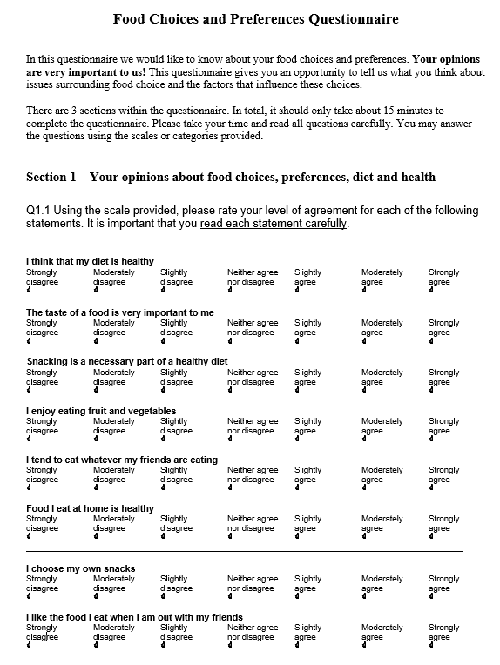
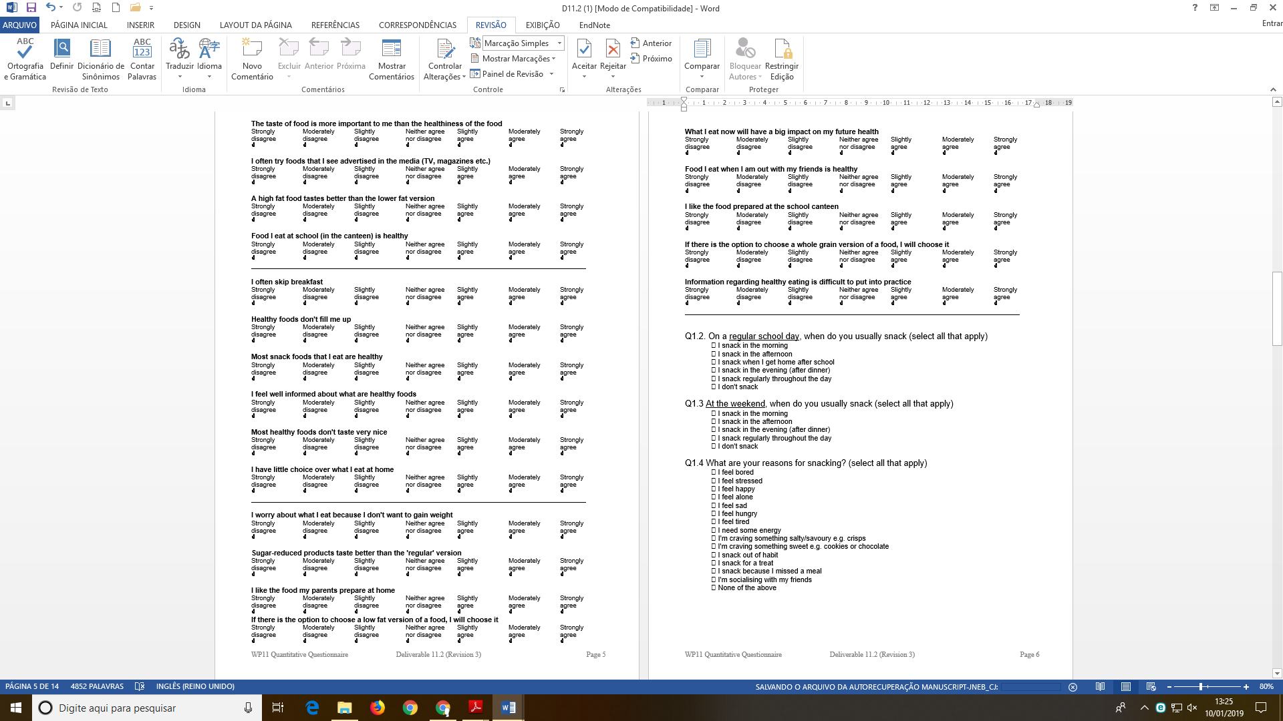

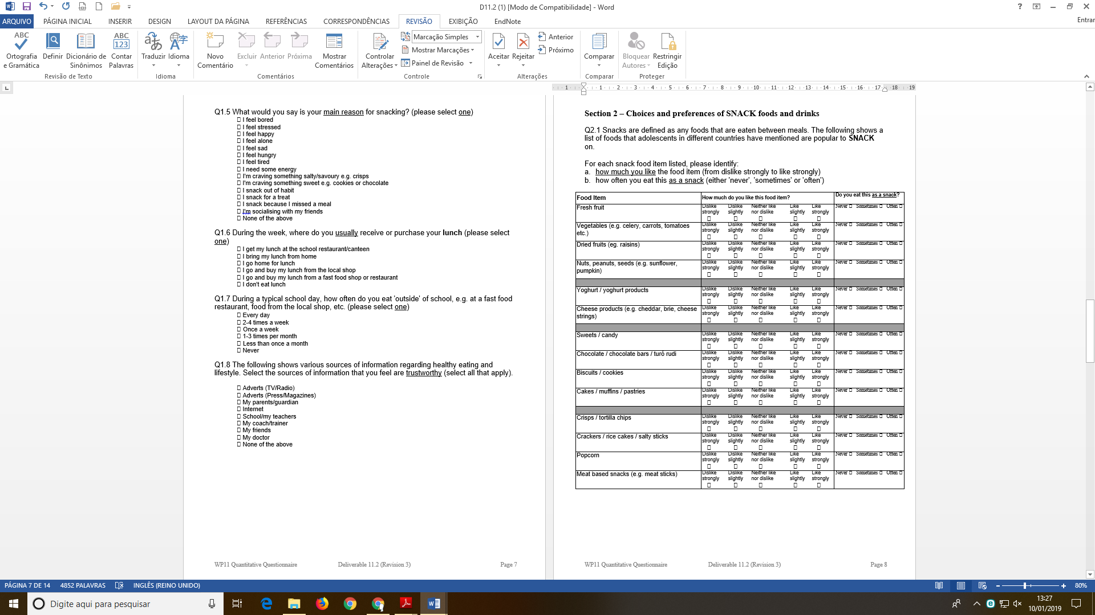

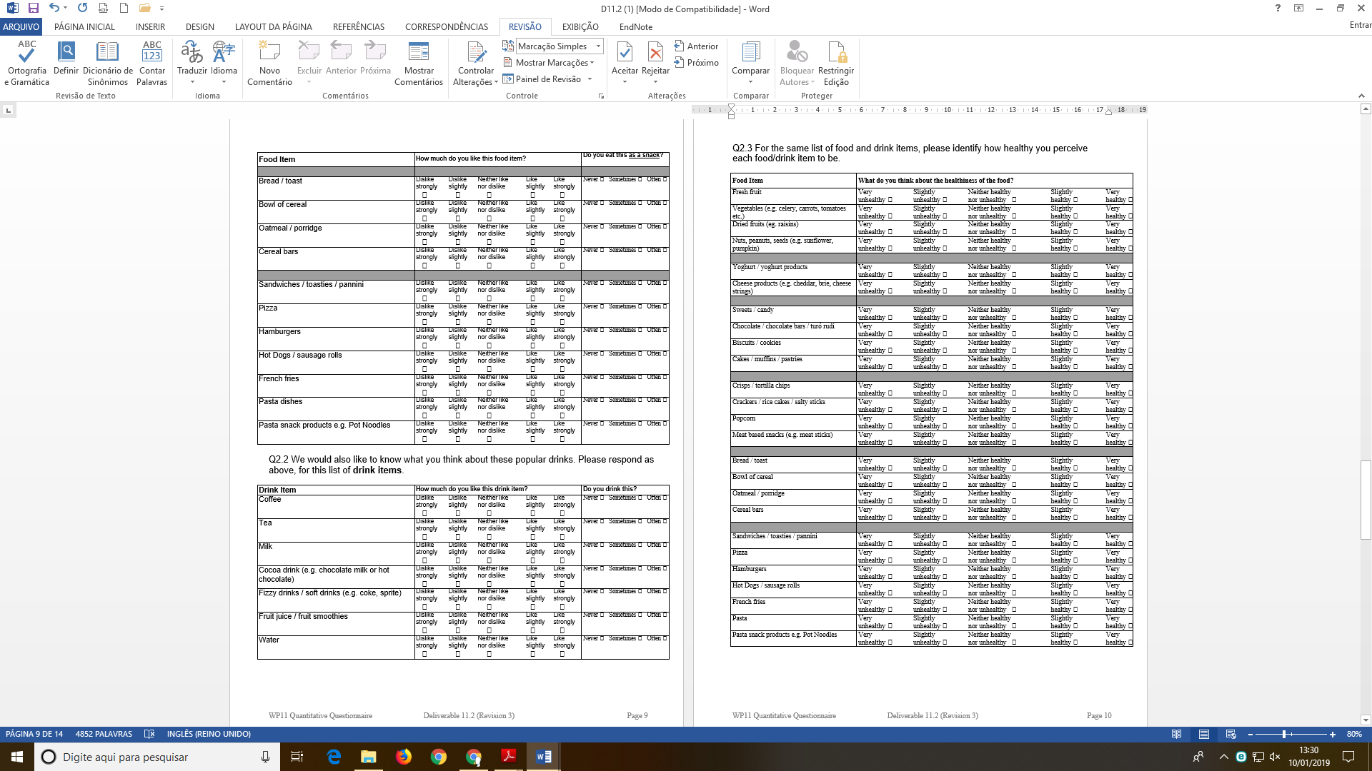
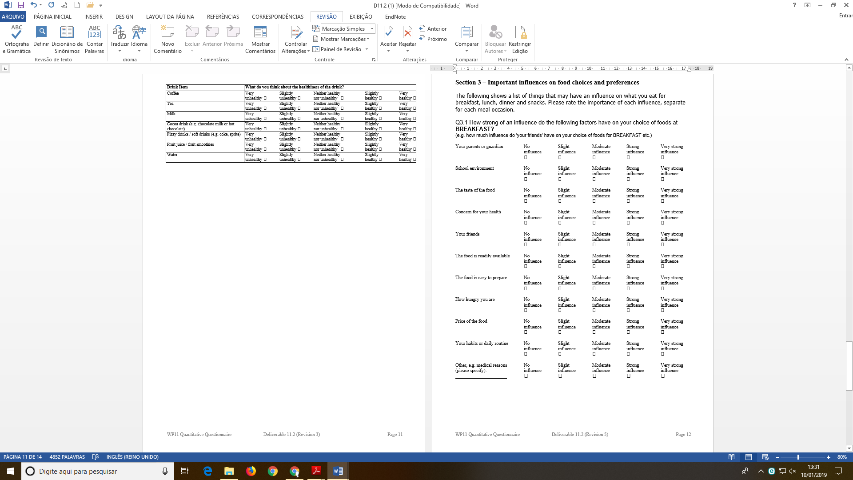
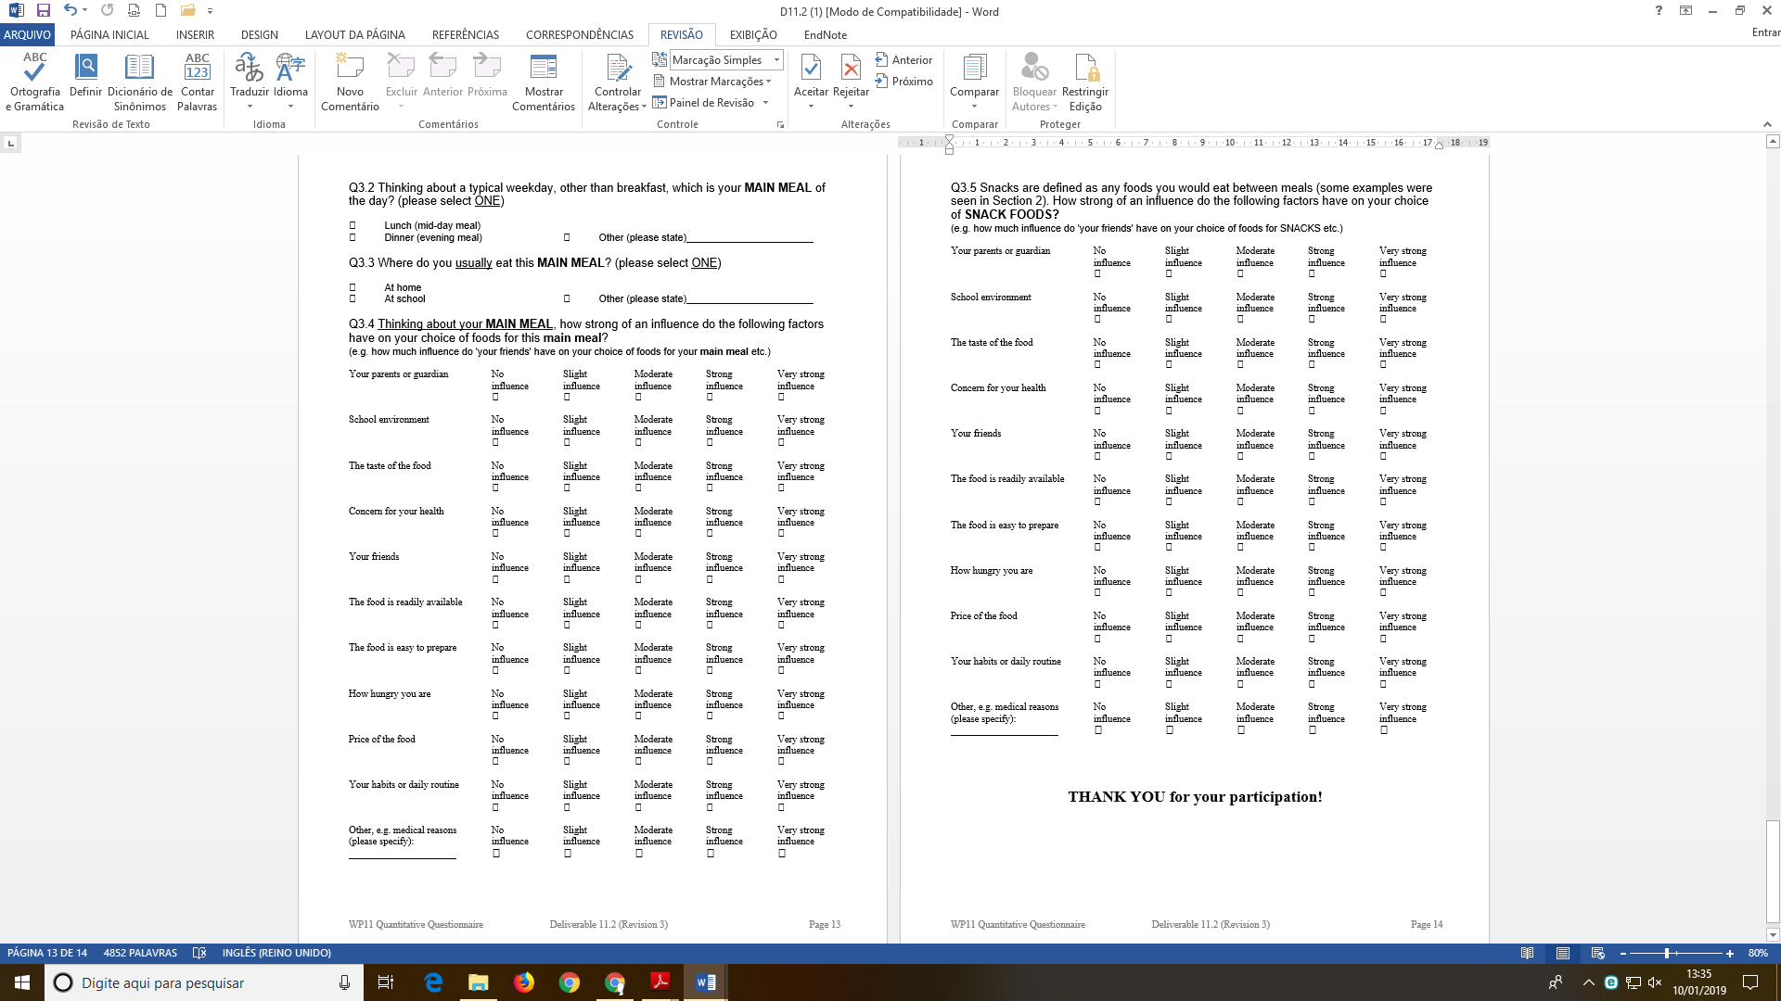

Figure 2: Items from the Scale of evaluatiOn of Food choIcEs (n = 2000).


