# Supplementary files

## Supplementary file 1: Desktop review, critical analysis

For each included document, the themes in each developmental stage were individually scored using a five-point scale, from 0 indicating the theme was not addressed at all to the highest score of 3 indicating the information was vegetable specific and provided detailed information include practical examples or tips. This scoring process was adapted from the review by Schwartz and colleagues [1] . Adaptations were made in order to specifically address vegetable preference development. Themes were assessed on the clarity, ease, detail and practicality of recommendations outlined in the policy, guideline and position statement documents as per the following scoring system:

|  |  |
| --- | --- |
| Score | Description |
| 0 | Theme not addressed at all |
| 0.5 | Theme is mentioned but is not specific to vegetable consumption |
| 1 | Theme mentioned is vegetable specific, but the information is not very clear and could be ambiguous for users |
| 2 | Vegetable specific theme is addressed with some detailed information |
| 3 | Vegetable specific theme is addressed with detailed information including practical examples and/or tips |

**Reference**

1. Schwartz C, Scholtens PA, Lalanne A, Weenen H, Nicklaus S. Development of healthy eating habits early in life. Review of recent evidence and selected guidelines. Appetite 2011;57(3):796-807.

Table S1a: Critical analysis of national / commonwealth policy, guideline and position statement documents

| Stakeholder | 1. NHMRC | 1. NHMRC | 1. COAG Health Council | 1. ACECQA | Department of Health | Department of Education and Learning |
| --- | --- | --- | --- | --- | --- | --- |
| Document name | 1. Australian Dietary Guidelines (2013) | 1. Infant Feeding Guidelines: Information for health workers (2012 updated 2015) | 1. Australian National Breastfeeding Strategy 2019 and beyond (2019) | 1. Guide to the National Quality Framework *(Quality Area 2 – Children’s health & safety) (2018)* | Get Up & Grow Healthy Eating and Physical Activity for Early Child-hood – Director/ Coor-dinator Book (2013) | Belonging, Being and Becoming -The Early Years Framework for Australia (2009 updated 2019) |
| 1. *Perinatal* |  |  |  |  |  |  |
| 1. Vegetable intake | 1. 2 | 1. 0 | 1. 0 | 1. 0 | 1. 0 | 1. 0 |
| 1. Variety of vegetables | 1. 1 | 1. 0 | 1. 0 | 1. 0 | 1. 0 | 1. 0 |
| 1. *Lactation* |  |  |  |  |  |  |
| 1. Vegetable intake specific | 1. 2 | 1. 0.5 | 0.5 | 1. 0 | 1. 0 | 1. 0 |
| 1. Variety of vegetables | 1. 1 | 1. 0 | 0 | 1. 0 | 1. 0 | 1. 0 |
| 1. *Complementary Feeding (4-24mths)* |  |  |  |  |  |  |
| 1. Initiation and progress in feeding- Timing of vegetable introduction | 1. 1 | 1. 1 | 0.5 | 1. 0.5 | 1. 0.5 | 1. 0 |
| 1. Sensory exposure- Taste | 1. 1 | 1. 0.5 | 1. 0 | 1. 0 | 1. 0.5 | 1. 0 |
| 1. Sensory exposure- Texture of vegetables | 1. 2 | 1. 0.5 | 0 | 1. 0 | 1. 1 | 1. 0 |
| 1. Sensory exposure- Appearance of vegetables | 1. 1 | 0 | 0 | 1. 0 | 1. 1 | 1. 0 |
| 1. Repeated exposure of vegetables | 1. 2 | 1. 0.5 | 0 | 1. 0 | 1. 0.5 | 1. 0 |
| 1. Variety of vegetables | 1. 1 | 1. 1 | 0 | 1. 0 | 1. 0.5 | 1. 0 |
| 1. Pairing vegetables with liked foods or caloric ingredients | 1. 0 | 1. 0 | 0 | 1. 0 | 1. 0.5 | 1. 0 |
| 1. *Toddlerhood (2-3years)* |  |  |  |  |  |  |
| 1. Vegetable intake | 1. 2 | 1. 0 | 0 | 1. 0.5 | 1. 1 | 1. 0.5 |
| 1. Sensory exposure- Taste | 1. 1 | 1. 0 | 1. 0 | 1. 0 | 1. 0.5 | 1. 0 |
| 1. Pairing vegetables with liked foods/flavours (Flavour-flavour learning) | 1. 0 | 0 | 0 | 1. 0 | 1. 0.5 | 1. 0 |
| 1. Pairing (Masking) | 1. 0 | 0 | 0 | 0 | 0 | 0 |
| 1. Repeated exposure to vegetables | 1. 0 | 0 | 0 | 0 | 0.5 | 0 |
| 1. Variety of vegetables | 1. 2 | 1. 0 | 1. 0 | 1. 0 | 1. 1 | 1. 0 |
| 1. Choice | 1. 0 | 1. 0 | 1. 0 | 1. 0.5 | 1. 0.5 | 1. 0 |
| 1. Parent-child interaction- Parent/caregiver response to vegetable refusal | 1. 0 | 1. 0 | 1. 0 | 1. 0 | 1. 0.5 | 1. 0 |
| 1. Parent-child interaction- Parental control | 1. 0 | 1. 0 | 1. 0 | 1. 0.5 | 1. 0.5 | 1. 0 |
| 1. Parent-child interaction- Positive reinforcement from parent | 1. 0 | 0 | 0 | 0 | 0.5 | 0 |
| 1. Vegetable availability and accessibility | 1. 0 | 0 | 0 | 0 | 0 | 0 |
| 1. Peer and parent role modelling | 1. 1 | 1. 0 | 1. 0 | 1. 0.5 | 1. 0.5 | 1. 0.5 |

Abbreviations: ACECQA: Australian Children’s Education and Care Quality Authority; COAG: Council of Australian Governments; NHMRC: National Health and Medical Research Council

Table S1b: Critical analysis of medical and health associations / organisations policy, guideline and position statement documents

| Stakeholder | The RACGP  Smoking, nutrition, alcohol, physical activity (SNAP): A population health guide to behavioural risk factors in general practice (2015) | The RACGP | Australian Breastfeeding Association | Australian Medical Association | Cancer Council |
| --- | --- | --- | --- | --- | --- |
| Document name | Guidelines for Preventive Activities in General Practice (2018) | Position statement on breastfeeding (2013) | Australian Medical Association: Infant Feeding and Parental Health (2017) | Fruit, vegetables and cancer prevention (2014) |
| *Perinatal* |  |  |  |  |  |
| Vegetable intake | 2 | 1 | 0 | 0 | 0 |
| Variety of vegetables | 1 | 0 | 0 | 0 | 0 |
| *Lactation* |  |  |  |  |  |
| Specific to vegetable intake | 1 | 0 | 0.5 | 0 | 0 |
| Variety of vegetables | 1 | 0 | 0 | 0 | 0 |
| *Complementary feeding (4-24mths)* |  |  |  |  |  |
| Initiation and progress in feeding- Timing of vegetable introduction | 0.5 | 0.5 | 0.5 | 0.5 | 0 |
| Sensory exposure- Taste | 0 | 0 | 0 | 0 | 0 |
| Sensory exposure- Texture of vegetables | 1 | 0 | 0 | 0 | 0 |
| Sensory exposure -Appearance of vegetables | 1 | 1 | 0 | 0 | 0 |
| Repeated exposure of vegetables | 0 | 0 | 0 | 0 | 0 |
| Variety of vegetables | 1 | 1 | 0 | 0.5 | 0 |
| Pairing vegetables with liked foods or caloric ingredients | 0 | 0 | 0 | 0 | 0 |
| Parent-child interaction- Parent response to vegetable refusal | 0 | 0 | 0 | 0 | 0 |
| *Toddlerhood (2-3years)* |  |  |  |  |  |
| Vegetable intake | 1 | 0.5 | 0 | 0 | 1 |
| Sensory exposure- Taste | 0 | 0 | 0 | 0 | 0 |
| Pairing vegetables with liked foods/flavours (Flavour-flavour learning) | 0 | 0 | 0 | 0 | 0 |
| Pairing (Masking) | 0 | 0 | 0 | 0 | 0 |
| Repeated exposure to vegetables | 0 | 0 | 0 | 0 | 0 |
| Variety of vegetables | 0 | 0 | 0 | 0 | 0 |
| Choice | 0 | 0 | 0 | 0 | 0 |
| Parent-child interaction- Parent response to vegetable refusal | 0 | 0 | 0 | 0 | 0 |
| Parent-child interaction- Parental control | 0 | 0 | 0 | 0 | 0 |
| Parent-child interaction- Positive reinforcement | 0 | 0 | 0 | 0 | 0 |
| Vegetable availability and accessibility | 0 | 0 | 0 | 0 | 0 |
| Peer and parent role modelling | 0 | 0 | 0 | 0 | 0 |

Abbreviations: RACGP: Royal Australasian College of General Practitioners; GP: General Practitioner

**Table S1c: Critical analysis of state health department policy, guideline and position statement documents according to the themes of interest**

| Stakeholder | Department of Health & Human Services (Victoria) | Department of Health and Human Services (Victoria) | Ministry of health (NSW) | NSW Health | Department of Health and Human Services (Tasmania) | Department of Health (NT) | Department of Health (SA) |
| --- | --- | --- | --- | --- | --- | --- | --- |
| Document name | Healthy Food Charter: Creating a vibrant healthy eating culture (2013) | Healthy Eating Advisory Service: Menu Planning Guidelines (2016) | Caring for Children Birth to 5 years (Food, Nutrition and Learning Experiences) (2014) | Breastfeeding in NSW - Promotion, Protection and Support (2018) | Food and Nutrition policy (2004) | NT Health Nutrition and Physical Activity Strategy 2015-2020 (2015) | The Eat Well Be Active Strategy for South Australia 2011-2016 (2011) |
| *Perinatal* |  |  |  |  |  |  |  |
| Vegetable intake | 0.5 | 0 | 0 | 0 | 1 | 0.5 | 1 |
| Variety of vegetables | **3** | 0 | 0 | 0 | 0 | 1 | 0 |
| *Lactation* |  |  |  |  |  |  |  |
| Specific to vegetable intake | 0 | 0 | 0 | 0.5 | 0 | 0 | 0 |
| Variety of vegetables | 0 | 0 | 0 | 0 | 0 | 0 | 0 |
| *Complementary feeding (4-24mths)* |  |  |  |  |  |  |  |
| Initiation and progress in feeding- Timing of vegetable introduction | 0 | 1 | 1 | 0 | 0 | 0.5 | 0.5 |
| Sensory exposure- Taste | 0 | 0.5 | 0.5 | 0 | 0 | 0.5 | 0 |
| Sensory exposure- Texture of vegetables | 0 | 0.5 | 3 | 0 | 0 | 0 | 0 |
| Sensory exposure- Appearance of vegetables | 0 | 0.5 | 0 | 0 | 0 | 1 | 0 |
| Repeated exposure of vegetables | 0 | 0 | 0.5 | 0 | 0 | 0 | 0 |
| Variety of vegetables | 0 | 2 | 0.5 | 0 | 0 | 1 | 0 |
| Pairing vegetables with liked foods or caloric ingredients | 0 | 0 | 0 | 0 | 0 | 0 | 0 |
| Parent-child interaction- Parent response to vegetable refusal | 0 | 0 | 0.5 | 0 | 0 | 0 | 0 |
| *Toddlerhood (2-3years)* |  |  |  |  |  |  |  |
| Vegetable intake | 0 | 2 | 2 | 0 | 0 | 0 | 1 |
| Sensory exposure- Taste | 0 | 0.5 | 0.5 | 0 | 0 | 0 | 0 |
| Pairing vegetables with liked foods/flavours (Flavour-flavour learning) | 0 | 0 | 0.5 | 0 | 0 | 0 | 0 |
| Pairing (Masking) | 0 | 0 | 0 | 0 | 0 | 0 | 0 |
| Repeated exposure to vegetables | 0 | 0 | 0.5 | 0 | 0 | 0 | 0 |
| Variety of vegetables | 0 | 2 | 1 | 0 | 0 | 0 | 0 |
| Choice (i.e. of two vegetables) | 0 | 0 | 0.5 | 0 | 0 | 0 | 0 |
| Parent/ child interaction- Parent response to vegetable refusal | 0 | 0 | 0.5 | 0 | 0 | 0 | 0 |
| Parent-child interaction- Parental control | 0 | 0 | 0.5 | 0 | 0 | 0 | 0 |
| Parent-child interaction- Positive reinforcement | 0 | 0 | 0.5 | 0 | 0 | 0 | 0 |
| Vegetable availability and accessibility | 0 | 0 | 0 | 0 | 0 | 0 | 0 |
| Peer and parent role modelling | 0 | 0 | 0.5 | 0 | 0 | 0 | 0.5 |

## Supplementary file 2: NGT evidence-informed statements

S2a: The evidence-informed statements (n=30) provided to participants of the NGT workshop

|  |  |
| --- | --- |
| **MATERNAL (PERINATAL & LACTATION)**  **4 MONTHS PRE-BIRTH UP TO 24MONTHS POST-BIRTH** | |
| **PERINATAL (AMNIOTIC FLUID): WHAT & HOW** | |
| 1 | A vegetable rich diet during pregnancy has health benefits for both mother and baby |
| 2 | Flavours originating from the maternal diet during pregnancy can transfer to and flavour amniotic fluid. Fetal flavour exposure may increase acceptance of similarly flavoured foods when re-exposed during infancy and potentially childhood. |
| **LACTATION (BREASTMILK): WHAT & HOW** | |
| **3** | Breastfeeding duration (>3months) for vegetable-consuming mothers supports vegetable intake in children up to 2 y and vegetable acceptance and intake at 3.7y |
| **4** | Flavours originating from the maternal diet during lactation transmit to and flavour breast milk in a time-dependent manner. Infants can detect diet-transmitted flavours in breast milk:   * within hours of a single maternal ingestion (alcohol, garlic, vanilla, carrot) * within days after repeated maternal ingestion (garlic, carrot juice)   within 1–4 month postpartum after repeated maternal ingestion (variety of vegetables including carrot) during lactation |
| **INFANCY/TODDLERHOOD (COMPLEMENTARY FEEDING)**  **4-6 MONTHS UP TO 24MONTHS** | |
| **COMPLEMENTARY FEEDING (WEANING): WHEN** | |
| **5** | Commencing complementary feeding (as per guidelines and when developmentally ready) with vegetables (not fruit) supports increased acceptance and intake of vegetables.  Stepwise (i.e. milk+veg puree, then rice cereal+veg puree then veg puree) introduction and promoting variety (veg type and texture) both daily and within meals has the greater the effect |
| **COMPLEMENTARY FEEDING (WEANING): WHAT** | |
| **6** | Complementary feeding commencing with vegetables (not fruit) supports increased acceptance and intake of vegetables |
| **7** | Exposure to vegetables in a variety of textures supports increased intake of target vegetable |
| **8** | Visual exposure to unfamiliar vegetables via story/picture books supports increased acceptance and intake in children aged 21-24 months |
| **COMPLEMENTARY FEEDING (WEANING): HOW\*** | |
| **9** | Repeated exposure (up to 10 times or more) of target vegetables increases acceptance (liking) and intake in children aged up to 24 months |
| **10** | Pairing vegetables with nutrients (i.e. oil/fat) provides no advantage in supporting vegetable acceptance or intake. |
| **11** | Pairing vegetables with liked flavour (i.e. salt, sucrose, spice) provides no advantage in supporting vegetable acceptance or intake. |
| **12** | Pairing vegetables with liked flavour & nutrients (i.e. dips, sauce, cream cheese, dressing) may support vegetable acceptance or intake but provides no advantage over repeated exposure. |
| **13** | Exposure to a variety of different vegetables daily (within and between meal variety) supports increased vegetable acceptance and intake in children aged up to 6 years. |
| **14** | Parental modelling of liking and consuming vegetables supports vegetable liking and intake in children 4 months to 36 months |
| **PRE-SCHOOL**  **24 – 36 MONTHS** | |
| **FAMILY FOODS: HOW** | |
| Parenting style and practices* | |
| **15** | Repeated exposure (up to 10 times or more) of target vegetables increases acceptance (liking) and intake in children aged 2 years and older. |
| **16** | Pairing vegetables with nutrients (i.e. oil/fat/sugar) provides no advantage in supporting vegetable acceptance or intake in children aged 2-5 years. |
| **17** | Pairing vegetables with liked flavour (i.e. salt, sucrose, spice) provides no advantage in supporting vegetable acceptance or intake. |
| **18** | Pairing vegetables with liked flavour & nutrients (i.e. dips, sauce, cream cheese, dressing) may support vegetable acceptance or intake but provides no advantage over repeated exposure in children aged 2-5 years. |
| **19** | Flavour masking may support vegetable acceptance or intake in bitter sensitive children aged 2-5 years |
| **20** | Potential inconclusive evidence (limited & conflicting findings) of the effect of offering choice of two vegetables on children’s vegetable intake  Choice between 2 vegetables has the potential to increase children’s vegetable intake |
| **21** | Exposure to a variety of different vegetables daily (including within meals) supports increased vegetable intake in children aged up to 5 years. |
| **22** | Increased availability (serving order, portion size, variety, choice, visual presentation) supports vegetable intake in children aged 2-5 years. |
| **23** | Serving vegetables at the beginning of meals may support increased vegetable intake in children aged 2-5 years |
| Home/day-care/preschool environment - learning | |
| **24** | Familiarisation of unfamiliar vegetables through picture books (every day/ 2 weeks) may support vegetable intake in children 21-24 months |
| **25** | Child targeted nutrition education (health benefits) may support vegetable intake in children but provides no advantage over taste exposure. |
| **26** | Narrative Review evidence only: Hands-on approaches such as gardening and cooking programs may encourage greater [vegetable consumption](https://www.sciencedirect.com/topics/food-science/vegetable-consumption) and may have a larger effect compared to [nutrition education](https://www.sciencedirect.com/topics/food-science/nutrition-education).  Narrative Review evidence only: Sensory education – taste lessons –Sensory lessons did not seem to greatly impact food preferences, but some studies found a decrease in neophobia in the short term |
| **27** | Non-food rewards can complement taste exposure and repeated exposure to support vegetable intake in children aged 2 years and older. Tangible rewards (stickers) are more useful than social rewards. Food rewards can be detrimental by reducing child’s liking for vegetables and increasing liking for reward food. |
| **28** | Parental modelling supports vegetable intake in children aged 2-5 years. Effect is greater when combined with taste exposure and non-food reward. |
| **29** | Parental modelling supports, and peer modelling may support, vegetable intake in children aged 2-5 years. Effect is greater when combined with taste exposure and non-food reward. |
| **30** | Narrative Review evidence only: Children who were high in approach temperament were less likely to express facial expressions of distaste (i.e. a gape of the jaws) and ate more of a bitter green vegetable |

Yellow highlighting represents those statements that were taken through from Phase 1 (silent generation) of the NGT to phase 4 (voting).

## Supplementary file 3: Delphi Survey

## Delphi survey example questions

**An example question from Delphi survey Round 1 - ranking**

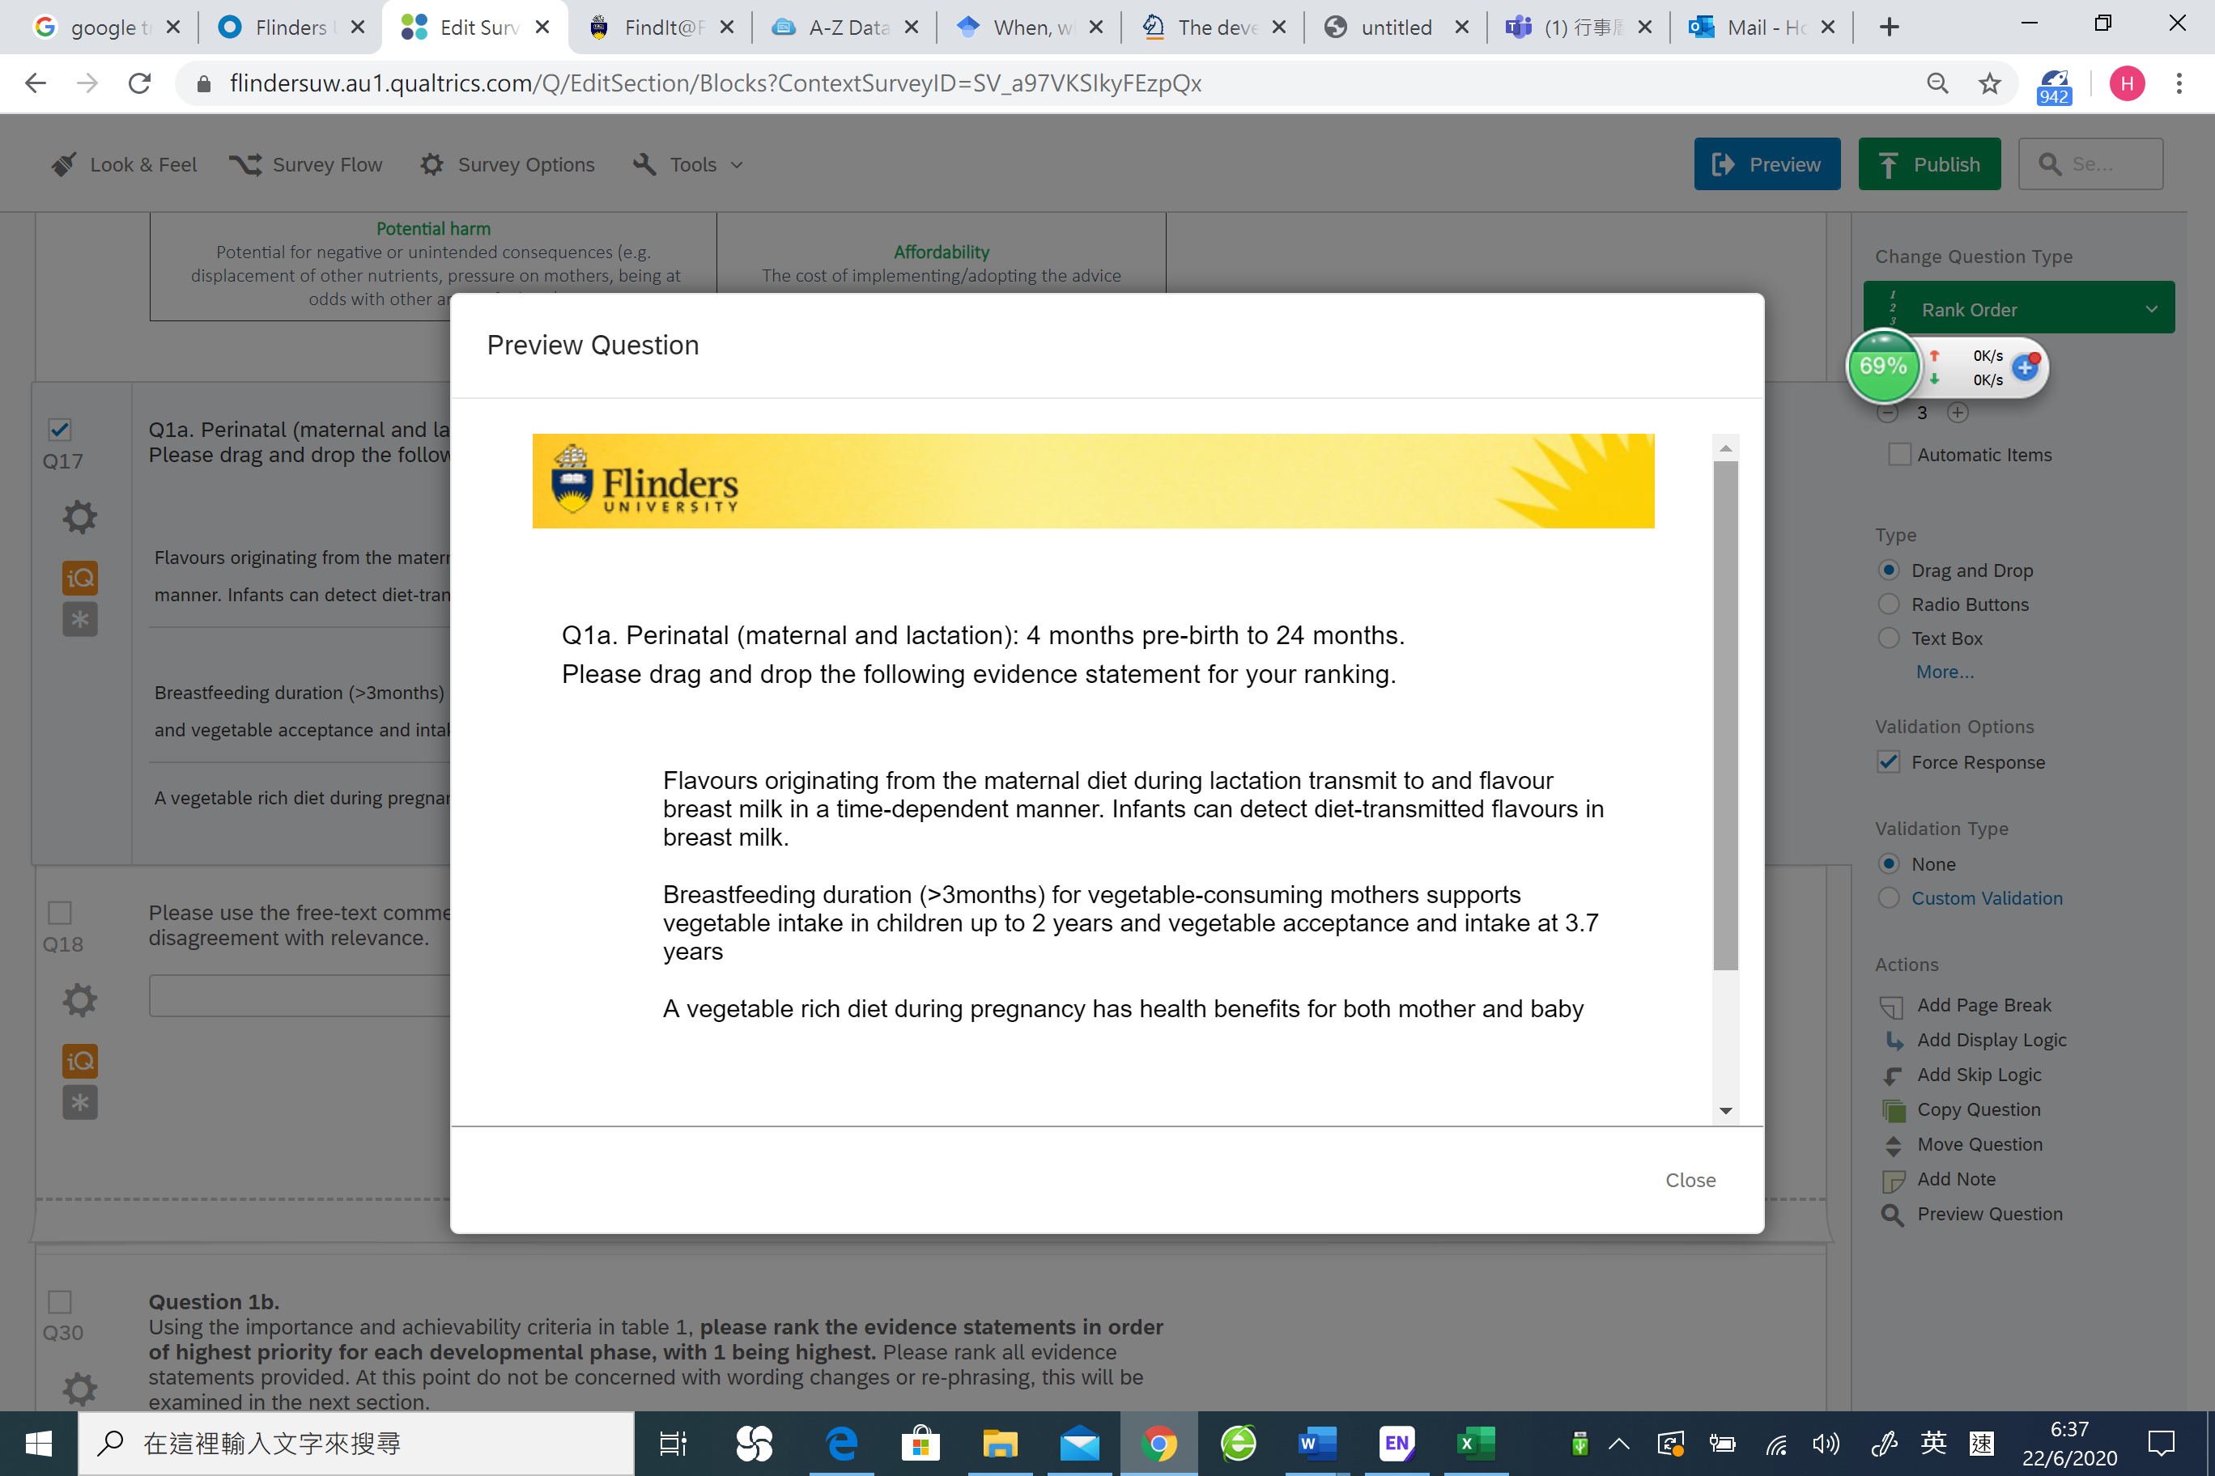

**An example question Delphi survey Round 1– translating evidence-informed statements to advice messages**

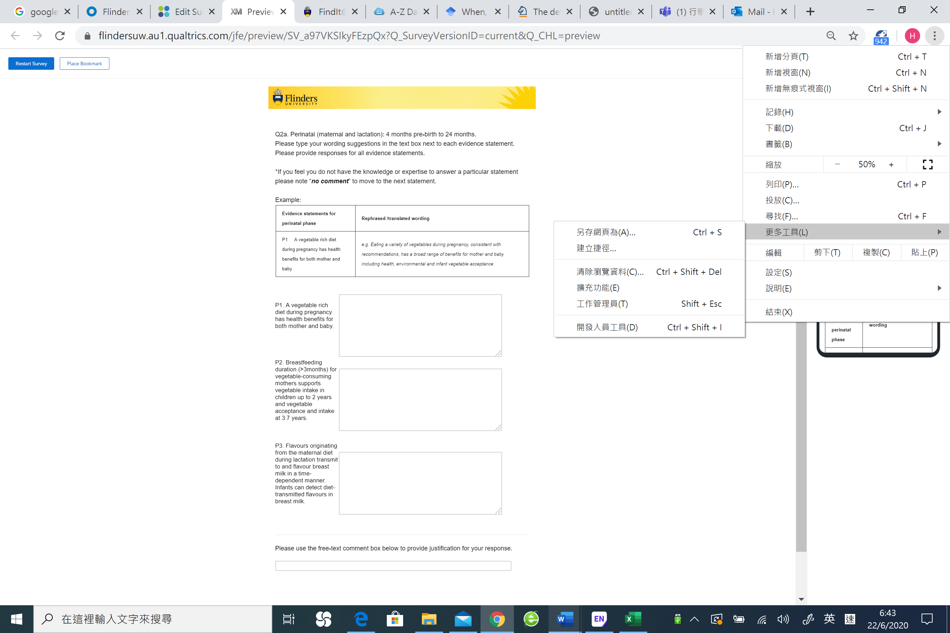

**Example of Round 2 level of agreement likert scale**

