Supplementary material I. Facilitation guide on “breast milk only” education session

Targeted behavior: “Provision of water in addition to breast milk to children under six months of age.”
Introduction:
Greet the audience.
Introduce yourself and your assistant (health worker).
Thank mothers for participating in this nutrition education session.
Start with encouragement: “I know it’s important to you that your child is healthy and growing well. That’s why today, we will discuss the benefits of giving only breast milk to your child until six months.”
Message 1:
Breast milk contains all the water a baby needs for the first six months of life, even in a hot, dry climate!
- Ask:
- What do you think are the benefits of exclusive breastfeeding for the baby?
- Who believes that there is already water in breast milk?
- Who already gives water to their infants under six months of age? What are the reasons?

- Activities:
- Tell mothers that you will prove to them that breast milk already contains water.
- Reiterate to mothers that you are there to prove that enough water is in breast milk.
- Use two clear 250 ml glasses.
- Fill the first one with 250 ml of water.
- Put 30 ml of fresh milk (1 tenth of the volume) in the second glass. Top up with 220 ml of water (9 tenths of a volume) to make the volume of the first glass.
- Then ask the mothers to compare the two glasses.
- Explain to mothers that the same amount of water is in both glasses. The difference is that the first glass contains nutrients (the orange part in the picture of the drop below) in addition to water, as is the case with breast milk.
- Then show mothers the composition of breast milk using the picture of the drop below: 88% water, 7% lactose, 4% fat, 1% protein, and use the figure below;
- Tell them that, as they can see from the picture of the drop, water is already available in the mother’s breast milk. When provided on demand (day and night), breast milk meets all the water needs of babies under six months of age.
- Tell mothers that this is why their child does not need water until six months of age, even when she is given medicine (syrup) or when it is hot.
- Reiterate that as long as there is water in the breast milk, the child will get used to it when he/she is six months old.
- Ask mothers again if they now believe breast milk contains water and if they still believe giving water to a child under six months of age prevents constipation, thirst, dry throat, and fatigue.
- Ask those who do not always believe to raise their hand and why they think there is insufficient water in breast milk.
- Try to convince them until all mothers are persuaded and address their concerns before continuing.
- Ask the mothers, knowing they now believe/know there is water in the breast milk, if they should give water to their child under six months of age to prevent certain health problems.
- Ask the mothers to repeat the message to make sure they understand it.
- Summarize this section with the elements below:
- Breast milk is 88% water. It contains all the water a baby needs for the first six months of life, even in a hot, dry climate!
- Like water, breast milk quenches thirst.
- By observing his/her urination, you can tell if your baby is getting enough water from breast milk.
- If it is hot and dry, breastfeed more often and make sure you drink enough water.
- Congratulate them for concluding this section.
Vitamins* (Lactose 7%, Fats 4%, Proteins 1%) | 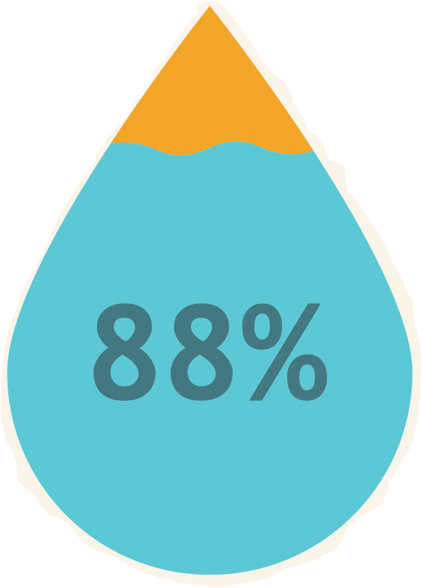
WATER
* This term is used to facilitate the understanding of mothers.

Message 2:
Even if you don’t have enough milk in your breast, the amount you give your babies will meet their nutritional needs for the first six months of life.
- Ask:
- According to you, does a child under six months of age need other fluids such as water when there is not enough breast milk?

- Activities:
- Demonstrate to mothers that the baby’s stomach volume allows him to be satisfied with breast milk only before six months.
- To do this, present mothers with a bitter kola as the baby’s stomach size in the first week of life, a chicken egg at one month, a large onion at three months, and an apple at six months.
- After they understood how a baby’s stomach size changes, ask the mothers if they must give their child other foods, including water, before six months.
- Tell them that giving water replaces milk and causes the baby to miss essential nutrients.
- Explain that if the baby is given water, he will demand less breast milk. This will reduce breast milk production. This means there is less food available for the baby.
- Ask mothers again if they now believe that water should not be given to the baby before the milk comes in. For those who still do not believe it, try to convince them until all mothers are persuaded and address their concerns.
- Ask the mothers to repeat the message to make sure they understand it.
- Congratulate them as you conclude this section.
 |  |  | 
 |  | 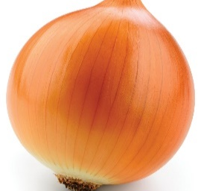
 | 
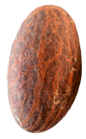
Bitter kola | Chicken egg | Small onion | Apple
First week | One month of age | Three months of age | Six months of age

Message 3:
The more your baby sucks, the more breast milk you produce to feed him. So, you will not need to give him/her water before six months.
- Ask:
- Why do some mothers feel they don’t have enough breast milk?
- Have you ever felt like you didn’t have enough breast milk? How did you know?
- What do you think caused this?
- How did you address it?

- Activities:
- Now that they know that breast milk contains water and the volume of milk produced can feed your baby, ask them what they do when they are worried about not having enough milk.
- Explain the following to mothers:
- Giving water means less time to suckle the breast, which decreases the amount of breast milk produced, leading to thinking they don’t have enough breast milk and may give the baby other substances.
- If they think they are not getting enough breast milk, the solution is to breastfeed more. The more the baby sucks at the breast, the more breast milk they will have for their baby!
- Even when they have to be away from their baby, they can express breast milk and store it safely for others to feed when they are unable to.
- To stimulate breast milk production, they need to suckle the baby day and night and continue to do so even when they or their babies are sick.
- Ask the mothers as they now believe/know that the more they feed their child, the more breast milk is produced for their child if they continue to give water to the child under six months. If they still do not believe, answer their questions and concerns;
- Ask the mothers to repeat the message to make sure they understand it;
- Congratulate them as you conclude this section.

Message 4:
Giving water to a child under six months can make a baby sick.
- Questions:
- What health problems do you think a child under six months of age will have when you give them water?

- Activities:
- Now that they know breast milk contains water, ask them if they know there are health risks of giving water to the child before six months?
- Ask them to list these risks?
- Thank the mothers for their answers.
- Summarize the mothers’ statements with the items below:
- Diarrhea due to microbes in water: 5 times greater risk; halved episodes of diarrhea; reduced reasons for consultation due to diarrhea by three quarters (78%);
- Cough and bronchitis: halved (68%) risk of ARI if EBF; halved ARI; halved (57%) reasons for consultation due to diarrhea;
- Weight loss due to diarrhea and the fact that the child will not take enough breast milk which is very rich in minerals and vitamins, which can lead to malnutrition (stunting and wasting);
- Abdominal pain;
- Otitis media (ear problems);
- Gurgling due to water indigestion;
- Breastfeeding prevents more than one-eighth (13.8%) of deaths of babies under 24 months of age;
- Increased health care costs for treatment if babies are sick.
- Ask the mothers again if they have any other questions about the disadvantages of giving water to a child under six months. If so, answer their questions;
- Ask the mothers to repeat the message to make sure they understand it;
- Congratulate the mothers and close the session.

Moms, know that breastfeeding gives your child a good start in life and allows for proper brain and body development. A baby who receives only breast milk until six months of age is a child who gets less sick. This concerns all of us, our families, and the whole country.
Please take these messages to other breastfeeding mothers in your communities.
Thanks again for your participation!

