**Supplementary Figure 1** The process of including or excluding participants in present study

**Supplementary Table 1** Components in the empirical dietary inflammatory pattern (EDIP) in NHANES

**Supplementary Table 2** Odds ratios and 95% confidence intervals for liver steatosis according to tertiles of EDIP scores adjusted by the nutrient residual method in NHANES 2017-2018

**Supplementary Table 3** Odds ratios and 95% confidence intervals for liver steatosis according to tertiles of EDIP scores that excluded alcohol intake components with further adjustment for alcohol drinking

**Supplementary Table 4** The heterogeneity on the associations of EDIP scores (per 1-SD increase) with odds of non-alcoholic fatty liver and other steatosis

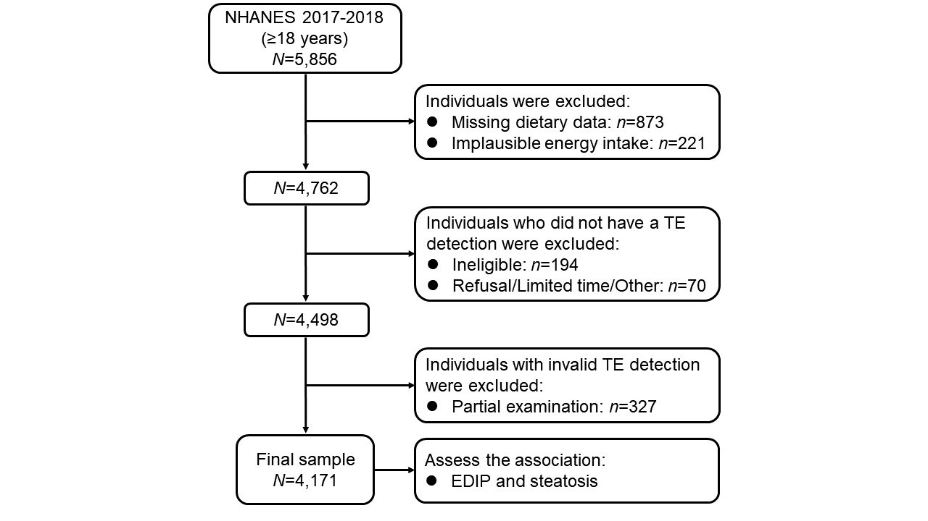

**Supplementary Figure 1** The process of including or excluding participants in present study

Abbreviations: NHANES, National Health and Nutrition Examination Survey; TE, Transient elastography

**Supplementary Table 1** Components in the empirical dietary inflammatory pattern (EDIP) in NHANES

| **EDIP components** | **Weight of EDIP** * |
| --- | --- |
| Intercept | 0.0902682605 |
| **Positive associations** |  |
| Regular carbonated drinks | 0.0001343970 |
| Low calorie carbonated drinks | 0.0001384061 |
| High fat dairy | 0.0003023257 |
| Low fat dairy | 0.0001695981 |
| Tea | 0.0000766342 |
| Coffee | 0.0001233368 |
| Margarine | 0.0044374986 |
| Eggs | 0.0004660760 |
| **Inverse associations** |  |
| Poultry | -0.0005540920 |
| Dark meat fish | -0.0010640650 |
| Dark-yellow vegetables | -0.0010732930 |
| Leafy-green vegetables | -0.0009532390 |
| Wine | -0.0006970280 |
| Snacks | -0.0014620360 |
| Fruits | -0.0003087480 |
| Pizza | -0.0003346070 |
| Nuts | -0.0022202990 |
| Sweets desserts | -0.0007715860 |
| Refined grains | -0.0047919700 |
| Whole grains | -0.0079106260 |
| Oil and vinegar salad dressing | -0.0030488597 |
| Condiments | -0.0011844700 |
| Other vegetables | -0.0001967530 |
| Regular fruit drinks | -0.0001187000 |
| Beer | -0.0000523110 |

Abbreviations: EDIP, Empirical dietary inflammatory pattern; NHANES, National Health and Nutrition Examination Survey.

* An EDIP with the use of dietary and inflammatory markers data from the NHANES 1999-2010.

**Supplementary Table 2** Odds ratios and 95% confidence intervals for liver steatosis according to tertiles of EDIP scores adjusted by the nutrient residual method in NHANES 2017-2018 *

|  |  |  |  |  |  |
| --- | --- | --- | --- | --- | --- |
|  | **Tertile 1** | **Tertile 2** | **Tertile 3** | **Per 1-SD** | ***Ptrend*** ‡ |
| **Steatosis** † **(≥S1, OR and 95% CI)** | | | | | |
| No. of cases | 544 | 590 | 672 |  |  |
| Model 1 | Reference | 1.33 (1.03-1.72) | 1.90 (1.49-2.42) | 1.34 (1.20-1.50) | <0.001 |
| Model 2 | Reference | 1.40 (1.10-1.78) | 1.93 (1.43-2.59) | 1.34 (1.16-1.53) | <0.001 |
| **Steatosis (≥S2, OR and 95% CI)** | | | | | |
| No. of cases | 415 | 477 | 544 |  |  |
| Model 1 | Reference | 1.41 (1.06-1.88) | 1.92 (1.49-2.49) | 1.36 (1.21-1.53) | <0.001 |
| Model 2 | Reference | 1.47 (1.11-1.95) | 1.84 (1.36-2.48) | 1.32 (1.15-1.52) | <0.001 |

Abbreviations: CI, Confidence interval; EDIP, Empirical dietary inflammatory pattern; HBV, Hepatitis B Virus; HCV, Hepatitis C Virus; NHANES, US National Health and Nutrition Examination Survey; OR, Odds ratio.

* Model 1 was adjusted for age; Model 2 was further adjusted for sex, smoking status, race, education, family income to poverty ratio, marital status, physical activity, total energy, HBV, and HCV.

† CAP values ≥ 274 dB/m and 290 dB/m were considered indicative of S1 and S2 steatosis, respectively.

‡ Linear trends across increasing categories of EDIP scores were tested by entering EDIP scores as a continuous variable into the models, and *P* values for trend were calculated using a Wald test.

**Supplementary Table 3** Odds ratios and 95% confidence intervals for liver steatosis according to tertiles of EDIP scores that excluded alcohol intake components with further adjustment for alcohol drinking *

|  |  |  |  |  |  |
| --- | --- | --- | --- | --- | --- |
|  | **Tertile 1** | **Tertile 2** | **Tertile 3** | **Per 1-SD** | ***Ptrend*** ‡ |
| **Steatosis** † **(≥S1, OR and 95% CI)** | | | | | |
| No. of cases | 563 | 588 | 655 |  |  |
| Multivariable-adjusted Model | Reference | 1.06 (0.80-1.40) | 1.57 (1.16-2.12) | 1.22 (1.07-1.39) | 0.003 |
| **Steatosis (≥S2, OR and 95% CI)** | | | | | |
| No. of cases | 437 | 469 | 530 |  |  |
| Multivariable-adjusted Model | Reference | 1.05 (0.81-1.36) | 1.33 (1.03-1.72) | 1.16 (1.02-1.33) | 0.026 |

Abbreviations: CI, Confidence interval; EDIP, Empirical dietary inflammatory pattern; HBV, Hepatitis B Virus; HCV, Hepatitis C Virus; OR, Odds ratio.

* Model was adjusted for age, sex, smoking status, race, education, family income to poverty ratio, marital status, physical activity, total energy, HBV, and HCV, BMI, diabetes and alcohol drinking.

† CAP values ≥ 274 dB/m and 290 dB/m were considered indicative of S1 and S2 steatosis, respectively.

‡ Linear trends across increasing categories of EDIP scores were tested by entering EDIP scores as a continuous variable into the models, and *P* values for trend were calculated using a Wald test.

**Supplementary Table 4** The heterogeneity on the associations of EDIP scores (per 1-SD increase) with odds of non-alcoholic fatty liver and other steatosis

|  |  |  |
| --- | --- | --- |
|  | **OR (95% CI) of EDIP per 1-SD increase** * | ***P* *heterogeneity***‡ |
|  | **Steatosis (≥S1)** |  |
| **EDIP** |  |  |
| Non-alcoholic fatty liver † | 1.21 (1.07-1.36) | 0.477 |
| Other steatosis | 1.07 (0.78-1.47) |  |

Abbreviations: CI, Confidence interval; EDIP, Empirical dietary inflammatory pattern; HBV, Hepatitis B Virus; HCV, Hepatitis C Virus; OR, Odds ratio.

* Model was adjusted for age, sex, smoking status, race, education, family income to poverty ratio, marital status, physical activity, total energy, HBV, HCV, BMI and diabetes.

† Non-alcoholic fatty liver diseases were defined if individuals i) were detected as steatosis through TE test; ii) did not have significant alcohol consumption (>2 drinks/day for women and >3 drinks/day for men); iii) were free of hepatitis B and/or C infection; iv) did not take steatogenic medications (i.e., amiodarone, valproate, methotrexate, tamoxifen, and corticosteroid) for at least 3 months or more before study enrollment.

‡ The heterogeneity tests were performed using Cochran's *Q* test.